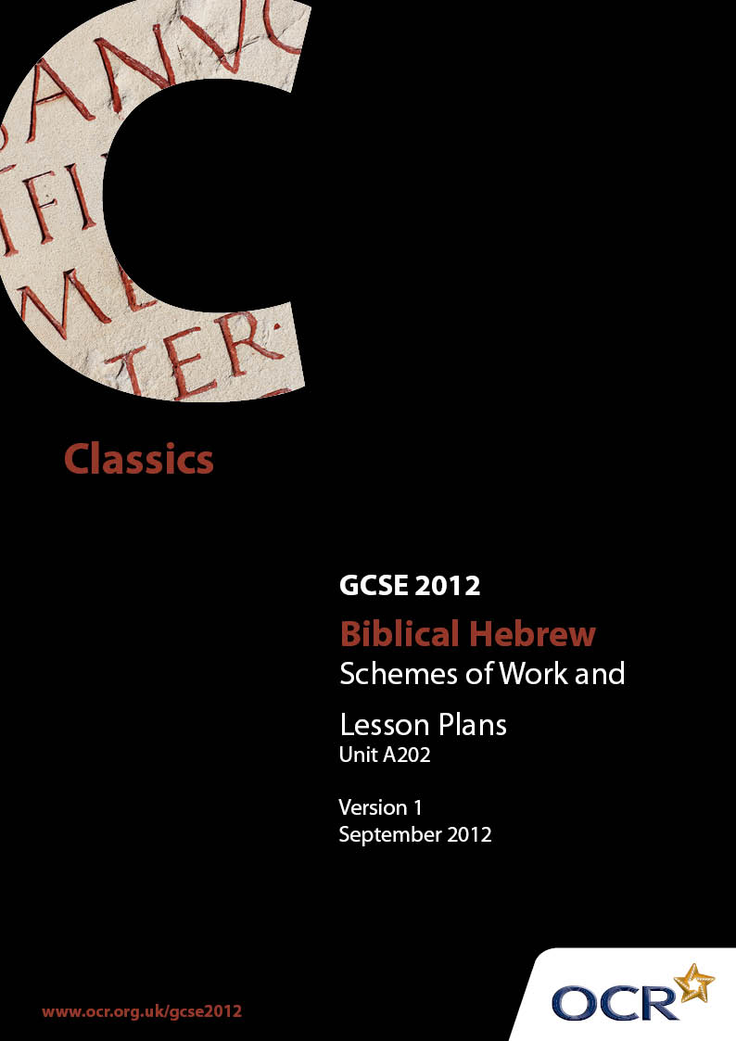

Contents
Contents 2
Introduction 3
Sample Scheme of Work: GCSE Biblical Hebrew Unit A202: Literature 5
Sample Lesson Plan: GCSE Biblical Hebrew Unit A202: Literature 12

Introduction

Background
OCR has produced a summary brochure, which summarises the changes to Biblical Hebrew. This can be found at www.ocr.org.uk, along with the new specification.
In addition and in response to reforms announced by the Government and in response to Ofqual mandated changes to GCSEs, unitised assessment of this qualification is being replaced by linear assessment from September 2012. This means that candidates commencing a two year course from September 2012 will take all of their GCSE units at the end of the course in June 2014.
In order to help you plan effectively for the implementation of the new specification we have produced these Schemes of Work and Sample Lesson Plans for Biblical Hebrew. These Support Materials are designed for guidance only and play a secondary role to the Specification.

Our Ethos
OCR involves teachers in the development of new support materials to capture current teaching practices tailored to our new specifications. These support materials are designed to inspire teachers and facilitate different ideas and teaching practices.
Each Scheme of Work and set of sample Lesson Plans is provided in Word format so that you can use it as a foundation to build upon and amend the content to suit your teaching style and students’ needs.
The Scheme of Work and sample Lesson plans provide examples of how to teach this unit and the teaching hours are suggestions only. Some or all of it may be applicable to your teaching.
The Specification is the document on which assessment is based and specifies what content and skills need to be covered in delivering the course. At all times, therefore, this Support Material booklet should be read in conjunction with the Specification. If clarification on a particular point is sought then that clarification should be found in the Specification itself.

A Guided Tour through the Scheme of Work

= Innovative Teaching Idea
This icon is used to highlight exceptionally innovative ideas.


= ICT Opportunity
This icon is used to illustrate when an activity could be taught using ICT facilities.

OCR GCSE Biblical Hebrew Unit A202: Literature
Suggested teaching time | 3 hours | Topic | Background To Joshua
Topic outline |  | Suggested teaching and homework activities |  | Suggested resources | Points to note
Background to Joshua |  | - Joshua’s family (1Chr 7:27; Nu 1:10), status as tribal Prince of Ephraim, military ancestry & spy  - With Moses/Moshe descending Sinai and as attendant (pupil/military aide) |  | - Times Atlas maps life of Egyptian slave/city builder ; desert peoples & Amalek  - A. Hakham Daat Mikra commentary on Exodus/Shemot  - Y.Moskowits Daat Mikra commentary on Numbers/Bemidbar  - Hartum Bible commentary  - Living Torah | - Jacob’s treatment / blessing of Ephraim.(Gn 48?)  - Date of name change to Joshua  - Battle with Amalek (Ex 17:8-16)
 |  | - Consider the rank of the 70 elders compared to Moses/Moshe, the duration of their appointment & Joshua’s prophetic standing (contrasted with /Moses prophetic rank) |  | - J. Comay Who’s Who in the Bible  - Biblical and general encyclopedia articles in e.g. Encyclopedia Judaica s.v. Joshua, prophecy | - The grammar and meaning of wa’yatzel  - Consider reasons for Joshua’s intervention about Eldad & Medad including Moses’/ Moshe’s diminished authority , true prophecy or Joshua’s jealousy
 |  | - Appointed leader (Nu 27:18)  - pupils as class or small groups enact scenes and list Pentateuchal mentions of Joshua |  | - Davka: Biblical Hebrew text programme.  - Computer generated vocabulary, parsing and grammatical notes

OCR GCSE Biblical Hebrew Unit A202: Literature
Suggested teaching time | 5 hours | Topic | Joshua 1-3
Topic outline |  | Suggested teaching and homework activities |  | Suggested resources | Points to note
Joshua 1-3  Joshua’s first steps as leader bringing people into Land |  | - Joshua reminded of the importance of the Sefer Torah (1:8)  - Pupils map the land of Israel & surrounding nations  (Joshua 1:4);  - Joshua’s spies  - Canaanite administration (“gate”), economy (eg flax production) and housing  - Map main regions of the land and inhabitants (eg Hittites, Amorites, Canaanites)  - Pupils map the River Jordan, its tributaries and places mentioned in chapter 3 (Adam, Zarethan)  - Pupils draw Ark being carried or Israelites crossing Jordan |  | - J.Kiel: Sefer Yehoshua Mosad HaRav Kook  - Hartum Commentary  - Atlas Daat Mikra  - Canaanite utensils (pictures from archaeological digs)  - Pictures of Jordan & tributaries | - Egyptian weakness allowing Israelite penetration  - Contrast the limited task & secrecy of Joshua’s spies with Moses/Moshe’s spy mission  - Contrast the Crossing of the Jordan with the Parting of the Re(e)d Sea  - A description of the Ark and its contents  - Linguistic points and constructions
 |  | - Use as an opportunity to reinforce the knowledge of accidence required |  | - Computerised text - leaving large gaps for students' additions, computerised overview and grammatical notes
- Hebrew and English Lexicon Oxford Press, and resources listed in other schemes
- Trial Specification question

OCR GCSE Biblical Hebrew Unit A202: Literature
Suggested teaching time | 8 hours | Topic | Later Episodes of Joshua’s Leadership
Topic outline |  | Suggested teaching and homework activities |  | Suggested resources | Points to note
Joshua/Yehoshua’s later leadership |  | - Joshua’s command of the Holy Ark  - The reason Joshua sets up commemorative stones  - Joshua prays.G-d answers and Achan is sentenced.  - Joshua responded to Calev’s request for the hill country as sworn by Moshe, even though the Anakim were there and had great fortified cities. The grant of Hebron/Hevron, formerly Kiryat Arba.  - Joshua’s assistance in apportioning the remaining land with the priest Elazar & the heads of the ancestral houses of the Israelite tribes for the 9½ tribes not apportioned by Moshe  - The reasons Judah was allocated first  - The separation of the (Levitical) cities of refuge for harbouring accidental manslayers.  - The Levites’ allocation |  | - Atlas Daat Mikra Maps and photos etc for 132-3 140-1,142-3,144-5,148-9,164-5 for:  - Ai  - Tribal allocation  - Levite cities  - Artefacts similar to the spoil taken by Achan  - Texts, summaries, vocabulary lists and significant grammatical information is computer generated | - As promised in 1:5 Joshua is made great & esteemed throughout his life like Moshe. (4:14).  - The prophecies are followed by their fulfilment  - General statements followed by an act which is only a detail.  - Phraseology similar to the Pentateuch and reminiscent of the miracles at the Reed Sea or the revelation  - Emotional almost poetic language in Chapter 7  - Caleb/Calev’s interchange with Joshua and its relation to Pentateuchal law  - There was no warfare in the land (14:15).  - Chapter 20’s opening, unique in the Prophets  - The significance of Joshua implementing Pentateuchal commands

OCR GCSE Biblical Hebrew Unit A202: Literature
Suggested teaching time | 10 hours | Topic | Jacob Leaves Canaan
Topic outline |  | Suggested teaching and homework activities |  | Suggested resources | Points to note
Jacob leaves Canaan |  | - Map the peoples then in the land and in the surrounding area including Haran  - Consider Jacob’s motives for flight  - Enact or list his experiences and conditions working for Laban/Lavan as shepherd and breeder  - Enact the chase, argument between Laban/Lavan & Jacob/Yaakov & the peace treaty they reach |  | - Y.Elitzur & J. Kiel Atlas Daat Mikra pp 86-89  - Times Bible Atlas map of international trade routes | - Lavan speaks Aramaic – relationship of Hebrew to Aramaic  - Pastoralist custom & practice: sheep shearing; marriage within the family or clan, older daughters must marry before younger; musical accompaniment for departing tribal members  - Peace treaty marked by pillar, heap of stones, meal & sacrifices

OCR GCSE Biblical Hebrew Unit A202: Literature
Suggested teaching time | 10 hours | Topic | Jacob Returns To Canaan
Topic outline |  | Suggested teaching and homework activities |  | Suggested resources | Points to note
Jacob returns to Canaan |  | - Experiences in Machanayim overnight  - Encounter with Esav/ Esau  - Preparations before going to Beit El/Beth El  - Benjamin’s birth & Rachel’s grave near Hevron/Hebron  - Pupils map routes of Esav/Esau from Seir & Yaakov/Jacob from Machanayim to Hevron/Hebron |  | - Davka: Biblical Hebrew text programme.  - Atlases – Daat Mikra, Carta, Times  - Illustrations of artefacts | - Burial practices e.g. of retainer under oak tree (or below the plateau/plain of Beth El)  - Omission of Rivka/Rebecca’s death
 |  | - Pastoralist pre-Sinai religion (pillar, libation, removal of idols, change of clothing, purification before building altar)

OCR GCSE Biblical Hebrew Unit A202: Literature
Suggested teaching time | 5 hours | Topic | Regnal History
Topic outline |  | Suggested teaching and homework activities |  | Suggested resources | Points to note
Kings - political and military aspects |  | - Locate all main places mentioned in texts, noting changing capitals & surrounding nations’ locations, & in the Kingdoms’ wars, especially with each other, & in Egyptian invasion, |  | - Times Atlas pp 96-7, 98-9  - E.g. Carta and Daat Mikra maps  - Hartum Commentary | - Emphasis on Jerusalem as Divinely chosen because of those contesting this in Israel
 |  | - Solomon and Rehoboam’s failures which led to Split Kingdom  - Note Kings’ buildings - forts/military exploits/politics) |  | - Times Atlas 82-3, 84-5 | - Assess each King’s political & military ability as expressed by the text studied
 |  | - Compare luxury at Hebrew (eg Solomon’s court provision requirements) & ancient Near Eastern palaces |  | - Times Atlas  - Archeological artefacts in eg D B Pritchard The Ancient Near East | - Perhaps Kings’ mothers names given because they were officially Queen Mother cp role of Bas Sheva/ Bath Sheba.  - Perhaps they had double names eg Maacha/Maacah
 |  | - Note royal Annals mentioned  - Problems dating regnal years |  | - Living Nach  - J.Kil Daat Mikra commentary & illustrations | - Compare with Divrei Hayamim 1 & 2 / 1 & 2 Chronicles. What type of details are being added or omitted

OCR GCSE Biblical Hebrew Unit A202: Literature
Suggested teaching time | 5 hours | Topic | Regnal History
Topic outline |  | Suggested teaching and homework activities |  | Suggested resources | Points to note
Kings – religious aspects |  | - List each King’s religious stance |  | - Times Atlas pp 101-3  - Living Nach | - Dynastic marriages as a reason for the encroachment of regional idolatries
 |  | - List prophets & their messages/activities  - How their prophecy is expressed and when it happens |  | - J.Kiel Daat Mikra commentary, introduction & illustrations | - Use of Prophetic symbolism by e.g. Ahiya/Ahijah the Shilonite; breaking open of altar
 |  | - Note prophetic Annals mentioned |  | - Davka: Biblical Hebrew text programme | - Compare the details added or omitted in parallel passages in 1 & 2 Chronicles/ Divrei Hayamim 1 & 2
 |  | - Use to reinforce the knowledge of accidence required |  | - Trial specification question

GCSE Biblical Hebrew Unit A202: Literature

An introduction to inseparable prepositions
OCR recognises that the teaching of this qualification above will vary greatly from school to school and from teacher to teacher. With that in mind this lesson plan is offered as a possible approach but will be subject to modifications by the individual teacher.
Lesson length is assumed to be one hour.

Learning Objectives for the Lesson
Objective 1 | To realise that initial beth, mem, lamedh or kaph is often an add-on to the word
Objective 2 | To be able to translate and understand words with initial prepositions correctly
Objective 3 | To recognise and understand add-ons when they have suffixes.

Content
Time | Content
5 minutes | Explain some Hebrew prepositions are separate; others join the word.  Elicit the inseparable prepositions & all their meanings, & write on board. Pupils copy, then practise adding to indefinite nouns and translating them.
10 minutes | Explain that where both preposition and definite article precede the word, the preposition (beth, lamedh or kaph, not min) attracts the vowel under the definite article. Write examples on board. Students copy, then point and translate examples.
10 minutes | Distribute lists of 10 Biblical examples with translation, but gap instead of missing preposition. Pupils should fill in answers with correctly pointed prepositions.  Pair pupils, then give them different parts of the set texts. Have them find examples. Collect these on the board.
20 minutes | Explain that prepositions can take suffixes. Distribute list of beth with suffixes and a translation; then lamedh. Practise with a short exercise from a standard grammar. Then do the same with min and kaf.
10 minutes | Pupils should then find examples from the different set texts or Tenach. Collect examples on the board & look at any difficult examples.

Consolidation
Time | Content
5 minutes | Allow the class to revise and understand all the forms. Try two or three oral questions to test this.

GCSE Biblical Hebrew Unit A202: Literature

To recognise various forms of initial Vav and help produce varied translation
OCR recognises that the teaching of this qualification above will vary greatly from school to school and from teacher to teacher. With that in mind this lesson plan is offered as a possible approach but will be subject to modifications by the individual teacher.
Lesson length is assumed to be one hour.

Learning Objectives for the Lesson
Objective 1 | To recognise various forms of initial vav
Objective 2 | To make aware of linguistic subtleties, and syntactical use of, especially in clauses, and so produce varied translation
Objective 3 | To practise punctuation

Content
Time | Content
5 minutes | The Hebrew letters didn’t always have the shape they have now. Show list of vav forms from table of alphabetic scripts using interactive white board. Ask what class thinks the shape means [Shape is “hook” to hook ideas together.]
10 minutes | Elicit simple meaning & punctuation of initial vav.  Give 4 words displaying varied punctuation. Emphasise how each is punctuated.  Collect the rules (found eg in Lambdin pg 46): u before beth, mem, peh ; vo before tone syllable. Pupils to copy rules down.
5 minutes | Divide into groups & have each use the Bible/ Tenach to find at least 4 other examples. Give their meanings.  Compare work in class. Put results on the white-board (or equivalent).
20 minutes | Ask for other meanings. Accept “but, or, yet, so that, then, surely, however, therefore, for the sake of, also, when, since, though, with, as truly as” or if”.  Give examples of each (use BDB or other lexicon).  In early texts was not fixed straight to the verb but cp Genesis/Bereishit 28:6.
5 minutes | Encourage pupils to find examples in the set texts eg Joshua 7:24
10 minutes | Compare results. Ask for class to improve each others' results.

Consolidation
Time | Content
5 minutes | Revise main alternative translations of “vav” with class. Tell them to be alert to these possibilities, & even combine several meanings together.

Homework
Set a basic punctuation or clause exercise from a text book, or prepare 5 to 10 examples & have pupils to translate.

