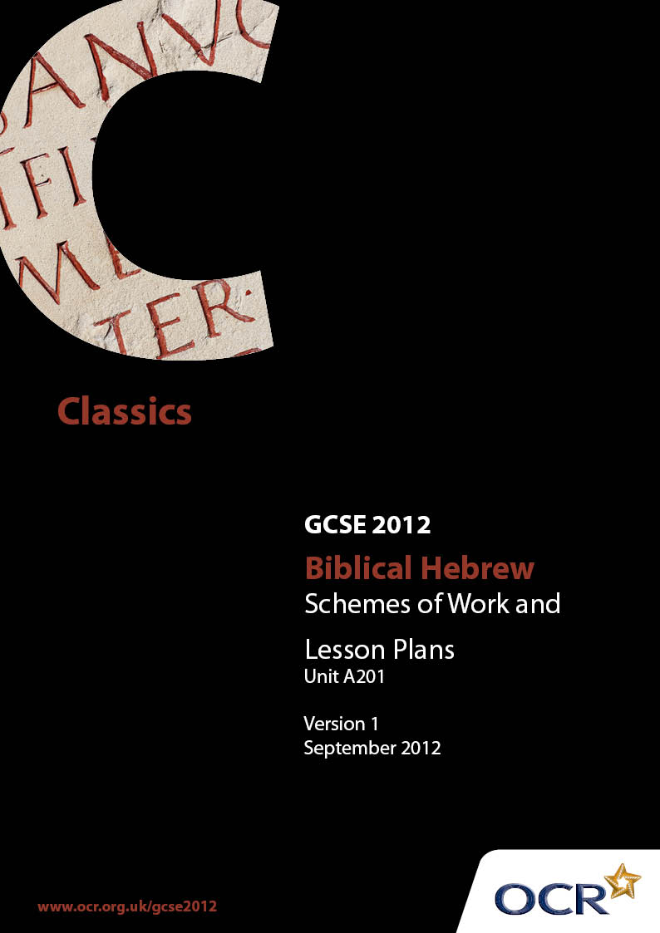

Contents
Contents 2
Introduction 3
OCR GCSE Biblical Hebrew A201: Language 5
Sample Lesson Plan: GCSE Biblical Hebrew Unit A 201: Langage 12

Introduction

Background
OCR has produced a summary brochure, which summarises the changes to Biblical Hebrew. This can be found at www.ocr.org.uk, along with the new specification.
In addition and in response to reforms announced by the Government and in response to Ofqual mandated changes to GCSEs, unitised assessment of this qualification is being replaced by linear assessment from September 2012. This means that candidates commencing a two year course from September 2012 will take all of their GCSE units at the end of the course in June 2014.
In order to help you plan effectively for the implementation of the new specification we have produced these Schemes of Work and Sample Lesson Plans for Biblical Hebrew. These Support Materials are designed for guidance only and play a secondary role to the Specification.

Our Ethos
OCR involves teachers in the development of new support materials to capture current teaching practices tailored to our new specifications. These support materials are designed to inspire teachers and facilitate different ideas and teaching practices.
Each Scheme of Work and set of sample Lesson Plans is provided in Word format so that you can use it as a foundation to build upon and amend the content to suit your teaching style and students’ needs.
The Scheme of Work and sample Lesson plans provide examples of how to teach this unit and the teaching hours are suggestions only. Some or all of it may be applicable to your teaching.
The Specification is the document on which assessment is based and specifies what content and skills need to be covered in delivering the course. At all times, therefore, this Support Material booklet should be read in conjunction with the Specification. If clarification on a particular point is sought then that clarification should be found in the Specification itself.

A Guided Tour through the Scheme of Work

= Innovative Teaching Idea
This icon is used to highlight exceptionally innovative ideas.


= ICT Opportunity
This icon is used to illustrate when an activity could be taught using ICT facilities.

OCR GCSE Biblical Hebrew A201: Language
Suggested teaching time | 3 hours | Topic | Unprepared Translation 1 – The story of Gedaliah
Topic outline |  | Suggested teaching and homework activities |  | Suggested resources | Points to note
Unprepared Translation |  | - Students could act out scenes of Gedaliah’s appointment, Johanan’s admonition for Gedaliah to beware an assassination attempt and the subsequent murder |  | - Jeremiah Chapters 40 (vv. 7 – 16) and 41 | - Use of seemingly similar roots with totally different translations ‘live’, ‘return’ and ‘capture’
 |  | - Class could discuss the moral issues of believing gossip and / or taking precautions as a consequence versus the naïveté of dismissing such gossip |  | - Computer generated texts | - Comparison to conspiracies within the set texts
 |  |  |  | - Vocabulary list necessary for words not in the set GCSE specification

OCR GCSE Biblical Hebrew A201: Language
Suggested teaching time | 4 hours | Topic | Unprepared Translation 1 – Jehoshaphat: His Justice, Wars and Alliances
Topic outline |  | Suggested teaching and homework activities |  | Suggested resources | Points to note
Unprepared Translation |  | - The origins of the split in the kingdom in 1 Kings |  | - 2 Chronicles Chapters 18 - 20 | - Guidance and rebuke of prophets  - Divine retribution
 |  | - Let students identify on map of Biblical Israel where the Northern and Southern kingdoms were situated. Useful for those studying the 1 Kings set texts |  | - Computer generated texts | - Change of Hebrew style from earlier books of the Bible e.g. days three (not three days)
 |  |  |  | - Vocabulary list necessary for words not in the set GCSE specification

OCR GCSE Biblical Hebrew A201: Language
Suggested teaching time | 4 hours | Topic | Comprehension 1 – The False Prophet
Topic outline |  | Suggested teaching and homework activities |  | Suggested resources | Points to note
Deuteronomy Chapter 19 ( vv. 15 – 22)  Jeremiah Chapter 28  1 Kings Chapter 13 |  | - Explore the definition of a false prophet |  | - Deuteronomy Chapter 13  - Maimonides, Foundations of the Law Chapters 7 – 10  (Available in English) | - Encourage students to write down what they understand to be the expectation of prophets and the severity of punishment for those who spoke falsely
 |  | - Since prophecy is found throughout the bible and especially in the GCSE set texts, students could be encouraged to research further - see next column |  | - Computer generated texts | - Accordingly, ponder also the difficulties raised by the chapter from 1 Kings
 |  | - Class could act out scenes using original texts, supplemented with explanations in English |  | - Vocabulary list necessary for words not in the set GCSE specification

OCR GCSE Biblical Hebrew A201: Language
Suggested teaching time | 2 hours | Topic | Comprehension 2 – To Test Recognition of Verbal Roots and Conjugations
Topic outline |  | Suggested teaching and homework activities |  | Suggested resources | Points to note
Leviticus Chapter 6 (vv. 1 – 23) |  | - Highlight with different colours [or code with different numbers] the six out of seven conjugations used extensively in the passage |  | - Exodus Chapter 29 as an introduction to the privileges of priests | - Differences between words which follow variant uses of the Hophal
 |  | - Write out the verbs giving both roots and conjugations |  | - Computer generated texts | - The Niphal conjugation and the change that occurs when the first root letter is a guttural
 |  | - Further discussion: the rights of priests and their sacrificial dues |  | - Vocabulary list necessary for words not in the set GCSE specification

OCR GCSE Biblical Hebrew A201: Language
Suggested teaching time | 4 hours | Topic | comprehension 3 – ruth’s loyalty
Topic outline |  | Suggested teaching and homework activities |  | Suggested resources | Points to note
Ruth Chapters 1 and 2 |  | - Explore the story as an example of ‘riches to rags’ |  | - Computer generated texts | - Identify uses of speech such as puns, unintentional errors, repetition for emphasis
Loyalty in the face of adversity |  | - Contrast the attitudes of Ruth and Orpah |  | - Vocabulary list necessary for words not in the set GCSE specification | - The concept of Divine Providence: Elimelech’s death; Ruth in Boaz’s field
The concept of kindness and charity |  | - Highlight the various feminine verbal suffixes

OCR GCSE Biblical Hebrew A201: Language
Suggested teaching time | 2 hours | Topic | Comprehension 4 – Demonstrations of Gratitude
Topic outline |  | Suggested teaching and homework activities |  | Suggested resources | Points to note
Deuteronomy Chapter 26 ( vv. 1 – 11) |  | - The idea that thanks to G-d can be shown in both verbal expression and a practical manner |  | - Computer generated texts | - The thankful Israelite farmer refers to historical events to affirm his gratitude
 |  | - Class could act out scenes using original texts, supplemented with explanations in English |  | - Vocabulary list necessary for words not in the set GCSE specification | - Recognition of G-d’s bounty in spite of one’s hard work and effort
For more advanced pupils  Psalm 118 (vv. 1 – 7, 19 – 24) |  | - Class should write down examples of parallelism and other devices prevalent in Psalmodic poetry |  |  | - Only very simple poetry would be considered for examination. Even then it will consist of a quotation or very limited number of phrases.

GCSE A201 Biblical Hebrew

Unseen text : Judges Chapter 3 (12 – 30)
OCR recognises that the teaching of this qualification above will vary greatly from school to school and from teacher to teacher. With that in mind this lesson plan is offered as a possible approach but will be subject to modifications by the individual teacher.
Lesson length is assumed to be one hour.

Learning Objectives for the Lesson
Objective 1 | Students to have some understanding of the period of the judges prior to the Israelite monarchy.
Objective 2 | Students to understand the story from the original Hebrew text.
Objective 3 | Students to raise points of grammar and styles of Biblical language.

Content
Time | Content
5 minutes | Brief explanation of the vicious cycle of ‘sin, punishment, prophetic admonition, repentance, complacency and sin’ prevalent in the book of Judges.
10 minutes | Distribute computerised text and prepared vocabulary. Ask students to study, in pairs, the first seven verses.
5-10 minutes | Discuss the significance of the left-handed judge and summarise, through questioning, what has been learned.
15 minutes | Explain the use of euphemism in the text. Ask students to study, in pairs, the next seven verses.
10 minutes | Students in turn to read the last five verses allowing class participants to translate odd words or phrases when the teacher indicates. Three or four grammatical points to be asked to the class.

Consolidation
Time | Content
10 minutes | Ask students to write down two points they learned about the period of the Judges from the passage and one point of linguistic style not yet raised.

GCSE A201 Biblical Hebrew

Unseen text : Joshua Chapter 22 (9 – 29)
OCR recognises that the teaching of this qualification above will vary greatly from school to school and from teacher to teacher. With that in mind this lesson plan is offered as a possible approach but will be subject to modifications by the individual teacher.
Lesson length is assumed to be one hour.

Learning Objectives for the Lesson
Objective 1 | Understanding of the tribal division of the land of Canaan / Israel and Transjordan.
Objective 2 | Students to understand via the text how those divisions caused potential rifts.
Objective 3 | Students to raise points of grammar and styles of Biblical language.

Content
Time | Content
10 minutes | Distribute computerised text and prepared vocabulary. Provide maps either by handouts to students or viewing map on interactive whiteboard. Show where the ‘two-and-a-half tribes’ settled (Transjordan) explaining why they chose to settle there and what conditions were attached.
25 minutes | Ask students to study, in pairs, the entire text.
5 minutes | Discuss the threat of idolatry in Canaan to explain the fears of the majority of the tribes.
10 minutes | Raise any grammatical points emerging from the text.

Consolidation
Time | Content
10 minutes | Ask students to write down two points they learned about the religious ideals of both sides of the argument. Discuss the answers in class.

