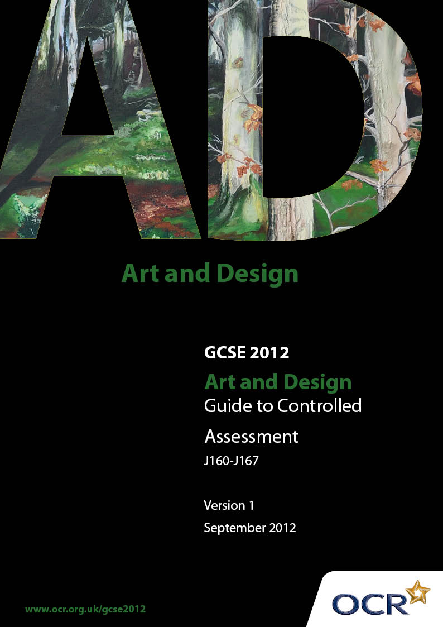

Contents

1 Introduction 3

1.1 What is Controlled Assessment? 3
1.2 What does ‘control’ actually mean? 3
1.3 What is the purpose of this Guide? 4

2 Summary of the Controlled Assessment unit 5

3 Teacher guidance on how to plan Controlled Assessment 6

3.1 Controlled Assessment delivery flow chart 6
3.2 Guidance on the release of Controlled Assessment tasks to candidates 7
3.3 Guidance on research/data collection 7
3.4 Guidance on the production of the outcome 8

4 Controlled Assessment candidate guidelines 10

4.1 | Task setting | 10
4.2 | Task taking | 10
5 Teacher guidance on task marking 14

5.1 Generic guidance on how to mark Controlled Assessment tasks 14
5.2 Unpacking assessment objectives in Controlled Assessment tasks 14
5.3 Interpretation of the marking criteria 15
5.4 Authentication of Controlled Assessment outcomes 15
5.5 Internal Standardisation of Controlled Assessment 16
5.6 Moderation of Controlled Assessment 16
5.7 Minimum requirements for Controlled Assessment 17
5.8 Submission date for Controlled Assessment 17

6 FAQs 18
1 Introduction

1.1 What is Controlled Assessment?

Controlled Assessment is a new form of internal Assessment. Following a coursework review by QCA, Controlled Assessment has been introduced as part of nearly all GCSEs, to replace coursework.

High, medium or limited control levels are set for each of the Controlled Assessment processes: task setting, task taking and task marking. For each stage, the level of control will ensure reliability and authenticity, and make Assessments more manageable for teachers and candidates.

For Art and Design medium to low levels of control are used.

Weighting of Controlled Assessments was defined by QCA subject criteria for OCR GCSE Art and
Design. This is 60% coursework portfolio unit and 40% for the OCR-set Task.

1.2 What does ‘control’ actually mean?

QCA has produced a Glossary of terms for Controlled Assessment regulations. The levels of controls are defined as follows:

• Formal supervision (High level of control) – the candidate must be in direct sight of the supervisor at all times. Use of resources and interaction with other candidates is tightly prescribed.

• Informal supervision (Medium level of control) – questions/tasks are outlined, the use of resources is not tightly prescribed and assessable outcomes may be informed by group work. Supervision is confined to (i) ensuring that the contributions of individual candidates
are recorded accurately, and (ii) ensuring that plagiarism does not take place. The supervisor may provide limited guidance to candidates.

• Limited supervision (Limited level of control) – requirements are clearly specified, but some work may be completed without direct supervision and will not contribute directly to assessable outcomes.
1.3 What is the purpose of this Guide?

This Guide provides detailed information for teachers about how to manage Controlled Assessment: some of the information applies to all GCSE subjects and some information provides subject specific guidance. It is important to make the point that this Guide plays a secondary role to the Specification itself. The Specification is the document on which assessment is based and specifies what content and skills need to be covered in delivering the course. At all times, therefore, this Guide should be read in conjunction with the Specification. If clarification
on a particular point is sought then that clarification should be found in the Specification itself.

Teaching of this qualification will vary greatly from school to school and from teacher to teacher. With that in mind, this Guide is offered as a reference but may be subject to modifications by the individual teacher.
2 Summary of the Controlled Assessment unit

Unit A110 – A117: Art and Design Portfolio

Unit A110 – A117: Art and Design Portfolio is a centre-set and centre-assessed unit that is externally moderated by OCR. Candidates need to produce a portfolio of work for this unit that demonstrates a personal response to starting points, briefs, scenarios or stimuli. Centres must set their own starting points, briefs, scenarios or stimuli. OCR-produced exemplar material is provided to help centres design and set their own starting points, briefs, scenarios or stimuli but
this material must not be used for assessment purposes.

The portfolio consists of a ‘sustained project, theme or course of study’. It may be presented in an appropriate format for the area of study using, for example, annotated sketchbooks, mounted sheets, maquettes, prototypes, scale models or written work and appropriate digital formats.
3 Teacher guidance on how to plan
Controlled Assessment

3.1 Controlled Assessment delivery flow chart

Centre devise task

Teacher Guidance/ Feedback
Candidate Work in Progress Could include: Planning
Researching
Visiting Museums
Understanding Materials & Techniques

Candidate Work in Progress Developing ideas Experimenting Extending/Reviewing
Timetabled
Lessons

Example Schemes of Work and Lessons Plans are available on the website and from OCR

Candidate Produce Outcome(s) for
Assessment Could include: Portfolio/CD
3 D/Ceramic(s) Painting(s)/Textile(s)
Animation/Photographs
Graphic presentation etc.
(Approx 45 hours work)

Evaluation/ Review

Teacher Assessment and Submission to OCR for Moderation by specified deadlines
Submission of marks:
June series:
15 May

3.2 Guidance on the release of Controlled Assessment tasks to candidates

3.2.1 Choice of Controlled Assessment task

For GCSEs in Art and Design OCR will assume a limited level of control in the production of assessment materials. OCR has produced exemplar starting points, briefs, scenarios and stimuli; this is intended to be used as guidance for centres on production of their own Controlled Assessment material. Centres must devise their own assessment material for live assessment purposes. Centre-devised material can be set by the tutor or alternatively can be based on a candidate’s own idea for a starting point, brief, scenario or stimulus. Assessment material should contain suggested activities or tasks for candidates to undertake and should also outline any advice, direction and guidance that centres wish to give to candidates.

Any Controlled Assessment material devised by centres must be designed to meet the full assessment requirements of the unit including the chance for candidates to gain marks at the highest level.

The same Controlled Assessment material must not be used as practice material and then again for live assessment purposes.

3.2.2 When and how to give Controlled Assessment tasks to candidates

Since the Art and Design Portfolio (A110-117) may be undertaken at any point during the programme Centres have considerable freedom in designing a course that embraces local needs and gives candidates sufficient time to both develop individual skills and fully ‘rehearse’ the Unit.

3.3 Guidance on research/data collection

(a) Authenticity control: Candidates must complete all work being submitted for assessment under informal supervision as described in 5.3.1. This may relate to work produced within the centre, or any other appropriate supervised learning environment (for example, work done during a visit to a gallery or local business). The only possible exception to this is research (see Additional Note on Research).

(b) Feedback control: It is expected that teaching staff will supervise and guide candidates who are undertaking work which is internally assessed. During this time candidates should work independently but teachers may advise, guide and direct candidates to appropriate resources. Guidance should be given to candidates about availability and choice of materials, health and safety, avoidance of plagiarism and completion of work in accordance with specification requirements and procedures. Advice can also be given to candidates to aid their research for example guidance to relevant artist/designer/craftsperson links, processes and techniques, or taking candidates on visits to galleries, businesses, museums and workshops. However, it should
be remembered that candidates are required to reach their own judgements and conclusions and produce their own work. Advice, direction and guidance given to candidates should be recorded and form part of the centre-produced assessment material for this unit.

(c) Time control: Candidates may have approx 45 hours (15-18 school weeks as a guide) in which to complete Unit 1 (A110 – A117): Art and Design Portfolio. The appropriate unit can be undertaken at any point during the course leading up to the series in which the candidates intend to submit; the start date and final deadline can be set and timetabled to suit centres’ needs. However, centres must note that marking and internal standardisation must be completed in time to submit marks to OCR by the 15 May deadline.

(d) Collaboration control: Candidates’ work may be informed by working with others, for example working with artists in residence or visiting galleries and museums. Where working in groups, each candidate’s contribution to group activities must be clearly identified. Each candidate must provide their own individual personal response for assessment that can be identified, authenticated and evidenced.

(e) Resource control: Centres must ensure that candidates have access to relevant and appropriate resources, which will facilitate their achievement of the Art and Design GCSE that they are entered for.

3.4 Guidance on the production of the outcome

3.4.1 Controls for the production of the outcome – Teachers must be able to authenticate candidate work

Teachers need to ensure enough checks are in place during the assessment period of approximately 45 hours (15 to 18 school weeks) to ensure they are able to authenticate candidate work. Teachers must keep live Controlled Assessment work secure at all times whilst in their possession. For example, candidates may collect the results of any research, investigations, practice work etc undertaken in a designated research or homework folder. The work may then be used to develop and inform classroom based outcome(s) for assessment. Candidate practice work, research etc which has not been developed under any teacher guidelines and therefore away from any authentication controls, may not be part of the assessment.

3.4.2 Controlled Assessment task security

It is the responsibility of the centre to ensure that candidates’ work is stored securely and correctly. Any issues which may arise in malpractice must be reported to OCR as soon a possible by submitting a written report (a blank report form is available on Interchange) from Head of Centre to OCR Quality and Standards Division detailing the circumstances, the candidates concerned and any action taken.

Candidates’ work for completed Controlled Assessment tasks must be stored securely and they should be available for moderation. Work may be returned to candidates after the last date for Enquiries about Results.
3.4.3 Presentation of work

Candidates are expected to evidence all of the assessment objectives whilst producing work for this unit. Candidates must select and present their own work for assessment purposes from the work that they have undertaken in response to this unit.

Candidate work may be presented in an appropriate format for the area of study using for example annotated sketchbooks, mounted sheets, maquettes, prototypes, scale models, written work or digital media.

Candidates must observe certain procedures in the production of Controlled Assessments.

•    any source material must be suitably acknowledged

•    quotations must be clearly marked and a reference provided wherever possible

•    work submitted for assessment and moderation should be labeled clearly with:

– centre number and name

– candidate number and name

– unit code

– title of candidate’s work indicating the starting point, brief, scenario or stimulus

– outcome(s) clearly identified.
4 Controlled Assessment candidate guidelines

4.1 Task setting

For all Art and Design qualifications OCR will allow your teacher to devise material for your Controlled Assessment tasks.

OCR will produce guidance and ideas such as starting points, briefs, scenarios and stimuli and these can be used to help your teacher devise tasks and activities for you to do and give you any advice, direction or guidance you need. These tasks may be based on OCR’s material, or on your teacher’s material or on your own ideas for starting points, briefs, scenarios or a stimulus. Materials can be adapted to allow you to use local resources and to make them more relevant your own environment and your interests and abilities.

4.2 Task taking

4.2.1 What can I do in relation to practice work and research?

Much of your practice work and research can be done outside your centre. The requirements for this will be clearly laid down by your teacher. Make sure you know how much time you have for any practice, research and exploration and plan how to spend your time, i.e. some may be in the classroom as well (AO2).

Any work for assessment, including some of your research, must be completed under what it is called ‘informal supervision’ or medium level of control. This means your teacher must be able to authenticate the work you do.

Not all the practice work or research that you complete will contribute to your assessment. Some of it may just inspire you or support your learning and so this could be completed under limited or low level of control from your teacher, possibly outside of your centre. This may be identified by using a coloured sticker on the artwork or page or a separate ‘homework’ folder.

There must be individual evidence of your work, so if you are allowed to work in groups, it is vital that your teacher can identify your individual contribution in your portfolio/work for assessment, and that your teacher knows your contribution to the group work and any outcome(s).

You will be given a time limit to work within and during that time you may produce a body of work/outcome(s) for assessment. During this process your teacher may give you support and guidance as outlined below.
You must include in your portfolio any references to the works of artists, designers and craftspeople you have used or researched to inform your outcome(s). Any quotations or written work, including digital work not your own must be clearly marked and referenced where possible. This is to ensure plagiarism does not take place. You may need to discuss this with your teacher so make sure you keep records of all the sources of information you intend to use.

Your teacher will advise you on appropriate formats for presenting your work for assessment and you may use a range of artists materials, new media, technologies and ICT as appropriate.

4.2.2 How much teacher support can I expect?

During your work for Controlled Assessment you must produce work/evidence independently but your teacher will be able to give you some advice, support, guidance and feedback but the amount will vary depending upon the type of task you are doing.

You must make your own judgements and draw your own conclusions but your teacher will:

• offer advice about how best to approach a task

• offer guidance on the way you work in groups so that you all have an opportunity to tackle your tasks

• offer guidance about the availability and choice of materials and resources, although how these are eventually used must be your responsibility

• offer advice to help your research, possibly arranging visits to place of interest such as galleries and exhibitions, if this is appropriate

• monitor your progress to make sure your work gets underway in a planned and timely manner

• ensure that your work meets the Specification requirements and assessment objectives

• keep a log of the feedback they give you
• supervise any practical work you do to ensure you receive advice about health and safety. The support given by your teacher will be to make sure you understand what it is you have to do.
Your teacher will not be allowed to provide direct model responses for you or work through your
responses or outcomes in detail.

4.2.3 What can I expect in the supervised sessions?

The work that you will be assessed on will take place in these sessions in school time and you will be supervised by your teacher.

These sessions are likely to be scheduled in normal classroom time, although some time may be included after school in art clubs for example, and the task(s) will normally spread over several sessions. During each session your teacher will monitor your developed work and may collect in your work, or make sure your work is kept secure. You are allowed access to your work as appropriate to inform and develop further outcome(s) if necessary.
The materials and equipment you will need for your assessment will be provided by your centre, as will access to resources that are appropriate for your particular task. If access to any specialist equipment and software is necessary this access will be provided.

You may wish to provide your own materials, for example, art materials, costumes, musical instruments etc. You may also wish to use your own digital media and equipment if appropriate to your course of study, in addition to those provided by your centre and this is acceptable.

CONTROLLED ASSESSMENT FLOW CHART

Centre devise task

Teacher Guidance/ Feedback
Candidate Work in Progress Could include: Planning
Researching
Visiting Museums
Understanding Materials & Techniques

Candidate Work in Progress Developing ideas Experimenting Extending/Reviewing
Timetabled
Lessons

Example Schemes of Work and Lessons Plans are available on the website and from OCR

Candidate Produce Outcome for
Assessment Could include: Portfolio/CD
3 D/Ceramic(s) Painting(s)/Textile(s)
Animation/Photographs
Graphic presentation etc.
(Approx. 45 hours work)

Evaluation/ Review

Teacher Assessment and Submission to OCR for Moderation by specified deadlines
Submission of marks:
June series:
15 May

5 Teacher guidance on task marking

5.1 Generic guidance on how to mark Controlled Assessment tasks

Candidates’ work for Unit 1 (A110 – A117): Art and Design Portfolio should be marked by the centre assessor according to the marking criteria, using a ‘best fit’ approach. The award of marks must be directly related to the marking criteria. Centre assessors use their professional judgement in selecting the descriptor that best describes the work of the candidate to place them within the appropriate band for each assessment objective strand. Marks should then be awarded as outlined below.

Where the candidate’s work:

• convincingly meets the descriptor; the highest mark within the band should be awarded

• adequately meets the descriptor; the most appropriate mark in the middle range of the band should be awarded

• just meets the descriptor; the lowest mark in the band should be awarded

• fails to meet any aspect of the descriptor within the lowest band then 0 marks should be awarded.

The candidate’s final mark is out of a total of 100 and is arrived at by totalling the marks awarded for each assessment objective.

5.2 Unpacking assessment objectives in Controlled Assessment tasks

Candidates are expected to demonstrate the following in the context of the content described:

5.2.1 AO1 Develop ideas

• Develop their ideas through investigations informed by contextual and other sources, demonstrating analytical and cultural understanding.

5.2.2 AO2 Explore ideas

• Explore and refine their ideas through experimenting and selecting appropriate resources, media, materials, techniques and processes.
5.2.3 AO3 Record ideas

• Record ideas, observations and insights relevant to their intentions in visual and/or other forms.

5.2.4 AO4 Present a response

• Present a personal, informed and meaningful response demonstrating analytical and critical understanding, realising intentions and, where appropriate, making connections between visual, written, oral or other elements.

Assessment objectives are written into the marking grid and centres will be able to see that tasks in the Controlled Assessment target the assessment objectives.

5.3 Interpretation of the marking criteria

Centre assessors are to use OCR marking grids and guidance. It is advisable to maintain records of the progress of individual candidates, as these will facilitate final assessment when the Unit is completed.

Candidates’ work should be marked in direct relation to the assessment criteria using a ‘best fit’ approach. Centre assessors should use their professional judgment in selecting the descriptor that best matches the candidate’s work to place them within the appropriate band for each Assessment Objective. Consequently assessors decide which mark point within the band best suits the work.
‘Convincingly’, ‘adequately’ and ‘just’ meeting the descriptor reflects the ‘highest’, ‘middle’ and
‘lowest’ points within the band, with latitude to award a mark in between.

When Unit 1 the Portfolio has been completed and assessed, preparatory work and outcomes are to be securely retained within Centres until results are published and centres are certain that they do not wish to engage the Enquiries About Results process or Appeals Procedure.

5.4 Authentication of Controlled Assessment outcomes

Teachers must be confident that the work they mark is the candidate’s own. This does not mean that a candidate must be supervised throughout the completion of all work but the teacher/course tutor must exercise sufficient supervision, or introduce sufficient checks, to be in a position to judge the authenticity of the candidate’s work.

Candidates must not plagiarise. Plagiarism is the submission of another’s work as one’s own and/or failure to acknowledge the source correctly. Plagiarism is considered to be malpractice and could lead to the candidate being disqualified. Plagiarism sometimes occurs innocently when candidates are unaware of the need to reference or acknowledge their sources. It is therefore important that centres ensure that candidates understand that the work they submit must be their own and that they understand the meaning of plagiarism and what penalties may be applied.
Additional Note on Practice work and Research

Candidates may refer to and use practice work, research etc but they must list their sources. The rewards from acknowledging sources, and the credit they will gain from doing so, should be emphasised to candidates, as well as the potential risks of failing to acknowledge such material.

The candidate must sign a declaration to this effect. Centres should reinforce this message to ensure that candidates understand what is expected of them.

Please note: Centres must confirm to OCR that the evidence produced by the candidate is authentic. The Centre Authentication Form includes a declaration for assessors to sign. It is a requirement of the QCA Common Criteria for all Qualifications that proof of authentication is received.

5.5 Internal Standardisation of Controlled Assessment

It is important that all internal assessors, working in the same subject area, work to common standards. Centres must ensure that the internal standardisation of marks across assessors and teaching groups takes place using an appropriate procedure.

This can be done in a number of ways; online reference material and OCR training meetings provide a basis for centres’ own standardisation. Centres’ own archive material may be used. Centres are advised to hold preliminary meetings of staff involved to compare standards through cross-marking a small sample of work. After most marking has been completed, a further meeting at which work is exchanged and discussed will enable final adjustments to be made.

5.6 Moderation of Controlled Assessment

All work is marked by the teacher and internally standardised by the centre. Marks are then submitted to OCR, after which moderation takes place in accordance with OCR procedures: refer to the OCR website for submission dates of the marks to OCR. The purpose of moderation is to ensure that the standard of the award of marks for work is the same for each centre and that each teacher has applied the marking criteria appropriately across the range of candidates within the centre.

The sample of work which is presented to the Moderator for moderation must show how the marks have been awarded in relation to the marking criteria. Each candidate’s work should have an identification label attached. If the work is to be submitted in digital format this should also be clearly identified against the candidate’s files.
5.7 Minimum requirements for Controlled Assessment

There should be clear evidence that work has been attempted and some work produced.
If a candidate submits no work for an internally assessed component, then the candidate should be indicated as being absent from that component on the mark sheets submitted to OCR. If a candidate completes any work at all for an internally assessed component, then the work should
be assessed according to the internal assessment objectives and marking instructions and the appropriate mark awarded, which may be zero.

5.8 Submission date for Controlled Assessment

Candidates marks must be despatched to the Moderator and to OCR by 15 May during the same academic year in which the candidates will certificate.
6 FAQs

When can Controlled Assessment be taken?

Controlled Assessment is a form of internal assessment and as such there isn’t a specified date in which Controlled Assessment has to be taken.

It is up to the centre to decide when Controlled Assessment will be taken: guidance on this can be found in Section 5: Controlled Assessment of all revised GCSE Specifications

When can teachers and candidates access the material?

The Controlled Assessment tasks for all Art and Design specifications will be devised by the centre from information provided in the subject specification.

Can any preparation work be done out of the classroom?

Yes. Controls are set at the level of tasks setting, task taking and task marking. Preparation work has a limited level of control i.e. work can be carried out without direct supervision. More guidance on this can be found can be found in Section 5: Controlled Assessment of all GCSE Specifications.

Is there a minimum or maximum time that can be spent on the assessments?

Centres are free to provide a designated time period they feel appropriate for the tasks set within the approximately 45 hours (15-18 weeks).

How long is each assessment valid for, ie, can we use last year’s assessment this year?

Controlled Assessment tasks will be devised by the centre from information provided in the subject specification and is under the control and discretion of the teacher.

Where can the Mark Schemes/Marking Criteria be accessed?

Mark Schemes/Marking Criteria are included in the specifications and can also be accessed from the OCR website.

Do we have to take approximately 45 hours Controlled Assessment under teacher supervision?

Yes, for certain tasks set by the teacher for monitoring and assessment purposes. Note this can be over more than one supervised session.
Can we resit the Controlled Assessment Portfolio unit?
From September 2012 candidates are only able to re-take a qualification in its entirety. It is no longer possible to re-sit individual units.
Centres have the responsibility to ensure that candidates complete tasks suitable for the Controlled
Assessment. This is for the approximate 45 hours.

Do we mark the tasks or do OCR?

Controlled Assessment tasks are internally marked by centres and externally moderated by OCR.

What is the Portfolio?

The Art and Design Portfolio (Unit 1) A110-A117

Candidates need to produce a portfolio of work for this unit that demonstrates a personal response to starting points, briefs, scenarios or stimuli. Centres must set their own starting points, briefs, scenarios or stimuli. OCR-produced exemplar material is provided to help centres design and set their own starting points, briefs, scenarios or stimuli but this material must not be used for assessment purposes.

What is the OCR- set Task?

The OCR-set Task (Unit 2)

This is the examined unit and is not part of the Controlled Assessment of approximately 45 hours (15-18 weeks). For further guidance on this unit please refer to the Art and Design specification and the Teachers’ Handbook available on our website.

Further Information

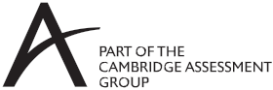
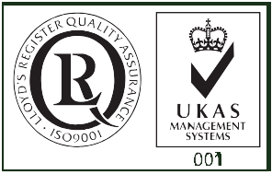

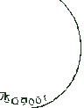





Please refer directly to The Teachers Handbook and SampleSchemes of Work and Lesson Plans for GCSE Art and Design already available on our website

