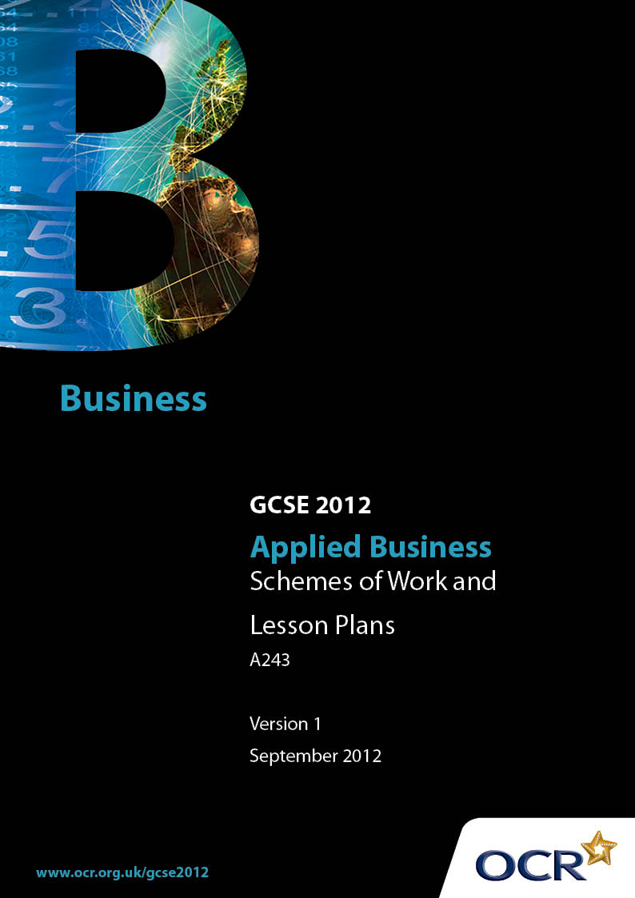

Contents
Contents 2
Introduction 3
Sample Scheme of Work: OCR GCSE Applied Business J213 & J226 Unit A243: Working In Business 5
Sample Lesson Plan: OCR GCSE Applied Business J213 & J226 Unit A243:
Working in Business 28

Introduction

Background
OCR has produced a summary brochure, which summarises the Applied Business GCSE. This can be found at www.ocr.org.uk, along with the new specification.

In response to reforms announced by the Government and in response to Ofqual mandated changes to GCSEs, unitised assessment of this qualification is being replaced by linear assessment. This means that candidates commencing a two year course from September 2012 will take all of their GCSE units at the end of the course in June 2014.
In order to help you plan effectively for the implementation of the specification we have produced these Schemes of Work and Sample Lesson Plans for Applied Business. These Support Materials are designed for guidance only and play a secondary role to the Specification.

Our Ethos
OCR involves teachers in the development of new support materials to capture current teaching practices tailored to our new specifications. These support materials are designed to inspire teachers and facilitate different ideas and teaching practices.
Each Scheme of Work and set of sample Lesson Plans is provided in Word format – so that you can use it as a foundation to build upon and amend the content to suit your teaching style and candidates’ needs.
The Scheme of Work and sample Lesson Plans provide examples of how to teach this unit and the teaching hours are suggestions only. Some or all of it may be applicable to your teaching.
The Specification is the document on which assessment is based and specifies what content and skills need to be covered in delivering the course. At all times, therefore, this Support Material booklet should be read in conjunction with the Specification. If clarification on a particular point is sought then that clarification should be found in the Specification itself.

A Guided Tour through the Scheme of Work

= Innovative Teaching Idea
This icon is used to highlight exceptionally innovative ideas.


= ICT Opportunity
This icon is used to illustrate when an activity could be taught using ICT facilities.

OCR GCSE Applied Business J213 & J226 Unit A243: Working in Business
Suggested teaching time | 60 - 70 hours | Topic | Working in Business
Topic outline |  | Suggested teaching and homework activities |  | Suggested resources | Points to note
2.3.1 Business Structure – how businesses organise themselves  2 hours |  | Theory  - Introduce the different ways a business can organise themselves – flat, hierarchical, matrix, by function, geographical location, the main features and how these structures can affect the different functional areas of a business.  Class  - Complete handout on different organisational structures.  Candidate  - Working through exercise on arranging a business into an organisation chart. |  | - PowerPoint presentation.  - Handouts so that candidates can copy diagrams on slides. | - Design a handout that candidates can use during the theoretical presentation. Candidates need to complete boxes which illustrate how businesses are structured. Discuss how power and control flows through different businesses and how this impacts on the communication in the business.  - Exercise – give the candidates a list of different people who would work in a business. Get the candidates to draw out their own organisation chart.
2.3.4 – 2.3.8 Functional areas within businesses and associated activities  3 hours |  | Teacher  Theoretical coverage of the main functional areas found within a business  - Finance  - Marketing and sales  - Administration and ICT  - Customer service  - Production  Class  - Match the description to the correct department. |  | - Cards which outline simply what each functional area would do. Get candidates to put the correct description under the correct heading. | - At this stage candidates just need a simplistic understanding of what each functional area actually does. This is developed in much greater depth in later sections.
2.3.2. Job Roles - key activities and responsibilities  3 hours |  | Teacher  Split the group into groups of six. Give each candidate a job role from the list below.  - Chief executive  - Chairman  - Directors  - Managers  - Supervisors  - Production operatives  Each candidate is to investigate the  - Key tasks  - Activities  - Skills  - Qualifications  - Personal qualities  required for their allocated job role. Each candidate produces a handout they bring to a group discussion and is given to the other five members of the group.  Teacher  - Review – pull together all the learning and ensure that all members of the class have sufficient information on each job role. |  | - Handout which clearly explains the task the candidates are being set.  - Guidelines on how to prepare for the group discussion and content and depth required for the candidate handout. | - It is important to spend time explaining exactly what each candidate is required to do and the depth required.  - It is vital to ensure that all candidates have sufficient information in order to tackle any possible exam questions. It may be necessary to have a handout that can support the work of weaker candidates.
2.3.3. Forms of Communication  4 hours |  | Candidates  Identify as many different methods of communication that you can under the following headings.  - Oral  - Written  - ICT  Class  - Pull together a class list of all the different methods of communication identified in the task above.  Teacher  Theoretical coverage of the advantages and disadvantages of the different forms of communication. Consider when it would be appropriate to use the different methods. To include  - Telephones  - Meetings  - Face to Face  Candidates  Design a leaflet explaining the advantages and disadvantages of the different types of oral communication  Teacher  - Through the use of examples discuss the advantages and disadvantages of memos, letters, notices and newsletters. Consider when it would be appropriate to use the different methods.  - Discuss correct layout, use of English, proof reading – fit for purpose.  Class  - Design a newsletter which explains the events that are currently taking place within your school/college.  Teacher  - Theoretical coverage of ICT communication to include email, PowerPoint presentations, websites.  - Consider advantages, disadvantages and when each method would be an appropriate form of communication.  Candidates  - Your teacher has just presented the above theory via a PowerPoint presentation. Do you think this is an effective method of communication? Give reasons for your decision.  - Describe when you use emails stating why this is an effective method of communication.  - Describe an occasion when you used a website – why was this is an effective method of communication. Consider both the advantages and disadvantages. |  | - Table with three columns – Oral, Written, ICT.  - Record all the ideas either on a large piece of paper, or projected onto the whiteboard so that all candidates have a complete list.  - PowerPoint presentation.  - Computers  - Examples of a memorandum, letter, notice and newsletter.  - PowerPoint presentation – ensure candidates have copies of slides – they will need these for the task below. | - In order to complete this task, candidates will need to know what is currently taking place within school/college.
2.3.4 Functional areas within a business and associated activities: Finance  20 hours |  | Teacher  Theoretical coverage of different methods by which employees can be paid  - Cash  - Cheques  - Bank transfers  - Bank Automated Clearing System  - To include the difference between gross and net pay – cover normal deductions taken from pay - national insurance, tax, student loans repayments, pension.  Teacher  - Give class an example of a payslip – completed.  Class  - Work through an example of how to calculate gross pay.  - Insert this information onto a payslip.  Candidate  - Work through a range of exercises on the calculation of pay  Candidate  - Complete an exam style question.  Teacher  Theory of the flow of document to include:  - Purchase orders  - Delivery notes,  - Good received notes  - Invoices  - Credit notes  - Statement of account  - Remittance advice slips  - Payment methods (as above)  - Receipts  - Petty cash voucher  Candidates  - Complete flow diagram – describe the role of each document within the flow diagram.  - Complete sequence showing the documents involved when businesses buy or sell goods or products.  Class  - Work through a set of documents using information supplied by the teacher.  Teacher  - Produce a variety of documents from those outlined above. They must all contain errors.  Candidates  - Identify the errors found in each of the document supplied by your teacher. Explain the impact each of these errors would have on (a) the business and (b) the customer.  Teacher  Procedures involved in making payments by:  - Cash – cash voucher  - Cheques – authorisation  - Debit, credit card  - Explain that there could be delay using some forms of payments.  Teacher  - Theory of profit and loss account.  - Correct layout working through a simple example with the candidates.  Candidates  Working through a variety of simple profit and loss accounts, discuss what can affect a profit and loss account:  - change in fixed costs  - change in variable costs  Teacher  - Introduce the cash-flow forecast – cover theory – why do businesses create a cash-flow forecast – to aid decision making.  - Work through a simple example with the candidates – this could be done on computers.  - Interpret the cash- flow forecast with the class.  Candidates  - Working through a series of simple cash- flow forecasts – analysis of the data. What is happening within the business?  Teacher  Introduce break-even – definition of  - Fixed costs  - Variable costs  - Calculation of sales revenue  - How to calculate break-even from given data.  Candidates  - Calculation of break-even using data supplied.  Teacher  - Illustration of how to draw a break-even graph and consider impact of changing costs and revenue.  Candidates  - Construction of a variety of break-even graphs – manually and computer based.  Teacher  Discuss the advantages and disadvantages of ICT when preparing the following financial statements:  - Cash-flow forecast  - Profit and loss statements  - Break-even charts |  | - PowerPoint presentation of theory.  - Example payslips – completed – explain all the deductions that have been made and how gross and net pay have been calculated.  - Example that class can work through together – use of whiteboard.  - Having undertaken the calculations insert the information onto a blank payslip.  - Set of questions on how to calculate gross and net pay.  - Set an exam type question on pay. Get the candidates to calculate the gross pay – number of hours worked by a set rate of pay could include overtime. Have a range of deductions. Candidate to complete a blank payslip.  - Scenario which allows candidates to complete each of the documents covered in theory section. Use of whiteboard to go through an example of each document as a group.  - Illustrate through a flow diagram which candidates complete as the discussion progresses.  - Stress the importance of accuracy.  - Set of documents that contain errors.  - Variety of documents that all contain errors. Ensure there are a range of obvious and those that are less obvious.  - Proforma of a profit and loss account that candidates can complete. This should be the same style as the one that will be used in the examination  - Profit and loss questions – get candidates to use a proforma  - Examples of profit and loss accounts – building up the complexity of the questions.  Computers  - Work sheet which candidates can use to make notes on why cash-flow forecasts are completed.  - Proforma of a cash-flow – hardcopy and electronic.  - Gapped handout where candidates can record definitions and break-even formula.  - Instruction sheet on how to draw a break-even graph and how to interpret each section – margin of safety, areas of profit and loss.  - Question sheet that enables candidates to practice calculation of break-even through the use of formula or break-even chart.  - Series of questions where candidates are required to make changes to one of the variables – fixed or variable costs.  - Scenario which candidates can pull out the advantages and disadvantages of using ICT to prepare financial statements. | - Interpretation is going to be as important as completion of the actual cash-flow statement  - If candidates are using computers for this section they must still able to complete a cash-flow forecast manually as this could be a requirement of the examination.  - Candidates can use a computer if this facility is available within the school/college. This will help them consider the advantages and disadvantages. However, it is not a requirement of the specification. Candidates will have to complete a break-even graph manually and therefore these are the skills that should be practiced.
2.3.5 Functional areas within businesses and associated activities – Marketing and sales  8 hours |  | Teacher  - Most of the theory in this section has been covered in Unit A242 of the specification. There are one or two new areas that need to be covered.  - Advertising Standards Authority  Candidates  - Make notes on the legislation that controls advertising using the gaped handout.  Group Work  - Review the advertisements that have breached the legislation – what do you think? Should they have been banned? If not why not?  - Look through the examples of advertisements that you have been given. Discuss why they have not breached the legislation. Feed back your thoughts to the class  Teacher  - Supply the candidates with some data which concerns past promotions and resulting sales levels. As a group comment on trends and draw conclusions. Look at percentage increases and decreases in order to help candidates develop their analytical skills.  Candidates  - Using information data supplied by your teacher interpret and analyse the trends being illustrated through the data concerning sales figures and past promotional data.  - Carry out practical in-tray exercises within a marketing context. |  | - PowerPoint presentation on the legislation  - Handout for candidates to complete during the presentation  - Examples of advertisements that have breached the legislation  - Examples of advertisements that have not breached the legislation  - Need an example of data which shows a correlation between sales promotions and increase/decrease in sales figures. This needs to be worked through with the candidates.  - Sample data which shows a correlation between promotional activity and increased or even decreased sales. | - The theory in this section has been covered in Unit A242. It would be beneficial if Unit A242 was delivered before this unit to help support delivery of the marketing functional area. The teacher may wish to spend some time reviewing exactly what candidates actually remember. From this a revision programme may be developed to ensure that all candidates have sufficient knowledge.
2.3.6 Functional areas within businesses and associated activities – Administration and ICT  8 hours |  | Teacher  Review the roles of members of staff working within the administration and ICT department  - Recording and distribution of messages  - Organising meetings  - Responding to queries  Candidates  - Joining in group discussion – what do they think are the main roles found within this department?  - Completion of gapped handout.  Teacher  - Review candidates’ knowledge of spreadsheets and data bases through the use of example questions.  Use an example to show candidates how to construct  - A formal letter  - An e-mail  - A memorandum  - A telephone message  Candidate  - Candidates to complete the above documents in response to a given context  Teacher  Discuss with candidates how a business welcomes visitors focus on  - Dress code  - Body language  - Manner and approach  - Set up a role play situation where candidates are required to receive visitors.  Candidates  - Participate in the role play situation. Focus on the above theory. To reflect about their own performance and how this could be improved.  Teacher  - Group discussion – what information should be on a visitor information fact sheet?  Teacher  - Show the candidates the information fact sheet actually produced by the selected business.  Candidates  - How could the business improve their information fact sheet?  Teacher  - Introduce the idea of different methods of record keeping systems  This could include  - Different methods of filing – manually  - Customer databases  - Specialised computer programmes – hotel booking systems  - Excel – financial record keeping  Candidates  - Using the scenario provided by your teacher to analyse the current record keeping systems in place making recommendations of how these could be improved.  Teacher  - Group discussion on the impact of the changing use of ICT on the working of this functional area.  - To reinforce the learning, candidates carry out practical in-tray exercises within an admin and ICT context. |  | - Organise a group discussion – what do the candidates consider are the different roles within this department?  - Pull all the information together  - Candidates to complete a gapped handout.  - Questions based on above to reinforce learning.  - Questions which test candidates’ knowledge of how to use spreadsheets and databases.  - Examples of all the above documents to illustrate good practice.  - A series of documents that the candidates can respond to. These documents should be set in a context.  - Use examples to illustrate the theory being covered.  - Role play situations were candidates have to receive visitors. Candidates can be the employee or the visitor. Get them to reflect on the above theory and the impact their behaviour, body language etc would have on the situation.  - Worksheet which outlines the information that should be available on an information fact sheet.  - PowerPoint presentation on the different types of record keeping systems available.  - Example of a customer data base that can be shown to the candidates.  - Consider advantages and disadvantages of the different systems.  - Scenario which outlines how a business currently records customer records.  - Points in order to facilitate group discussion on how ICT has impacted on this functional area.  - Exam style question based on sample or past papers available at time of teaching. | - Candidates will need to have the knowledge and understanding of how to produce spreadsheets and update databases.  - If possible choose a business that already has an information leaflet. The candidates can then make a final comparison between their own leaflets and the businesses. Do not give this to the candidates until they have designed their own.
2.3.7 Functional areas within businesses and associated activities – Customer service  6 hours |  | Teacher  The majority of the content of this unit has been covered in section A242 – Making your mark in business. You need to ensure candidates have knowledge of the following points  - Reasons for keeping customers happy  - Range of customer service – link to coverage of customer needs  - Information and advice required by customers  - How customer service can be improved  - Consequences of poor customer service  Teacher  - Discuss emergency procedures that businesses have to have in place. This should include fire evacuation, bomb threat.  - Provide the candidates with data extracted from a customer satisfaction survey. Show the candidates how to analyse this data and suggest improvements that could be made to the selected business as a result of this analysis.  - Candidates to carry out practical in-tray exercises within a customer service context. |  | - Questions that will cover the theory specified in the left hand column. From candidates achievement develop a revision programme.  - Take candidates around the college, pointing out fire exits, signs that would facilitate fire/evacuation procedures.  - Data taken from a customer satisfaction survey. This could be ‘real data’ or a made up scenario
2.3.8 Functional areas within businesses and associated activities – Production  2 hours |  | Teacher  Theory of different types of production  - Flow  - Job  - Batch  - Cell  Candidates  - Make notes on the advantages and disadvantages of the different types of production.  Teacher  - Group discussion on the impact that advancing technology has had on production methods.  Candidates  - Write up notes from group discussion on the impact technology has had on different production methods.  - Carry out practical in-tray exercises within a production context. |  | - PowerPoint presentation on different production methods.  - Gapped handout to facilitate candidates in note taking. Coverage of advantages and disadvantages  - Notes on the main points that need to be covered during this discussion.
Exam Practice  5 hours |  | - Set a mock examination – either use the sample or past papers as available at time of teaching. |  | - Mock examination papers – ensure that all areas of the syllabus have been covered.

OCR GCSE Applied Business J213 & J226 Unit A243: Working in Business

2.3.1 Business Structure – how businesses organise themselves
OCR recognises that the teaching of this qualification above will vary greatly from school to school and from teacher to teacher. With that in mind this lesson plan is offered as a possible approach but will be subject to modifications by the individual teacher.
Lesson length is assumed to be one hour.

Learning Objectives for the Lesson
Objective 1 | To introduce the examined unit – how the examination will be structured
Objective 2 | To test knowledge, understanding of 3.3.1 Business structure – how businesses organise themselves
Objective 3 | To work together in small groups to investigate different types of business structure

Recap of Previous Experience and Prior Knowledge

Content
Time | Content
15 minutes | Introduction to examined unit. Explain length of examination and how the examination paper will be structured. Topics that will be covered within this unit. Emphasise that some of the knowledge, understanding and skills required have already been covered within the previous three units.
40 minutes | Split the class into five groups. Allocate each group one type of business structure. Each group to start to investigate their allocated type of business structure. The focus of the investigation is the main features and how they affect the different functional areas of a business. They could link the theory to a local business that fits their allocated category.

Consolidation
Time | Content
5 minutes | Explain to the group that they will have a further 60 minute lesson to produce a PowerPoint presentation on the findings of their investigations.  Homework – find a local business that fits their allocated category – discover as much as they can about the business in order to increase the depth and breadth of the presentation.

OCR GCSE Applied Business J213 & J226 Unit A243: Working in Business

2.3.1 Business Structure – how businesses organise themselves
OCR recognises that the teaching of this qualification above will vary greatly from school to school and from teacher to teacher. With that in mind this lesson plan is offered as a possible approach but will be subject to modifications by the individual teacher.
Lesson length is assumed to be one hour.

Learning Objectives for the Lesson
Objective 1 | To understand research as a group in order to prepare PowerPoint presentation
Objective 2 | To produce a PowerPoint Presentation on their allocated type of business structure
Objective 3 | To be able to work successful in a group situation

Recap of Previous Experience and Prior Knowledge
- In the previous lesson candidates revised what they knew about different types of business structure. Candidates have been allocated into small groups to investigate one type of business structure. Research has started to take place. Candidates should have investigated a local business for homework.

Content
Time | Content
5 minutes | Five starter questions based on the different types of business structure.  Put candidates into their groups to continue their investigations into the different types of business structure.
45 minutes | Candidates working in small groups researching and preparing their presentation.  Checking progress of each group providing one to one help as required.
5 minutes | Candidates to print off a copy of their presentation slides and notes so that these can be photocopied for the other members of the class.

Consolidation
Time | Content
5 minutes | Remind candidates that during the next lesson they will be presenting their findings to the remainder of the class. Inform the candidates of the order of presentation.

OCR GCSE Applied Business J213 & J226 Unit A243: Working in Business

2.3.1 Business Structure – how businesses organise themselves
OCR recognises that the teaching of this qualification above will vary greatly from school to school and from teacher to teacher. With that in mind this lesson plan is offered as a possible approach but will be subject to modifications by the individual teacher.
Lesson length is assumed to be one hour.

Learning Objectives for the Lesson
Objective 1 | To present findings on the different types of business structure
Objective 2 | To gain an overall understanding of the all the different types of business structure through listening or participating in the presentations
Objective 3 | To encourage candidates to question one another about their presentation in order to develop depth of understanding

Recap of Previous Experience and Prior Knowledge
- In the previous lesson candidates were researching and preparing their PowerPoint presentations

Content
Time | Content
5 minutes | Arrange the class, ensure that all groups are aware of the order of presentation.
45 minutes | The five groups deliver their PowerPoint presentations on the different types of business structure.  Each group has approximately 5 minutes presentation time and then 2 minutes for question and answers.

Consolidation
Time | Content
10 minutes | Thank the candidates for their hard work.  Introduce the next topic – job roles.  Ask candidates to try and bring in an example of a job role and its key activities and responsibilities for the next lesson.

