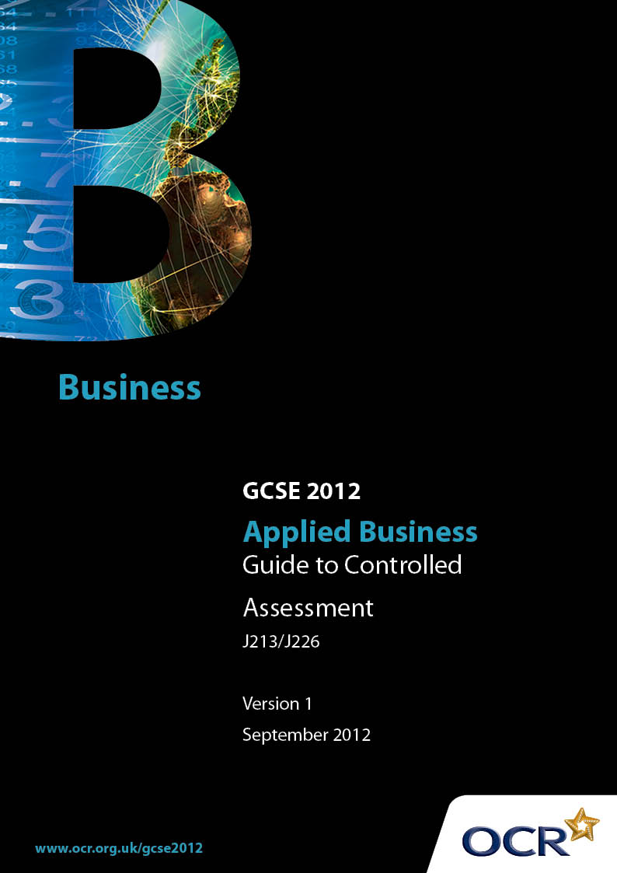
Contents

1 Introduction 3

1.1 What Is Controlled Assessment? 3
1.2 What does ‘control’ actually mean? 3
1.3 What is the purpose of this Guide? 3

2 Summary of the Controlled Assessment units 5

Unit A242: Making your mark in business 5
Unit A244: Business and you 5

3 Teacher guidance on how to plan Controlled Assessment 6

3.1 Controlled Assessment delivery flow chart 6
3.2 Guidance on the release of Controlled Assessment tasks to candidates 7
3.3 Guidance on research/data collection 8
3.4 Guidance on the production of the outcome 9

4 Controlled Assessment candidate guidelines 12

4.1 Task setting 12
4.2 Task taking 12

5 Teacher guidance on task marking 14

5.1 Generic guidance on how to mark Controlled Assessment tasks 14
5.2 Unpacking assessment objectives in Controlled Assessment tasks 14
5.3 Interpretation of the Controlled Assessment marking criteria 15
5.4 Authentication of Controlled Assessment outcomes 15
5.5 Internal Standardisation of Controlled Assessment 16
5.6 Moderation of Controlled Assessment 16
5.7 Minimum requirements for Controlled Assessment 16
5.8 Submission date for Controlled Assessment 17

6 FAQs 18

7 Guidance on downloading Controlled Assessment task from Interchange 23

Before you start 23
Step 1 – Log into Interchange 24
Step 2 – Navigate to Controlled Assessment materials area 25
Step 3 – Search for materials 26
Step 4 – Open materials 27
Step 5 – Troubleshooting 28

8 Guidance for the production of electronic Controlled Assessment 31
1 Introduction

1.1 What Is Controlled Assessment?

High, medium or limited control levels are set for each of the Controlled Assessment processes: task setting, task taking and task marking. For each stage, the level of control will ensure reliability and authenticity, and make assessments more manageable for teachers and candidates.

Weighting of Controlled Assessments is defined by QCA subject criteria and, depending on the subject, will be 25% or 60% of the total assessment.

In response to reforms announced by the Government and in response to Ofqual mandated changes to GCSEs, unitised assessment of this qualification is being replaced by linear assessment.

This means that candidates commencing a two year course from September 2012 will take all of their GCSE units at the end of the course in June 2014.

1.2 What does ‘control’ actually mean?

QCA has produced a Glossary of terms for Controlled Assessment regulations. The levels of controls are defined as follows:

• Formal supervision (High level of control) – the candidate must be in direct sight of the supervisor at all times. Use of resources and interaction with other candidates is tightly prescribed.

• Informal supervision (Medium level of control) – questions/tasks are outlined, the use of resources is not tightly prescribed and assessable outcomes may be informed by group work. Supervision is confined to (i) ensuring that the contributions of individual candidates
are recorded accurately, and (ii) ensuring that plagiarism does not take place. The supervisor may provide limited guidance to candidates.

• Limited supervision (Limited level of control) – requirements are clearly specified, but some work may be completed without direct supervision and will not contribute directly to assessable outcomes.

1.3 What is the purpose of this Guide?

This Guide provides detailed information for teachers about how to manage Controlled Assessment: some of the information applies to all GCSE subjects and some information provides subject specific guidance. It is important to make the point that this Guide plays a secondary role to the Specification itself. The Specification is the document on which assessment is based and specifies what content and skills need to be covered in delivering the course. At all times, therefore, this teacher support should be read in conjunction with the Specification. If clarification on a particular point is sought then that clarification should be found in the Specification itself.

Teaching of this qualification will vary greatly from school to school and from teacher to teacher. With that in mind, this Guide is offered as guidance but may be subject to modifications by the individual teacher.
2 Summary of the Controlled Assessment units

Unit A242: Making your mark in business

This unit represents 60% of the total GCSE (Single Award) marks and 30% of the total GCSE (Double Award) marks. It has a maximum of 60 marks.

Candidates will choose one business scenario from a selection of five. They then choose a local business on which to base their subsequent research and complete all the tasks.

This unit is internally assessed, applying the principles of Controlled Assessment. Controls are set within the assessment in each of the stages of the assessment process:

Task setting: high level of control in relation to the setting of tasks.

Task taking: this stage is divided into 2 different stages, each with a different level of control:
- Research/data collection: limited level of control
- Analysis and evaluation: high level of control

Task marking: medium level of control.

More information about each stage of the process is provided in the following sections of this
Guide.

Unit A244: Business and you

This unit represents 60% of the total GCSE (Single Award) marks and 30% of the total GCSE (Double Award) marks. It has a maximum of 60 marks.

Candidates will choose one job role from a selection of five and investigate a range of human resource activities in relation to this role.

This unit is internally assessed, applying the principles of Controlled Assessment. Controls are set within the assessment in each of the stages of the assessment process:

Task setting: high level of control in relation to the setting of tasks.

Task taking: this stage is divided into 2 different stages, each with a different level of control:
- Research/data collection: limited level of control
- Analysis and evaluation: high level of control

Task marking: medium level of control.

More information about each stage of the process is provided in the following sections of this
Guide.
3 Teacher guidance on how to plan
Controlled Assessment

3.1 Controlled Assessment delivery flow chart

OCR set tasks for centres
Timetabled Lessons

Unit A242
Making your mark in business

Task 1: Get prepared
2 hours

Teacher Guidance/ Feedback

Candidates:
Work in Progress
Task induction
Task research

Candidates:
Work in Progress
Review outcomes of research

Candidates:
Produce Outcome for Assessment
Task completion
Task authentication

Evaluation/ Review
Task 2: Research
Up to 30 hours

Task 3: Consider your results
5 hours

Task 4: Attract customers
6 hours

Task 5: Reflect on outcome
2 hours

Unit A244
Business and you

Task 1: Research
Up to 30 hours

Task 2: Apply for the post
5 hours

Task 3: Getting selected
5 hours

Task 4:
Best practice - induction
2 hours

Task 5:
A promotional opportunity
3 hours

Teacher Assessment and Submission to OCR for Moderation by specified deadlines
Submission of marks: June series: 15 May

3.2 Guidance on the release of Controlled Assessment tasks to candidates

3.2.1 Choice of Controlled Assessment task

For these GCSEs in Applied Business, OCR will assume a high level of control with regard to task setting. A number of scenarios will be available from OCR for the Controlled Assessment units. Once a scenario has been chosen, then the candidate will carry out necessary research in order to respond to a series of tasks. These tasks have been designed to meet the full assessment requirements of the unit. It is important that before candidates begin the assessment, they are equipped with the necessary knowledge, understanding and skills specified in each of the unit specifications for Units A242 and A244.

Unit A242 – The candidate must choose one business scenario from a list of five and then choose a local business on which to base their subsequent investigations. The series of tasks which the candidate must complete are supplied by OCR. It should be noted that the types of business scenario have been chosen to be as wide ranging as possible to suit all centre requirements.

Unit A244 – The candidate must choose one job role scenario from a list of five and investigate a range of human resource activities in relation to this role. The series of tasks which the candidate must complete are supplied by OCR. It should be noted that the types of job role scenarios have been chosen to be as wide ranging as possible to suit all centre requirements.

Further guidance on how to choose a scenario for the Controlled Assessment will be provided within the Controlled Assessment scenario.

Live OCR Controlled Assessment material must NOT be used as practice material. Centres should devise their own practice material or use the specimen Controlled Assessment material.

3.2.2 When and how to give Controlled Assessment tasks to candidates

Controlled Assessment tasks will be available from Interchange. Centres must be aware that live Controlled Assessment material will be reviewed on a regular basis to ensure to ensure that it continues to be fit for purpose. Should it be necessary to amend or revise the material then centres will be notified.

Controlled assessment tasks may be undertaken at any point between release of the task by OCR and the examination series for which the task must be submitted. Centres must ensure that candidates undertake a task that is valid for submission in the year in which the candidate intends to submit it.
The series in which each task can be submitted will be clearly marked on the front cover of each task. Tasks will not be valid for submission in any examination series other than that indicated.
Centres should refer to the sample scheme of work and lesson plans which are available to download from OCR’s website to assist planning and delivery of the Controlled Assessment units and its assessments.
3.3 Guidance on research/data collection

There must be a medium level of supervision when candidates complete the research/data collection element of these units. Candidates may need access to the internet; library, textbooks, and/or optional visits to local businesses. This research element can be carried out as part of a group or individually as outlined in the specification.

(a) Authenticity control: Candidate can complete the research individually or in a group without direct teacher supervision. In Unit A242, each candidate MUST carry out both individual and group research. The write up of findings and responding to tasks must be completed individually and under direct supervision. The teacher must be able to authenticate the work.

(b) Feedback control: Feedback to the candidate will be permissible but tightly defined. Within these specifications, OCR expects teachers to equip candidates with the knowledge, understanding and skills which they will need before they respond to the tasks. It should be remembered that candidates are required to reach their own judgements and conclusions without any guidance or assistance from others. When supervising tasks, teachers are expected to:

Exercise continuing supervision of work in order to monitor progress and to prevent plagiarism

Exercise continuing supervision of practical work to ensure essential compliance with Health and
Safety requirements

Ensure that the work is completed in accordance with the specification requirements and can be assessed in accordance with the specified marking criteria and procedures.

(c) Time control: The overall time limits available to the candidate to complete the Controlled Assessments are specified in Sections 4.1 and 4.2 of these specifications. A more detailed breakdown of time limits for particular tasks is contained in the specimen Controlled Assessment material for Units A242 and A244.

Tasks should be completed within the time limits set, and be supervised and marked by the teacher. Some of the work, by its very nature, may be undertaken outside the centre, eg research work. The use and application of the research material will be undertaken under direct teacher supervision. With all internally assessed work, the teacher must be satisfied that the work submitted for assessment is the candidate’s own work and be able to authenticate it using the specified procedure in Section 5.4.4 of these specifications.

(d) Collaboration control: Group work is permissible in some cases for the research phase of the units. However, each candidate must respond to the tasks individually. Where group work is suggested as an alternative to individual work, candidates will still be analysing the outcome of the group work on an individual basis before forming their own conclusions.

(e) Resource control: Access to resources will be limited to those appropriate to the task and as required by the unit. Candidates will need to be provided with the most appropriate materials and equipment to allow them full access to the marking criteria but this must be closely monitored and supervised, especially the level of ICT access. During the write up (Unit A242 Tasks 3, 4 and 5 and Unit A244 Tasks 2, 3, 4 and 5) candidates should only have access to their research which they have made during the research phase of task taking (Unit A242 Task 2 and Unit A244 Task 1). Generating and reviewing the action plan should be done in the specific time allocated for the completion of this task and should not form part of the write-up phase. It is the responsibility of the
centre to ensure that these are only research and that they do not include a draft or final version of the tasks

3.4 Guidance on the production of the outcome

3.4.1 Controls for the production of the outcome

Teachers must keep live Controlled Assessment tasks secure and confidential at all times whilst in their possession. For example, candidates may collect the results of any research or investigations undertaken in a research folder which must be handed in to the teacher before the writing up sessions begin. In such circumstances, it is the responsibility of the teacher to keep the research folders secure between the writing up sessions and that candidates do not have access to these folders outside of the allotted sessions.

There must be a high level of supervision when candidates complete the Controlled Assessment tasks for these units. Although candidates will have access to their research notes, they must work individually and be supervised at all times.

Analysis and evaluation of findings – high control

When candidates analyse and evaluate their findings as they address each of the Controlled Assessment tasks (excluding the research tasks, which carry no marks), they must be supervised at all times and work individually.

Completing the tasks

The candidate will be provided with sufficient time to complete all of the tasks. It is suggested that evidence is produced in a number of sessions, each focusing on a specific mini-task.

Each candidate must produce individual and authentic evidence for each of the (mini) tasks. It is particularly important that those candidates who conducted research as part of the group still produce individual evidence.

The teacher may give appropriate support and guidance to the candidates during the research phase of these units but not during the write-up phase. This support and guidance should focus on checking that the candidates understand what is expected of them. It is not acceptable for the teacher to provide model responses or to work through answers in detail.

The candidate will have the opportunity to use information from a wide range of resources as part of their research time in Units A242 and A244. This research will help them to produce evidence which is clearly targeted to meeting the assessment requirements of each of the remaining tasks. It is not permissible, however, for candidates to introduce any new material into their evidence that is not accessed during this research time, and teachers must safeguard against this.

Candidates must also be guided on the use of information to ensure that confidentiality and intellectual property rights are maintained at all times. It is essential that any material directly used from a source is appropriately and rigorously referenced. In both Units A242 and A244, candidates
will be asked to complete a bibliography during their research time which will be required for review at the point of internal assessment and external moderation.

3.4.2 Controlled Assessment task security

It is the responsibility of the centre to ensure that downloaded Controlled Assessment Tasks and candidates’ scripts are stored securely. Any breach in security must be reported to OCR as soon a possible by submitting a written report (a blank report form is available on Interchange) from Head of Centre to the OCR Quality and Standards Division detailing the circumstances, the candidates concerned and any action taken.

Candidates’ scripts for all completed Controlled Assessment tasks must be stored securely and they should be available for moderation. It is suggested that they are destroyed after the last date for Enquiries about Results following the examination series in which entries for the units concerned are made.

Candidate absence at the time of assessment

If a candidate is absent from a centre when an assessment is carried out, the Controlled Assessment task may be set at an alternative time provided that the centre is satisfied that security has been maintained by keeping all materials secure.

Unexpected circumstances

If an unexpected problem (such as a fire alarm or other circumstances beyond the teachers’ control) occurs while a Controlled Assessment task is taking place, the task may be resumed subsequently provided the teacher ensures that no candidate is likely to have been advantaged or disadvantaged by doing so.

3.4.3 Presentation of work

Candidates must observe certain procedures in the production of Controlled Assessments.

• charts, graphs, images and tables may be produced using appropriate ICT. These should be inserted into the candidate’s evidence at the appropriate place

• any copied material must be suitably acknowledged

• quotations must be clearly marked and a reference provided wherever possible

• work submitted for moderation or marking must be marked with the:

– centre number
– centre name
– candidate number
– candidate name
- unit code and title

Work submitted on paper for moderation or marking must be secured by treasury tags. Work submitted in digital format (CD or online) must be in a suitable file structure as shown in Appendix B of the Specification.
4 Controlled Assessment candidate guidelines

4.1 Task setting

For this subject OCR will provide a list of tasks.

4.2 Task taking

4.2.1 What can I do in relation to research, drafting and re-drafting?

Your teacher will discuss the tasks on offer and the proposed areas of enquiry and the resources available. An induction period into the research methods, sourcing and the use of equipment may also take place. Time constraints and a programme should be adopted and this will be explained by your teacher.

Your research and planning may involve interviews, fieldwork, visits, library research, internet research or questionnaires. You should keep a record of the sources you have consulted at this stage and this will form part of your portfolio. You should provide a plan of action to the teacher which can be discussed. You teacher will inform you what materials are appropriate and inappropriate.

Your draft piece will be discussed with your teacher and they may offer advice, answer any questions and give feedback. Throughout this process your teacher will supervise to ensure there is no plagiarism and will ensure all your work is within the Health and Safety requirements and that all candidates work is in accordance with the Controlled Assessment regulations. At no stage will model answers be provided. You should reach your own conclusions and make your own judgements and any teacher support will be recorded.

You may be given opportunity to edit, check redraft and reorganise your work. During this period your teacher may make general observations but will not give any specific advice.

4.2.2 How much teacher support can I expect?

During your work for Controlled Assessment you must produce work/evidence independently but your teacher will be able to give you some advice, support, guidance and feedback but the amount will vary depending upon the type of task you are doing.

You must make your own judgements and draw your own conclusions but your teacher will:
• offer advice about how best to approach a task

• offer guidance on the way you work in groups so that you all have an opportunity to tackle your tasks

• offer advice to help your research, possibly arranging visits to place of interest, if this is appropriate

• monitor your progress to make sure your work gets underway in a planned and timely manner

• ensure that your work meets the Specification requirements

• keep a log of the feedback they give you

• supervise any practical work you do to ensure you receive advice about health and safety.

The support given by your teacher will be to make sure you understand what it is you have to do.
Your teacher will not be allowed to provide model responses for you or work through your
responses or outcomes in detail.

4.2.3 What can I expect in the supervised sessions?

This period should include some form of evaluation either in the written form, in a teacher interview or a presentation to the group. For the last two your teacher may record these sessions. This is particularly essential in group work where the teacher will be attempting to ascertain your individual contribution within the group.

You should reference all sources used and any materials you have used in the whole piece whether in supervised or unsupervised sessions. Quotations should be clearly marked and referenced to ensure all intellectual property rights are maintained. It is unlikely that complete downloaded documents from the internet are suitable. Your teacher will sign an authentication form to complete the process. You may also be asked to sign the form.
5 Teacher guidance on task marking

5.1 Generic guidance on how to mark Controlled Assessment tasks

The marking criteria detail the skills, knowledge and understanding which the candidate is required to demonstrate.

The (mini) task should be marked by the teacher according to the given marking criteria using a
‘best fit’ approach. For each of the (mini) tasks, the assessor should select the descriptors, provided in the marking criteria, which most closely describe the quality of work being marked.

Marking should be positive, rewarding achievement rather than penalising failure or omissions. The award of marks must be directly related to the marking criteria.

Teachers use their professional judgement in selecting the descriptor which best describes the work of the candidate.

To select the most appropriate mark within this descriptor, teachers should use the following guidance:

• where the candidate’s work convincingly meets the descriptor, the higher marks in the mark range should be awarded

• where the candidate’s work adequately meets the descriptor, the most appropriate mark in the middle range should be awarded

• where the candidate’s work just meets the descriptor, the lowest marks in the mark range should be awarded.

The final mark for the candidate for each unit is out of a total of 60 and is found by totalling the marks for each of the (mini) tasks.

5.2 Unpacking assessment objectives in Controlled Assessment tasks

Assessment objectives (AOs) identify what the candidate has to do. They specify the context and use the ‘command words’ to indicate the level of the intellectual task, so, for example, the candidate may be directed to ‘identify’, ‘describe’ or ‘explain’.
Assessment objective 1 assesses candidates’ ability to recall, select and communicate their knowledge and understanding of concepts issues and terminology;

Assessment objective 2 assesses candidates’ ability to apply skills, knowledge and understanding in a variety of contexts and in planning and carrying out investigations and tasks;

Assessment objective 3 assesses candidates’ ability to analyse and evaluate, make reasoned judgements and present conclusions.

5.3 Interpretation of the Controlled Assessment marking criteria

These general assessment objectives have been contextualised to the specific tasks in each
Controlled Assessment (see the assessment grids below). So the teacher needs to:

1. identify the knowledge and skills the candidate will need to demonstrate if they have meet the AO

2. identify what the candidate has to do with this knowledge and/or skill; for example, should they be describing or explaining?

Each assessment objective has been written at 3 levels, which increase in intellectual difficulty. The teacher will need to make a holistic judgement of which level (1, 2 or 3) best fits the candidate’s work.

In general terms, a candidate who is able to produce some limited evidence for a task is likely to achieve Mark Band 1. A candidate who produces a range or evidence but where there are significant gaps in coverage, knowledge and understanding, is likely to achieve Mark Band 2. A candidate who has addresses most, or all of the issues needed to fully complete the tasks is likely to achieve Mark Band 3.

For example, in Mark Band 1 a candidate might identify some relevant knowledge required to address the task but fails to adequately explain the issues. In Mark Band 2 a candidate might list a comprehensive range of issues and explore them all to the required standard but some explanations are incorrect or lacking application to the context. In Mark Band 3 a candidate is likely to identify an appropriate range of issues and analyse them all appropriately, in depth and within the required context.

5.4 Authentication of Controlled Assessment outcomes

Teachers must be confident that the work they mark is the candidate’s own. This does not mean that a candidate must be supervised throughout the completion of all work but the teacher/course tutor must exercise sufficient supervision, or introduce sufficient checks, to be in a position to judge the authenticity of the candidate’s work.

Candidates must not plagiarise. Plagiarism is the submission of another’s work as one’s own and/or failure to acknowledge the source correctly. Plagiarism is considered to be malpractice and could lead to the candidate being disqualified. Plagiarism sometimes occurs innocently when candidates are unaware of the need to reference or acknowledge their sources. It is therefore
important that centres ensure that candidates understand that the work they submit must be their own and that they understand the meaning of plagiarism and what penalties may be applied.

Candidates may refer to research, quotations or evidence but they must list their sources. The rewards from acknowledging sources, and the credit they will gain from doing so, should be emphasised to candidates, as well as the potential risks of failing to acknowledge such material.

The candidate must sign a declaration to this effect. Centres should reinforce this message to ensure that candidates understand what is expected of them.

Please note: Centres must confirm to OCR that the evidence produced by the candidate is authentic. The Centre Authentication Form includes a declaration for assessors to sign. It is a requirement of the QCA Common Criteria for all Qualifications that proof of authentication is received.

5.5 Internal Standardisation of Controlled Assessment

It is important that all internal assessors, working in the same subject area, work to common standards. Centres must ensure that the internal standardisation of marks across assessors and teaching groups takes place using an appropriate procedure.

This can be done in a number of ways. In the first year, reference material and OCR training meetings will provide a basis for centres’ own standardisation. In subsequent years, this, or centres’ own archive material, may be used. Centres are advised to hold preliminary meetings of staff involved to compare standards through cross-marking a small sample of work. After most marking has been completed, a further meeting at which work is exchanged and discussed will enable final adjustments to be made.

5.6 Moderation of Controlled Assessment

All work is marked by the teacher and internally standardised by the centre. Marks are then submitted to OCR, after which moderation takes place in accordance with OCR procedures: refer to the OCR website for submission dates of the marks to OCR. The purpose of moderation is to ensure that the standard of the award of marks for work is the same for each centre and that each teacher has applied the standards appropriately across the range of candidates within the centre.

The sample of work which is presented to the Moderator for moderation must show how the marks have been awarded in relation to the marking criteria. Each candidate’s work should have a cover sheet attached to it with a summary of the marks awarded. If the work is to be submitted in digital format this cover sheet should also be submitted electronically within each of the candidate’s files.

5.7 Minimum requirements for Controlled Assessment

There should be clear evidence that work has been attempted and some work produced.
If a candidate submits no work for an internally assessed component, then the candidate should be indicated as being absent from that component on the mark sheets submitted to OCR. If a candidate completes any work at all for an internally assessed component, then the work should
be assessed according to the internal assessment objectives and marking instructions and the appropriate mark awarded, which may be zero.
5.8 Submission date for Controlled Assessment

Candidate’s marks must be despatched to the Moderator and to OCR. Please refer to the OCR
website for details of submission dates relevant to the current series of examinations.
6 FAQs

When can Controlled Assessments be taken?
Controlled assessment tasks may still be undertaken at any point between release of the task by OCR and the examination series for which the task must be submitted. Each controlled assessment task will be valid for submission in a single examination series only. Centres must ensure that candidates undertake a task that is valid for submission in the year in which the candidate intends to submit it.
The series in which each task can be submitted will be clearly marked on the front cover of each task. Tasks will not be valid for submission in any examination series other than that indicated.
Tasks for the controlled assessment will be made available on OCR Interchange, ahead of the examination series for which the tasks are to be submitted. These will be removed upon expiry. Guidance on how to access controlled assessment tasks from OCR Interchange is available on the OCR website: www.ocr.org.uk.
When can teachers and candidates access the material?
Controlled Assessment tasks will be available from Interchange on 1 April of the year prior to an assessment series, i.e. 1 April 2013 for assessment in June 2014 series.
Tasks change every year and it is the responsibility of centres to make sure that candidates are submitting the correct task. Tasks will be taken off Interchange on 15 May every year for this subject.

Why are you not making hard copies available to centres?

This is an internal assessment and centres are responsible for the resource of internal
assessment. It would be impossible to despatch hard copies of the Controlled Assessment without vast amounts of provisional entry data.

Can any preparation work be done out of the classroom?

Yes. Controls are set at the level of tasks setting, task taking and task marking. Preparation work comes into the task taking level, under Research and Data Collection, which have a limited level of control i.e. work can be carried out without direct supervision. More guidance on this can be found can be found in Section 4: Controlled Assessment of all revised GCSE Specifications (Linear 2012).

Is there a minimum or maximum time that can be spent on the assessments?

Suggested time limits vary per subject: there are suggested time limits given in Section 4: Controlled Assessment of all revised GCSE Specifications (Linear 2012).

Where can the Controlled materials be accessed and by whom?

Controlled Assessment tasks and other documents are accessed via Interchange.

Centre access to the Interchange Controlled Assessment area will be available to the registered Centre User (normally the Examinations Officer). However, the Centre User can set access permissions to others within their centre, eg HODs, subject leaders or subject teachers.

How long is each assessment valid for i.e can we use last year’s one this year?

Tasks change every year and it is the responsibility of centres to make sure that candidates are submitting the correct task. Tasks will be taken off Interchange on 15 May every year for this subject.

Where can the Mark Schemes be accessed?

The Mark Scheme can be accessed from Interchange. A specimen Mark Scheme is at the end of the Sample Assessment Material.

Do we have to take the Controlled Assessment under exam conditions/teacher supervision?

Yes, but only for the write up , i.e. the last part of Controlled Assessment when candidates are producing the outcomes of their research – note that this can be over more than one supervised session. More guidance on this can be found in Section 4: Controlled Assessment of all revised GCSE Specifications (Linear 2012).

Can learners re-sit the qualification?
Yes but only in its entirety, re-sitting individual units mid-course is no longer possible.

Can a candidate carry forwards controlled assessment results if they are retaking the qualification?
Yes they can.

Are materials sent based on estimated entries or can we download them from Interchange?

Tasks will only be available as downloads from Interchange: they will not be sent in hard copy to centres.

Do we mark them or do OCR ?

Controlled Assessment tasks for ALL subjects are internally marked by centres and externally moderated by OCR.

When do we start and finish the Controlled Assessment?

Controlled Assessment is a form of internal assessment and as such there isn’t a specified date in which Controlled Assessment has to be taken.

Controlled assessment tasks may be undertaken at any point between release of the task by the centre and the examination series for which the task must be submitted. Centres must ensure that candidates undertake a task that is valid for submission in the year in which the candidate intends to submit it.
The series in which each task can be submitted will be clearly marked on the front cover of each task.

Can I modify the scenario?

No. A choice of scenarios will be provided which will supply the candidate with enough of a range to make an informed choice of an area that is of particular interest to them.

Can I devise my own tasks?

No. The tasks are clearly linked into assessment objectives so they cannot be changed.

Can candidates take tasks home to complete?

This will vary from subject to subject but on of the principles of Controlled Assessment is to complete tasks within the classroom. Therefore it is expected that for this specification the response to the assessment tasks will be completed under classroom conditions.

What can candidates bring into class to help them do a task?

Teachers will give clear guidance on what materials are suitable and what are not. It is likely that candidates will have access to their research which they collected in the allotted time for researching their chosen context and also their action plans. No new material should be introduced once the allotted time for researching and creating/revising the action plan has passed. It may be that candidates hold some of their research on-line which they may wish to refer to during the write up phase. This is possible as long as the Centre can validate that this information was collected during the research phase to the unit and no new material has been added.

During controlled conditions are candidates able to access ICT? If graphs/charts were produced as part of the research, are these OK to take into the controlled conditions?

It is acceptable for any graphs/charts that were produced during the research phase to be taken into the controlled conditions, eg Unit A242, Task 2 is the research phase and as part of that task candidates are required to collect research results. The Controlled Assessment tasks state that in Task 3 for example, candidates can take their research findings into the controlled conditions. During controlled conditions, access to internet etc is not permitted.

Can Controlled Assessment be handwritten?

Yes or can be done using ICT. ICT can be used for the write up but centres must ensure that the candidates only have access to research if this is stored electronically. Access to the internet etc is not acceptable.

Can candidate’s word process their work and use ICT to draw graphs?

It is expected that candidates will use ICT in the production of their work wherever applicable.

Can candidates have access to the Internet?

Yes in the research phase as the candidate investigates particular contexts but not in the write up.

Can candidates talk to each other?

In the learning and research phases of the unit it maybe that candidates pool resources and some generic classroom activities are created to reinforce learning and understanding. However in the write up the candidate needs to work on their own to produce individual, authentic evidence.

What should I do if there is evidence of candidates producing identical work?

The teacher is required to authenticate the work and the marks awarded for each candidate. Where the teacher is not prepared to authenticate the work, marks should not be submitted.

Teachers should keep an eye open for all potential plagiarism and report it to the school authorities and take the action above.

Are candidates able to copy sections straight from a book or a website?

This will very rarely be appropriate and only where tasks require the use of reference books or websites. As a requirement for both Controlled Assessment units a bibliography is required with all sources fully acknowledged.

Can candidates draft and redraft tasks?

Candidates can redraft tasks in most subjects. Where this is the case teacher involvement should be advisory at a top level only. For example if the candidate is struggling with evaluation
techniques teachers could offer support on the types of techniques that could be considered - i.e. cost/benefit, short verses long term, etc but specifics of assessment tasks should not be entered into. All drafts should be included in the candidate portfolio.

Can I tell candidates their mark for each task?

Yes. But the marked task must not be given back to or shown to the candidate. The candidates must also be told that this is a provisional mark, subject to moderation and scaling from a raw mark to a UMS mark. It might be better practice to give the candidate an indication of the mark rather than the mark itself.

What feedback can I give to a candidate?

Formative feedback is important. Feedback specific to the completed task must not be given. The type of feedback should be advisory and should focus on top level techniques and areas of study that will help a candidate to demonstrate their knowledge/understanding of a particular issue.

Is there a way of me sharing good practice as a teacher with other practitioners?

Yes you can use the e-community for the new specification which has been established with a view to providing a forum for practitioners to share good practice and resources connected with the delivery of the course.

Can I get guidance on my marking?

Yes. OCR runs regular INSET events where internal assessment will feature strongly. The Qualification Manager for the relevant subject can be contacted via the Customer Contact Centre. Mark schemes will be available in the specification to guide the Centre through the marking process. In time exemplar material will be provided to reflect the standard for this particular specification.

Will the marking of the tasks be moderated?

Yes. A moderator, appointed by OCR, will moderate a sample of your candidates’ work. The Centre should keep a portfolio of work for each of its candidates with as much evidence as possible. The Moderator will inform the Centre what he needs to see in the first instance.
7 Guidance on downloading Controlled
Assessment task from Interchange

Before you start

Controlled Assessment materials will be available to download from OCR Interchange. If you are not a current user of OCR Interchange, please contact OCR‘s Customer Contact Centre on 01223 553998 to request an Interchange user account.
Further details on how to access the materials is available on Interchange.
Step 1 – Log into Interchange

Click on the following link https://interchange.ocr.org.uk

Enter your log in details

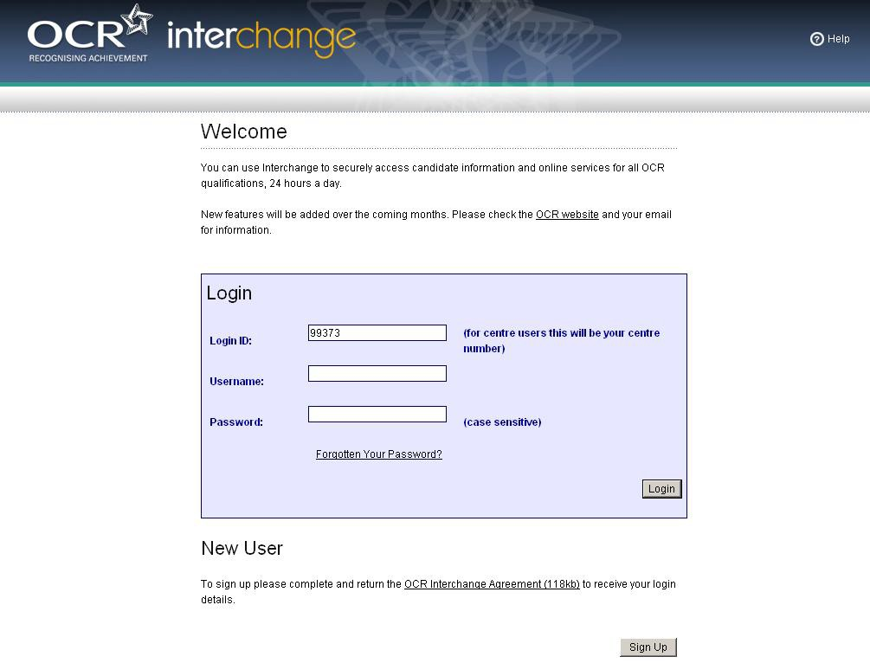
Step 2 – Navigate to Controlled Assessment materials area

Click on ‘Coursework and tests’

Click on ‘Controlled Assessment materials’

** If you are unable to see either of these menu items then it is likely that you do not have the
‘Tutor / teacher’ role assigned to you.

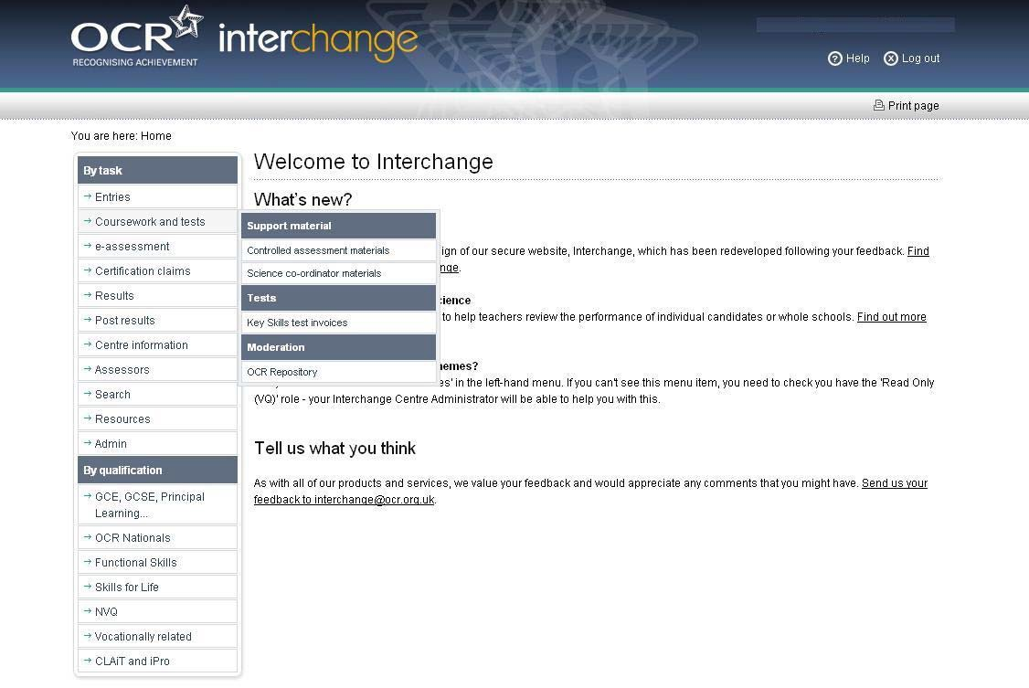
Step 3 – Search for materials

You can search for materials by unit code. Enter the unit code and click on the ‘search’ button.

Or, you can search for materials by subject information by selecting from the ‘drop down’ options. All available documents will be displayed below the search.
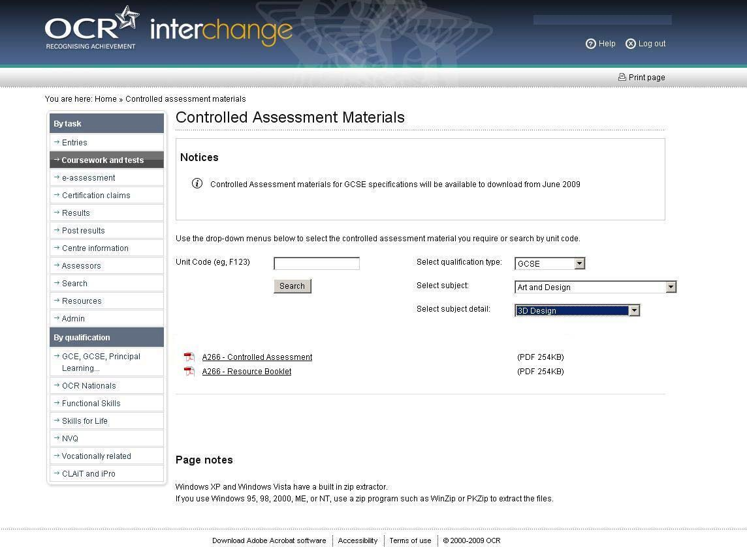
Step 4 – Open materials

Click on the document link, the document will open in your browser

Click on ‘Save As’ to save to a location of your choice.

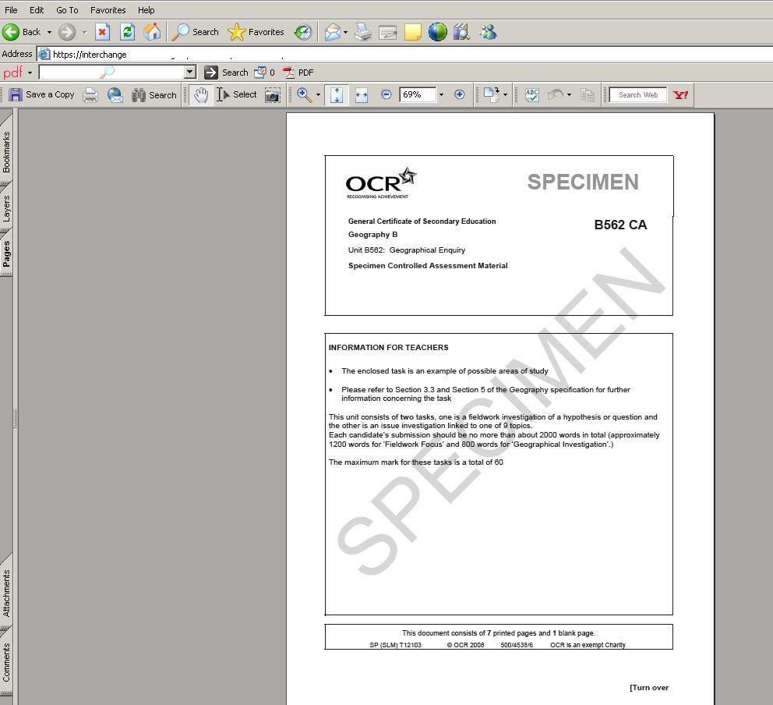
Step 5- Troubleshooting

If you search for an invalid unit code, the following error message will be displayed.

Q.ScBT :
t

interchange 0Help 0Logout
---- - _.

You are here:Home» Controlled assessment materials
Bytask Controlled Assessment Materials

Entries
Coursework andtests Notices

"""* e-assessment

"""* Certification claims
"""* Results Use the drop-down menus below to select the controlled assessment materialyou require or search by unit code.

"""* Post results

"""* Centre information

"""* Assessors

Unit Code (eg,f123) laq6et
CD Invalid UnCode entered
Select qualification type: [ ·Please Select· iJ
Select subject: [ ·Nothing to Select·iJ

"""* Search Select subject detail: [·Nothing to Select·iJ

"""* Resources

-* Admin

By qualification

-> GCE.GCSE.Principal
Learning...

Page notes

.., OCR Nationals

-+ Functional Skills

Windows XP and Windows Vista have a built in zip extractor.
Ifyou use Windows 95. 98. 2000.ME. or NT.use a zip program such as WinZip or PKZip to extract the files.

-+ Skills for Life

-> NVQ

.., Vocationally related

-+ CL..AiT and iPro

If you search for a valid unit code but there is no document currently available, the following message will be displayed.

Q.Sc : interchange 0Help @ Logout
·-- - -'--

You are here:Home» Controlled assessment materials
Bytask Controlled Assessment Materials

-+ Entries
-+ Coursework andtests Notices

-+ e-assessment

-+ Certification claims
-+ Results Use the drop-downmenus below to select the controlled assessment materialyou require or search by unit code.
-+ Post results Unit Code (eg,F123) JA982 Select qualification type· J -Piease Select- :::J
-+ Centre information
,@, Print page

-+ Assessors
Select subject J -Nothing to Select· :::J

-+ Search Select subject detail:

-+ Resources

-+ Admin No document available.Please check the unit code.
J -Nothing to Select· :::J

By qualifiCatiOn

-> GCE,GCSE, Principal
Learning

-+ OCR Nationals

-+ Functional Skills
-+ Skills for Life Page notes

-> NVQ

-+ vocationally related

Windows XP and Windows Vista have a built in zip extractor.
If you use Windows 95,98, 2000,ME, or NT, use a zip program such as WinZip or PKZip to extract the tiles.

-+ CLAiT and iPro

If you search via the 'drop down' menus but there is no document currently available, the following message will be displayed.

Q.Sc :interchange <Z>Help @Logout

·-- _...:.

You are here:HomeControlled assessment materials
By task Controlled Assessment Materials

,@, Print page

-;. Entries
-7 Coursework andtests Notices

-;. e-assessment

-;. Certification claims

-;. Results

..... Post results

--+ Centre information

(]) Controlled Assessment materials for GCSE specifications will be available to download from June 2009

Use the drop-down menus below to select the controlled assessment materialyou require or search by unit code.

..... Assessors Unit Code (eg.F123) Select qualification type: J GCSE

..... Search Select subject Jl:iii..jif!Wii!IG.!U!I.!iili!iill.!,
"'"" Resources

-;. Admin
Select subject detail: J Developing Bus Comm Systems iJ

By qualification

...,. GCE, GCSE, Principal
Learning...

No document available.Please check the search details

-+ OCR Nationals

-7 Functional Skills

-7 Skills for Life

t
-7 NVQ

-t Vocationally related

-7 CLAiT and iPro

Page notes

Windows XP and Windows Vista have a built in zip extractor
If youuse Windows 95, 98, 2000, ME, or NT, use a zip program such as WinZip or PKZip to extract the files

Download Adobe Acrobat software

8 Guidance for the production of electronic
Controlled Assessment

Structure for evidence

A Controlled Assessment portfolio is a collection of folders and files containing the candidate’s evidence. Folders should be organised in a structured way so that the evidence can be accessed easily by a teacher or moderator. This structure is commonly known as a folder tree. It would be helpful if the location of particular evidence is made clear by naming each file and folder appropriately and by use of an index, called ‘Home Page.’

There should be a top level folder detailing the candidate’s centre number, candidate number, surname and forename, together with the Unit code A242/A244, so that the portfolio is clearly identified as the work of one candidate.

Each candidate’s Controlled Assessment portfolio should be stored in a secure area on the centre network. Prior to submitting the Controlled Assessment portfolio to OCR, the centre should add a folder to the folder tree containing Controlled Assessment and summary forms.

Data formats for evidence

In order to minimise software and hardware compatibility issues, it will be necessary to save candidates' work using an appropriate file format.

Candidates must use formats appropriate to the evidence that they are providing and appropriate to viewing for assessment and moderation. Open file formats or proprietary formats for which a downloadable reader or player is available are acceptable. Where this is not available, the file format is not acceptable.

Electronic Controlled Assessment is designed to give candidates an opportunity to demonstrate what they know, understand and can do using current technology. Candidates do not gain marks for using more sophisticated formats or for using a range of formats. A candidate who chooses to use only word documents will not be disadvantaged by that choice.

Evidence submitted is likely to be in the form of word-processed documents, PowerPoint presentations, digital photos and digital video.

To ensure compatibility, all files submitted must be in the formats listed overleaf. Where new formats become available that might be acceptable, OCR will provide further guidance. OCR advises against changing the file format that the document was originally created in. It is the centre’s responsibility to ensure that the electronic portfolios submitted for moderation are accessible to the moderator and fully represent the evidence available for each candidate.
Accepted File Formats

Movie formats for digital video evidence

MPEG (*.mpg)

QuickTime movie (*.mov) Macromedia Shockwave (*.aam) Macromedia Shockwave (*.dcr) Flash (*.swf)
Windows Media File (*.wmf) MPEG Video Layer 4 (*.mp4) Audio or sound formats MPEG Audio Layer 3 (*.mp3)
Graphics formats including photographic evidence

JPEG (*.jpg) Graphics file (*.pcx) MS bitmap (*.bmp) GIF images (*.gif) Animation formats
Macromedia Flash (*.fla) Structured markup formats XML (*xml)
Text formats

PDF (.pdf)

Comma Separated Values (.csv) Rich text format (.rtf)
Text document (.txt) Microsoft Office suite PowerPoint (.ppt) Word (.doc)
Excel (.xls) Visio (.vsd) Project (.mpp)

www.ocr.org.uk
OCR customer contact centre

General qualifications
Telephone 01223 553998
Facsimile 01223 552627
Email general.qualifications@ocr.org.uk

For staff training purposes and as part of our quality assurance programme your call may be recorded or monitored.
© OCR 2011 Oxford Cambridge and RSA Examinations is a Company Limited by Guarantee. Registered in England. Registered office 1 Hills Road, Cambridge CB1 2EU. Registered company number 3484466. OCR is an exempt charity.



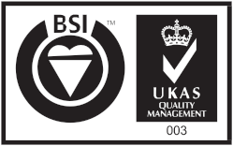
FS 27093

