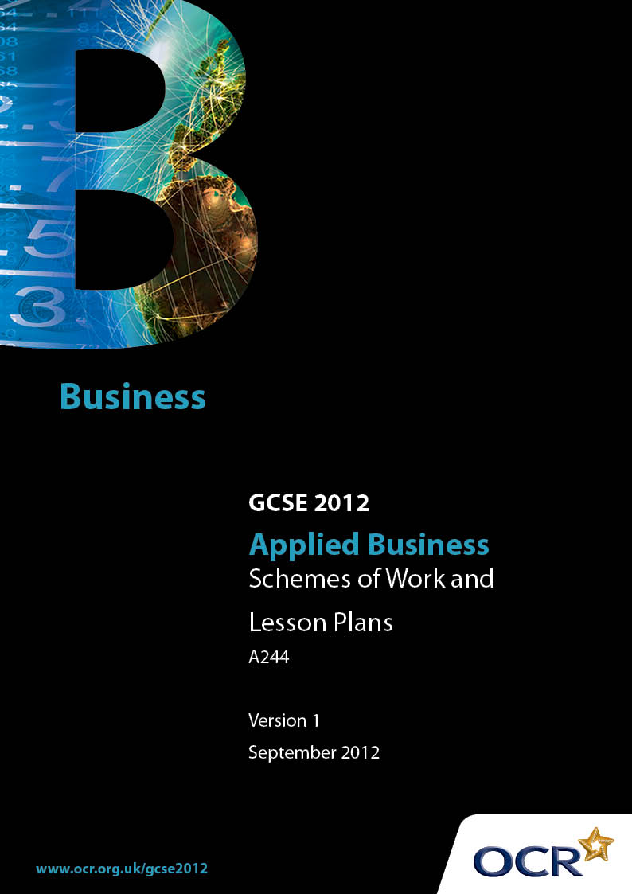

Contents
Contents 2
Introduction 3
Sample Scheme of Work: OCR GCSE Applied Business Unit A244:
Business and You 5
Sample Lesson Plan: OCR GCSE Applied Business Unit A244:
Business and You 14

Introduction

Background
OCR has produced a summary brochure, which summarises the Applied Business GCSE. This can be found at www.ocr.org.uk, along with the new specification.

In response to reforms announced by the Government and in response to Ofqual mandated changes to GCSEs, unitised assessment of this qualification is being replaced by linear assessment. This means that candidates commencing a two year course from September 2012 will take all of their GCSE units at the end of the course in June 2014.

From September 2012 assessment tasks may be undertaken at any point between release of the task and the examination series for which the task must be submitted. Centres must ensure that candidates undertake a task that is valid for submission in the year in which the candidate intends to submit it.

In order to help you plan effectively for the implementation of the new specification we have produced these Schemes of Work and Sample Lesson Plans for GCSE in Applied Business. These Support Materials are designed for guidance only and play a secondary role to the Specification.

Our Ethos
OCR involves teachers in the development of new support materials to capture current teaching practices tailored to our new specifications. These support materials are designed to inspire teachers and facilitate different ideas and teaching practices.
Each Scheme of Work and set of sample Lesson Plans is provided in Word format – so that you can use it as a foundation to build upon and amend the content to suit your teaching style and candidates’ needs.
The Scheme of Work and sample Lesson Plans provide examples of how to teach this unit and the teaching hours are suggestions only. Some or all of it may be applicable to your teaching.
The Specification is the document on which assessment is based and specifies what content and skills need to be covered in delivering the course. At all times, therefore, this Support Material booklet should be read in conjunction with the Specification. If clarification on a particular point is sought then that clarification should be found in the Specification itself.

A Guided Tour through the Scheme of Work

= Innovative Teaching Idea
This icon is used to highlight exceptionally innovative ideas.


= ICT Opportunity
This icon is used to illustrate when an activity could be taught using ICT facilities.

GCSE in Applied Business Unit A244 Business and You
Suggested teaching time | 70 hours | Topic | Business and you
Topic outline |  | Suggested teaching and homework activities |  | Suggested resources | Points to note
2.4.1 The human resources functional area (1 hour) |  | - Introduction to purpose of HR. General discussion. What activities happen in Human Resources? What would happen to a business if there were no HR functional area?  - Write up discussion.  - Introduce methods of primary and secondary research. |  | - GCSE textbooks
RESEARCH  (2 hours) |  | - TASK 1 Undertake primary and secondary research on the key phases of the recruitment process.
2.4.4 Human resources legislation  2.4.7 Effective research (5 hours) |  | - Split class into 5 groups (use lead learners?) - provide basic information pack for each law, encourage more in-depth research and provide opportunities. Each group works on a different law and prepares information in a (pre-determined?) format to share with rest of group. Possible ideas - leaflet/presentation/poster/display material.  - Candidates to design best way to communicate what they have learned to the rest of the class – give guidance on key features to include. Opportunities for note making/handout.  - Check understanding through Q+A. |  | - GCSE textbooks and GCSE Applied textbooks cater for all abilities.  - Following websites for higher ability:  http://www.opsi.gov.uk/acts/acts1996/UKpga_19960018_en_1 Employment Rights Act 1996  http://www.pfc.org.uk/node/297  Sex Discrimination Act 1975  http://www.equalityhumanrights.com/en/yourrights/equalityanddiscrimination/race/pages/whatisdiscrimination.aspx  Race Relations Act 1976  http://www.direct.gov.uk/en/DisabledPeople/RightsandObligations/DisabilityRights/DG_4001068  Disability Discrimination Act 1995  http://www.hse.gov.uk/pubns/ohsingb.pdf  Health and Safety at Work Act 1974  Lead learners information  http://www.teachers.tv/video/4912 | - Information preparation could be in form of a video/podcast/website/link to VLE.  - Lead learner – select a candidate that finds learning easier to access than others and place one in each group. The lead learner then takes a role in the group work and asks others questions and supports them in their learning and understanding. This enables candidates to learn from the lead learner too rather than only from the teacher.
2.4.7 Effective research |  | - Demonstrate how to write a bibliography and reference primary and secondary research
RESEARCH  (5 hours) |  | - TASK 1 Legislation which will impact on the recruitment and selection process.  - Start bibliography.
2.4.7 Effective research  2.4.2 The recruitment process  (6 hours) |  | - How do people apply for jobs? What methods can be used to search for a job?  - Write up notes from discussion.  - Model how to write an evaluation. Evaluate benefits and limitations of primary and secondary research. Peer assess evaluations. |  | - DVDs on recruitment and selection – see resources page  - Examples of job description/person specification/advertisement in all GCSE textbooks. Some more detailed examples in A level applied books can be adapted.  - Documents can also be collected from a business. | - Topics could be teacher led or independent learning driven depending on ability/needs/preferred styles of learners.  - Activities in this topic area could be adapted for individuals, pairs or groups. Many opportunities for AfL.  - (Assessment for Learning)
 |  | - Research task - respond to an advertisement. Need to provide job description/person specification to support this. Can be a real advertisement or as a case study set up by the teacher. Complete application form – can be real or adapted by the teacher. Write letter of application (for a different advertisement) Research into 3 CVs - justify which is the best layout.
 |  | - Why is it important to complete these documents accurately? Use examples of incomplete application form and application form with mistakes. What impression does this make on the business? What advice would you give to applicant?  - Using a poor letter of application - comment on how it could be improved and why. |  | - http://www.channel4.com/life/microsites/B/  brilliantcareers/survival/gaipy/presenting.html Interactive ICT opportunity to learn about CV, application form. | - Could be as class discussion, group discussion, pair/individual challenge.
- Complete own CV, peer assess - how could it be improved? Produce final draft.
- How successful are your documents? Make judgements on CV and letter of application. What are the positive features? What could be improved?
 |  | - Design an application form for a chosen business. Explain how your application form meets the legal framework.
RESEARCH  (6 hours) |  | - TASK 1 Recruitment documentation.
RESEARCH  (2 hours) |  | - TASK 1 Generic/specific skills looked for by employers.  - Update bibliography.
TASK 2 Apply for the post  (5 hours)  (Total 15 hours – for controlled assessment) |  | - Take detail from Controlled Assessment material.
3.4.3 The selection process  (5 hours) |  | - Use case study of job/person specification for a job. Brief details of 6 candidates on different cards - how can we shortlist the best ones to interview? Group work - discussion - how did the team work together to decide? |  | - Prepare cards showing the details of a variety of candidates for the chosen job role.
 |  | - As a group design questions to be used in an interview for the selected post. Are there any other methods you may use to select the best candidate?  - Use role play - each group could use their questions to interview teacher/visitor on rotation with rest of class observing.  - Lead discussion – candidates make guided notes.  - Class/group/individual evaluation - which questions were good and why, which questions would you change? What to and why? How did you select the successful applicant? How did you inform applicants of the outcome? |  | - DVDs on recruitment and selection – see resources page.  - Details of candidates. Job description/person specification also required. Could use documents from recruitment section.
 |  | - Produce a leaflet – Interviewer’s guide to an effective interview - successful questions - how to meet the legal framework. Explain why questions are successful. |  | - GCSE textbooks.  - Many website suggest interview questions and answers. | - Activity could be pair/individual.
 |  | - Produce a presentation which can be used in school to give advice to other students - how to be successful at interview. |  |  | - Activity could be pair/individual.
RESEARCH  (5 hours) |  | - TASK 1 Shortlisting, forms of selection, informing applicants of a successful/unsuccessful application.  - Update bibliography.
TASK 3 Getting selected (5 hours)  (15 hours – from controlled assignment) |  | - Take detail from Controlled Assessment material.
2.4.5 Induction  (4 hours) |  | - Thought shower – how were they inducted into the school? What were the key features of the induction? Discussion - How is this different from an induction programme in a business?  - Candidates make guided notes.  - Use case study business and design a poster/leaflet/induction pack which includes all of the key information required. |  |  | - Could link to work experience placement.
 |  | - Rights and responsibilities as an employee and on the job training - prepare a presentation with supporting notes which can be used during the induction process. |  | - http://www.businessstudiesonline.  co.uk/AppliedGcseBusiness/Activities/  Unit2/Unit2Menu.htm#GCSEAppBusU2Rights Rights of Employees. | - Link to earlier unit?
RESEARCH  (5 hours) |  | - TASK 1 Induction training  - Update bibliography.
TASK 4 Best practice – induction  (2 hours)  (15 hours – from controlled assignment) |  | - Take detail from Controlled Assessment material.
2.4.6 Promotion - training, skills, competencies required  (4 hours) |  | - Link back to advertisement from recruitment process. Discussion - If you had been in post for a year, what opportunities would you now have for promotion? E.g. Receptionist to Office Manager. Pair work - what skills would you have developed through doing this job for a year? What skills would you need to have to be successful in a promotion? What day to day activities would be expected? How is this different from the current job? |  | - Original advertisement and original job description and person specification.  - Job description/person specification for more senior post.
 |  | - Training – group work/discussion. How could the skills/knowledge be gained? What training is available for that job role? Cost/benefit analysis on financial and time issues related to the training and its short term and long term impact on the business. |  | - GCSE textbooks – methods of training. Training programmes used in businesses e.g. from research during work experience.
RESEARCH  (5 hours) |  | - TASK 1 Key issues for applying for a more senior position. Skills and competencies, day to day activities, types of training, cost and duration of training.  - Finalise bibliography.
TASK 5 A promotional opportunity (3 hours)  (15 hours – from controlled assignment) |  | - Take detail from Controlled Assessment material.

OCR GCSE Applied Business J213 & J226 Unit A244: Business and You

2.4.2 The recruitment process
OCR recognises that the teaching of this qualification above will vary greatly from school to school and from teacher to teacher. With that in mind this lesson plan is offered as a possible approach but will be subject to modifications by the individual teacher.
Lesson length is assumed to be one hour.

Learning Objectives for the Lesson
Objective 1 | To know the importance of making a good first impression when applying for a job
Objective 2 | To be able to complete an application form and write letter of application accurately

Recap of Previous Experience and Prior Knowledge
- Job description, person specification, adverts, research into application forms and CVs.

Content
Time | Content
5 minutes | Starter – use cards showing key words used in an application form. Sort and match key word with the definition/purpose of that section on the form.
10 minutes | Why is it important to make a good first impression when you apply for a job?  Group/pair work – each given an incomplete application form, an application form with mistakes and an accurately completed, well presented application form.  Task: What is the first impression of each candidate?  Bullet point the advice you would give to each candidate and explain reasons to the class.
15 minutes | Individually – using the application form with mistakes, complete a blank form with accurate details.  Self assess – how successful is the completed document? Is there anything that could be improved?
15 minutes | Pair work – using a poor letter of application, identify and discuss the problems. Feed back to class. Individually or in pairs redraft an improved copy. Peer-assess and comment on positive features, suggest further improvements.

Consolidation
Time | Content
10 minutes | Could use interactive recruitment – pirate/teacher ‘walk the plank’ activity http://www.businessstudiesonline.co.uk/AppliedGcseBusiness/Activities/Unit2/  RecruitmentTraining/RecruitmentTrainingPlank/RecruitmentAndTraining.html  (Aimed at mid/lower ability)  Or differentiated targeted Q+A about key features of application and importance of accuracy for that feature. (Aimed at mixed ability)
5 minutes | Plenary – use mini whiteboards/A5 paper/post-it - write down 2 things you have learned from today’s lesson.  Look back at your completed application form and letter of application. What advice would you give to someone when applying for a job?

