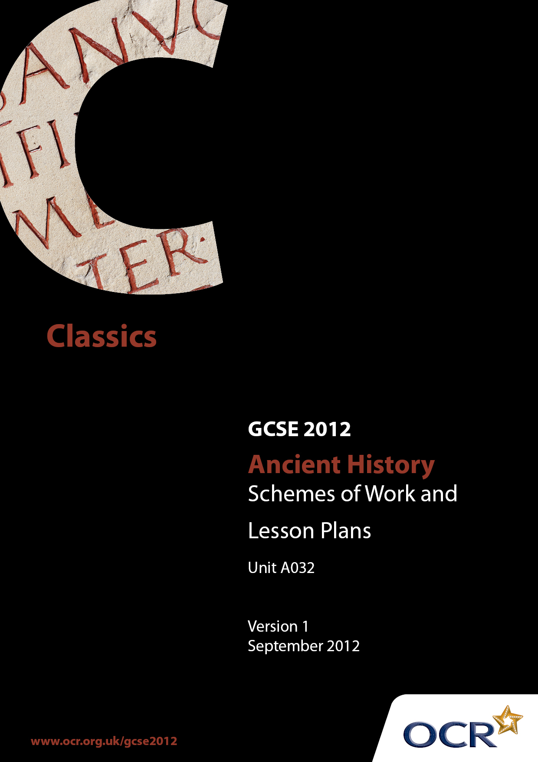

Contents
Contents 2
Introduction 3
Sample Scheme of Work: OCR GCSE Ancient History Unit A032: Option 1 5
Sample Scheme of Work: OCR GCSE Ancient History Unit A032: Option 2 11
Sample Lesson Plan: OCR GCSE Ancient History Unit A032: Option 1 16
Sample Lesson Plan: OCR GCSE Ancient History Unit A032: Option 2 18

Introduction

Background
OCR has produced a summary brochure, which summarises the new Ancient History GCSE. This can be found at www.ocr.org.uk, along with the new specification.
In addition and in response to reforms announced by the Government and in response to Ofqual mandated changes to GCSEs, unitised assessment of this qualification is being replaced by linear assessment from September 2012. This means that candidates commencing a two year course from September 2012 will take all of their GCSE units at the end of the course in June 2014.
In order to help you plan effectively for the implementation of the new specification we have produced these Schemes of Work and Sample Lesson Plans for Ancient History. These Support Materials are designed for guidance only and play a secondary role to the Specification.

Our Ethos
OCR involves teachers in the development of new support materials to capture current teaching practices tailored to our new specifications. These support materials are designed to inspire teachers and facilitate different ideas and teaching practices.
Each Scheme of Work and set of sample Lesson Plans is provided in Word format so that you can use it as a foundation to build upon and amend the content to suit your teaching style and students’ needs.
The Scheme of Work and sample Lesson plans provide examples of how to teach this unit and the teaching hours are suggestions only. Some or all of it may be applicable to your teaching.
The Specification is the document on which assessment is based and specifies what content and skills need to be covered in delivering the course. At all times, therefore, this Support Material booklet should be read in conjunction with the Specification. If clarification on a particular point is sought then that clarification should be found in the Specification itself.

A Guided Tour through the Scheme of Work

= Innovative Teaching Idea
This icon is used to highlight exceptionally innovative ideas.


= ICT Opportunity
This icon is used to illustrate when an activity could be taught using ICT facilities.

OCR GCSE Ancient History Unit A032: Option 1
Suggested teaching time | 30 hours | Option | The origins of Rome: the kings, 753-508 BC
Topic outline |  | Suggested teaching and homework activities |  | Suggested resources | Points to note
Introduction |  | - Issue students with a copy of the relevant section of the specification read through and discuss so that students have an outline of the unit. |  | - Specification from OCR website | - As the different parts of the specification are covered, students can tick them off so they have confidence that they are well prepared for the examination.  - A colour coding system may also be used to annotate sections of the set texts and link them to points on the specification.
Context:  Geography of Rome and the indigenous peoples of Latium  - The position of Rome, and the advantages of its site for trading and the development of the state;  - The peoples of Latium and their relationship with the early Romans;  - Etruscans and Greek city states and their relationship with the early Romans |  | - Using maps of the area, in class discussion, students may be encouraged to identify the reasons why the site of Rome was a good place to settle.  - On a large, blank map of Italy, mark where the tribes lived and where the Greek colonies were. In boxes drawn on the map, explain relationships with Rome.  - Discussion should encourage the understanding of the development of the Romans into a powerful force in the development of Europe. |  | - Maps of Italy and Rome  - Information on this section  - http://history-world.org/rome.htm  - Ancient peoples of Italy http://faculty.ed.umuc.edu/~jmatthew/naples/ancient.html
- Sources  - Livy, The History of Rome Preface  - Livy, The History of Rome 1.3–29, 1.39–40, 1.49–59  - Virgil, Aeneid Book 1, 1–11; Book 6, 752–859; Book 8, 626–651  - Bronze she-wolf with (later addition of) twins from the Capitoline museum |  | - With the class taking turns to read aloud, read through all the set texts in order to get an over view. Students may be encouraged to make comments and observations about how the texts relate to points on the specification but in-depth discussion can be saved for later when covering the Themes. Students may begin to develop a colour coding system with a colour or symbol for each of the Themes so that they can mark significant sections on the text for when they come back to it later. |  | - Livy http://etext.virginia.edu/toc/modeng/public/Liv1His.html  - Virgil  - http://www.perseus.tufts.edu/hopper/text.jsp?doc=Perseus:text:1999.02.0054  - or  - http://www.users.globalnet.co.uk/~loxias/aeneid1.htm  - A Google image search for ‘bronze she wolf’ produces a page full of images of the sculpture | - Photocopies or internet printouts are better than books because students can be provided with just the relevant sections so that the text does not look too long.  - Students can annotate and colour code their copies to make them more accessible to their own learning styles.  - The idea of reading through the texts at the start is to allow students to develop ideas independently at their own pace. If this seems too laborious, the teacher could select extracts as a starting point and then bring in the full texts as necessary later.
Themes  Identity of the Romans; conflicting versions of the origins of Rome  - The myth of Aeneas and the connection with Troy;  - The myth of Romulus and Remus;  - The myth of Evander and Hercules;  - The Sabines and their connection with Rome. |  | - Divide the class into groups and give each group a different story: Aeneas and the connection with Troy; Romulus and Remus; Evander and Hercules; Rome’s relationship with the Sabines. Using the sources which they have already read, internet and books each group could make a presentation or ‘documentary’ for the rest of the class. Each group could make a hand-out/information sheet to give to the rest of the class |  | - Copies of the sources, internet | - The teacher could split the groups so they are mixed ability ensuring equal coverage of each story
Themes  The character and reigns of the kings  - The nature of kingship in early Rome and its development under each king;  - The character and reign of: Romulus, Numa, Tarquinius Priscus, Servius and Tarquinius Superbus;  - The death of Romulus and his subsequent deification. |  | - After class discussion on the nature of kingship in early Rome and its development under each king, the class could make job  advertisements for the job ‘King of  Rome’ saying what skills are needed  and what sort of a person.  - Individually or in groups, the class could produce a character study on each king. A famous actor could be chosen to ‘play’ each king  then biographies may be produced or newspaper exposés with interviews and comments from people who knew the king.  - Students could produce a newspaper report on the death of Romulus with theories about what happened and coverage of his deification. |  | - Copies of the sources
Themes  The constitutional, religious and economic development of the Roman state under the kings  - The establishment of Rome under Romulus;  - The development of religion under Numa;  - The distinctive nature of the Tarquins and their effect on the development of Rome;  - Reasons for the removal of the kings. |  | - Students could write an article or TV interview: ‘Romulus on Romulus – What I did for Rome’  - The students could write a speech for Numa in which he outlines how he has developed religion.  - Students could make a newspaper exposé ‘The Tarquins Revealed – what they were really like’ This could include ‘interviews’ with sources, witnesses etc.  - The class could re-create a Judge Judy or Jeremy Kyle style show: Why the kings had to go, with different viewpoints put forward. |  | - Copies of the sources | - Within this topic the teacher should encourage the understanding of the development of the Romans into a powerful force in the development of Europe
Sources  Livy and Virgil as sources and factors that affect how they write  - Livy’s own statements on his work in the Preface and their significance;  - The presentation of foundation myths by Livy and Virgil;  - Livy’s sources and his use of them;  - Attitudes towards kingship in Livy and Virgil’s writing. |  | - Teacher-led close analysis of Livy’s preface with students highlighting and annotating as they discuss Livy’s statements and how they may be interpreted.  - Class debate with half the class representing Livy and half Virgil: Who makes the best representation of the founding of Rome? The teacher could guide the debate towards what the writers were trying to achieve by their representations and how successful this was.  - Students may read and discuss the article on Livy’s sources at http://www.livius.org/li-ln/livy/livy4.html  - Class discussion: Livy Book 1: History or Myth?  - One student could play Livy and another Virgil and each be asked to explain his own attitude to kingship on a Question Time style show. Each ‘author’ could have a ‘PR team’ to help him get his statement ready and the rest of the class could be the audience who ask questions once the initial statements have been made. One student could be the host of the show. |  | - Article on Livy’s sources http://www.livius.org/li-ln/livy/livy4.html
Topic Review |  | - In order to consolidate the understanding of the development of the Romans into a powerful force in the development of Europe, students may be encouraged to produce a wall display, flow-chart, big spider diagram or mind map representing the Context and Themes as represented by the Sources. |  | - Paper, pictures from the internet, colours to appeal to visual learners

OCR GCSE Ancient History Unit A032: Option 2
Suggested teaching time | 30 hours | Option | Hannibal’s invasion and defeat, 218-146 BC
Topic outline |  | Suggested teaching and homework activities |  | Suggested resources | Points to note
Introduction |  | - Issue students with a copy of the relevant section of the specification read through and discuss so that students have an outline of the unit. |  | - Specification from OCR website | - As the different parts of the specification are covered, students can tick them off so they have confidence that they are well prepared for the examination.  - A colour coding system may also be used to annotate sections of the set texts and link them to points on the specification.
Context  Relations between Rome and Carthage under Hasdrubal: Sicily and Spain  - Rivalry of Rome and Carthage over Sicily;  - The significance of the first Punic war;  - The significance of Spain as a Carthaginian base and the conflict at Saguntum;  - The Barcids in Carthage, including the status of Hamilcar and Hasdrubal. |  | - On a large, blank map of the Mediterranean Sea and the surrounding countries, mark all relevant locations and annotate as teacher led discussion brings out the key points in the Context section.  - Territories belonging to Rome and Carthage may be colour coded which can stimulate discussion on Sicily and Spain.  - Students could draw a family tree of the known Barcids and annotate it with biographical facts.  - Facts about the 1st Punic War may be added to the Hamilcar biography section and their significance discussed. |  | - Maps | - Discussion should encourage the understanding of the development of the Romans into a powerful force in the development of Europe.
Sources  - Livy, The History of Rome 21.21–37  - Livy, The History of Rome 22.23–26, 22.44–52  - Livy, The History of Rome 30.27–37  - Polybius, The Rise of the Roman Empire 1.1–4  - Polybius, The Rise of the Roman Empire 3.50–56, 3.81–89  - Plutarch, Life of Fabius Maximus 5 |  | - Issue students with copies of all the set texts as a booklet.  - With the class taking turns to read aloud, read through all the set texts in order to get an over view. Students may be encouraged to make comments and observations about how the texts relate to points on the specification but in-depth discussion can be saved for within the Themes. Students may begin to develop a colour coding system with a colour or symbol for each of the Themes so that they can mark significant sections on the text for when they come back to it later. |  | - Livy 21 and 22  http://mcadams.posc.mu.edu/txt/ah/Livy/Livy21.html  http://mcadams.posc.mu.edu/txt/ah/Livy/Livy22.html  - Livy 21 and 22  http://etext.virginia.edu/toc/modeng/public/Liv3His.html  - Livy 30  http://mcadams.posc.mu.edu/txt/ah/Livy/Livy30.html  - Polybius  http://penelope.uchicago.edu/thayer/e/roman/texts/polybius/home.html  - Plutarch  http://penelope.uchicago.edu/Thayer/E/Roman/Texts/Plutarch/Lives/Fabius_Maximus*.html | - Photocopies or internet printouts are better than books because students can be provided with just the relevant sections so that the text does not look too long.  - Students can annotate and colour code their copies to make them more accessible to their own learning styles.  - The idea of reading through the texts at the start is to allow students to develop ideas independently at their own pace. If this seems too laborious, the teacher could select extracts as a starting point and then bring in the full texts as necessary later.
Themes  Hannibal’s invasion of Italy, including details of the battles between Rome and Carthage  - Hannibal’s invasion of Italy, including the crossing of the Alps;  - The battles at Trebia, Trasimene, Cannae and Zama;  - The weapons, armour and tactics used by the Carthaginians and Romans. |  | - Using the set sources and history  books /internet research, students  could take on the roles of ‘War  Correspondents’ and different groups within the class could report on Hannibal crossing the Alps, the different battles outcomes, armour weapons and tactics used. Each group could perform the news report for the rest of the class and their notes be distributed to the class as hand outs.  - Discussion should encourage the understanding of the development of the Romans into a powerful force in the development of Europe. |  | - Set sources | - The teacher could group the students in mixed ability groups so that all aspects with be covered to a similar standard.
Themes  Character, role and achievements of key individuals  - Hannibal;  - Fabius Maximus;  - Scipio Africanus;  - The relationship of each of these individuals with their governments and people. |  | - Using the set sources, history books/internet research, individually or in groups, students could make profiles of each character. They could choose a famous actor to play the character and use pictures to illustrate the profile. The profile could be a biography or even an autobiography e.g. ‘My side of the story by Hannibal’ |  | - Set Sources
Themes  The significance of the conflict against Carthage in the development of Rome  - The shift in power in the Mediterranean as a result of the Roman victory;  - The consequences of the Carthaginian; defeat for the expansion of Roman trade and the Roman Empire;  - The consequences of defeat for Carthage. |  | - Using set sources, history books and  internet, students could give accounts  from each side of the outcome of the  conflict. Students could write the diary of a Roman soldier/soldier’s wife etc. and the diary of a Carthaginian soldier/inhabitant.  - Teachers should encourage the understanding of the development of the Romans into a powerful force in the development of Europe |  | - Set sources | - This Theme should encourage the understanding of the development of the Romans into a powerful force in the development of Europe
Sources  Livy and Polybius as historians and the relationship between their works  - Livy’s sources and his use of them;  - Polybius’ sources and his use of them;  - Relationship between the works of Livy and Polybius. |  | - Students could make summaries of the sources and then put these into a table so that they can compare the two accounts.  - Class debate with students playing Livy and Polybius, one student could be Jerry Springer/Jeremy Kyle and the other class members be the audience who ask questions and challenge the historians on their telling of the story. |  | - Set sources
Topic Review |  | - In order to consolidate the understanding of the development of the Romans into a powerful force in the development of Europe, students may be encouraged to produce a wall display, flow-chart, big spider diagram or mind map representing the Context and Themes as represented by the Sources. |  | - Paper, pictures from the internet, colours to appeal to visual learners

OCR GCSE Ancient History Unit A032: The Rise of Rome

Option 1: The Origins of Rome: The Kings, 753-508 BC

Livy, The History of Rome Preface
OCR recognises that the teaching of this qualification above will vary greatly from school to school and from teacher to teacher. With that in mind this lesson plan is offered as a possible approach but will be subject to modifications by the individual teacher.
Lesson length is assumed to be one hour.

Learning Objectives for the Lesson
Objective 1 | Students to have detailed knowledge of Livy, The History of Rome: Preface.
Objective 2 | Students to evaluate Livy’s own statements on his work in the Preface.
Objective 3 | Students to understand the significance of Livy’s own statements on his work.

Recap of Previous Experience and Prior Knowledge
- Students should be asked to recall what the Preface is and should be encouraged to discuss the function/intention of a preface.

Content
Time | Content
10 minutes | Warm up activity to assess prior knowledge. Teacher asks students what a preface is and by looking at books containing a Preface, students agree on the purpose of it. Teacher asks students to recall what they remember about the Livy’s preface from the read-through.
5 minutes | Teacher to issue students with blank text of The History of Rome Preface on a large sheet of paper with space around the edges for annotations. The class take turns to read the text aloud.
10 minutes | Students split into groups and are told to underline (perhaps in pencil so that mistakes may be rectified later) statements Livy makes about his work and Rome and also underline statements where deductions may be made about Livy’s point of view/intention/values. They should be encouraged to make rough notes on what they have picked out and why they think it is important.
10 minutes | Teacher led class discussion where students offer suggestions for text to highlight and notes to make on its significance. Once the class has agreed on a chosen statement and its significance, each student notes this on their sheet.
15 minutes | In groups or individually, using the notes they have just made, students prepare responses to the following:  - What do we learn about Livy’s intentions as he sees them?  - What do we learn about Livy’s attitude to history?  - What do we learn about Livy as a source?  - What does the Preface suggest about Livy’s attitude to Rome in general?  - What does the Preface suggest about Livy’s attitude to morality?  The questions could be typed onto a sheet with spaces for responses so that students would have a written record.

Consolidation
Time | Content
10 minutes | Teacher asks students to give their response to the questions prepared earlier; the answers are developed by further contributions from the class. Students make additions to their notes on the sheet.  Further consolidation with homework: potential bias in Livy, other sources.

Resources
Books with Prefaces – any that happen to be around.
Text of Livy, The History of Rome Preface
Worksheet with the questions printed on and gaps for the answers
Pencils, rubbers, highlighters

OCR GCSE Ancient History Unit A032: The Rise of Rome

Option 2: Hannibal’s Invasion and Defeat, 218-146 BC

Livy’s account of The Battle of Zama
OCR recognises that the teaching of this qualification above will vary greatly from school to school and from teacher to teacher. With that in mind this lesson plan is offered as a possible approach but will be subject to modifications by the individual teacher.
Lesson length is assumed to be one hour.

Learning Objectives for the Lesson
Objective 1 | Students to know about the events the actions/ tactics of the generals in the Battle of Zama as described by Livy.
Objective 2 | Students to evaluate the consequences of victory/defeat in this battle.
Objective 3 | Students to understand the importance of the battle in the development of the Romans into a powerful force in the development of Europe.

Recap of Previous Experience and Prior Knowledge
- Students should be asked to recall the main events so far in the 2nd Punic War. They should also be able to recall the situation as the war enters the decisive stage with the Battle of Zama.

Content
Time | Content
5 minutes | Warm up activity to assess prior knowledge. Teacher asks students to recall what they remember about events of the 2nd Punic War so far and within class discussion highlights the situation as the war enters the decisive stage with the Battle of Zama.
15 minutes | Split the class into 4 groups and give them copies of different parts of Livy’s text: the two generals’ speeches to each other; the generals’ speeches to the troops; tactics before the battle; the battle itself.  Ask the groups to read the text together and underline in pencil anything they think is relevant to:  - The consequences of victory/defeat in this battle – what is there to be lost/won?  - Tactics used by the generals  - The attitudes of the generals  - Bias on the part of Livy.
10 minutes | With the class referring to their copies of the full text, each group feeds back their findings to the class with the teacher filling in any gaps. Students make notes on their copies of the text.
20 minutes | Using their copies of the whole of Livy’s account, in groups or individually, students prepare brief responses to:  - What are the main events of the battle as described by Livy and what are the key factors in defeat/victory?  - How does Livy contrast the two generals?  - What are the implications for the development of the Romans into a powerful force in the development of Europe?  - How does Livy make the story interesting?  The questions could be put on a sheet with spaces for responses so that students have a structured, written record.

Consolidation
Time | Content
10 minutes | Teacher asks students to give their response to the questions prepared earlier; the answers are developed by further contributions from the class. The class members add to their own written answers in light of comments from others.

Resources
Livy 30.27-37
Question sheets

