Duration: 1.25 Hours

Lesson aims:
Learners to understand and use statistical methods to investigate situations.
Specific learning outcomes:  Students will be able to:  - Understand and use mean, median, mode and range.  - Use and interpret statistical measures, tables and diagrams.  - Use appropriate checking procedures. | Assessment method(s):  - Group activities  - Question & Answer during the session..  - Learner engagement during session.  - Worksheet

Linked Functional Skills:
Speaking, listening and communicating:
Students participate in discussions during the session, how they articulate answers and communicate with other learners.

Previous knowledge assumed:
Understand and use positive and negative numbers of any size in practical contexts.
Carry out calculations with numbers of any size in practical contexts.
Collect and represent discrete and continuous data.

Materials and equipment required:
Number cards, graphic cards, Worksheet

Time/ Stage | Subject Matter/Content | Teacher Activity | Student Activity | Resources/Notes
5-10 min | Small Group Activity:  Number Cards – arrange these in order and find mean, median, mode and range. | Each number set has a specific focus; e.g. one set has no modal number, another set has an even number of cards; so the median has to be calculated.  Each of these focuses will give an opportunity for discussion following the activity. | Sort the cards in number order, and find the mean, median, mode and range.  Discussions and agreement. | The sets of cards are best printed in different colours. Each card set has a specific focus, so it is best to keep them separate.  Shuffle each set before handing them out, so they will have to place the cards in order. Guidance/help will be needed for some groups.
5-10 min | Explanation and Discussion. | Clarify the definition of the words mean, median, mode and range. Use the results of the starter activity to give focus.  Introduce checking procedures. | Ask Questions | Reinforce that the checking of procedures is a vital part of mathematics (and are a requirement of the tests).
10 min | Small Group Activity:  Graphic Sources – interpret the mean, median, mode and range. | Introduce this session by explaining that statistical data is often represented in graphic forms. | Interpret the representation and find mean, median, mode and range. Discussions and agreement. | Many learners have difficulty in interpreting data from graphical formats.
5 min | Explanation and discussion. | Identify the use of visual skills in interpreting from graphic data, and how to extract data from calculations.  Reinforce checking procedures – both visual and calculations. | Ask questions
5 min | Comparing Data | Explain that most statistical data is used for comparison purposes; e.g., comparing the cost of a flat in London with one in Bath. | Ask Questions | This can provide the focus for a discussion of using statistics in real life.
25 min | Worksheet | Hand out worksheets and guide students to showing their calculations.  Introduce the need to do some problem solving and ask them to check their answers. | Complete Worksheet. | Worksheet.
10 min | Worksheet Answers. | Provide answers and give explanations where necessary.  Ask questions and give explanations where necessary. Discuss the checking procedures. | Ask Questions. | The answers requested in the questions relate to themean, median, mode and range.  At this stage it will be useful to expand their understanding of statistics; i.e. Task 3 – in 2009 more than half of those questioned said ‘cleanliness was poor or very poor.’  In the present survey more than half said ‘cleanliness was satisfactory, good or very good’.
5 min | Conclusion. Redefine mean, median, mode and range. Ask for questions. | Guide them to common sense checking. | Ask questions.

7 | 13 | 13 | 16
17 | 22 | 23 | 25

8 | 11 | 13 | 14
17 | 19 | 23 | 23
25

7 | 11 | 12 | 12
14 | 14 | 17 | 19
21

8 | 11 | 13 | 16
18 | 22 | 23 | 25

A record of the luxury chocolate bars sold from January to September.
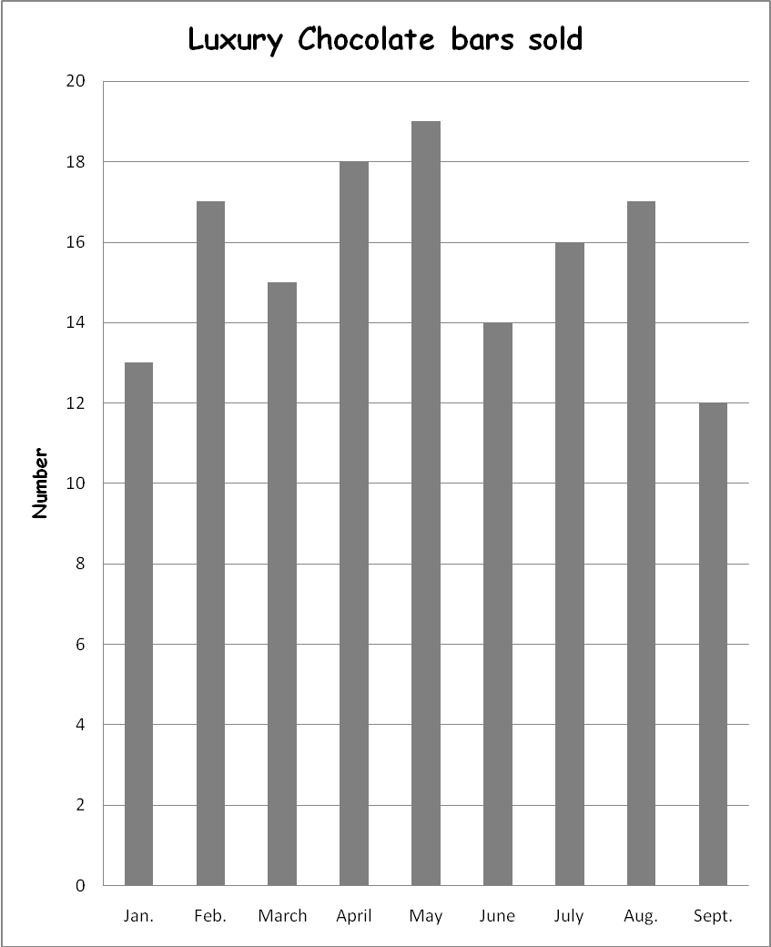

A record of the complaints received from January to September.
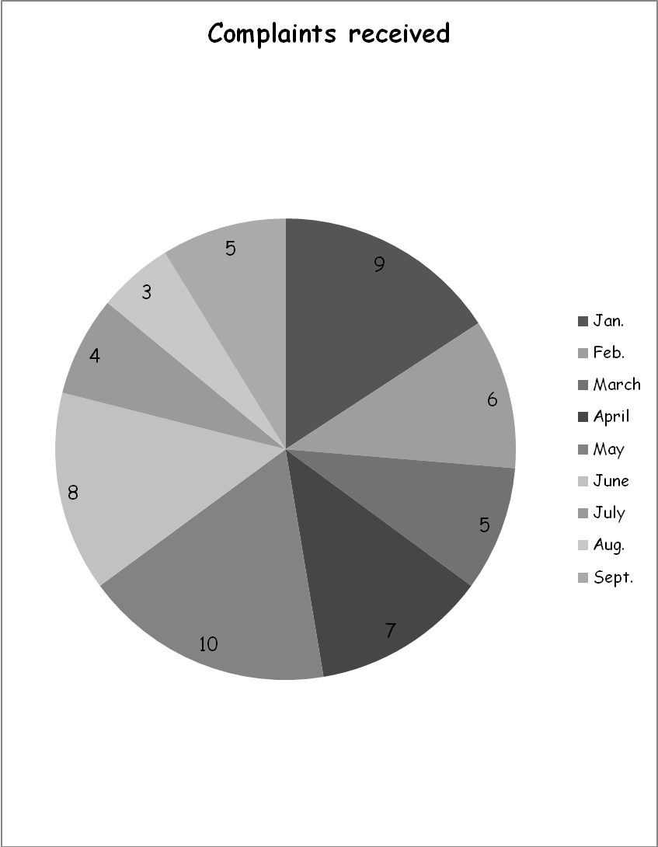

A record of a student’s monthly training sessions from January to September.

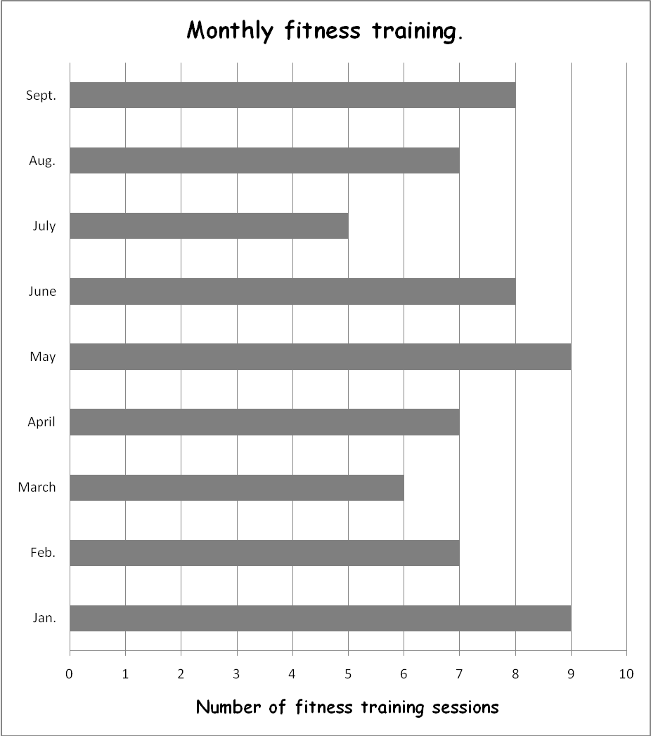

A record of a company’s expenses from January to September.
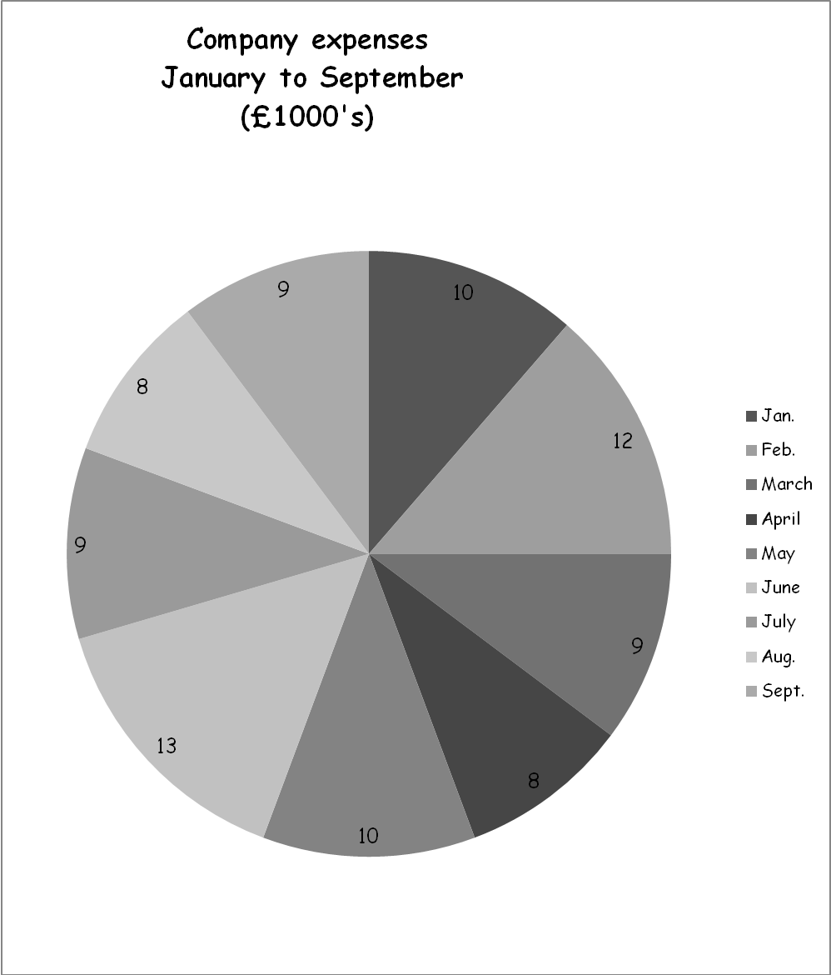

Task 1
Two students kept a record of the number of hours they spent watching TV for 5 weeks.
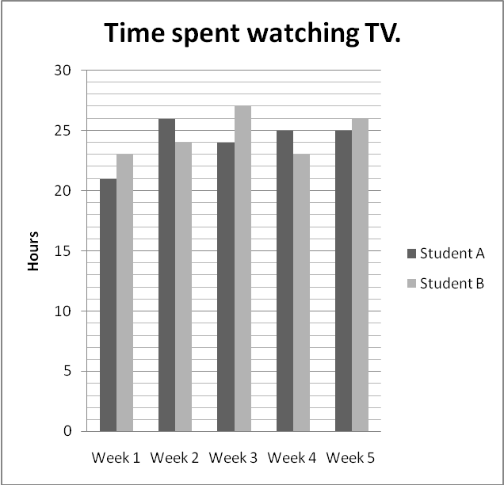
Which student has the largest mean time watching TV per week? Show your workings.
Which student has the largest range of time watching TV?

________________________________________________________________________
________________________________________________________________________
________________________________________________________________________
________________________________________________________________________
________________________________________________________________________
________________________________________________________________________
________________________________________________________________________
________________________________________________________________________
________________________________________________________________________
________________________________________________________________________

Task 2
Two groups of students doing fitness training measured their times for a 50 step exercise.

Group 1 | A | B | C | D | E | F | G
Time (sec) | 32 | 25 | 40 | 28 | 22 | 33 | 23

Group 2 | P | Q | R | S | T | U | V
Time (sec) | 40 | 26 | 33 | 24 | 31 | 24 | 25

Which group had the best performance overall? Use mean and median to compare the results of the two groups. Show your workings.

________________________________________________________________________
________________________________________________________________________
________________________________________________________________________
________________________________________________________________________
________________________________________________________________________
________________________________________________________________________
________________________________________________________________________
________________________________________________________________________
________________________________________________________________________
________________________________________________________________________
________________________________________________________________________
________________________________________________________________________

Task 3
Yesterday your local hospital asked outpatients to comment on the cleanliness of the hospital environment. 19 survey forms were completed.

Survey results from outpatients.
Ratings: 5 = Very good, 4 = Good , 3 = Satisfactory, 2 = Poor, 1 = Very poor
Patient | a | b | c | d | e | f | g | h | i | j | k | l | m | n | o | p | q | r | s
Cleanliness | 4 | 3 | 1 | 2 | 5 | 3 | 3 | 3 | 5 | 3 | 4 | 3 | 2 | 1 | 2 | 4 | 5 | 3 | 4

The results of a previous survey, done in 2009, show:
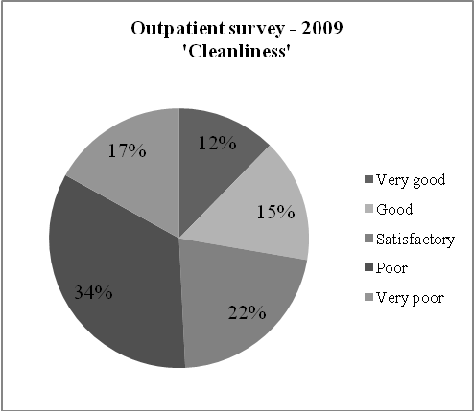

Use the modal values to compare the results for yesterday’s survey with the survey from 2009.
________________________________________________________________________
________________________________________________________________________
________________________________________________________________________
________________________________________________________________________
________________________________________________________________________
________________________________________________________________________
________________________________________________________________________
________________________________________________________________________

Task 4
A group of students are planning a ski-trip for the beginning of December. One of the students downloads a graph of the temperatures at the ski resort for the previous ten days.
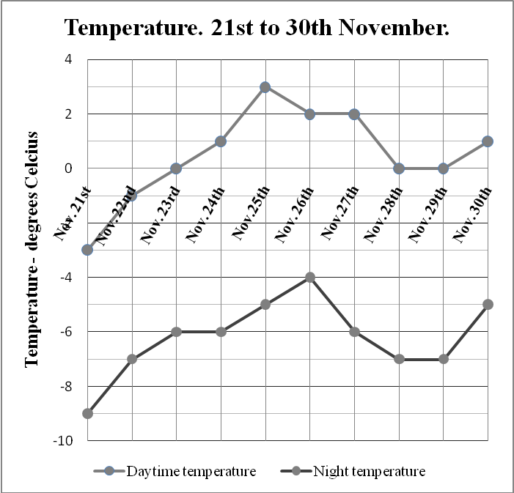

The same pattern of weather is likely to continue for their ski-trip.
What is the range of daytime temperature they should expect?
What is the mean night temperature for the period 21st to 30th November?
Which day(s) in the period 21st to 30th November had the greatest difference between the day and night time temperature?
________________________________________________________________________
________________________________________________________________________
________________________________________________________________________
________________________________________________________________________
________________________________________________________________________
________________________________________________________________________
________________________________________________________________________

Task 5
All participants in the next marathon run were asked to submit an estimate of how much money they expected to raise for charity. They were asked to select from three expected donation ranges.

Number of participants | Expected donations  £
78 | 1 ≤ x ≥ 50
109 | 51 ≤ x ≥ 100
64 | 101 ≤ x ≥ 150

No participants expected to raise more than £150.
Use the median value for each category to calculate the total amount expected to be raised.
________________________________________________________________________
________________________________________________________________________
________________________________________________________________________
________________________________________________________________________
________________________________________________________________________
________________________________________________________________________
________________________________________________________________________
________________________________________________________________________
________________________________________________________________________
________________________________________________________________________
________________________________________________________________________
________________________________________________________________________
________________________________________________________________________
________________________________________________________________________
________________________________________________________________________
________________________________________________________________________
________________________________________________________________________
________________________________________________________________________

