Duration: 1.25 Hours

Lesson aims:
Learners to understand and use mean and range.
Specific learning outcomes:  - Students will be able to:  - Understand and use range and mean in practical situations data.  - Calculate range and mean and do comparisons.  - Use appropriate checking procedures. | Assessment method(s):  - Group activities  - Question & Answer during the session..  - Learner engagement during session.  - Worksheet

Linked Functional Skills:
Speaking, listening and communicating:
Students participate in discussions during the session, how they articulate answers and communicate with other learners.

Previous knowledge assumed:
Add, subtract, multiply and divide whole numbers using a range of strategies.
Collect and record discrete data

Materials and equipment required:
Timing device (clock, watch or stop-watch)
Worksheet

Time/ Stage | Subject Matter/Content | Teacher Activity | Student Activity | Resources/  Notes
5 min | Small Group Activity:  Number Cards – arrange in order and find range | When they have completed this, ask questions, such as:  - Which group has the highest number?  - Which group has the lowest number?  - Which group has the highest range?  Explain that the range is the link between the highest and the lowest, and not just the highest or the lowest. | Sort the cards in number order and find the range. | This activity can be done directly, without explaining what the range means. This gives an opportunity for group discussion.  Number cards – There are three different number orders. Each with a simple progression pattern. Shuffle each set before handing them out so they will have to place the cards in order. Guidance/help needed for some of the groups.
10 min | Measuring pulse: Creating a table to record data.  The pulse will be measured several times during the lesson. A clock or stop watch must be used and one time kept to. Provide two opportunities to record pulse records to ensure that everybody does so. | Instructions and guidance on measuring a pulse. Guidance on how to record data, e.g. a table with appropriate columns and headings.  Monitor and announce the beginning and end of the 1 minute timing. | Create a table to record pulse rate. Measure pulse for one minute and record.  Ask question if there is any confusion about how to measure pulse. | To take a pulse, hold the wrist with only four fingers pressed gently until you feel the pulse pulsating. Then count the number of beats you feel for one minute.  You can also do this by pressing your two fingers just under your chin bone or on either side of the neck. Practice this yourself before the lesson to show learners the correct method. More information can be found online.
10 min | Calculating the mean – Following the teacher | Demonstrate how to calculate the mean set of numbers.  Guide the group to calculating the mean for their number set and discuss how to check that their answer is correct. Provide feedback on this. | Calculate the mean of their number set. Discuss how to check their answer is correct. | Reinforce that checking procedures is an important part of mathematics.
5 min | Measuring the pulse | Monitor and announce the beginning and end of the timing. | Measure pulse for one minute and record. | You will need to give some time for them to settle before stating the timer.
10 min | Worksheet | Hand out work sheet | Complete work sheet.
5 min | Worksheet answers | Provide answers and give explanations where necessary. Ask questions. | Ask questions, listen to answers. | Let the learners know in advance that you will be doing another pulse reading to help tie up this task.
5 min | Students calculate their pulse rate mean and average. | Guide them to common sense checking i.e. Mean lies within the range. Ask if any significant change in the pulse can be linked e.g. a higher pulse rate at the beginning, or in the middle of the work sheet etc. | Calculate mean and range of the pulse. Give feedback and ask questions. | This can provide a focus for a discussion of using range and mean in real life.
5 min | Conclusion – Redefine range and mean and ask for questions

Task 1
A volunteer worker at the local community recorded the number of Lorries that passed down the village high street in the middle of the day.
Time | Number of Lorries
10:00 to 11:00
11:00 to 12:00
12:00 to 13:00
13:00 to 14:00
14:00 to 15:00

Calculate the mean number of Lorries per hour that passed down the high street.
________________________________________________________________________
________________________________________________________________________
________________________________________________________________________
________________________________________________________________________
________________________________________________________________________
________________________________________________________________________

Task 2
In a cold week in December the maximum temperature recorded on each day is given in the table.
Monday | Tuesday | Wednesday | Thursday | Friday | Saturday | Sunday
3oC | 2oC | -1oC | 1oC | 1oC | 2oC | 4oC

What is the range of temperature for this week?
________________________________________________________________________
________________________________________________________________________
________________________________________________________________________
________________________________________________________________________

Task 3
A trainee child-care assistant recorded the height of all the children in the group.

Name | Gender | Height in centimetres
Peter | m | 97
Joan | f | 98
Saliha | f | 92
Mateus | m | 89
Frances | f | 90
Lebo | f | 96
Samuel | m | 92
Lizzy | f | 89
Howard | m | 86

What is the difference between the mean height of the boys and the mean height of the girls?
________________________________________________________________________
________________________________________________________________________
________________________________________________________________________
________________________________________________________________________
________________________________________________________________________
________________________________________________________________________

Task 4
One of the members of a fitness club does cross-country running 4 times every week. The range of distances run is 6 miles. When asked, the person said that the shortest distance run is 2 miles.
What is the longest distance the person runs?
________________________________________________________________________
________________________________________________________________________
________________________________________________________________________
________________________________________________________________________
________________________________________________________________________
________________________________________________________________________

Task 5
A student prepared a chart to show the expenses for the first six weeks of attending a college course. This included travel, food and study materials.
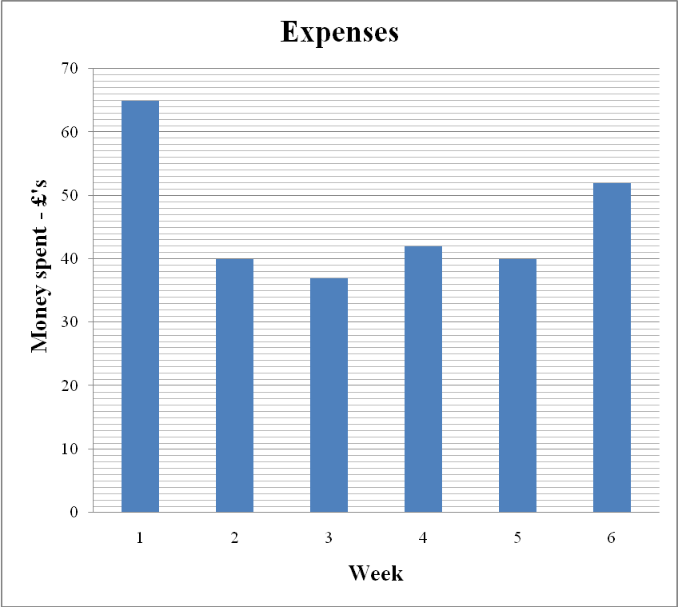

Calculate the mean amount spent each week.
________________________________________________________________________
________________________________________________________________________
________________________________________________________________________
________________________________________________________________________
________________________________________________________________________
________________________________________________________________________

Task 6
A friend has kept a record of calories consumed over the past week
 | Breakfast  kcal | Lunch  kcal | Evening meal  kcal | Daily total  kcal
Monday | 475 | 615 | 785 | 1875
Tuesday | 530 | 655 | 765 | 1950
Wednesday | 570 | 685 | 780 | 2035
Thursday | 665 | 635 | 805 | 2105
Friday | 520 | 685 | 890 | 2095
Saturday | 525 | 735 | 745 | 2005
Sunday | 435 | 865 | 645 | 1945

The national guidelines for healthy eating are:

Guideline Daily Amounts
Adults
Calories 2000kcal

Calculate the mean number of calories the friend consumed each day. Compare this value with the ‘guideline daily amounts’ for calories.
________________________________________________________________________
________________________________________________________________________
________________________________________________________________________
________________________________________________________________________
________________________________________________________________________
________________________________________________________________________

