Duration: 1.25 Hours

Lesson aims:
Learners to understand and use methods to collect and record discrete data.
Specific learning outcomes:  - Students will be able to:  - Collect and record discrete data.  - Understand the requirements for graphic representations of data  - Construct charts. | Assessment method(s):  - Group activities  - Question & Answer during the session..  - Learner engagement during session.  - Worksheet

Linked Functional Skills:
Speaking, listening and communicating:
Students participate in discussions during the session, how they articulate answers and communicate with other learners.

Previous knowledge assumed:
Add, subtract, multiply and divide whole numbers using a range of strategies.

Materials and equipment required:
Sheets – bar chart, pie chart
Worksheet
Protractor

Time/ Stage | Subject Matter/Content | Teacher Activity | Student Activity | Resources/  Notes
5min | Group Starter Activity:  Gather in groups according to the defined parameter. One member to create a tally chart and one member to create a table of the data. | - Define the parameter by which they should devide into groups.  - Select one person to draw a tally chart of the results.  - Select one person to draw a table of the results. | Identify which group they belong to. Gather in the group and allow the tally chart and table to be drawn. | This activity will need to be considered and planned some time in advance. Select a parameter that has at least three sub-sets. This could be eye-colour or make of their mobile phones. Be careful to choose a parameter that does not have any prejudice.
5-10 min | Explanation of recording data | - Cover the structure, design and content of tally charts and tables.  - Identify the need for headings and units to be clearly visible | Ask questions
5 min | Small Group Activity:  Discuss the bar chart they are given and decide on a heading. | Instruct the groups to look at and discuss the content of the bar charts they have been given, and agree on a title for the chart. | - Discuss the content of the bar chart.  - Identify the chart labels.  - Reach an agreement on a suitable title for the chart. | There are three different bar charts. Devide the class into six small groups and distribute two of each bar chart type.  If possible, distribute each bar chart so that the other one of the same type is not with an immediately adjacent group. This will support the possibility that two groups with the same bar chart will create different titles.
5-10 min | Explanation of need for titles in graphic representations. | Begin with a discussion of the titles that the group created for their charts. Focus on differences between groups with the same bar chart. Identify the need to title graphic representations. Discuss the axis tables. | Ask questions
5 min | Small Group Activity:  Discuss the pie chart they have been given and decide how many children (students, adults) responded to each category. | Instruct the groups to look at; discuss the sector of the pie chart. | Discuss the content of the pie chart. Reach an agreement on how many responded to each category. | Three different pie charts. Distribute as recommended for previous activity.
5-10 min | Explanation of the structure of pie charts | Begin with a discussion of the category numbers students agreed on for each pie chart.  Focus on methods of doing this e.g. visual or using a protractor.  Emphasise the 360 degrees for a circle. Discuss the need for a legend. | Ask Questions
20-25 min | Work sheet | Hand out the worksheets:  Give some guidance on checking the accuracy of their representations. | Complete work sheet | The categories for swimming have totals which are convenient for drawing the bar chart.
10 min | Work sheet answers | Identify main features of work sheet bar and pie charts. Give explanations where necessary. Explain how to check accuracy of representations. Ask questions. | Ask questions | If you have an interactive whiteboard, it would be useful to create the bar and pie charts in advance of the session so you can show accurate versions.
5 min | Conclusion | Focus on the need to represent data in a visual and accurate structure. Ask for questions | Ask questions

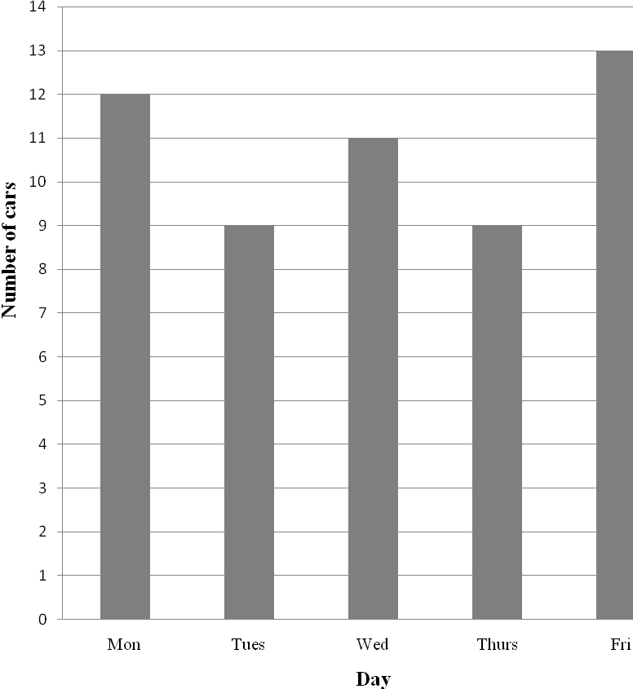
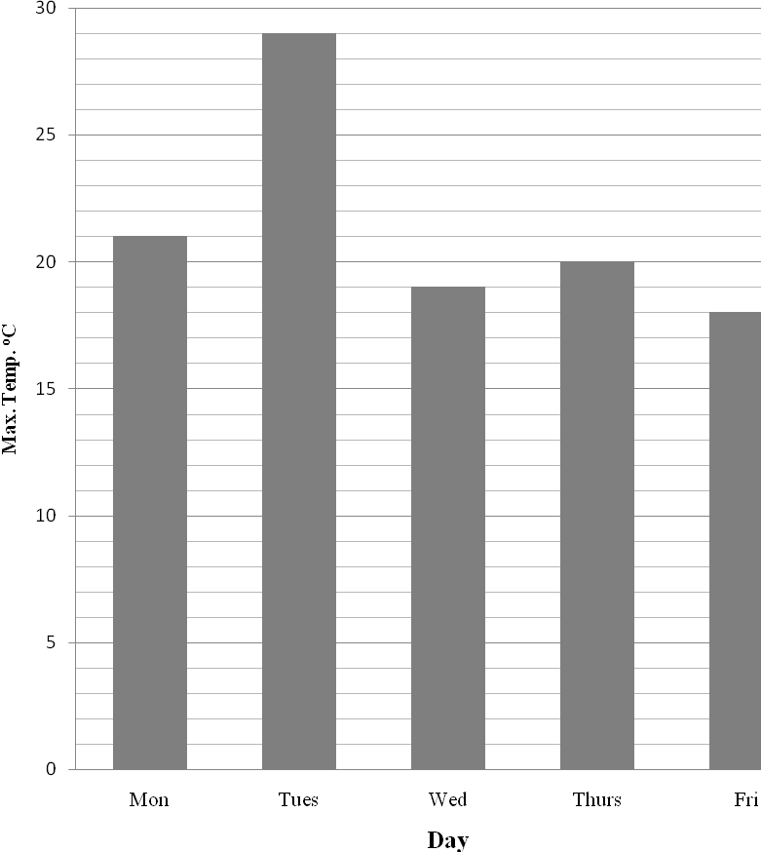

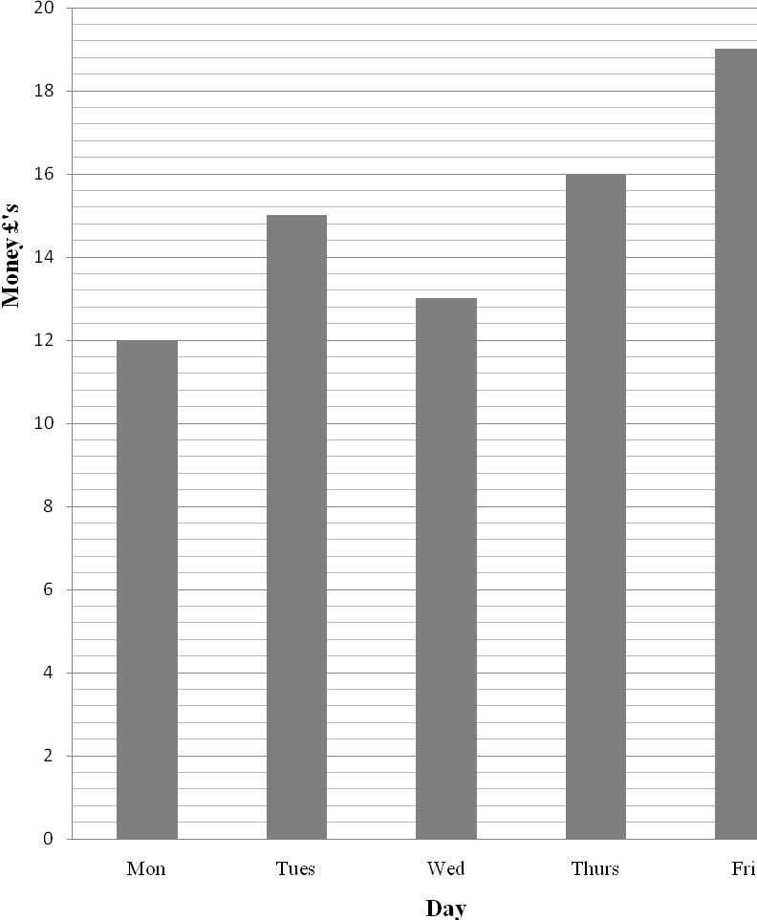

A Numeracy test was trialled on a sample of children in England. After the test those taking part were asked to say how easy or difficult the test was. Their responses were recorded.
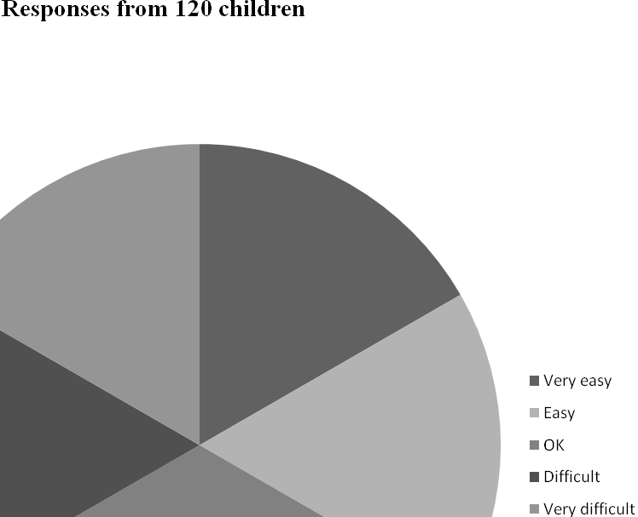

A Numeracy test was trialled on a sample of students in England. After the test those taking part were asked to say how easy or difficult the test was. Their responses were recorded.

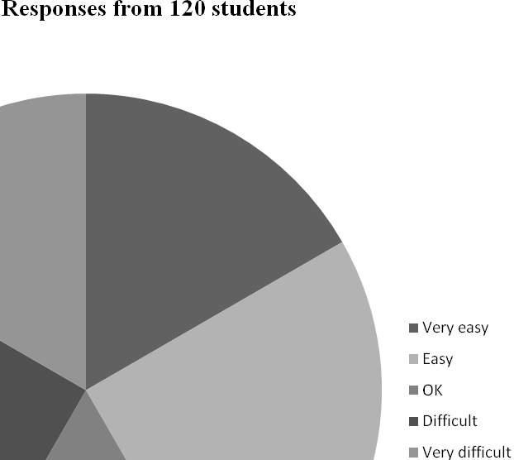

A Numeracy test was trialled on a sample of adults in England. After the test those taking part were asked to say how easy or difficult the test was. Their responses were recorded.

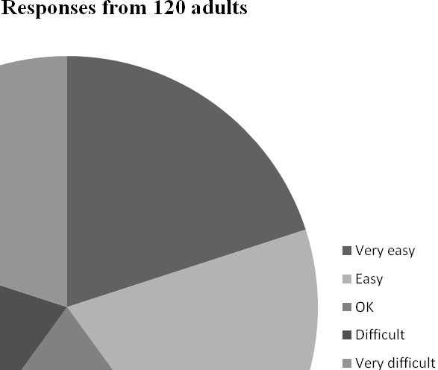

Task 1
A new swimming pool has open in the town. In the first week 740 people came to enjoy a swim. The records for the week show the four different age groups.

Day | Child | Student | Adult | Senior
Monday | 25 | 22 | 19 | 17
Tuesday | 27 | 20 | 20 | 18
Wednesday | 26 | 23 | 17 | 19
Thursday | 31 | 23 | 20 | 20
Friday | 36 | 24 | 21 | 18
Saturday | 59 | 35 | 31 | 24
Sunday | 56 | 33 | 32 | 24
Total:

- Draw a bar chart showing the total number of swimmers who used the pool during the first week. The chart must show how many swimmers there are for each of the four groups (Child, Student, Adult and Senior).
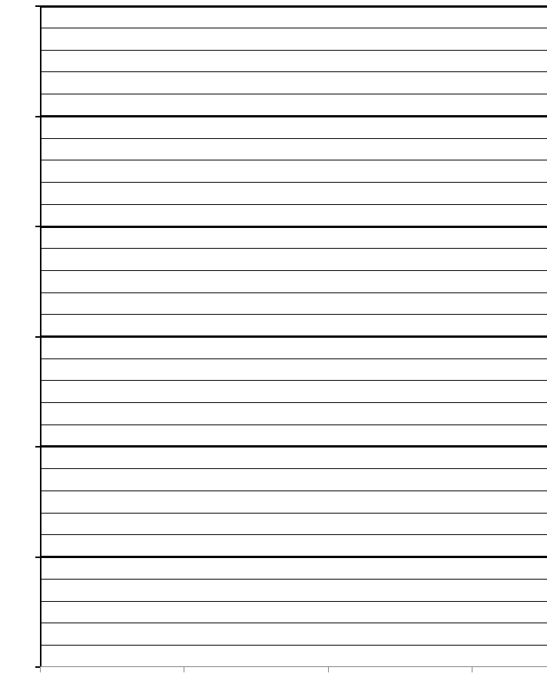
- You need to check that your chart shows the correct information. Show how you can check this.
________________________________________________________________________
________________________________________________________________________
________________________________________________________________________
________________________________________________________________________

Task 2
A student used a tally chart to record the number of different water birds on a local lake.
Water bird | Number
Swan
Canada geese
Grebe
Duck
Coot

Draw a pie chart to show the number of different birds on the lake,

