Duration: 1.25 Hours

Lesson aims:
Learners to understand and use common fractions, decimals and percentages.
Specific learning outcomes:  Students will be able to:  Understand and use fractions, decimals and percentages.  Understand and use equivalences.  Apply fractions, decimals and percentages in practical situations.  Extract and interpret information from tables, diagrams and charts | Assessment method(s):  Group activities  Question & Answer during the session..  Learner engagement during session.  Worksheet

Linked Functional Skills:
Speaking, listening and communicating:
Students participate in discussions during the session, how they articulate answers and communicate with other learners.

Previous knowledge assumed:
Understand and use whole numbers in practical contexts.
Add, subtract, multiply and divide whole numbers using a range of strategies.

Materials and equipment required:
Cards ( circles, fractions/percentages/decimals)
Worksheet

Time/ Stage | Subject Matter/Content | Teacher Activity | Student Activity | Resources/  Notes
10 min | Starter Activity: Circle Segment Cards.  Estimate the fraction of the whole. Find the other segments. | Give each student a segment card. Ask them to estimate the fraction of a whole circle that the card represents.  When they have done this, ask them to link with others in the class who have the same segments and create a circle shape. This will determine if their estimation is correct. | Estimate a fraction of a whole circle (represented by their card).  Link with others in the class who have the same segments. Place them in a circle to view the whole. | The sets of fragments are 5, 6 and 8. Depending on the number of students in the class, some sets will have to be doubled e.g. for a class of 24 students two of set 5. one of set 6 and 1 of set 8 would provide 24 segments.
10 min | Explanation time | Define fractions, decimals and percentages and how they are linked. | Listen and ask questions | Fractions, decimals and percentages are all proportions; so a clear understanding of what the term proportion means is a good starting point.
10 min | Small group activity: Linking Fractions and Percentage | Explain the activity. Hand out the cards – one set of fractions and percentage cards per group.  Ask them to match the percentage to the correct fraction. NB – Only hand out the fraction and percentage cards (the decimal cards will be used later).  Provide correct answers and guide them on reasoning. | Group work:  Discussions and agreements.  Ask questions. | Guidance/help needed for some groups.  If they start with the ones they are certain of, then moving to others can be a logical process.  It is useful to encourage them to learn and remember the simple conversions e.g. 1/8=12.5% or 1/5=20% etc.
5 min | Small group activity:  Linking decimals to fractions and percentages cards used previously. | Explain the activity:  Hand out the cards – one set of decimals per group. Ask them to match the decimal to the correct fraction and percentage. | Ask Questions | Guidance/help needed for some groups:  If they start with the ones they are certain of then moving to the others can be a logical process.
5 min | Explanation time | Provide correct answers and guide them on reasoning. Introducing the concept of rounding – used most frequently in decimals. |  | Introduce 1/3 = 0.3333333… rounded to 0.33
20 min | Worksheet | Hand out worksheets and guide students to showing their calculations. | Worksheet  Ask questions | Worksheet
5 min | Worksheet answers | Provide answers and give explanations where necessary. | Ask questions
5 min | Conclusion: Redefine proportion and link to fractions. |  | Ask questions | Good practice advice to learners – ‘Show your Calculations’. The reason for this – ‘If you get the answer wrong in the test you can still get marks if some of your calculations are correct’  Reinforce that checking procedures are an important part of mathematics.

1/5 = | 1/4 = | 1/8 =
3/4 = | 3/5 = | 3/8 =

20% | 25% | 12.5%
75% | 60% | 37.5%

0.20 | 0.25 | 0.125
0.75 | 0.60 | 0.375

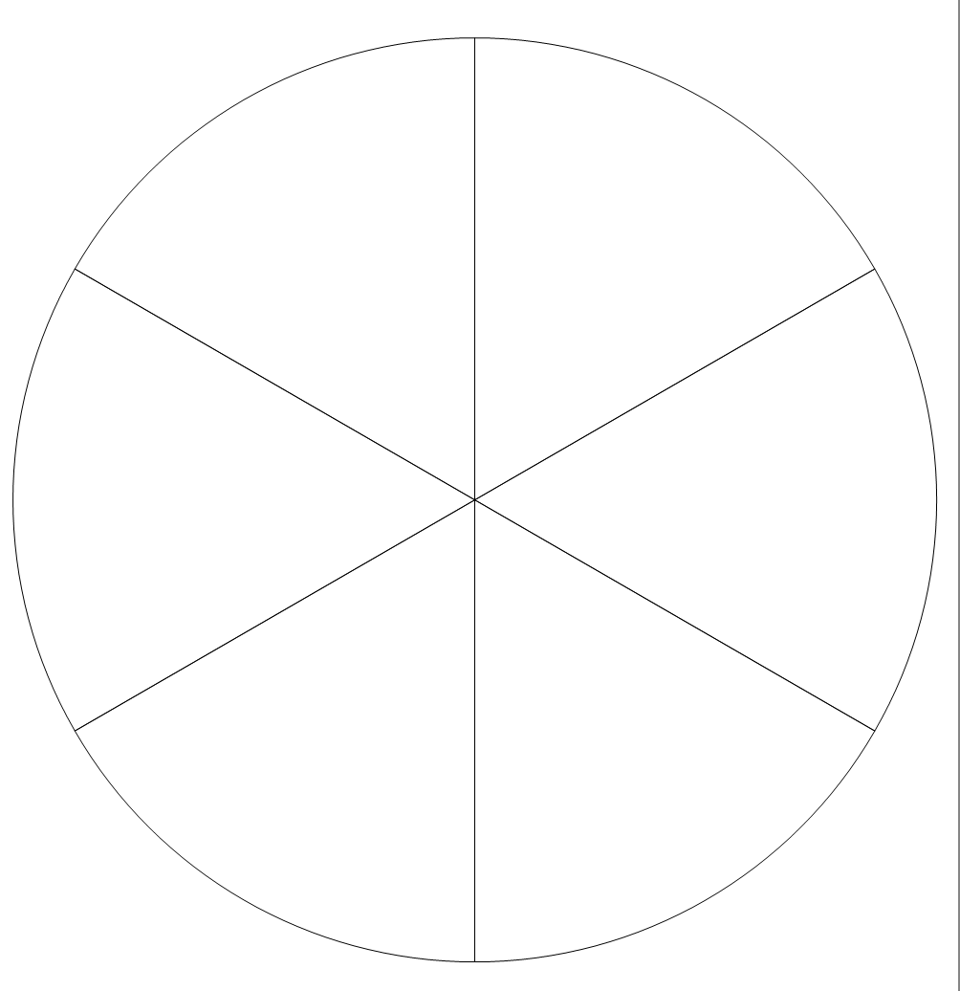
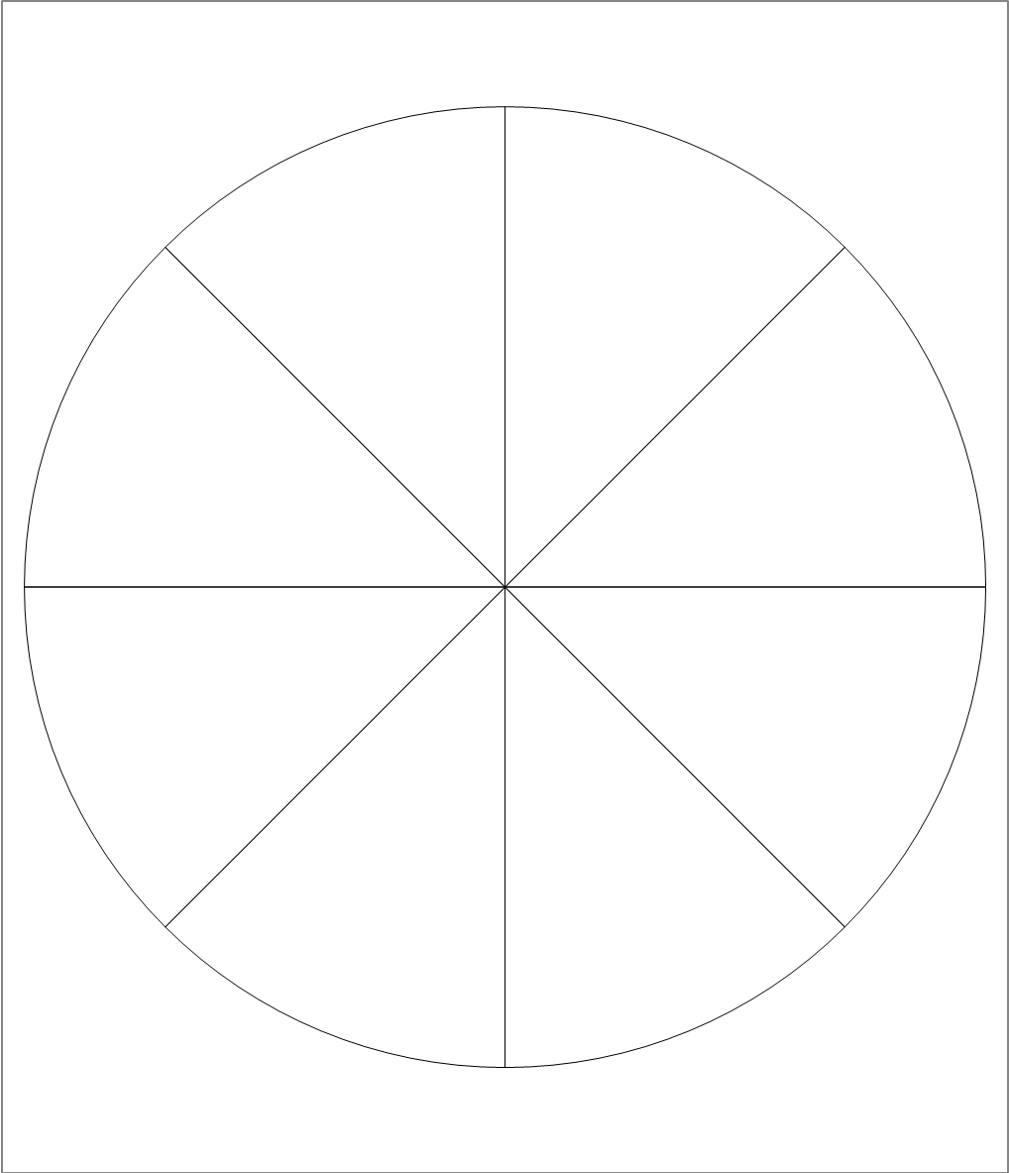

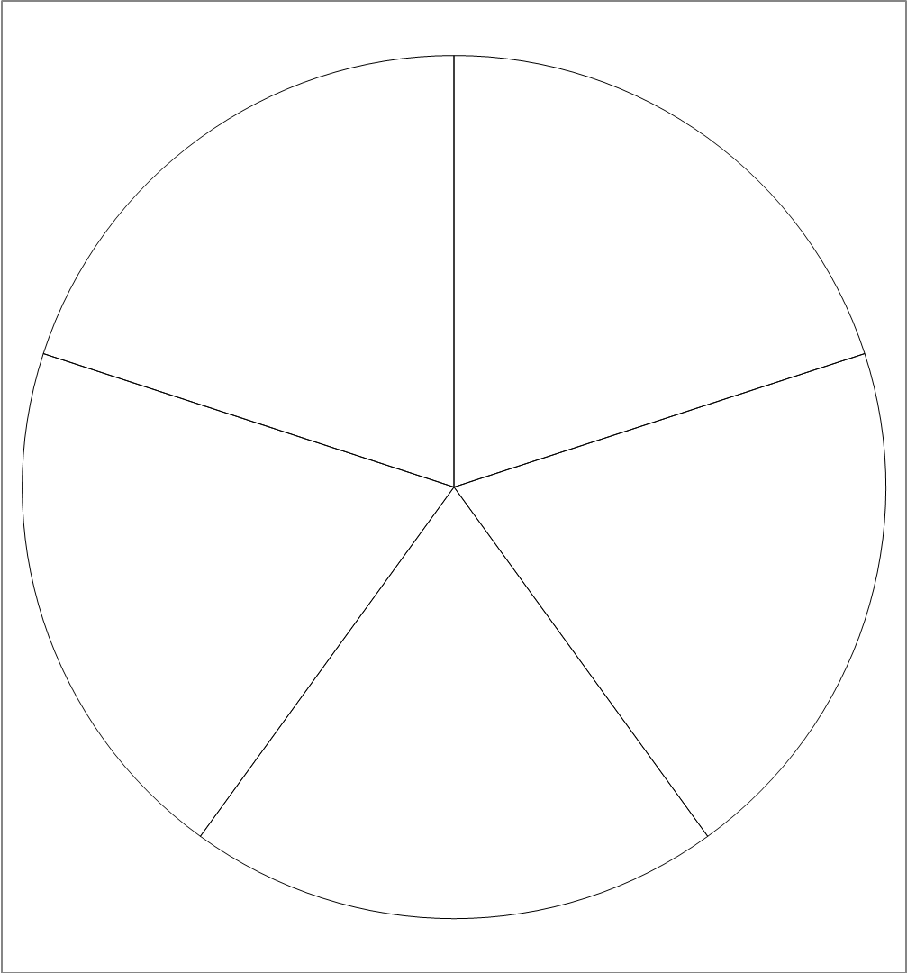

Level 1 Functional Mathematics - Fractions, decimals and percentages

Task 1
You have a meal including two sausages.
There is information on the sausage packet:
Content Per 2 sausages
Calories  265kcal | Fat  19.4g | Saturates  6.5g | Salt  2.0g | Sugars  0.1g

There is also information on healthy eating:
Guideline Daily Amounts
Calories 2000kcal
Sugars 90g
Fat 70g
Saturated fat 20g
Salt 6g

What fraction of the guideline daily amount for salt do your two sausages contain? Give your answer in its simplest form.
______________________________________________________________________
________________________________________________________________________
________________________________________________________________________
________________________________________________________________________

Task 2
A swimmer is beginning a training session of 40 lengths. To keep to the training schedule the swimmer needs to do 25% of the lengths as back-stroke. The rest of the lengths are divided equally between breast-stroke and crawl-stroke.

Calculate the number of breast-stroke lengths the swimmer needs to do.
________________________________________________________________________
________________________________________________________________________
________________________________________________________________________
________________________________________________________________________
________________________________________________________________________

Task 3
A trainee child-care assistant recorded the height of all the children in the group.
Name | Gender | Height in centimetres
Peter | m | 97
Joan | f | 98
Saliha | f | 92
Mateus | m | 89
Frances | f | 90
Lebo | f | 96
Samuel | m | 92
Lizzy | f | 89
Howard | m | 86

What fraction of the children have a height above 95 centimetres? Give your answer in its simplest form.
________________________________________________________________________
________________________________________________________________________
________________________________________________________________________
________________________________________________________________________
________________________________________________________________________
________________________________________________________________________

Task 4
A student keeps a record of the number of glasses of water he drank each day.
Day | Number of glasses of water
Monday
Tuesday
Wednesday
Thursday
Friday

Five glasses of water altogether contain 2 litres of water. What proportion of the days had more than 2 litres of water? Give your answer as a decimal.
________________________________________________________________________
________________________________________________________________________
________________________________________________________________________
________________________________________________________________________
________________________________________________________________________
________________________________________________________________________

Task 5
Weather | 6-day (Long Range) Weather Forecast for next week

Area | Monday | Tuesday | Wednesday | Thursday | Friday | Saturday
Alton Towers |   13°C | 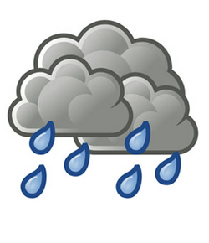  11°C | 13°C |   17°C | 19°C | 15°C
Chance of rain: | 0.6 | 0.8 | 0.5 | 0.4 | 0.3 | 0.5

_

A student prepared a chart to show the expenses for the first six weeks of attending a

college course. This included travel, food and study materials.

The ‘Chance of rain’ is given as a decimal in the weekly forecast. What is the percentage chance of rain for Tuesday?
________________________________________________________________________
________________________________________________________________________
________________________________________________________________________
________________________________________________________________________
________________________________________________________________________
________________________________________________________________________

Task 6
Two members of a running club recorded the times for a 1 mile run to see if they could complete the mile run in less than 5 minutes. They decided to record the times for each 1 mile run they did in the next six weeks.
They met at the end of the six weeks to compare results.

 | Proportion of 1 mile runs completed in less than 5 minutes
Member J | 84%
Member K | 7/8

Who had the highest proportion of the runs in less than 5 minutes?
________________________________________________________________________
________________________________________________________________________
________________________________________________________________________
________________________________________________________________________
________________________________________________________________________
________________________________________________________________________

