Lesson 9 | Study Module 5: Working with numbers and charts (1/3) | Time
Lesson objectives | In this lesson students are learning how to:  - select and apply appropriate formats  - carry out calculations with relative and absolute references
Learning outcomes | At the end of the lesson students will be able to:  - display numbers and text in appropriate formats  - enter formulas using (+, -, *, /)  - use functions SUM, AVERAGE, COUNT, MAX and MIN  - use absolute cell references
Specification coverage | L1: 2.1, 7.1, 8.1, 8.2  L2: 2.1, 6.1, 7.1, 7.2
Resources  Study Module 5  SAM Mark Scheme  Images:  L9.1-100-Display  L9.2-100-Display-Format  L9.3-100-DataEntry-Display-Format  L9.4-10x10-text-number  L9.5-10x10-results  L9.6-10x10-warning  L9.7-10x10-comment  Key vocabulary  Spreadsheet  Value  Formula | Starter  Tell students you have two puzzles for them.  Puzzle1:  Show them the image L9.1-100-Display.  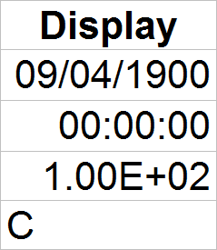  Ask students to tell you what was entered into the four cells and what format they have. If students struggle, show them the image L9.2-100-Display-Format and tell them that the same number was entered into all four cells.  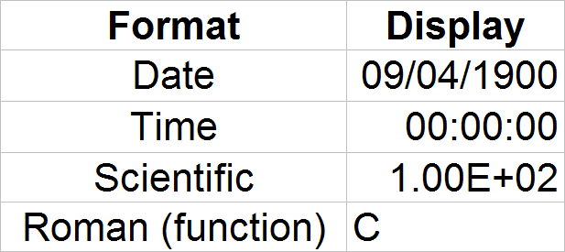  The Roman number “C” should give students a clue. What is the number behind the display? Show them the image L9.3-100-DataEntry-Display-Format.  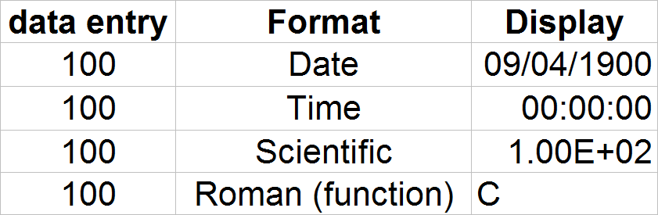 | 5 -10 mins
Key vocabulary  Function  SUM, MAX, MIN, AVERAGE, IF, COUNT, LOOKUP  Range  Cell reference  Relative  Absolute  View data  View formulas  Tab / Tabs | Puzzle 2:  ‘Spot the difference’. Show the image L9.4-10x10-text-number.  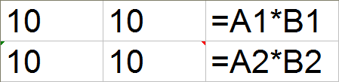  Ask students to predict the result for each line (10 x 10 = 100). Show them the image L9.5-10x10-results.  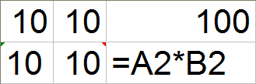  Can students explain why cell C1 displays the expected and correct result but C2 still shows the formula. Show image the L9.6-10x10-warning.  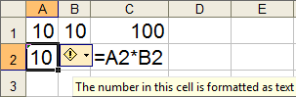  Explain that spreadsheets can treat numbers as text if (a) the cell is formatted to text, or (b) the user put a ‘ in front of the number, e.g. ‘100.  Show them the image L9.7-10x10-comment – point out the different colour (red) and location (top-right) of the marker to indicate a comment. Stress that comments do not impact in calculations or formatting.  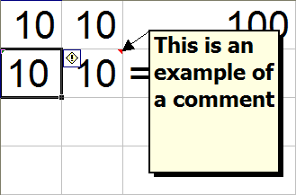  Conclude the starter by stressing that formatting matters.
 | Share lesson objectives  Introduce the lesson and share learning objectives and outcomes. | 5 mins
 | Formatting cells  Write the number 45.27 on the board. Ask students what formats they could apply. Use section Formatting cells on page 4 to illustrate some of the possible formats. Extend formatting of Number to Alignment, Font, Border and Patterns – students can explore Protection as part of their homework.  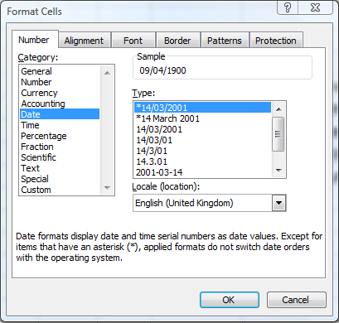 | 5 mins
 | Formulas and functions  Remind students of the formula used in puzzle 1 to multiply ten by ten (=A1*A2). Check that they know about + for additions, - for subtractions, / for divisions.  Tell them that spreadsheets have a range of ready-made formulas for users to choose from. Using them is (a) more efficient (saves time), and (b) reduces the risk of making mistakes when typing in a formula from scratch.  Illustrate the two points by asking students how often they would have to enter the + symbol to add togther the points of 100 members in the Loyalty Card Scheme. Explain that the Function SUM is much better as it adds up all points between the first and last member. The first and last cell set the range over which the function works.  Use the table on top of page 4 to introduce Functions AVERAGE, COUNT, MAX and MIN. | 15 mins
Ask students to open digital asset SB4.1.1, the Loyalty Card Scheme spreadsheet and demonstrate the use of the SUM function. Show them how they can switch between data-view and formula-view by using Ctrl + ` (to the left of the number key 1).
Ask students on which fields it would not make any sense to use the SUM function (all pure text fields, text-number fields like postcodes and number fields such as telephone numbers).
Tell students they need to find the number of entries, the total, average, highest and lowest entries in (a) the Points and then (b) in CashValue fields. Can they suggest a way so that they do not have to do the work twice? If students do not know how to copy a formula, give them a brief demonstration.
Extension: LOOKUP Function – see page 5
 | Relative and absolute cell references  Introduce Skill Builder 5.4 as a challenge to create a flexible times table. Tell students to work in pairs. When the first pair has used the $ sign for the necessary absolute reference, stop the class. Through discussion of this example ensure that students understand the difference between relative and absolute cell references and how they are entered into a spreadsheet.  Remind students of their work on the Loyalty Card Scheme spreadsheet earlier in the lesson. Ask them to describe the outcomes if they had used absolute cell references in the functions under Points and then copied the Function across to CashValue.  Tell students to continue with Skill Builder 5.4. | 20 mins
 | Plenary  Remind students of the learning objectives and recap on what they have learnt in this lesson.  Recap how students protected files in Lessons 2 and 3 and introduce the homework: | 5 mins
Homework | Ask students to:  - create a simple spreadsheet and find ways to protect it  - complete Skill Builder 5.2. | 40 mins
Extension
Tell students you have one piece of information about a member but need a second one. Introduce the LOOKUP function as an easy way to find linked information. Use the images as illustrations.
L9.8-LOOKUP
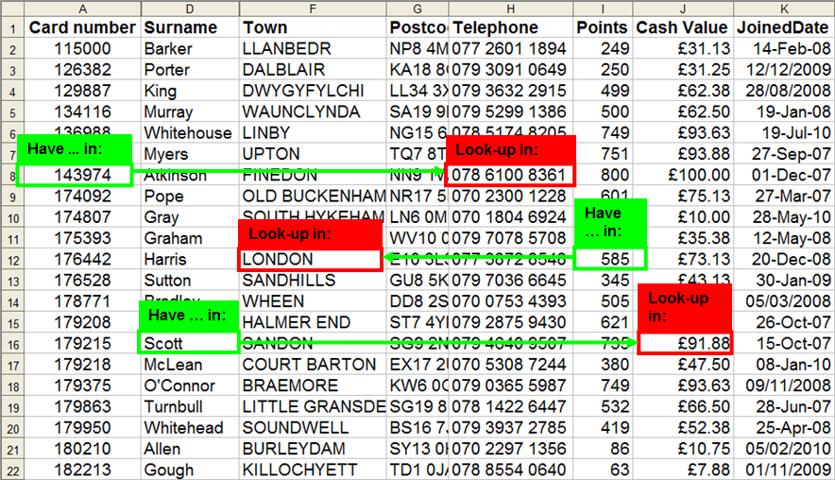
L9.9-LOOKUP-Function-Arguments
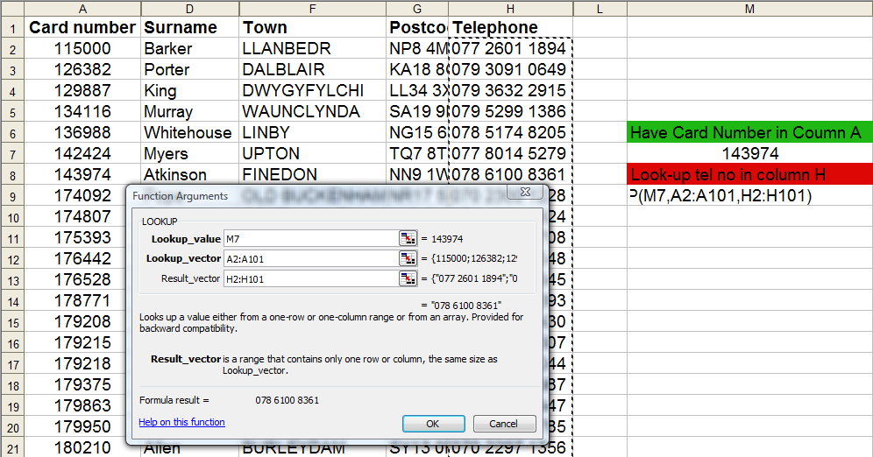
L9.10-LOOKUP-result
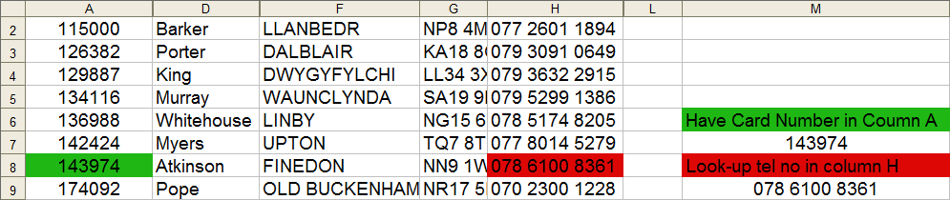
L9.11-LOOKUP-formula
