Lesson 6 | Study Module 4: Working with structured data (1/3) | Time
Lesson objectives | In this lesson students are learning how to:  - structure and present data in a table
Learning outcomes | At the end of the lesson students will be able to:  - build a data table  - enter meaningful field names  - work with different types of data  - format data  - sort data in different ways
Specification coverage | L1: 2.1, 5.1, 7.1, 8.3, 8.4  L2: 2.1, 4.1, 6.1, 7.3, 7.4
Resources  Study Module 4  SAM Mark Scheme  Key vocabulary  Table  Column  Row  Record  Field  Header row  Heading  Field name  Unique identifier  Sorting  Formatting  Header / Footer | Starter  Call the register. When you have finished, ask students to suggest three other ways of ordering everyone in the group. Ensure one is based numbers e.g. date of birth, UPN - unique pupil number on text.  Ask them to come up with combinations of criteria, such as all girls first, in age, name or UPN order, followed by boys in age name or UPN order. | 5 mins
 | Share lesson objectives  Introduce the lesson and share learning objective and outcomes. | 5 mins
 | Tables to structure data  Take time to introduce key terms for structured data. Make sure students fully understand them at the end of the lesson.  Show students the webpage http://www.bankofengland.co.uk/banknotes/current/index.htm and scroll down so that the £5 note is at the top of the screen with other notes showing underneath.  Ask students to tell you obvious features that differentiate UK bank notes.  Leaving space on the left for one other, write some of their features on one line on the board in capital letters. Include the following to ensure a mixture of data types and formatting options. | 15 mins
Start with DENOMINATION (data type: number; format: currency); 1st ISSUED (data type: number; format: date); SIZE (data type: number; format: number – option to calculate to area in square mm); PORTRAITS (data type: text; format: standard); COLOUR (data type: text; format: matching font colour).
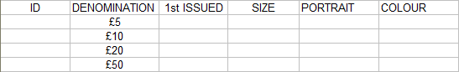
Ask students how many entries you can have under ‘denomination’. Write £5, £10, £20 and £50 underneath denomination.
Draw vertical and horizontal lines to highlight the structure of the display – do not use the word ‘grid’ but introduce the terms table, rows (one for the ‘headings’ in capital letters and one each for the four denominations, and columns (one for each feature).
Point out that, where rows and columns intersect, they create fields. Each one has a name (fieldname) which it gets from the column heading it is under.
With that information in place underneath DENOMINATIONS, ask students to tell you what to write, in small letters, under the other categories or call students out to fill in one row or column.
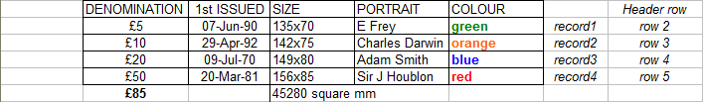
Explain that:
- a record is a set of data that belongs together, arranged on the same row. In this case there are four records, one per denomination
- there are different types of data which you can format to aid understanding
- you can carry out calculations with numbers, e.g. totalling-up of DENOMINATION (£85) and SIZE (45280 mm).
Show students webpage
http://www.bankofengland.co.uk/banknotes/about/stats.htm and zoom in on the table showing the stock of notes in circulation.
Ask students whether or not it is possible to uniquely identify each of the thousands of notes in circulation or stock – and if so, how.
The answer is yes: each bank note has a unique serial number. Extend the table to the left, add a new column and label it ID in the space on the left of the header line.
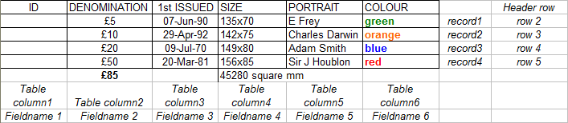
Ask students by how many rows the table would grow if you included the serial numbers as a bank note’s unique identifier. The answer is tens of thousands, too many to write manually on the board. Ask if they know a software application program that could handle that many records?
Stress that a table gives data a structure, however small or large the data set, and that once data is in a table it is much easier to work with it.
 | Which application software should I use?  Explain that both spreadsheets and database software can handle large amounts of structured data. State that they (the students) will use spreadsheets as they will handle single tables, not several tables at the same time (related tables).  Note:  You might want to point out that both spreadsheet-speak and table-speak use the terms header row and rows, columns, records – but the intersection of a row and column is called field in table-speak and cell in spreadsheet-speak.  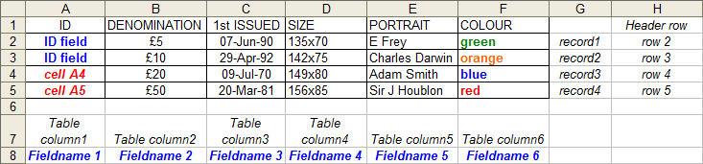 | 5 mins
Conclude by wiping off or deleting the table’s header row and ask students whether or not the remaining words on the board make as much sense as before.
Remind students of the importance of meaningful names for files and folders (Lesson 2). The same applies to fields.
 | Formatting data  File and folder names cannot be formatted but field names can. Tell students that field names – like headlines in a newspaper or magazine – should stand out and not be trancated. Ensure students know how to adjust the width of a column to show a long fieldname in full.  Use the example in Study Module 4, page 2 to illustrate the importance of meaningful and formatted names for fields.  Optimising presentation by hiding columns  The table on page 3 shows most of the data in the text lines above it. Ask students what happened to the missing data. If they do not mention hidden columns, explain that the data is there but hidden to get more important data into view. To prove your point, tell students to look at the same table on page 8: members’ address details have pushed loyalty scheme information off the screen.  Tell students to work in pairs to complete Skill Builder 4.1. When they have completed all tasks they should practise hiding und unhiding columns.  Wipe off or remove the display of the table for bank notes. | 10 mins
 | Sorting data  Remind students of the different ways of calling the register you discussed at the start of the lesson. Then ask them for an alternative way to arrange the four records for bank notes using their denomination (£50 - £5). Introduce the terms descending and ascending for numbers.  Ask students how the four records could be rearranged by using one of the text field names. Check they understand descending (A-Z) and ascending (Z-A) with letters.  Use the example in Study Module 4, Section B, Sorting data to illustrate sorting records in descending and ascending order (numbers and text).  Ask students to complete Skill Builders 4.2 and 4.3. | 15 mins
 | Plenary  Remind students of the learning objective and recap on what they have learnt in this and previous lessons.  As an aside, ask students what they thought of the website you used at the beginning of the lesson, how they would rate it. If they could not read the website address, tell them the web pages were from the Bank of England website.  Ask students to recall Lesson 4 and the rating criteria for websites they used (validity, accuracy and authority) – how would they rate the Bank of England and why? | 5 mins
 | Homework  - Design and create a five-column table for books, cars, or mobile phones.  - Devise a unique identifier and choose a meaningful name for it.  - Format the fieldnames in the header row so that they stand out and are easy to read.  - Create six records by entering data for six different items.  - Present the six records sorted in three different ways.  Note: consider giving Level 1 students a unique identifier, e.g. ISBN for books, serial number for mobile phones.  A table structure for holding details of cars might have these fields: Registration number, Make, Model, Engine size, Fuel (diesel/petrol) | 20 mins

