Lesson 5 | Study Module 3: Finding and selecting information (2/2) | Time
Lesson objective | In this lesson students are learning how to:  - manage and acknowledge information selected for use in own work
Learning outcomes | At the end of the lesson students will be able to:  - save information appropriately  - acknowledge sources and information they use  - evidence how they manage information saved from the internet
Specification coverage | L1: 2.1, 5.1, 6.1  L2: 2.1, 4.1, 5.1, 5.2
Resources  Study Module 3  SAM Mark Scheme  Images:  L4.8-Copyright-not-right-to-copy  L5.1-Copyright-protected  L5.2-Task1-Task3  Key vocabulary  Copyright  Plagarism | Starter  Show the image L4.8-Copyright-not-right-to-copy which concluded the previous lesson.  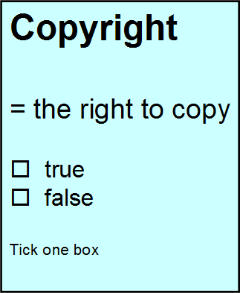  Invite students to summarise what they have found out, what search criteria they used, what websites they judged to be best.  Conclude the starter summarising that copyright is not a right to copy or show students image L5.1-Copyright-protected.  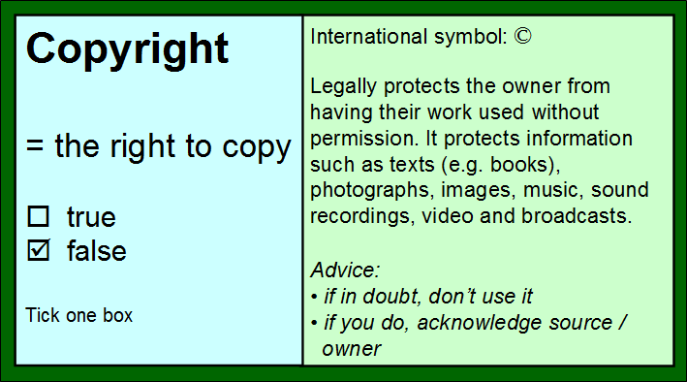 | 5 mins
 | Share lesson objectives  Introduce the lesson and share learning objective and outcomes. | 5 mins
 | Test Tips  Ask students how much time they spend on the internet every day. Then tell them that in the test they have access to the internet for just 15 minutes or 12.5% of the 2-hour paper, that it is one block of time, right at the start of the test.  Stress that it is not just the marks for Task 1 that depend on how well they do in the first 15 minutes. They will need the information they find, select and save in Task 1 when they are doing Task 3 – without access to the internet.  And, by the way, the first 15 minutes includes time for reading through all the tasks because – as they learnt in the previous lesson - they must establish the information requirements, audience and purpose before they can search, select and save appropriate information.  Show students image L5.2-Task1-Task3 to illustrate that some marks available in Task 3 depend on successful completion of Task 1 in the first 15 minutes of the test.  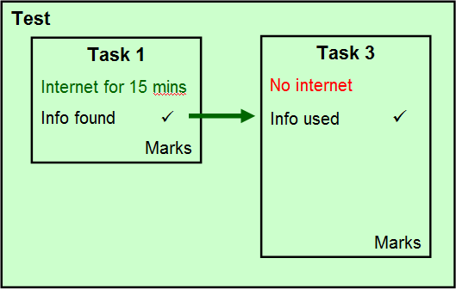 | 10 mins
 | Managing selected information for future use  Tell students that they have just 15 minutes on the internet to practice searching for and selecting information, then saving and pasting it into a new document.  Before you ‘start the clock’, remind students what they learnt as good and efficient practice in previous lessons:  - Is the website reliable (apply evaluation criteria from previous lesson) | 20 mins
 | Managing selected information for future use (continued)  - Where and how do I record the sources I selected? (it is best to copy the URL directly from the address browser window and paste into a text document with a date)  - How can I save the information I have found? (lessons on managing data, e.g. appropriate folder structure, meaningful file names / file types, accessible storage area – not the internet!)  - How long will it take to download it? (if the speed is slow, what do I do while I am waiting?)  - Is the information in a format that I can work with? Do I have the necessary software?  - How much editing do I have to do? How long will it take?  Agree with students a theme for a picture search. Ask them to complete Skill Builder 3.5 and tell them to start their picture search on the website creativecommons.org. | 20 mins
 | Evidencing management of saved information When the time is up, ask students to take screenshots of the folder(s) and files they have created, paste the screenshots into a new document and save it. Who can do this in the shortest time?  Tell students that, in future lessons, they will have to take many more screen shots and save them with their name, date and other information in the footer. What can they do to avoid repetitive typing and save themselves time? Answer: create and save a personalised screenshot template. | 10 mins
 | Plenary  Remind students of the learning objective and recap on what they have learnt in this and the previous lesson.  - It is not enough to find just any information, they must select information that is fit for purpose and audience and comes from a trustworthy source.  - They must record and acknowledge their sources of information, and  - For the test, they must be able to show with a screenshot how they have managed the information selected for easy retrieval and use (files, folders, storage – and entries in Favourites / Bookmarks).  Alternatively, use Tips for finding reliable information on the internet (page 9, Study Module 3).  Remind students what skills they need by going through the Skill Check (page 10, Module 3).  Introduce the homework task by stressing time constraints in the test. | 10 mins
Homework | Time trial: 20 minutes  Challenge students to:  - find and select appropriate information from the internet, and save it efficiently  - paste one picture and one paragraph of text into a new document and save it  - produce evidence of their searches (!), sources, folders and files in a separate document and save it (no print-outs!)  - write down source(s) used.  Topic: plagiarism  Requirement  - to acknowledge other people’s work  Purpose  - to avoid being penalised for ‘plagiarism’  Audience  - Key Stage 4 students | 20 mins

