Lesson 4 | Study Module 3: Finding and selecting information (1/2) | Time
Lesson objective | In this lesson students are learning how to:  - find and select reliable information appropriate for purpose and audience
Learning outcomes | At the end of the lesson students will be able to:  - identify the information requirements and audience of a task  - construct efficient searches  - evaluate websites
Specification coverage | L1: 2.1, 5.1, 6.1  L2: 2.1, 4.1, 5.1, 5.2
Resources  Study Module 3  SAM Mark scheme  Images:  L4.1-Road-layout  L4.2-Real-road-junction  L4.3-Rail-crossing-audio  L4.4-Give-Way-text  L4.5-Give-Way-sign  L4.6-Lesson4-Objectives  L4.7-Fit-for-purpose  L4.8-Copyright-not-right-to-copy  Key vocabulary  Information requirement  Fir for purpose and audience  Browser  Search engine  Search criteria  Evaluation  Validity  Accuracy  Authority  Copyright | Starter  Note: this Starter is longer than most others. It covers this lesson and the next.  Show student the image L4.1-Road-layout.  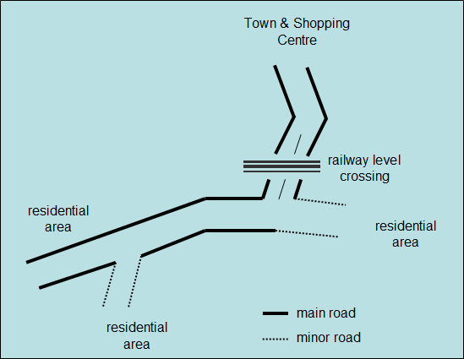  Ask them what information is needed to avoid accidents on the three roads shown. Tell students to work in pairs and give them three minutes to identify what information is needed and where.  Introduce the feedback session by limiting responses to just one piece of information per pair. Tell students they need to say who the information is for. Ask several pairs – no repeats allowed. | 15 mins
Starter (continued)
Conclude by showing students the image L4.2-Real-Road-Junction (looking east towards the level crossing)
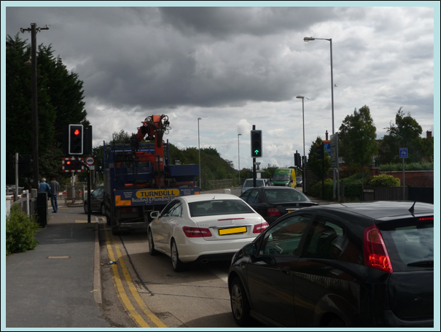
If students did not include information provided by sound, show them the image L4.3-Rail-crossing-audio, the flashing lights are accompanied by sound.
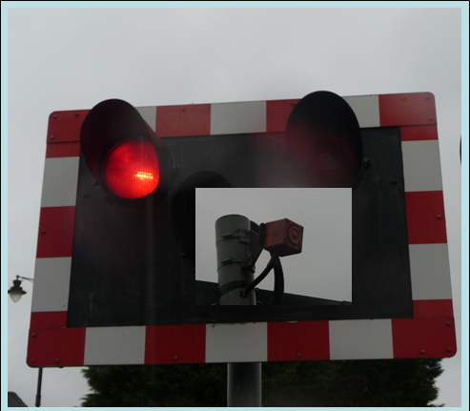
Tell students that you will show them a photo taken from one of the minor road. Show them the image L4.4-Give-Way-text.
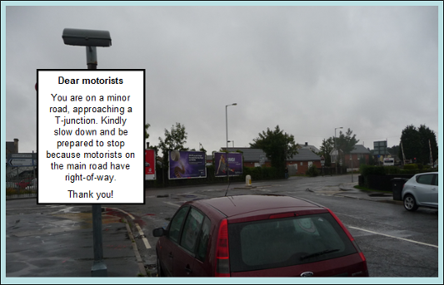

Starter (continued)
Ask them if such a text sign is appropriate – if not, why not? (Text is not fit for purpose as it takes motorists too long to read, style inappropriate). Show them image L4.5-Give-Way-sign. Why is this fit for purpose?
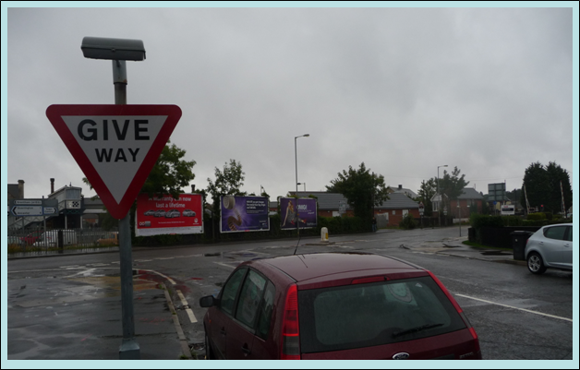
Briefly draw attention to the bill boards in the background. Ask students for key features of bill board posters.
 | Share lesson objectives  Introduce the lesson objectives by recapping the scenario at the start of the lesson. Show them the image L4-6-Lesson4-Objectives.  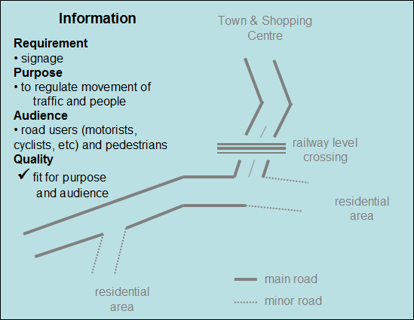  Stress that - before they start to look for information - they need to understand what is required and ensure that they select only information that is fit for purpose and audience.  Conclude that in this lesson and the next they will learn to find information on the internet, select only what is appropriate and save it - and apply what they learnt about files, folders and storage in the previous two lessons. | 5 mins
 | Browsers and search engines  Check that students understand the difference between  - a browser (to view and navigate pages on the world-wide-web), and  - a search engine (a program that looks through databases of web pages to find those that match state criteria).  Ask students in which of the two (browser or search engine) you would expect to find bookmarks or favourites. Check understanding by asking one student to explain how each helps users.  Switch from browsers to search engines and ask students what text they would enter into a search engine to find pages on road safety. Explain that detailed searches are more efficient as they produce more relevant hits and reduce the likelihood of having to cope with information overload.  Steer the conversation towards narrowing down a search by adding search criteria such as a particular group, e.g. children.  Show students how they can use operators to narrow down searches, e.g. AND, OR, NOT, = , <, >, <=, =<.  Stress that finding hundreds of text documents on road safety is of no use when you need an image.  Show students the advanced search facility of the browser and encourage them to use it.  Note:  Each browser has its own advanced search interface – they have in common that they enable users to enter combinations of search criteria, e.g. target audience or sub-section, e.g. schools, educational, file type, e.g. .ppt, .pdf, language, e.g. in English or Welsh, and/or a specific website, e.g. http://www.ipo.gov.uk , the Intellectual Property Office, http://www.licensing-copyright.org/  Demonstrate that they get information overload with just using ‘road safety’ – and progressively more manageable returns or hits when narrowing the search by adding criteria such as children or specifying a particular file type or website e.g. www.dft.gov.uk) | 15 mins
Check that students remember from Lesson 2 how to take a screenshot and paste it into a document.
Ask students to work in pairs to complete Skill Builder 3.1 and then search for a leisure park called Smarts Leisure. Tell them to find out three facts about this particular leisure park – they must not talk to other pairs or compare answers whilst they are searching.
http://www.smartsleisure.co.uk/
 | Evaluating websites  Briefly talk about Skill Builder 3.1, then focus on Smarts Leisure.  Use a show of hands to establish who found one fact, two and then three facts.  If students have not discovered it themselves, there is only one fact about Smarts Leisure: it is fictional - it exists only as a website! It was created for Edexcel and is used by learners studying Edexcel’s ICT qualifications. It says so on the page “What is smarts?” (http://www.smartsleisure.co.uk/pages/whatissmarts.htm)  Tell students that over the years the website existed, many tourists actually tried to book holidays at Smarts Leisure and were looking for it on maps!  Use Smarts Leisure to lead into a brief discussion about the reliability of websites. Introduce ‘validity’, ‘accuracy’ and ‘authority’ as criteria for evaluating websites.  As a whole class exercise complete Skill Builder 3.3.  Tell students that Ofqual, the Exams watchdog, has advised pupils in England not to rely on Wikipedia as a research tool for their coursework. It warned them that information on Wikipedia may not “be authoritative and accurate" and, in some, cases could be "completely untrue". It said that search engines such as Google and Yahoo are excellent sources of information because they pool material from lots of different sources.  Ask students to work in pairs or small groups to complete Skill Builder 3.4. You can vary this exercise by agreeing a small number of websites for all to evaluate, and compare results as a class. Allow 5 minutes for discussion of the scores. | 15 mins
 | Staying safe whilst on the internet  Remind students of the risks to folders and files you discussed in the previous lesson. Continue the theme ‘minimising risks’, by talking briefly about spyware (Did you know, page 9, Study Module 3) and the points in Tips for staying safe online (page 9, Study Module 3) | 5 mins
 | Plenary  Show students the image L4.7-Fit-for-purpose.  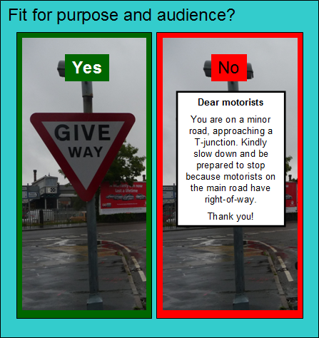  Remind students of the learning objective and recap on what they have learnt in this lesson.  Lead into the homework by showing them the image L4.8-Copyright-not-right-to-copy or asking students: Copyright means the right to copy – true or false?  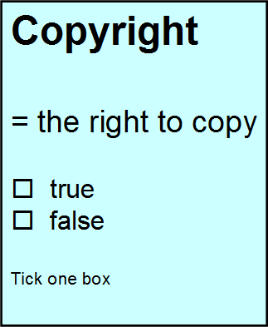 | 5 mins
Homework | Ask students to:  - complete Skill Builder 3.2, and to add the sites they use to their evaluation table.  - Find out more about copyright. | 40 mins

