Lesson 3 | Study Module 2: Managing Information (2/2) | Time
Lesson objectives | In this lesson students are learning how to:  - manage storage areas  - work safely and securely
Learning outcomes | At the end of the lesson students will be able to:  - select appropriate storage areas  - check available free storage space  - compress files into a folder  - take action against loss of information in files and folders
Specification coverage | L1: 3.1, 4.1, 4.2  L2: 3.1, 5.2
Resources  Study Module 3  A memory stick  Images:  L3.1-Storage-outdoor-indoor  L3.2-Storage-different-kinds  L3.3-Storage-full  L3.4-Storage-uncompressed  L3.5-Storage-compressed  L3.6- Storage-external-insecure-  Key vocabulary  Digital storage  Storage media  Storage capacity  Files  Folders  Zipped-folders  Extract files  Computer virus  Back-up | Starter  Show students the image L3.1-Storage-outdoor-indoor, a garden shed and part of a kitchen.  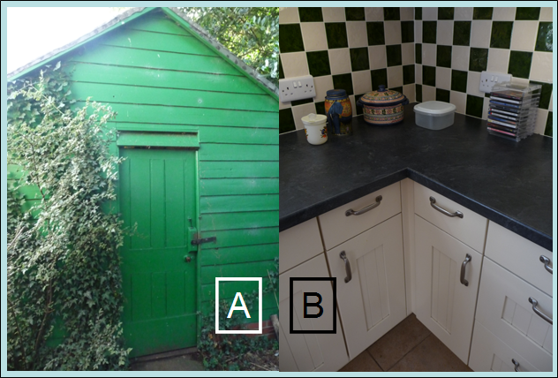  Refer to the garden shed as ‘external’ to the house (preparing students for the concept of external digital storage locations). Do not spend time on what people store in sheds, instead ask why there are different sized drawers in kitchen units and various storage containers on the kitchen worktop  Show them the image L3.2-Storage-different-kinds.  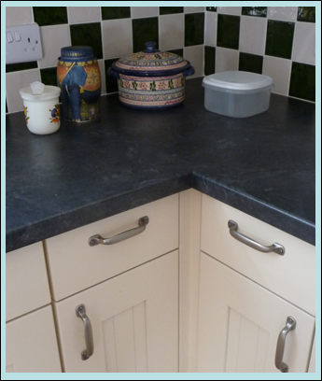. | 5 mins
Starter (continued)
Conclude by saying that having different sized and shaped storage areas enables users to put things into locations that are convenient to reach (on worktop / in top / bottom drawer,), the right size (drawers / jars), and right kind (fixed cupboards, portable loose-lid / air-tight jars).
 | Share lesson objectives  Introduce the lesson and share learning objectives and outcomes. | 5 mins
 | Storage areas for files and folders  Ask students to describe where they stored the files used in the previous lesson, then to give alternative storage areas.  List storage areas under three heading: ‘onboard’ (inside the computer itself), ‘in-house’ (network server), external/portable (internet, memory stick, CD/DVD).  Through discussion, cover advantages and disadvantages of storage areas. When talking about storage include size and cost but do not use absolute numbers – instead use symbols for comparisons: = equal, < lower/less than, > bigger/more than and combinations, e.g. <= lower or equal to. Note: Students will use these as search operators in Lesson 4.  Ask students to work in pairs / small groups to choose the most suitable storage media for the five scenarios given in Skill Builder 2.5; after 3-5 minutes compare answers through show of hands. | 10 mins
 | Managing storage  Show students the image L3.3-Storage-full.  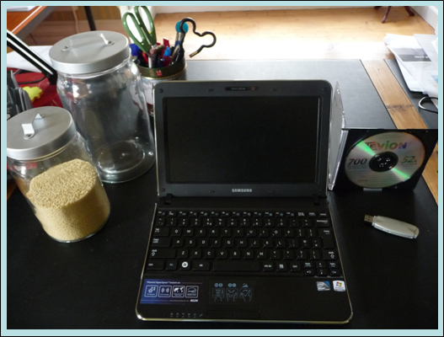  It is obvious if a glass jar is empty, full or how much room is left in it - but how about digital storage areas such as the hard drive, optical disk or memory stick? | 5 mins
Managing storage (continued)
Demonstrate to students how to find out how much space is left on a drive or memory stick by looking at its properties, then ask students to find out how much storage space they have left (network area or hard drive).
Use a show of hands to find out who in the class has most and who has least storage left.
Conclude this session with questions about consequences:
What if I run out of storage …
- out of school
- in a lesson?
- in a/the test?
 | Zipped folders  Show image L3.4-Storage-uncompressed.    Pick up the homework-challenge to find a way to use up less space when storing jumpers.  Ask for a show of hands: who has found a solution? Ask three students how they would do it and with which other household items their solution does not work and why.  Lead into the next session by showing them ‘your solution’. | 10 mins
Show them image L3.5-Storage-compressed.
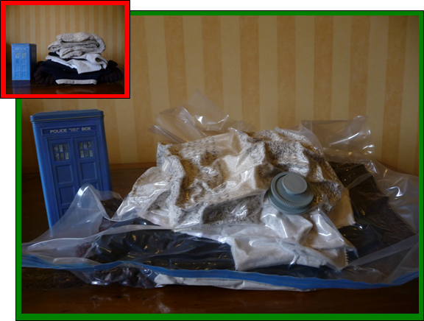
Explain that the jumpers now take up less space because
- they are in a bag, and
- you have removed the unwanted air inside the bag with a vacuum cleaner.
Introduce the terms ‘compressed’ and ‘compression’ – there are different technique but, in essence, they are all ‘space savers’.
Tell students that, in ICT terms
- the jumpers are files
- the vacuum-bag a special folder called ‘zipped folder’ (the clothes-bag has a blue zip)
- zipping-up reduces certain kinds of files more than others.
Ask students about retrieving a jumper (no direct access to it). Then tell them that just as you have to open the vacuum-bag to get a jumper, you cannot get directly to files in a zipped-up folder, you need to ‘extract’ them before you can use them. A standard folder is like a shelf with direct access to all on it.
Demonstrate how to
- create a zip-folder
- extract files from a zipped folder.
 | Minimising risks to files and folders  Using the pie chart on page 11 discuss briefly the main reasons why people lose work, then focus on computer viruses.  Ask the class for reasons why a medical term is used. Through Q&A cover:  - the way a virus is transmitted (from one person / computer to another)  - impact (by the time you notice you/your computer has a virus it is too late)  - ongoing mutations (new strains / versions)  - ways to avoid viruses (avoid contact with infected people / computers, do something to strengthen your defences)  Stress that antibiotics do not work with medical viruses but antivirus software does with computer viruses (at least the known ones).  Introduce the next session by saying that one way of guarding against loss of files and folders, for whatever reason, is to keep a second copy of them. Introduce the concepts of backing-up and disaster recovery. | 10 mins
 | Backing up files and folders  Tell students that making a copy of files is called ‘backing up’. Ask them for the best location of a backup of the files they used in the previous lesson.  Revisit the three categories ‘onboard’ (inside the computer itself), ‘in-house’ (network server), external/portable (internet, memory stick, CD/DVD). This time, consider retrieval: how easy is to get files and folders back? Are students as owners in full control or did they give somebody else rights over their files, including rights to access, use and delete? | 5 mins
Show students the image L3.5-Storage-external-insecure, a photo of the unlocked garden shed.
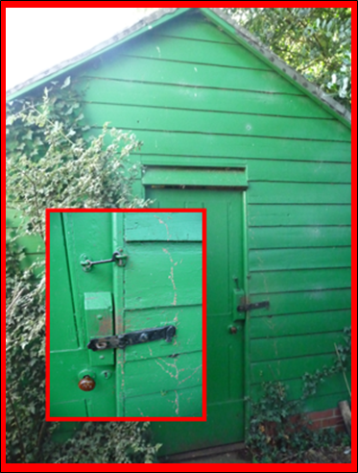
Stress that back-ups in external locations need to be secure. Refer to the homework task and ask students for the strongest password they created.
Sum up the session by going through the Tips for managing information storage on page 11.
 | Plenary  Remind students of the learning objectives and what they have learnt in this and the previous lesson.  Sum up both by going through the Skill Check (page 13, Study Module 2), stressing that they gain marks if they can demonstrate these skills in the test.  Conclude that the test is not all about ‘demonstrating’ but can include questions requiring short written answers – hence the first part of their homework: | 10 mins
Homework | Ask students to  (1) time themselves to find out how long it takes them to write brief statements about:  - two features of strong passwords  - reasons to make a file read-only  - the need to have back-ups.  (2) complete Skill Builder 2.7.  (3) complete Skill Builder 2.2 (zipping-up files) on school network or outside school. | 60 mins

