Lesson 2 | Study Module 2: Managing Information (1/2) | Time
Lesson objective | In this lesson students are learning how to:  - manage information storage
Learning outcomes | At the end of the lesson students will be able to:  - create and work with files and folders  - build appropriate folder structures  - control access to files
Specification coverage  Resources  Study Module 2  SAM Mark Scheme  Images:  L2.1-Filing-systems  L2.2-Files-in-folders  L2.3-File-security  L2.4-Mark-Scheme-Lesson2  L2.5-Storage-uncompressed  Key vocabulary  Files  File name  File extension  File types  Permissions  Folder  Sub-folder  Directory  Security  Read-only  Password  Secure | L1: 3.1, 4.1 – 4.2  L2: 3.1, 5.2
 | Starter  Show students the image L2.1-Filing-systems.  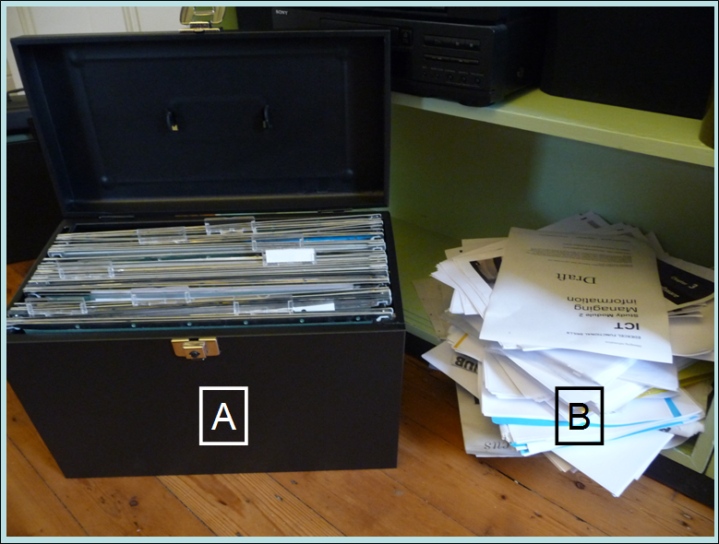  Tell students they need to find an important document quickly. Ask them where they would rather look for it (A or B) and why.  Show them the close-up image L2.2-Files-in-folders.  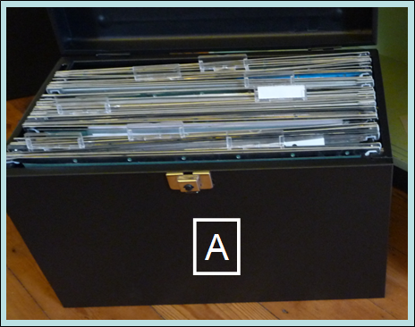  Ask what improvement could be made (labels on the suspension files). Tell students that for paper and electronic documents they need a naming and storage/retrieval system that works for them. | 5 mins
 | Share lesson objectives  Introduce the lesson and share learning objective and outcomes. | 5 mins
 | File names, types and sizes  Ask five students in turn to give a file name that they have used in the past.  - If students do not include the file extension, ask others whether or not their fellow student has given them the full file name or only part of it.  - If students include the extension, ask others if they know what software application was used to create the file.  Note: Alternatively, write five file names on the board, e.g.  - Doc1.doc  - Essay v5 due-5Sept10.doc  - Poster SB7-9 v1.pub  - table.xls  - my-times-table final.xls  Summarise that a filename has two parts: the first given by the user, the second by the application software. Ask students what makes a filename meaningful to them – and others.  Introduce the hands-on activity with questions to which the students need to find the answers:  - How meaningful are your filenames?  - Can you always tell which application software has created a file?  - Is the file extension fixed by the application software or does the user have a choice?  - Can you use exactly the same filename more than once?  Working in pairs students (a) carry out peer-assessment on how meaningful each other’s file names are (5 spot-checks on files saved in their own user areas) and (b) complete Skill Builder 2.1. Conclude this hands-on session by asking students for the answers to your four questions (above). | 15 mins
 | Keeping control of information and files  Show students the image L2.3-File-security.  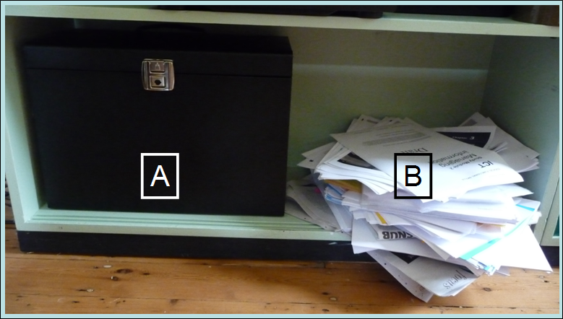  Ask them which one is more secure, A or B, then how the protection of documents in A could be strengthened.  Tell students that they need to consider security options for:  (1) information in files:  - making them read-only  - setting permissions to limit what others can do with their files (read, write, edit)  (2) files themselves  - setting a password to prevent others from opening a file.  Demonstrate how to save a file so that it is:  - read-only  - password-protected.  Focus on making a file read-only.  Discuss with students what combination of characters makes a strong password (mixture of at least 8 upper- and lower-case letters and numbers). Give students the tip to think of a short phrase that means something to them and use the first letter of each word to make a password: My brother James is 8 years old on 5 April = MbJ8yoo5A.  Tell students that in the next hands-on activity, they will find out what happens when they try to open a password-protected file - but they should not waste time trying to guess the password.  Ask students to complete Skill Builder 2.3. | 15 mins
 | Folders structures and files sizes  Introduce the section on folder names and structures with digital asset SB2.4.1 (Skill Builder 2.4). Ask students if the folder names are meaningful to them – and if not, how they could be improved.  Demonstrate yourself or ask a student to show the class how to create and delete a folder and a subfolder, using the folder names in digital asset SB2.4.1.  Ask students to complete Skill Builder 2.5 and to make one file read-only.  At the end of the session ask students if the folder structure was appropriate for a holiday and invite suggestions for additional folders.  Conclude the session by asking students which file in the Holiday folder is the largest, which is the smallest. Do they think file size matters? If so, why? What can they do about file sizes? Tell them you will talk more about file size in the next lesson. | 15 mins
 | Plenary  Show students image L2.4-Mark-Scheme-Lesson2.  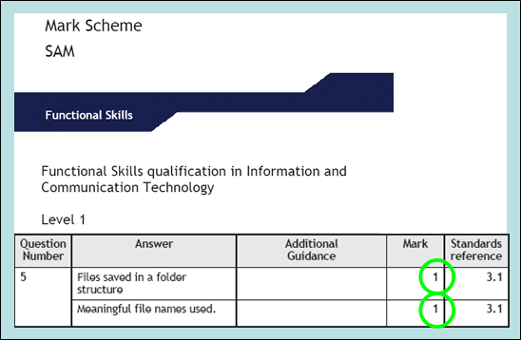  Remind students of the learning objective and recap on what they have learnt in this lesson: using meaningful files and folder names, creating appropriate folder structures and knowing how to control access to files is good and efficient practice – and gains them marks in the test.  Explain to students that in the test they need to produce print-outs showing the folders and files they created. Demonstrate or ask a student to show the class how to capture a folder structure and files in a folder using PrintScreen (Prt Sc), and refer student to the Tip on page 8 of Study Module 2. | 5 mins
Homework | Conclude by showing them image L2.5-Storage–uncompressed.    - Challenge students to find a way of reducing the space needed for storing a pile of jumpers without taking any out, and to name three other household items with which their solution would also work, three with which it would not.  - Ask them to compose 5 different strong passwords, find a website that lets you test the strength of passwords and see how good they really are. | 40 mins

