Double  Lesson  19-20 | Study Module 7: Combining and  presenting information: presentation | Time
Note | Two 60-minute lessons are allocated for the activities in this block. Please adjust overall- and section-specific timings to reflect the needs and skill levels of your students.  Before the first lesson, check the Recap Appendix at the end of this lesson plan and customise it for your students.
Lesson objectives | In this lesson students are learning how to:  - plan and carry out the production of a screen-based publication  - apply a mark scheme
Learning outcomes | At the end of the lesson students will be able to:  - optimise computer settings and interface features for the task in-hand  - manage the storage of information needed for a publication  - select and combine appropriate types of information  - select slide designs and layouts that are fit for purpose and audience  - select and use appropriate language and formatting  - apply suitable actions, animations and transitions  - review own work and ways of working  - check for accuracy, meaning and fitness for purpose  - minimise risks of losing the publication  - use a mark scheme to assess own and somebody else’s work  - draw up a personal improvement plan  time permitting  - give a presentation
Specification coverage | L1: 1.1, 2.1, 10.1, 10.2, 11.1  L2: 1.1, 2.1, 9.1, 9.2, 10.1
Resources  Study Module 7  SAM and Mark Scheme  Images:  L19.1-5slides  L18.3-Bear1-for-your-text  L18.4-Bear2-for-your-text  L18.5-Bear3-for-your-text  L18.6-group-of-bears  L18.7-2bears-standing  L18.8-2bears-sitting1  L18.9-2bears-sitting2  L18.10-bear1  L18.11-bear2  L18.12-bear3  L18.13-bear4 | Starter  Show students the image L19.1-5slides or display a similar image with your presentation software.  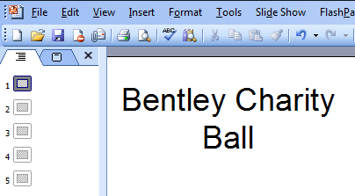  Explain to students that their task is to plan, produce and mark a screen-based presentation for councillors - topic: the Bentley Charity Ball.  If time permits, some will give their presentation to the group representing the councillors.  Which software application should I use?  The question is, in this case, easier to answer, as Skill Builder 7.9 states specific requirements, including five slides.  Share lesson objectives  Introduce the lesson and share learning objectives and outcomes. Consider mentioning that students will draw up a personal action plan at the end of the second lesson. | 5-10 mins
 | Creating a publication  Write on the board (in the same way as in Lesson 17):  (1) understanding requirements  (2) planning, then doing  (3) reviewing, checking and improving  Tell students that – before they start work - they will, as a group, briefly check key points in relation to this specific presentation. | 5 mins
 | (1) Understanding requirements  Ask students to recall the requirements for the presentation.  Remind them: reduce the risk of getting it wrong by checking the instructions, do not rely solely on what you think you remember from first reading them!  Explain to students that they do not have to work with numbers to create a chart – this has been done for them. Graphs are provided but it is up to them to select the most appropriate.  Ask students how many graphs are provided and how many of those show the break-even point. Spoilt for choice? Remind them to rank the graphs, at least mentally.  Remind students of the image bank for their posters and inform them it is available for their presentation.  Same event – different audience  Ask students how the target audience for the presentation differs from the target audience for the poster. What does that mean for their use of language, style, colour, etc?  Move from language fit-for-councillors to other aspects of planning and getting ready to produce a publication.  Tell students that – as with the printed poster - you play the role of the event organisers: if students have questions, they should address them to you in class. | 5-10 mins
Key vocabulary  Presentation  Master slide  Slide  Slide design  Slide Layout  Background  Slide sorter  Hide slide  Speaker notes  Slideshow  Slide Transition  Action buttons  Timings  Animation  Custom animation  Printouts  Handouts  Notes ages  Outline view | 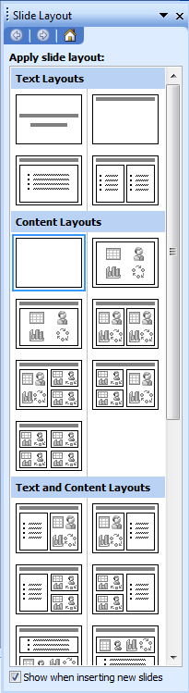  (2) Planning  Ask students what slide layout is fit for this particular purpose and audience?  Show students the choice of ready-made slide-layouts or show them image L19.2-Slides-Layout or a similar display in the presentation software. Ask students which category is most appropriate for the task in-hand. Before they answer, point out that there are even more, e.g. Other Layouts. As the requirements specify text, e.g. details about the organiser and the taxi firm’s offer, and content (meaning images), e.g. a graph, students should not opt for text-only or content-only layouts.  Remind students of the criteria they used when looking at newsletters and posters. The same questions apply to this presentation. There are many aspects to consider, e.g. writing style (key words NOT full sentences), selecting and formatting text and images, use of colours, text styles, etc.  Given the time limits, advise students not to be over-ambitious but to keep there presentation appropriately straight forward. Spending some minutes to map out the presentation first will help them to structure their presentation and fit all required information on five slides. | 5-10 mins
 | Before moving on, remind students that optimising system settings and interface features is part of planning and getting ready.  Note: If students work on their presentation over two lessons:  - conclude Lesson 19 (Plenary) by encouraging students to revisit their Action Plan (homework task, Lesson 18) before they start today’s homework: which of their actions will help them with the new task?  - use section (3) as the Starter of Lesson 20 | 5-10 mins
(3) Reviewing, checking and improving
Remind students that in their planning they need to allow quality time for all three.
Encourage students to quietly recall personal lessons learnt from making the poster and marking it. Do they feel they need to improve on (a) how and (b) when to review and check their work? If so, how?
Did they have sufficient time to make improvements to their work, especially at the end? If not, how can they improve their time-keeping? Can they use the computer?
 | Presentation software  Use the terms in the Key Vocabulary for this lesson to remind students of important tools and features and how to use them. | 5 mins
Optional: recap Study Modules 1 – 7
If students need or will benefit from recaps of earlier Study Modules, then use the sections under Planning in the double lesson 18 & 19.
 | Creating the Bentley Charity Ball presentation to councillors  Write on the board:  Functional Skill ICT  Evidence needed at end:  1. Final or latest version of presentation file saved as read-only  2. Screenshot of folder structure with file names and file types in a text document with, in the footer,  - candidate name  - candidate number (if allocated else made up)  - centre number (if known else made up)  Set a time limit that will challenge your students.  Advise them that you will warn them when they have just five minutes of working time left. | 20-30 mins
 | 5-minutes warning  Announce that students have just 5 minutes left. When the five minutes are over, call stop. If you see students using the keyboard or mouse after you have called stop, explain to them that if they did this in the test they would be in breach of examination conditions – not worth the risk, the harshest sanction would be disqualification. | 5 mins
 | Applying the mark scheme  Show students the image L19.3-Mark-Scheme-Categories.  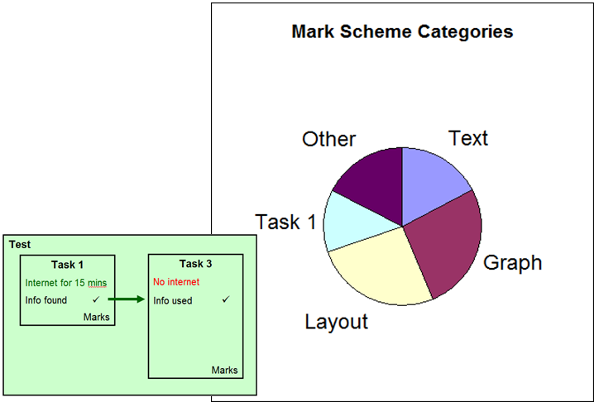  Remind them that some marks available in Task 3 depend on the successful completion of Task 1 during the first 15 minutes of the test: finding, selecting and saving information from the internet, and then inserting it appropriately into a publication (Task 3). | 5 mins
 | Assessing own and a partners presentation  Hand out print-outs of the document L19-Mark-Scheme-presentation or ask students to open it.  Give students time to read all entries under the heading Answers.  Pair-up students. (Depending on the group it might be better not to have the same pairs as for the printed poster.)  Self-assessment  Ask students to honestly assess their own presentation and enter the marks they award themselves in the Own Marks column.  Peer-assessment  Ask students to exchange mark sheets, fairly assess their partner’s presentation and enter marks they award in the Peer Marks column.  Ask students to compare and discuss their decisions.  Feed-back on assessments  Ask students for feed-back. Use a show of hands to establish how many pairs agreed  - 80% - 100 %  - 60% - 79%  - 40% - 59%  - 39% or less?  Note: adjust the boundaries to reflect the group’s skill level.  Conclude this section by summarising key lessons and introducing the next section. | 10 mins
 | Personal improvement plan  Ask students to identify weaknesses (a) in their work, and (b) their ways of working, from understanding of requirements to saving the final version. Ask them to draw up a personal improvement plan with targets and time scales. | 5-10 mins
Optional and time permitting:
Ask students to give their presentation to a group (role-playing the councillors) –ideally using a data projector and big screen.
 | Plenary  Remind students of the learning objectives and learning outcomes of the double lesson. | 5-10 mins
Homework  Lesson 19 | Ask students to:  - revisit the Skill Check on page 13  - plan and start work on the digital poster as specified in Skill Builder 7.9  - keep a log of:  - time spent  - things found easy to do  - things found difficult to do  - actions for improvement plan. | 30 mins
Homework  Lesson 20 | Ask students to:  - Improve their presentation, save it under a new file name, and remark it themselves  - Draw up an personal improvement plan from lessons learnt creating and marking the presentation covering:  a. the quality and effectiveness of what they produce, e.g. the poster  b. their own ways of working  - Complete the digital poster | 40 mins

Appendix: Recap of previous Study Modules

General points | Group-specific points:
Study Module 1: Making the most of your computer
- Desktop, icons – put the icon of the software you use frequently into quick launch bar and save time.
- Windows – mention resizing to have more than one window as they have to copy information from files provided into their own
- System setting – is language set to UK English?
- Mouse – need to customise click-speed, for left-handed use?
- Screen resolution – is it fit for presentation-work?
- Printer – is the default printer fit for purpose or do you have to select another one if they need to print out slide, speaker notes and/or handouts?
Study Module 2: Managing information
- Folder structures – tell students they must create a folder specifically for Skill Builder 7.9, but they can decide what structure of subfolders to have underneath it, e.g. one folder per publication.
- File name – let three students suggest file names for the poster, then ask the group to comment on them. Remind them file names need to be meaningful and indicate which version of the publication it is.
- Keeping control of information – point out that setting a strong password is not appropriate for a piece of work that needs to be marked. How can they make sure that people can look at their work but not change it? Answer: make file read-only.
- Risk to folders and files – ask students if they think they need to back-up their work. If so, when they would back-up their files for the first time, where would they store the back-up, and when would they do subsequent back-ups? (Suggest at important stages rather them every x days).
Tips for managing information storage (page 11)
Point out to students that they gain their first marks by just creating a suitable folder structure – provided they can provide the necessary evidence. Recap with students how to take a screenshot using Prt Sc. Remind them of Lesson 5 and the advice to use a personalised screenshot template.
Reiterate the message that typing information into the header and footer every time they take a screenshot is not an efficient way of working as it (1) wastes time and (b) increases the likelihood how making mistakes – typing in the wrong candidate number will cause problems.
Study Module 3: Finding and selecting information
Note: Focus on selecting as students do not have to find information on the internet.
- Information overload – slows you down …
- be selective - the wording of the last bullet point of Skill Builder 7.9 says you can, not you must use all information provided
- when faced with choice, rank information
Study Module 4: Working with structured data
Study Module 5: Working with numbers and charts
Note: less relevant for producing this printed poster.
Study Module 6: Working with text and images
- Formatting – different features e.g. font, font size, colour, borders, shading, background, etc.; specific for images: cropping, resizing, compressing
- Ask students in what type of file the information is provided for Skill Builder 7.9 and what that tells them (text file = plain text = needs formatting)

Other points:

