Double  Lesson  17-18 | Study Module 7: Combining and  presenting information: printed poster | Time
Note | Two 60-minute lessons are allocated for revision and the activities in this block. Please adjust overall- and section-specific timings to reflect the needs and skill levels of your students.  Before the first lesson, check the Recap Appendix at the end of this lesson plan and customise it for your students.
Lesson objectives | In the double lesson students are learning how to:  - plan and carry out the production of a paper-based publication  - apply a mark scheme
Learning outcomes | At the end of the double lesson students will be able to:  - optimise computer settings and interface features for the task in-hand  - manage the storage of information needed for a publication  - select and combine appropriate types of information  - select page designs and layouts that are fit for purpose and audience  - select and use appropriate language and formatting  - review own work and ways of working  - check for accuracy, meaning and fitness for purpose  - minimise risks of losing the publication  - use a mark scheme to assess own and somebody else’s work  - draw up a personal improvement plan
Specification coverage | L1: 1.1, 2.1, 10.1, 10.2, 11.1  L2: 1.1, 2.1, 9.1, 9.2, 10.1
Important Note: The information on the Bentley Charity Ball states that proceeds from the event are to go to Children in Need. Pudsey Bear and the logo Children in Need is a registered trademark. There are very strict rules about who can use it.
Students can visit http://www.bbc.co.uk/pudsey/fundraising/logosandbanners.shtml and look at colour schemes but should not copy anything. Instead they should select and use one of the digital images provided and/or placeholders, e.g. Text Boxes or AutoShapes saying Charity logo / artwork.
Resources  Study Modules 1 - 7  SAM and Mark Scheme  Digital images:  L18.1-Mark-Scheme-Categories1  L18.2-Mark-Scheme-Categories2  L18.3-Bear1-for-your-text  L18.4-Bear2-for-your-text  L18.5-Bear3-for-your-text  L18.6-group-of-bears  L18.7-2bears-standing  L18.8-2bears-sitting1  L18.9-2bears-sitting2  L18.10-bear1  L18.11-bear2  L18.12-bear3  L18.13-bear4  Text file:  L18-Mark-Scheme-poster  Key vocabulary  For recaps:  See Study Modules 1 – 7  Poster  Flyer  Requirements  Planning  Reviewing  Action Plan  Presentation software:  For Key Vocabulary please see Double Lesson 19-20  Desktop publishing:  Master Page  Duplicate page  Apply Master Page  Sections  Publication designs  Schemes  - Colour  - Font  Design checker  Graphics manager  Styles  3-D style  Shadow style  Formatting  Auto-fit text  Guides  - Layout  - Ruler  Baseline Guide  Boundaries  Snap / Nudge  Text wrapping  Group, Ungroup, Regroup  Publish  Pack and go  Print preview  Commercial printing tools  Convert to web publication  Web page preview | Starter  Tell students that you want to know whether or not they like the style of a publication. Tell them they have 5 seconds to make up their minds and then to raise their hand if they like it. Show students digital asset SB7.8.2, and count aloud 5, 4, 3, 2, 1 – stop: show of hands now.  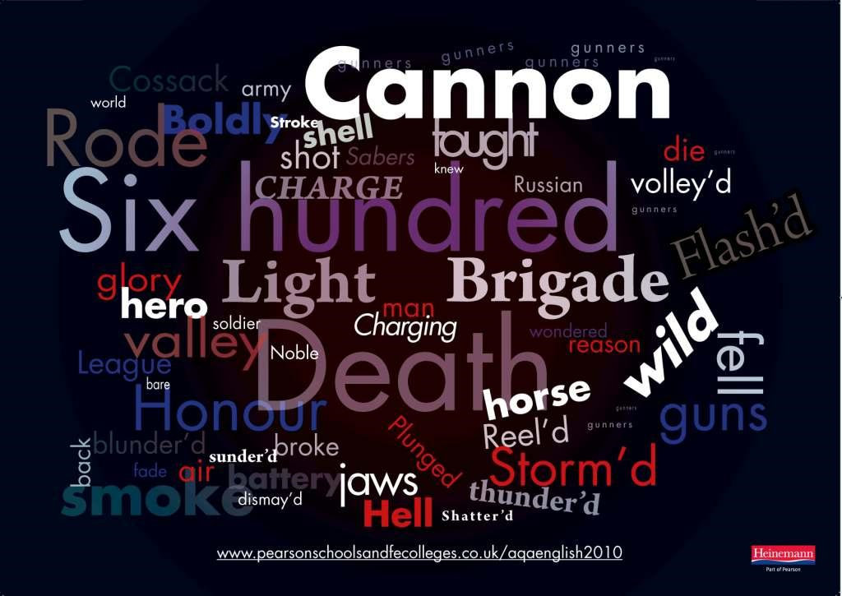  Ask some of those with their hand up to give one reason why they like the publication. Then ask others why they do not like it and why.  Ask students to tell you, without looking at the Study Module, the main points they learnt by reading through the section What is style? (homework task). Recap the five points and do Skill Builder 7.6 as a class activity. | 10 mins
 | Optional – if students need another opportunity to look at posters before creating one themselves.  Ask students to work in pairs or small groups to complete Skill Builder 7.7. Put them under time pressure and give them just a couple of minutes to assess the two posters and prepare verbal answers.  After no more than five minutes, ask for answers to the first and last question. Start with a show of hands, then ask some students to explain their views.  Question 1: Are the posters fit for purpose? Yes / No  Is poster 1 (on the left) fit for purpose?  Is poster 2 (on the right) fit for purpose?  Question 2: Which poster does the best job? | [10 mins]
 | Share lesson objectives  Introduce the lesson and share learning objectives and outcomes. | 5 mins
 | Creating a publication  Write on the board:  - understanding requirements  - planning, then doing  - reviewing, checking and improving  Give them a couple of minutes to read Skill Builder 7.9.  (1) Understanding requirements  Ask one student to summarise, from memory and without looking at Skill Builder 7.9, the requirements. Then ask the rest of the class if their fellow student has left out anything - if so, what? Advise students not to rely on their memory in the test, reduce the risk of getting it wrong by reading and checking the requirements.  Ensure that students understand that they will produce four publications, then inform them where they will produce them and in which sequence:  Tell them that you will play the role of the event organiser: if they have any questions later on, they should address them to you in class.  Note: Email will be covered in the last two lessons, Using ICT to communicate, Study Module 8.  Working under time pressure  Test conditions, including time limits, do not apply to Skill Builder 7.9 but students should work on their own and time themselves to find out how long it takes them to create each of the four publications. | 10 mins
  No | Publication | Scenario
  1 | Printed poster | in class
  2 | Flyer | homework
  3 | Presentation | in class
  4 | Digital poster | homework
 | (2) Planning, then doing  Explain to students that they all start today with the printed poster.  Which software application should I use?  Remind students of the Tips for choosing software (Study Module 1, page 7). Posters are not mentioned specifically but as a poster generally combines words and images, students can carry out this task using desktop publishing, word processing or presentation software.  Draw up a list of key terms for important software tools and features and check students know how to use them.  Optional: recap of previous Study Modules  Use the table in the Lesson Appendix. Be selective and focus on points that address the needs of your students and the task in-hand. | 5-10 mins
 | Note: If students work on their poster over two lessons:  - conclude Lesson 17 (Plenary) by reminding students that they need to create four different publications in total. Good planning will make this task more manageable and improve their personal productivity and efficiency.  - use section (3) as the Starter of Lesson 18  (3) Reviewing, checking and improving  Tell students that in their planning they need to allow quality time for all three. Reviewing and checking need to be part of their planning: right at the outset, they need to decide when to review what and allow enough time to ‘do a good job’ – otherwise it will be a waste of time. Remind them of the saying A check in time saves nine. Take them through the section Keep on checking on pages 12 and 13. | 5-10 mins
 | Creating the printed poster for the Bentley Charity Ball  Inform students that there are digital images they can use, and remind them that they can edit and format them. Show them image L14.6-Picture-Icons-numbered.  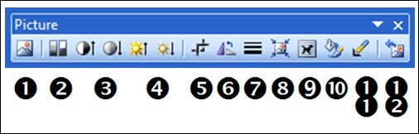 | 15–25 mins
Write on the board:
Functional Skill ICT
Evidence required:
1. Final or latest version of poster file saved as read-only.
2. Screenshot of folder structure with file names and file types with, in the footer,
- candidate name
- candidate number (if allocated else made up)
- centre number (if known else made up)
Set a time limit that will challenge your students. Explain to students that they have such limited time as (a) the requirements of publications for the Bentley Charity Ball are not new to them, and (b) they have already done some preparatory work. Remind them to respect copyright restrictions, e.g. Children in Need trademark/artwork.
Advise them that you will warn them when they have just five minutes of working time left.
 | 5-minute warning  Announce that students have just 5 minutes left. When the five minutes are over, call stop. If you see students using the keyboard or mouse after you have called stop, explain to them that if they did this in the test they would be in breach of examination conditions – not worth the risk, the harshest sanction would be disqualification. | 5 mins
 | Applying a mark scheme  Tell students that in one Level 1 test there were 18 marks available for creating a poster.  Ask five students what they think marks are awarded for and how many.  Show students the image L18.1-Mark-Scheme-Categories1.  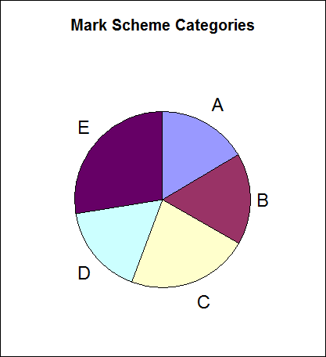 | 10-15 mins
Ask to students
- Are they surprised that there are five categories?
- What do the five categories relate to?
Show students the image L18.2-Mark-Scheme-Categories2.
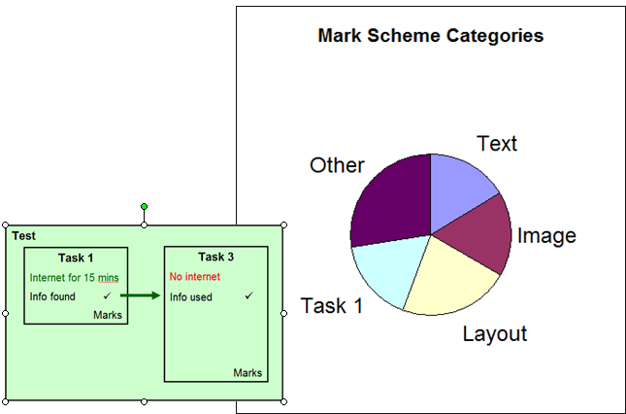
 | Remind them that in Lesson 5 you pointed out that some Marks available in Task 3 depended on the successful completion of Task 1 during the first 15 minutes of the test: finding, selecting and saving information from the internet, and then inserting it appropriately into the poster (Task 3).
 | Assessing own and a partner’s poster  Hand out print-outs of the document L18-Mark-Scheme-poster or ask students to open it.  Stress that this Mark Scheme is based on the SAM Level 1 test but arranged in a different way and without the 3 Marks related to Task 1.  Give students time to read all the entries under the heading Answers.  Explain the entries under the heading Additional Guidance, e.g. can be inferred. Discuss the Mark Scheme with students. For which entries are marks awarded objectively, e.g. content within margins, evidence that file is read-only?  Focus on category Other, and remind students that you mentioned some of these as you progressed through the Study Modules, starting with interface features and systems facilities in Lesson 1! | 15-20 mins
Pair-up students.
Self-assessment
Ask students to honestly assess their own work and enter the marks they award themselves into the fields under the heading Own Marks.
Peer-assessment
Ask students to exchange mark sheets, fairly assess their partner’s poster and enter marks they award a fellow student in the fields under the heading Peer Marks.
Tell pairs to return mark sheets, then to compare and discuss their markings.
Feed-back on assessments
Ask students for feed-back. Use a show of hands to establish how many pairs agreed:
- 80% - 100 %
- 60% - 79%
- 40% - 59%
- 39% or less?
Note: adjust the boundaries to reflect the group’s skill level.
 | Personal improvement plan  Ask students to identify weaknesses (a) in their work, and (b) in their ways of working, from understanding the requirements to saving the final version. Ask them to draw up a personal improvement plan with targets and time scales. | 5-10 mins
 | Plenary  Remind students of the learning objectives and learning outcomes of the double lesson. Tell them that in the next two lessons they will create the presentation and mark it. | 5-10 mins
Homework  Lesson 17 | Ask students to:  - revisit Skill Builder 7.1.1.  - plan and start work on the 1-page flyer as specified in Skill Builder 7.9.  - keep a log of:  - time spent,  - things found easy to do,  - things found difficult to do,  - actions for improvement plan. | 30 mins
Homework  Lesson 18 | Ask students to  - Improve their printed poster, save it under a new file name, and re-mark it themselves  - Draw up an Action Plan from lessons learnt creating and marking the printed poster covering:  (a) the quality and effectiveness of what they produce, e.g. the poster, and  (b) their own ways of working  - Complete the one-page flyer | 40 mins

Appendix: Recap of previous Study Modules

General points | Group-specific points:
Study Module 1: Making the most of your computer
- Desktop, icons – put the icon of the software you use frequently into quick launch bar and save time.
- Windows – mention resizing to have more than one window as they have to copy information from files provided into their own
- System settings – is language set to UK English?
- Mouse – need to customise click-speed, for left-handed use?
- Screen resolution – is it fit for poster-work?
- Printer – is the default printer fit for poster-work or do you have to select another printer, e.g. colour printer?
Study Module 2: Managing information
- Folder structures – tell students they must create a folder specifically for Skill Builder 7.9, but they can decide what structure of subfolders to have underneath it, e.g. one folder per publication.
- File name – let three students suggest file names for the poster, then ask the group to comment on them. Remind them the file names need to be meaningful and indicate which version of the publication it is.
- Keeping control of information – point out that setting a strong password is not appropriate for a piece of work that needs to be marked. How can they make sure that people can look at their work but not change it? Answer: make file read-only.
- Risk to folders and files – ask students if they think they need to back-up their work. If so, when they would back-up their files for the first time, where would they store the back-up, and when would they do subsequent back-ups? (Suggest at important stages rather them every x days).
Tips for managing information storage (page 11)
Point out to students that they gain their first marks by just creating a suitable folder structure – provided they can provide the necessary evidence. Recap with students how to take a screenshot using Prt Sc. Remind them of Lesson 5 and the advice to use a personalised screenshot template.
Reiterate the message that typing information into the header and footer every time they take a screenshot is not an efficient way of working as it (1) wastes time and (b) increases the likelihood how making mistakes – typing in the wrong candidate number will cause problems.
Study Module 3: Finding and selecting information
Note: Focus on selecting as students do not have to find information on the internet.
- Copyright
- Acknowledging sources
- Evaluating websites
- Information overload – slows you down …
- be selective - the wording of the last bullet point of Skill Builder 7.9 says you can, not you must use all information provided
- when faced with choice, rank information

Study Module 4: Working with structured data
Study Module 5: Working with numbers and charts
Note: less relevant for producing this printed poster.

Study Module 6: Working with text and images
- Formatting – different features e.g. font, font size, colour, borders, shading, background, etc.; specific for images, e.g. cropping, resizing, compressing
- Ask students in what type of file the information is provided for Skill Builder 7.9 and what that tells them (text file = plain text = needs formatting)

Other points:

