Lesson 15 | Study Module 7: Combining and  presenting information (1/4) | Time
Lesson objective | In this lesson students are learning how to:  - identify features of effective publications
Learning outcomes | At the end of the lesson students will be able to:  - identify the purposes of , target audience for and features of different types of publications  - map out page layouts  - describe text styles
Specification coverage | L1: 1.1, 2.1, 10.1, 10.2, 11.1  L2: 1.1, 2.1, 9.1, 9.2, 10.1
Resources  Study Module 7  Key vocabulary  types of publications:  poster presentation website brochure information point  report personal / business letter newsletter flyer factsheet  requirements  fit for purpose  fit for audience  content  storyboard  layout  image  text  style  on paper  on screen | Starter  Draw a table on the board, with double-width columns for What? and How?  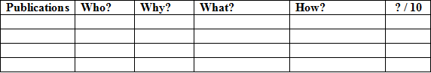  Ask students to hold up the publications they have brought in (homework task). Select between three and five students with very different publications. Ask them, one by one, to show their publication to the class, and say what type of publication it is, e.g. a newsletter, a leaflet, a flyer.  Ask others:  - Who is it aimed at? Who is the target audience?  - Why was it produced? (to inform, entertain, sell, collect, etc.)  - What is in it? (types of information only, e.g. text, images, charts)  - How is it presented? (paper size, orientation, most striking formatting feature), and  - what mark out of 10 do they give it and why  Enter the students’ key points into the table. Ask other students whether or not they agree – add constructive contributions into the table.  Revisit What? and How? and ask for more details. Under What?, use symbols (=, >, <, =<, >=) to indicate the quantitative balance between text and images. Under How?, ask for features covered in previous lessons about text, e.g. font size, colour, etc. | 15 mins
 | Share lesson objective  Introduce the lesson and share learning objective and outcomes. | 5 mins
 | Tell students to look at the three publications on page 3 and ask them to answer the questions above them.  Continue by asking students to describe differences between the three publications covering:  - the use of  - colours  - images  - text  - page layout.  Recap with students their work in Lesson 12 when they selected, formatted and saved text for four publications to promote the Bentley Charity Ball. Use the diagram on page 3 to point out that what goes into a publication depends on what type it is, its purpose and target audience.  Ask students to complete Skill Builder 7.1.  When students have finished ask them for their answers to:  - Bullet 5: what sort of publication the Study Guide is, and do they agree that it is fit for purpose (studying) and audience (they themselves), then  - Bullet 6: what other types of publications they added to the table. | 15 mins
Where is what?
Ask students to return to page 3 and look at the first publication (RAPID, Writing, Teaching Guide, Stage 2).
Ask students if the publication is one in a series? If so, what needs to be replaced on the page to create a new version? Examples: WRITING could be replaced by READING, Stage 2 by Stage 1.
 | 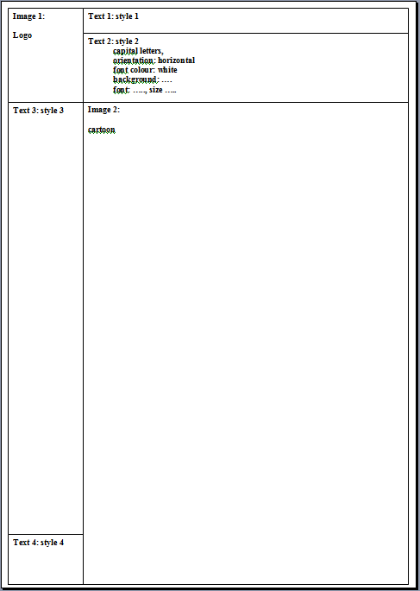  Ask them how the page is constructed. How many components are there? What shapes are the components? If you wanted to version the page, which of the components (a) remain on the page, e.g. logo, top left, and (b) are replaced, e.g. Writing? What about the cartoon image? What would the series look like if it features on all front pages?  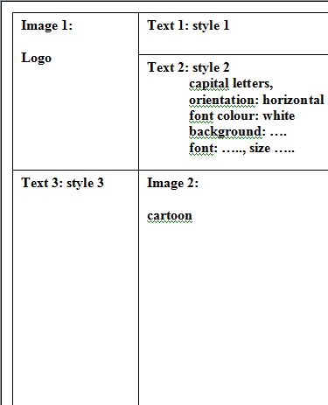  Explain to students that you can map out the layout of a page to show what the components are and how they fit together. Stress that you do not want to show any details, only shapes and the types of information they hold, text or image.  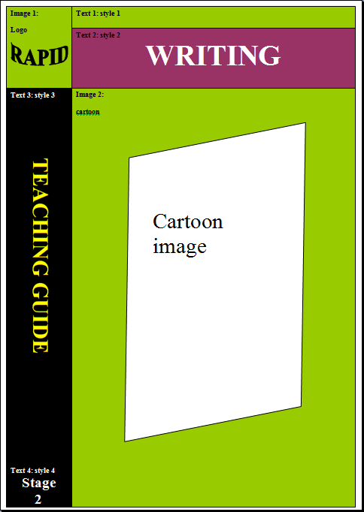  Open a new word processing document in portrait orientation. If the Drawing Toolbar is not displayed, click on View, Toolbars, Drawing. Switch between zoom settings: zoom out so that students can see the whole page, zoom in so that they can see the writing.  Tell students to start in the top left hand corner and to work across and down the page.  Click on the Text Box icon, then just away from the top left corner of the page and expand the text box to resemble the shape and size on the publication page.  Note: do not (1) create the Text Box inside the area labelled “Create your drawing here”, and (2) keep away from the edge otherwise you lose some of the handles of the Text Box. | 20 mins
Enter Image 1 and ask students what type of image it is. Call it logo and add type: logo into the box.
Draw the second box and enter Text: – ask students how many different text formats there are (4), call them styles and add style 1 into the second box.
Draw the other boxes and label them. Before doing the last one, click on AutoShapes. Show students the Basic Shapes and point out that they can enter text into them as well (right-click on shape, select Add Text; with text entered: Edit text).
Revisit the box for Text 2. Ask students to give you key features of style 2. Build up the specification of style 2 by adding features into box 2. Do the same with style 3.
Ask students to look at the other two publications on page 3. How many components do they have? How are they arranged to fill the page? How many hold text, how many images? How many text styles do they have? How easy would it be to map them out?
If students do not spot it, point out that the middle publication has a transparent text box on top of an image that fills nearly the whole page.
Conclude by stressing that the success factors for an effective publication include
- what information is selected (fit for purpose and audience)
- how types of information are combined (text, images and other components)
- how they are presented (page layout, use of colours and text styles, etc).
… especially on a front page!
 | Plenary  Remind students of the learning objective and recap on what they have learnt in this and the previous two lessons. | 5 mins
Homework | Ask students to:  (1) complete Skill Builder 7.2. (Tell them to design a table and enter their short descriptions into it.)  (2) map out the page layout of digital asset SB7.2.1 using Text Boxes and/or AutoShapes. | 60 mins

