Lesson 14 | Study Module 6: Working with text and images (3/3) | Time
Lesson objective | In this lesson students are learning how to:  - format and integrate images to meet requirements
Learning outcomes | At the end of the lesson students will be able to:  - select appropriate formatting tools to edit images  - add features to images  - combine text and images to produce print-outs that meet requirements (similar wording as in Lesson 8 and 11)
Specification coverage | L1: 2.1, 7.1  L2: 2.1, 6.1
Resources  Study Module 6  SAM Mark Scheme  Images:  L3.5-Storage-compressed  L14.1-Picture-4-versions  L14.2-Picture-version4  L14.3-Text-images  L14.4-Which-software  L14.5-View-Toolbars-Picture  L14.6-Picture-icons  L14.7-Image-plus  Text file:  San-Francisco-Diary  Key vocabulary  Image  Colour  Contrast  Brightness  Rotate  Text Wrapping  Transparency  Reset  Cropping  Resizing  Compressing  File forma  Page  Layout  Orientation  Margins  Text  Alignment  Style  Font  Font size  Line spacing  Lists  - bulleted  - numbered  Border  Shades | Starter  Show students the image L14.1-Picture-4-versions.  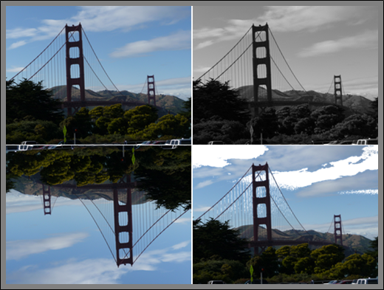  Ask them which one is the original photo and what changes were made to the original to get the other three.  Show them the image L14.2-Picture-version4.  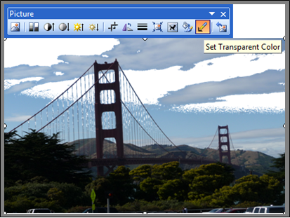  Tell students that this version was created using the Transparency tool and that they will use it and other tools to customise the photo for inclusion in a publication. | 5 mins
 | Share lesson objective  Introduce the lesson and share learning objective and outcomes. | 5 mins
 | Which software should I use?  Remind students that this Study Module is called Working with text and images. Stress the word and, then show them the image L14.3-Text-Images.  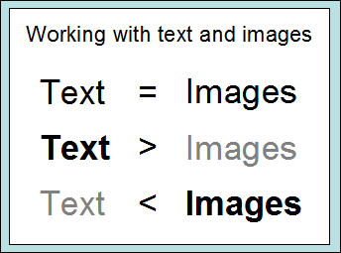  Let students suggest what kind of publications match the three scenarios and what application software they would select to produce them:  - balance of text and images  - mainly text with some supporting images  - mainly images with some supporting text  Inform students that today they will work in scenario Text > images. Show students the image L14.4-Which-software, remind them that the graphs and charts they created in a previous lesson are also images. Tell them that in this lesson they will use presentation software to format a photo so that it can be used in a text document.  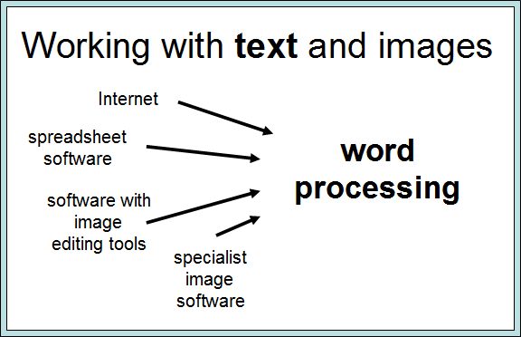  Recap with students what they learnt about files, folders and storage as they need to save images they create. | 5 mins
 | Formatting a picture  Show students the image L14.5-View-Toolbars-Picture.  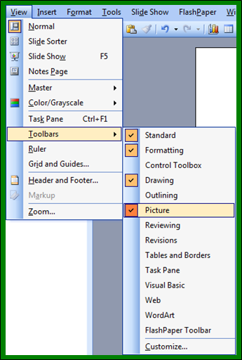  Point out that this screenshot was taken in PowerPoint. Tell them they need to have the Picture toolbar open for today’s lesson.  Show them the image L14.6-Picture-Icons-numbered.  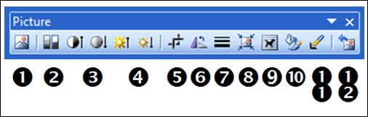  Go through all 12 icons so that students know what they do (they might not necessarily know how exactly they change a picture but can find out in the hands-on session).  1 Insert Picture (alternative on top toolbar: Insert, Picture)  2 Colour | 15 mins
3 More / less Contrast
4 More / less Brightness
5 Crop (remove unwanted parts at the edges of picture)
6 Rotate Left 90 degrees (click 4 times for complete circle)
7 Line Style (around picture)
8 Compress Pictures
9 Text Wrapping (8 choices)
10 Format Picture (same as right-clicking on picture)
11 Set Transparent Colour
12 Reset Picture
Show students the image L3.5-Storage-compressed. Remind them or recap that Size matters – with files (Lesson 3) and now with images.
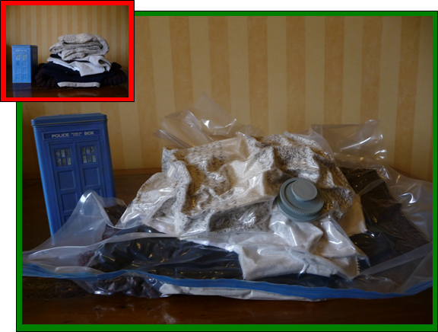
Check that students know how to resize a picture (explanation on page 8). Tell students to complete Skill Builder 6.7, and – using the resized photo of the Golden Gate Bridge - explore the icons on the Picture Toolbar.
Note:
Students will use presentation software in the next hands-on session. To save time, they can do Skill Builder 6.7 in that rather than word processing software
 | Creating an image fit for a text  Show students the image L14.7-Image-plus.  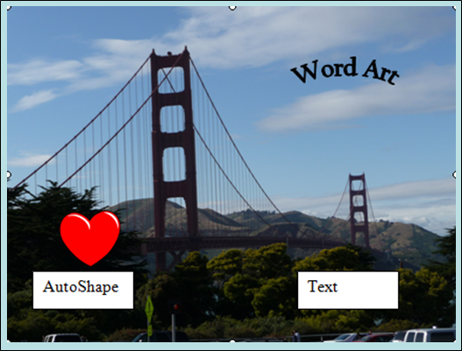  Ask students to open the text file San-Francisco-Diary and to read the text. Their task is to create a version of the photo to go with this text. They can design the image to illustrate a particular point in the story, matching the text’s tone or sentiment, or the author’s experience.  Ask them to use presentation software, insert the reduced original photo or one of the versions they created, add two features to it, group photo and features together, right-click on the grouped image, and then save their composition using a meaningful filename and file type. Advise students to save the slide as well just in case they want to enhance their composition image at a later stage.  Tell students to format the plain text, select a suitable place in the document for (a) their image and (b) the table (homework from previous lesson), and insert both with two different Text Wrapping styles. Text and images combined must fit on one A4 page. Students should save the document under a new name, with their name, date and filename in the footer. | 20 mins
 | Plenary  Remind students of the learning objective and recap on what they have learnt in this and the previous two lessons.  Use Wrapping up on page 10 to (1) remind students what skills they need when working with text and images, and (2) explain what they are and what they are not expected to do in the test.  Tell students that the next couple of lessons are about paper-based publications. | 10 mins
Homework | 1. Complete Skill Builder 6.6  2. Create and save 3 different versions of digital asset SB6.6.1 using the Picture tools. Arrange the original plus your three versions, in the same or different sizes, on a single A4 page (portrait or landscape); add information into the header and footer, and save under a new file name.  3. Bring to the next lesson one printed publication, e.g. a magazine, ‘junk-mail’, advertisement, flyer, etc. | 60 mins

