Lesson 13 | Study Module 6: Working with text and images (2/3) | Time
Lesson objective | In this lesson students are learning how to:  - display information in a table
Learning outcomes | At the end of the lesson students will be able to:  - create a table in a text document  - format it to aid understanding  - produce print-outs to meet requirements
Specification coverage | L1: 2.1, 7.1  L2: 2.1, 6.1
Resources  Study Module 6  SAM Mark Scheme  Images:  L13.1-Tables-previous  L13.2-Table-menu  L13.3-Table-properties  Text file:  Lesson 13 Homework text for table  Key vocabulary  Page  Layout  Orientation  Margins  Text  Alignment  Style  Font  Font size  Line spacing  Lists  - bulleted  - numbered  Table  Row  Column  Cell  Border  Shades | Starter  Ask students what key words spring to their minds when you say: “table” – a data table, not a piece of furniture!  Show students image L13.1-Tables-previous or examples of tables / spreadsheets used in previous lessons.  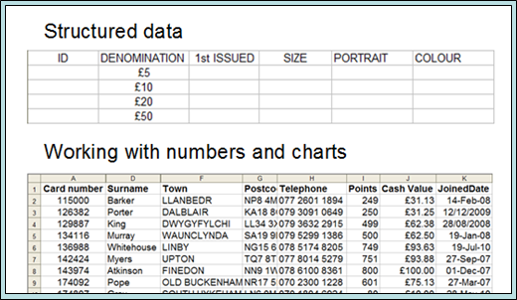  Ask them to recall key points they learnt about tables for structured data (Lesson 6) and working with numbers and charts (Lesson 9). | 5 mins
 | Share lesson objective  Introduce the lesson and share learning objective and outcomes. | 5 mins
 | Table menu (in word processing software)  Show students the image L13.2-Table-menu or open a new text document and display the table menu (use the mouse to open it or keyboard shortcut).  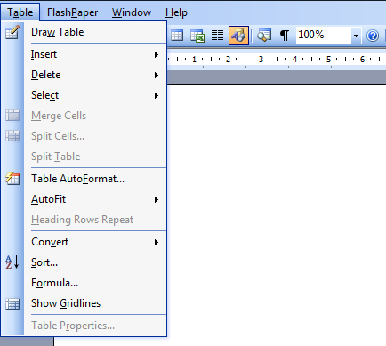  Ask them why some options are greyed out (blank document, options will turn black/active once a table is inserted and the cursor is in the table).  Go through all the menu options, including the next layer of sub-options apart from Table Properties.  Cover Convert, then ask students  - what Sort and Formula… might offer them  - is A>Z in alphabetical sort order ascending or descending? (ascending)  - under which heading is Sort in spreadsheet software? (Data) | 10 mins
 | Table Properties  Show students the image L13.3-Table-properties or display the Table Properties window.  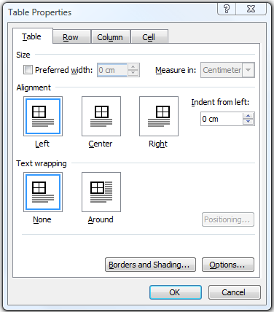  Cover the features displayed in the open tab (Table), draw students attention to the other tabs Row, Column and Cell. Tell students to explore these and Borders and Shading… in the hands-on sessions. | 5 mins
 | Exploring a table  Ask students to complete Skill Builder 6.4 and in addition use it to explore Table Properties tabs Row, Column, Cell, and Borders and Shading…. | 10 mins
 | Creating a table  Ask students to start Skill Builder 6.5 and to complete it as homework if they do not finish in lesson time. | 15 mins
 | Plenary  Ask students to feed-back on their work with tables, which aspects they find easy, which difficult to handle.  Remind students of the learning objective and recap on what they have learnt in this and the previous lesson. | 10 mins
Homework | Ask students to  - open a new text document (portrait orientation),  - present the information below in a table,  - format it appropriately, and  - use a formula within the table to add-up the expenditure  - put a suitable title in the header, and their name, date and filename in the footer.  Information  Title: San Francisco, diary summary  Sunday: City, cable cars & trams, $64.00, great fun!  Monday: China Town, guided walking tour with lunch, $45, strange food  Tuesday: Golden Gate Bridge, bicycle, $32, fantastic  Wednesday: Museums, buses, $50 , impressive  Thursday: Golden Gate Bridge, walking, free, don’t remind me!  Friday: Piers and Alcatrez, boat tour, $36, shocking  Saturday: airport, BART, $10, sorry to be leaving  Reminder to students: complete Skill Builder 6.5 if not finished in lesson | 40 mins

