Lesson 12 | Study Module 6: Working with text and images (1/3) | Time
Lesson objective | In this lesson students are learning how to:  - select and format text to meet requirements
Learning outcomes | At the end of the lesson students will be able to:  - select and prepare text for publications  - apply appropriate formatting  - apply bullets and numbering to lists  - produce print-outs to meet requirements
Specification coverage | L1: 2.1, 7.1  L2: 2.1, 6.1
Resources  Study Module 6  SAM Mark Scheme  Images:  L4.7-Fit-for-purpose  L12.1-Bullets-Numbering  Key vocabulary  Page  Layout  Orientation  Margins  Text  Alignment  Style  Font  Font size  Line spacing  Lists  - bulleted  - numbered  Table  Row  Column  Cell  Border  Shades | Before the start of the lesson, go to the Gutenberg-Museum Shop website: www.gutenberg-shop.de .  Click on English Version (last option of the menu on the left).  Click on Online Shop, then Miniature Books. Click of the image of a miniature book for a closer look.  The page shows the smallest book in the world. Click on Miniature Accordion fold books to display a wide range of small books.  Starter  Show students the webpage with the range of small books.  Ask students to speculate  - what font size is needed to fit text onto such small pages (2 cm x 2 cm)?  - could the text be formatted – if so, in what ways?  - what character sets are needed to print the text in languages other than German?  - how would you read such text?  For information on the history of printing, visit the Gutenberg Museum’s website  http://www.gutenberg-museum.de/index.php?id=29&L=1 | 5 mins
 | Share lesson objective  Introduce the lesson and share learning objective and outcomes. | 5 mins
 | Formatting text  Continue with fonts and font size using the examples on page 3 and/or demonstrations on the board.  Move on to text alignment, style and colour using the examples on page 4 and/or demonstrations on the board.  Stress that the word processing software has a convenient tool to copy and paste formatting across and within documents. Its icon generally shows a paint brush (Tip on page 4).  Ask students to work through Skill Builder 6.1. | 15 mins
 | Bullets and numbering  Show students the image L12.1-Bullets-Numbering or display the Bullets and Numbering window on the board.  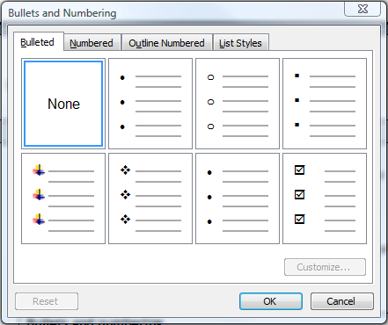  Point out the tabs Numbered, Outline Numbered and List Style and tell students to explore them when they have finished Skill Builder 6.2.  Ask students to work through Skill Builder 6.2 and, in addition,  (1) explore the Customise … option, and  (2) find out what happens when they highlight one line in the middle of a bulleted list and then click on the Increase Indent key.  For example:  - Abseiling  - Orienteering  - Canoeing  - Disco Dancing  Note: change depends on the first type of bullet used | 15 mins
 | Selecting and formatting text for publications  Show students image L4.7-Fit-for-Purpose from Lesson 4.  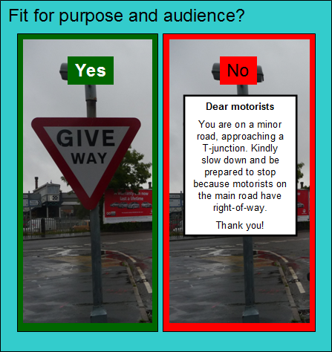  Recap that information and the way it is presented must be fit for purpose and audience. Expand that a tiny font size is appropriate if you want to produce the smallest book in the world - but no good at all traffic sign, bill board or poster.  A book is one type of publication - name posters and flyers as examples of other types and ask students what they, as audience, would expect:  (1) how much text?  (2) what kind of text? (single words/short phrases or complete sentences)  (2) what format or formats? (not just font size)  Open digital asset SB6.3.1. With the plain text on the board ask students three “yes / no” questions:  Are 228 words suitable for (a) a poster, and (b) a flyer?  Is the wording of the text suitable for (a) a poster, and (b) a flyer?  Is plain / unformatted text suitable for (a) a poster, and (b) a flyer?  Introduce Skill Builder 6.3 – the text about the Bentley Charity Ball.  Explain to students that they must select, edit, format and save the text for four publications (for different purposes and audiences), and that they will use their text selections when they create the four publications (Lesson 15 onwards).  Tell students to start Skill Builder 6.3 in lesson and finish it as homework. | 15 mins
 | Plenary  Remind students of the learning objective and recap on what they have learnt in this lesson. | 5 mins
Homework | Finish Skill Builder 6.3. | 30 mins

