Lesson 11 | Study Module 5: Working with numbers and charts (3/3) | Time
Lesson objective | In this lesson students are learning how to:  - display numerical data in graphical form
Learning outcomes | At the end of the lesson students will be able to:  - select and create appropriate charts and graphs  - label graphs / charts to aid understanding  - produce print-outs to meet requirements
Specification coverage | L1: 2.1, 7.1, 8.1, 8.2  L2: 2.1, 6.1, 7.1, 7.2
Resources  Study Module 5  SAM Mark Scheme  Image:  L11.1-Bar-Chart-no-info  Key vocabulary  Chart / Graph  Bar, pie, line  Axis  Label  Value  Legend | Starter  Show students the image L11-1-Bar-Chart-no-info.  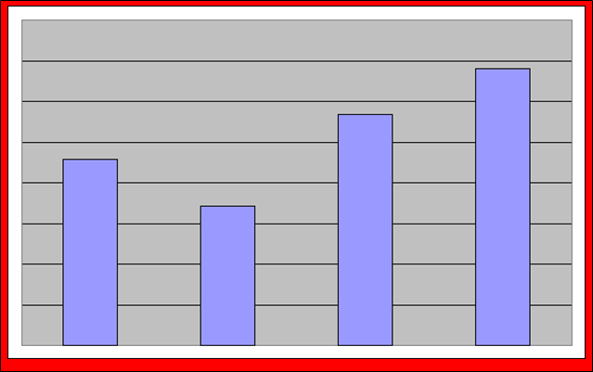  Ask them what it is (bar chart), what it tells them - and what is missing.  With the blank bar chart on the board, tell students to turn to page 10 and look at the bar chart. The bars in the book are the same as those on the board – what makes the chart in the book more meaningful? What is still missing? For example: Sales - of what? | 5 mins
 | Share lesson objective  Introduce the lesson and share learning objective and outcomes. | 5 mins
 | Which type of chart should you use?  Go through the three charts on page 10, then ask students what other charts and graphs they know and/or have seen. | 5 mins
 | Creating a Bar Chart  Take time to go through the five bullet points on page 11 and the features that add meaning to a chart, e.g. title, axis labels, gridlines, values, legend and data labels.  Ask students to complete Skill Builder 5.7. Draw their attention to the last task which is different: students have to write a short explanation, not demonstrate an ICT skill. Limit students to 4 lines of text. | 20 mins
 | Creating a Line Graph  Ask students to open digital asset SB5.8.1.  Ask students what features add meaning to this spreadsheet, e.g. two titles in bold, tab with meaningful name rather than Sheet1 or 2. Ask students to describe the layout of the spreadsheet. Is the block of numerical data where they expected it? The cells in column A left are left blank – does this enhance the overall layout?  Take 2-3 minutes to recap key points (a) from Lessons 6-8 on structured data, e.g. records, fieldnames, appropriate formatting (text wrap in row 6), and (b) from Lessons 4 and 5 on finding and selecting information – remind them they need to acknowledge their sources and it is useful to paste addresses of sources into a document.  To conclude, ask students:  - If they knew that they had to use AutoFilter, would they use a layout such as for digital asset SB5.8.1? If not – why not?  - Do they think they can use AutoFilter with digital asset SB5.8.1?  Ask students to find out the answer to question 2 in the hands-on session, and stress that what they know about the use or purpose of a spreadsheet needs to inform the design of its layout.  Give students 15 minutes to create a line graph, ready for printing out. Refer them to layout matters on page 8 and stress a good layout for a spreadsheet is as important as meaningful labelling to a chart.  Differentiation L1 and L2  Tell:  - L1 students to use HIGHEST and LOWEST temperatures (data in adjacent columns)  - L2 students to use AVERAGE DAILY MAXIMUM and LOWEST temperatures | 20 mins
The challenge for L2 students is to select data in non-adjacent columns for their chart.
Note: temperatures below 0 will appear below the x-axis.
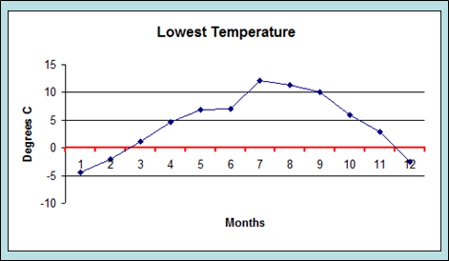
In the last couple of minutes take feedback from L1 and L2 students.
 | Plenary  Remind students of the learning objective and recap on what they have learnt in this and the previous two lessons.  Take students through the Skill Check on page 12 and stress that they need all the skills listed to gain marks in the test. | 10 mins
Homework | Tell students to:  - produce three more fully annotated charts based on digital asset SB5.8.1, two for printing out on A4 portrait, one on A4 landscape.  - place each chart as a new sheet (not as an object with the data)  - use Print Preview to check that the charts are fully labelled and that additional information is formatted and placed appropriately on the page, e.g. header/footer with own name, name given to the spreadsheet and Tab with chart, date, etc.  - write a statement saying which type of chart is most appropriate and why. | 60 mins

