Lesson 10 | Study Module 5: Working with numbers and charts (2/3) | Time
Lesson objective | In this lesson students are learning how to:  - work with conditions
Learning outcomes | At the end of the lesson students will be able to:  - use the IF Function  - apply conditional formatting
Specification coverage | L1: 2.1, 7.1, 8.1, 8.2  L2: 2.1, 6.1, 7.1, 7.2
Resources  Study Module 5  SAM Mark Scheme  Key vocabulary  Function  IF  Condition  True  False  Formatting  Conditional  Font  Border  Patterns  Comment | Starter  Tell students that the Loyalty Card Scheme wants to introduce a weekly Lucky-Number draw: a computer will randomly generate numbers between the minimum and maximum number of points – the first five members whose number of points match the Lucky-Number win 100 bonus points!  Develop the following on the board  If Lucky-Number = Points, 100 bonus points, else no points  condition then if true if false  Lucky-Number = Points is a condition that can be met and thus can be true, or not and thus be false.  Change the statement into a formula:  =IF(Lucky-Number=Points, “100 bonus points”, “no points”)  Open digital asset SB4.1.1. Point out that the numbers of Points are already in column I for all members.  Tell students you want to test the formula with an obvious example. Type Lucky-Number into cell N1 and type 249 as the first lucky number underneath into cell N2 – if the formula works, Mr Barker is a lucky winner!  Highlight cell L2 – instead of typing in the formula, click on Insert, Function and select IF. Take students through the fields in the Function Arguments window:  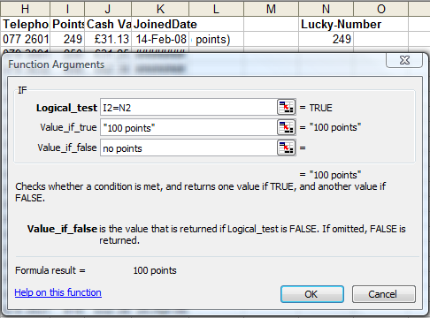 | 10 mins
Ask students to recall what other symbols they could use instead of = (<, >, >=, =<) and how they would change the outcome of the weekly Lucky-Number draw.
Check the formula works by changing the Lucky-Number.
Ask students how they would apply the formula to all the other members.
Before they copy it down – tell them to recall what the learnt in the previous lesson about cell references. The reference to the cell with the Lucky-Number needs to be absolute, the reference to the cells with Points can stay relative.
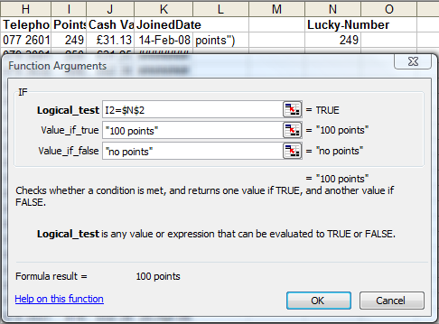
Delete the formula in cell N2 and rebuild the IF Function, adding the $ sign manually before clicking OK.
 | Share lesson objective  Introduce the lesson and share learning objective and outcomes. | 5 mins
 | Introduce Skill Builder 5.3 as an extension to their homework (Skill Builder 5.2). Ask students to open the spreadsheet they created and add the condition for free and chargeable delivery, then save it again. | 15 mins
 | Conditional formatting  Remind students that, so far, the formatting they used in a spreadsheet stayed in place unless they changed it e.g. currency - but what if they wanted formatting to apply only under particular circumstances? Similar to the IF function: define a condition, then set one format if true, a different one for false.  There are two parts to conditional formatting:  - defining the condition or conditions, and  - selecting an appropriate format.  Start with a simple example;  Enter the number 50 into a cell. Highlight it, then select Format, Conditional Formatting. Explore the options given in the two drop-down list (recap data validation to Keep rubbish out) and ask them for the symbols for the entries (=, >, <, >=, =<)  The entries in the three fields for Condition 1 need to read like a sentence: Cell Value is equal to 50; click on Format and select a different font colour. Use this opportunity to include Border and Shading as formatting features. Confirm with OK.  The number 50 should now be displayed in the selected colour. Change the number and the format changes back to the default format.  With the cell highlighted, return to conditional formatting – click Add, then Add again. Tell students to remember that the maximum number of conditions is 3. Ask them to give examples when conditional formatting might be useful. For what purposes and audiences might they use it?  Introduce the scenario of Skill Builder 5.5 – the challenge is apply conditional colour-coding for three grades of membership: bronze, silver and gold. | 20 mins
 | Plenary  Remind students of the learning objective and recap on what they have learnt in this and the previous lesson.  Tell them that in the next lesson they will use the spreadsheet to create graphs and charts. | 10 mins
Homework | Ask students to complete Skill Builder 5.6 and, in addition,  (1) use the IF Function to display an appropriate text message to the right of the delivery charge, one text for £0, another text for £18  (2) then apply appropriate conditional formatting to the text (combination of different Font and Border or Patterns features)  (3) insert a comment into the cell as reminder of the conditional formatting. | 45 mins

