Lesson 1 | Study Module 1: Making the most of your computer | Time
Lesson objective | In this lesson students are learning how to:  - customise computer settings to increase their own efficiency
Learning outcomes | At the end of the lesson students will be able to:  - personalise the desktop  - adjust system settings  - resolve straightforward problems
Specification coverage | L1: 2.1 – 2.3  L2: 2.1 – 2.4
Resources  Study Module 1  SAM and Mark Scheme  Images:  L1.1-PC-in-the-box  L1.2-PC-out-of-the-box  L1.3-PC-effective-settings  L1.4-Mark-Scheme-Lesson1  Key vocabulary  Desktop  Interface features  System settings  Icons  Quick launch bar  System tray  Software application | Starter  Show students the image L1.1-PC-in-the-box.  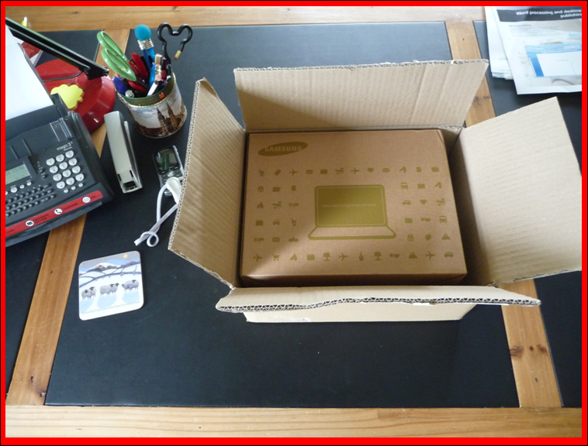  Ask students what the owner is likely to do with the new computer and why. Cover:  - Installing applications software  - give students different scenarios: who would install which application software and why? Examples: a teacher, an architect, a shop-keeper  - ask students what application software they would install and why (leisure, socialising, studying)  - Interface features (mouse, keyboard, touchpad, screen, audio and video) | 5-10 mins
Show them the image L1.2-PC-out-of-the-box.
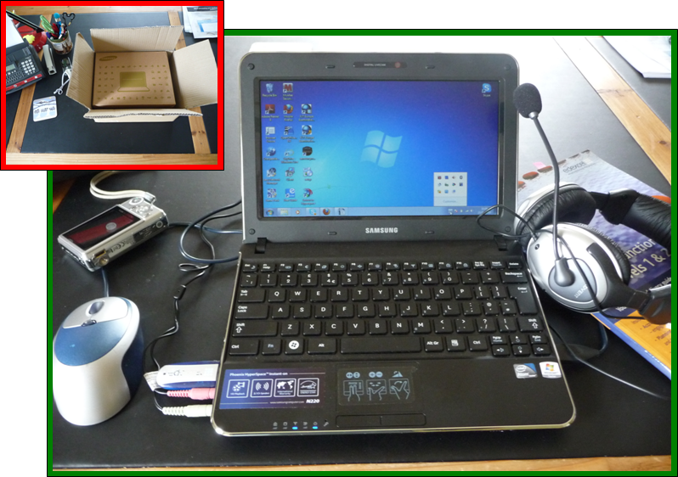
Although students cannot see fine details, ask them what this photo tells them about how the owner has customised their new computer. Cover:
- the user is left-handed
- desktop: many icons for application software, some icons on the quick launch toolbar
- interface features: screen: angle for best view; settings for mouse (left-handed user) and touch pad, volume for headset with microphone; system tray
- external storage: memory stick, camera’s memory card
Not visible on the photo:
- printer
- date and time
Refer students to page 6 in Study Module 1.
 | Optional: input by ICT/network staff (see note at the end) | 15 mins
 | Share lesson objectives  Introduce the lesson and share learning objective and outcomes. | 5 mins
 | Customising the desktop, changing system settings  Show students a desktop. Tell them that it does not have to look like this. Make some changes, e.g. move some icons to new locations, rearrange all icons or change their size. Open the volume control and an application by double-clicking on its icon (make sure the students hear the clicks or count them).  Establish that the mouse is a key tool to customise the desktop and get to system settings. Conclude with an open question which students answer after the hands-on activity: can the mouse itself be customised? | 30 mins  (20 mins if optional session included)
Ask students to explore the settings of their computer completing Skill Builders 1.1, 1.3, 1.4, 1.5 and 1.6.
Notes:
Include Skill Builder 1.2 if students need practice resizing, moving, layering and/or restoring windows.
Skill Builder 1.4, last bullet “Experiment with using a data projector …”. Students can take it in turns; alternatively demonstrate to all or cover without hands-on activity.
Ask two or three pairs/groups what desktop and which settings improve, which hinder their use of the computer.
Conclude with going through the Tips for choosing software (Study Module 1, page 7)
 | Troubleshooting  Users can face problems even with the best customised computer. Ask students what technical troubles they have come across that stopped or delayed them from completing a task. Ensure that you cover issues that could impact negatively on the students’ performance during the test:  - printer: off-line, paper jam, out-of-paper  - software: application is not responding  - internet: no access  - network: no access  - screen / monitor: no display  Stress health & safety issues (handling electrical items with care) and tell students who to turn to for help.  You may want to include Tips for working safely on page 9 of Study Module 1. | 10 mins  (5 mins)  if optional session included
 | Plenary  Remind students of the learning objectives and what they have learnt in this and the previous lesson.  Show students the image L1.3-PC-effective-settings.  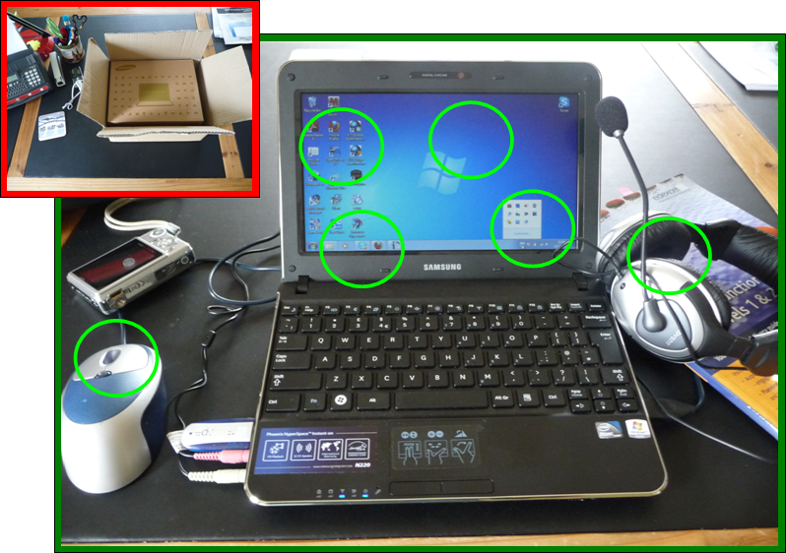  For each of the green rings, ask them to summarise what settings can be changed and how this helps users to get the most of their computer.  Encourage them to reflect on their skill level and refer them to the Knowledge Check on page 10 of Study Module 1.  Conclude the lesson and introduce the homework by referring students to the Test Tips on page 10 and by showing them image L1.4-Mark-Scheme-Lesson1.  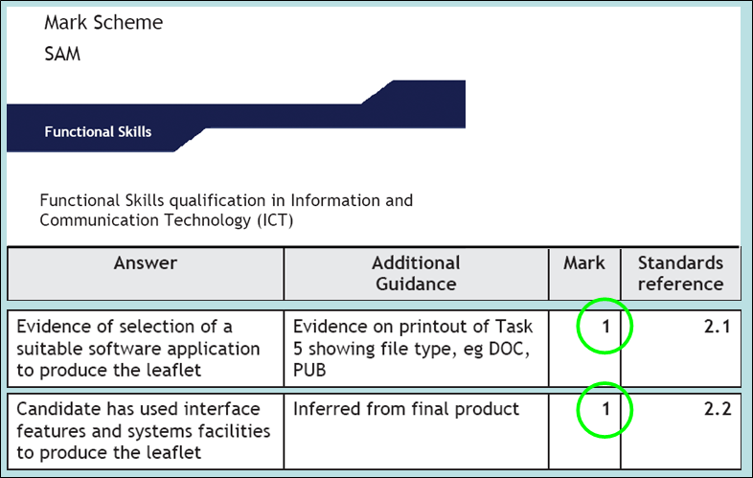  Tell students that they will not be expected to change system settings in the test but that they can earn marks for:  - using interface and system facilities  - selecting a suitable software application | 10 mins
Homework | Which software application should I use?  Ask students to complete Skill Builders 1.7 and 1.8 | 30 mins
Notes | Optional  If the computers students use are ‘locked-down’ and managed in-house or by an external ICT Service Provider, invite the Network Manager or one of the ICT technical staff to attend the lesson for the first 10 minutes.  After students have looked at the photo L1.2-PC-out-of-the-box, ask them what they do when they take a computer out of its box.  Give them 15 minutes to cover the thinking behind the centre’s choice of:  - application software  - interface features  - system settings  - troubleshooting (school-specific ‘You can … but must not …’, especially with printers) | 15 mins

