Edexcel Onscreen On-Demand

Functional Skills

Administrative Support Guide 2012-13

Contents

Contents 2

Introduction 4

Our offer to you: Onscreen On-demand English and Maths Levels 1 and 2 4

Level 1 and 2 Functional Skills 4

Subject details 4

Technical requirements 5

How will the onscreen assessment model work? 5

Registering learners 6

Test bookings 11

Viewing and amending test bookings 14

Preparation for the test 15

Laptop testing 16

Taking the test 17

After the test 22

Special requirements/considerations 24

Fees 24

Invoices 24

Functional Skills Mathematics onscreen: entry codes 25

Assessment structures for Mathematics 25

Assessment structure for Mathematics onscreen test at level 1 25

Assessment structure for Mathematics onscreen test at level 2 25

Functional Skills English onscreen: unit codes 26

Assessment structures for English 26

Assessment structure for English level 1 speaking, listening and communication 26

Assessment structure for English reading onscreen test at level 1 27

Assessment structure for English writing onscreen test at level 1 27

Assessment structure for English level 2 speaking, listening and communication 27

Assessment structure for English reading onscreen test at level 2 27

Assessment structure for English writing onscreen test at level 2 27

Submission of learner achievement for English speaking, listening and communication (ENC01 and ENC02) 28

Viewing onscreen results 30

Results 32

Component results 32

Qualification results 32

Resits 33

Malpractice and plagiarism 33

Certification 33

Claiming certificates 33

Spiky profile 33

Mixing paper and onscreen test results 34

Post-results services (Functional Skills onscreen testing) 34

EAR Service 1: clerical re-check 35

EAR Service 2: Post-results review of marking 35

Checklist 35

Pre-test 35

During test 35

After test 36

Contact us 36

Introduction

We are pleased to announce that Edexcel has been accredited to offer onscreen on-demand testing for Level 1 and 2 Functional Skills qualifications in English and mathematics.

This guide has been produced to help you with all administrative activity you are likely to encounter when using the Functional Skills onscreen tests for your learners.

Our offer to you: Onscreen On-demand English and Maths Levels 1 and 2

The onscreen test may be taken at any point in the year by arrangement with Edexcel. Registered learners can be booked onto the onscreen test any time up until two hours beforehand. There is no registration fee; you are only charged for learners that complete the test.

You will need an internet connection to download the software needed to unlock tests and upload results. The software can be installed onto any machine. Installation of the software required for the test is free. An internet connection is not required during testing, thus increasing test security.

Test results will be available via Edexcel Online within four weeks of Edexcel receiving the test file. Learners can be entered to re-sit on the same day the initial results are received, after that – it is left open to you wanting to book a resit prior to results otherwise. The tests can be taken in a non-traditional exam environment, making the tests more engaging for learners.

Level 1 and 2 Functional Skills

Subject details

The qualifications are graded ‘Pass’ or ‘Fail’. However, only ‘Pass’ grades will appear on certificates.

Mathematics is a one test qualification. Once a pass is achieved, learners are automatically certificated.

English consists of three separate units; Speaking, Listening and Communication, Reading and Writing. Once all three units have been successfully completed a pass will be issued and a certificate generated.

Further information on how to register learners, make bookings and submit Speaking, Listening and Communication claims can be found on the relevant pages in this guide. For English, it is no longer possible for you to transfer credit from the pilot qualification for awards in the new specifications. You were able to use units from the pilot qualifications for awards in the new specifications **until August 2011 only**. There is no transfer of credit possible from the pilot to the new specification for Mathematics. However, you can still transfer credit for units achieved with other Awarding bodies.

Technical requirements

If your centre does not currently offer Edexcel Onscreen tests (for any qualification) a Technical Requirements Form will need to be completed before you can participate in the online assessment model. This form can be found at: [www.edexcel.com/onscreen-new](http://www.edexcel.com/onscreen-new).

Alternatively, you can contact us on **0844 576 0024** where you will be able to speak to one of our Onscreen Technical Advisors.

If you require technical support our Onscreen Technical Advisors are available from 08:00 to 18:00 Monday to Friday (excluding bank holidays).

How will the onscreen assessment model work?



**[www.edexcelonline.co.uk](http://www.edexcelonline.co.uk)**

Edexcel Online is a website used by centre staff to register and enter candidates.

If you do not already have a username and password please contact the Edexcel Online helpdesk on 0844 576 0024.



**Enterprise SiteManager**

The Enterprise SiteManager is an application which is downloaded from [www.catglobal.com/Edexcel](http://www.catglobal.com/Edexcel).

This can be installed onto any machine.

The software is used to unlock tests and upload results.

**Administrator**

The Administrator software is also downloaded and installed by logging onto [www.catglobal.com/edexcel](http://www.catglobal.com/edexcel).

This is the application used by learners to sit examinations, and is installed over your Local Area Network (LAN) using files created automatically during the Enterprise SiteManager installation.

Registering learners

To register learners you will need to login into Edexcel Online. If you do not have login details please contact the Edexcel Online team on **0844 576 0024**.

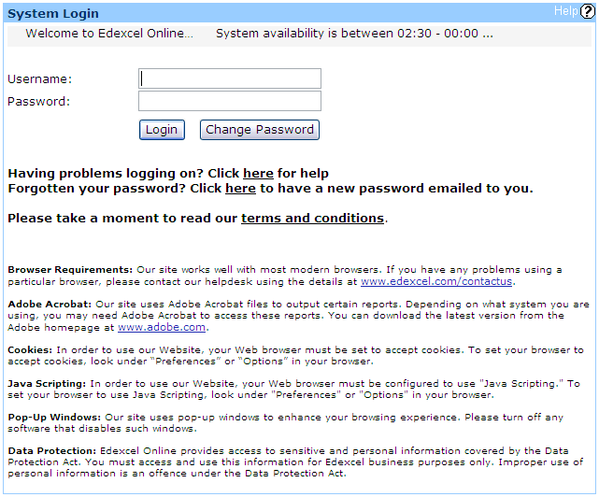

Select itheround at the online are e. so the 10th mmencing 14th contact me.rs when the onscreen version of functional skillsthe **FS/Diploma** tab at the top of the screen.

To register your learners for either the Functional Skills English or Functional Skills Mathematics test, select **Register candidate**.

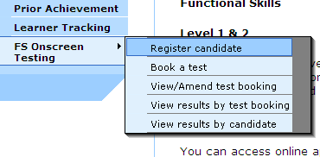

You will then be required to enter the enrolment date for your learner. Once entered you should confirm that this information is correct by ticking the box and selecting **Next.**

**Please note:** The SRF option should be set to ‘**No’**

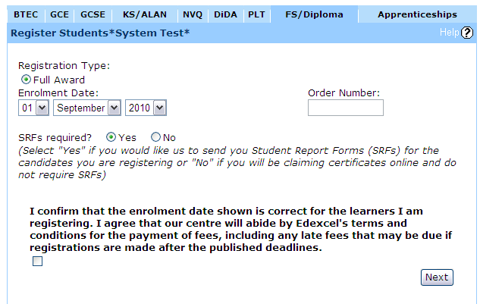

After selecting **Next**, you should have a drop down list of courses to register your learner for.

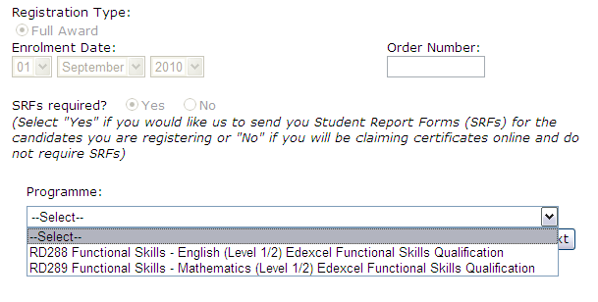

Now you have chosen your desired programme, the option whether to register **individual** or **bulk** learners should be available.



To register learners individually you will be expected to complete all mandatory fields (excluding ULN) as shown below:

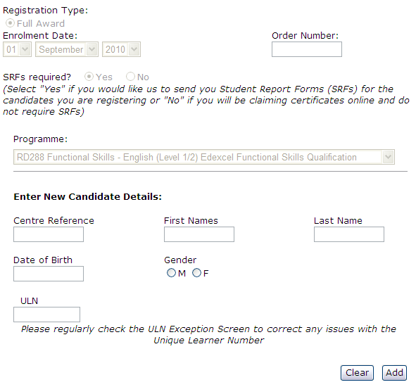

On completing a learner’s details simply select **Add** which will provide you with a summary of details just submitted. At this stage, we ask that you review your learner’s details. If your submitted details are correct simply select the **Register** button.

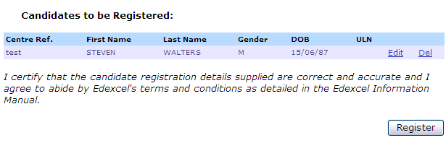

On completion of registering your learners, you will then be able to print off a Confirmation report by clicking on the **Confirmation Report** button at the bottom of the page.

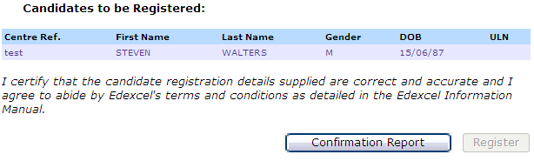

Below is an example of a Functional Skills confirmation report.

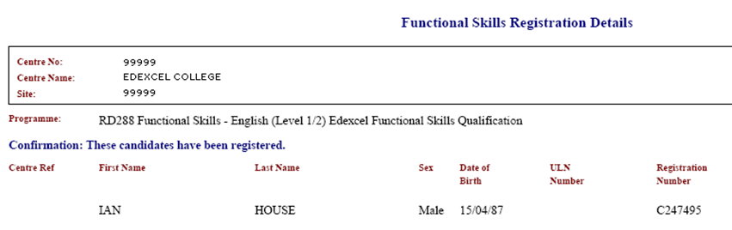

For those wishing to register large groups of learners, the bulk registration process enables **200 learners** to be registered at the same time.

To register learners in bulk you will be required to complete the registration template.

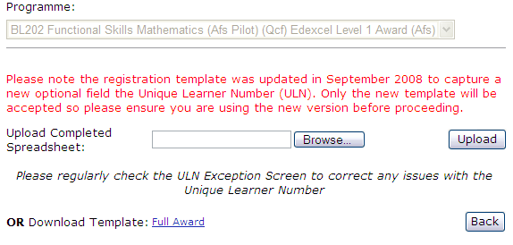

The mandatory fields for the registration template are shown below:

First name

Last name

Gender

Date of Birth (DOB)

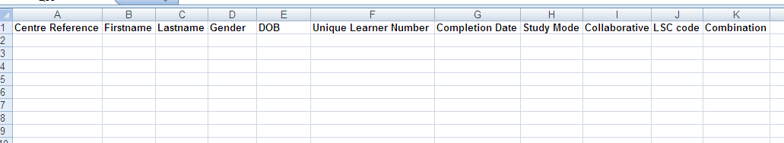

Once you have entered your learner’s details onto the template, you will be required to upload your template and again review your learner’s details.

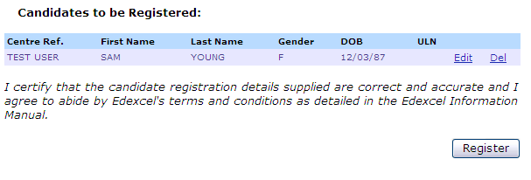

To confirm your learner details select **Register.** You will then be able to print off a Confirmation Report by clicking on the **Confirmation Report** button at the bottom of the page.



See below for a copy of the Confirmation Report:



Test bookings

After registration is complete you can book your learners straightaway for an onscreen test. Approval is required before you can make an onscreen test booking. If your centre needs to get approval please contact the approvals team by emailing [approvals@pearson.com](mailto:approvals@pearson.com)

To schedule onscreen tests you must have installed Promissor software. If your centre does not have Promissor installed you will need to complete the Onscreen application form found on [www.edexcel.com](http://www.edexcel.com).

On the Edexcel Online website select the **Book a test** function on the bottom left hand side of the page under **FS Onscreen Testing**.

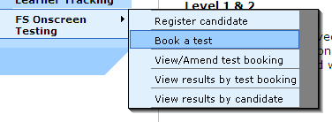

You will need to complete both the **Test setup** and **Refine learner** fields:

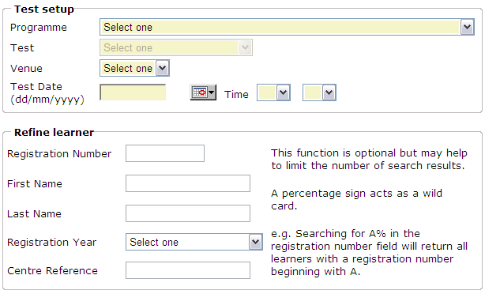

A list of all onscreen Functional Skills tests available to you will be displayed under the **Test** drop down menu.

|  |  |
| --- | --- |
| Onscreen code | Subject |
| **ENR01** | English Reading level 1 |
| **ENR02** | English Reading level 2 |
| **ENW01** | English Writing level 1 |
| **ENW02** | English Writing level 2 |
| **MAT01** | Mathematics level 1 |
| **MAT02** | Mathematics level 2 |

A venue code (also referred to as the Promissor ID) is allocated to each installation of the software in the form of three letters and three numbers **i.e. ABC123**

Note that when selecting the test date and time, the earliest a test can be scheduled is 2 hours in advance.

The **Refine learner** function allows you to choose which registered learners you wish to sit the test. All fields can be used to search for learners but they are not compulsory. Click **next** when you are ready to proceed.

The next screen will confirm your test booking details and supply you with a list of

registered learners filtered by the refine learner search. You can use the column headings to search and choose to view a different number of learners per page.

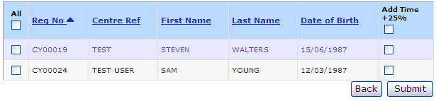

You can choose how many learners you wish to view per page. The list can also be sorted by heading.

Select the learners who will take the test by completing the tick box next to the learner name on the left-hand side.

Select the learners you would like to enter for the test and click **Submit**.

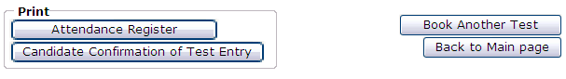

The learners have now been booked and will each have a unique Username and Password.

To print out the usernames and passwords select either the **Attendance Register** or **Learner Confirmation of Test Entry**.

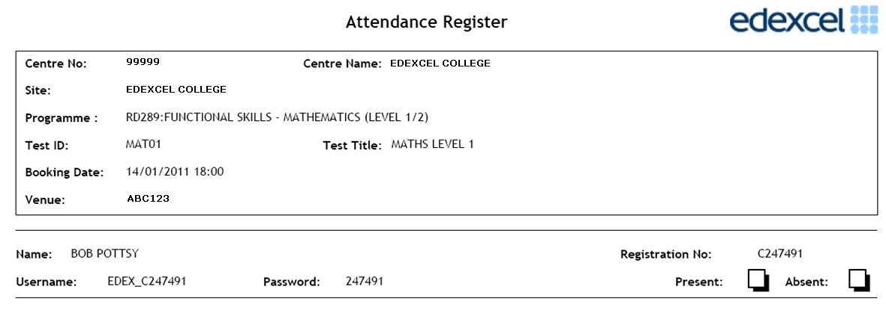

Viewing and amending test bookings

To amend test bookings you will need to navigate to the **View/Amend test booking** function on the left hand side of the screen.

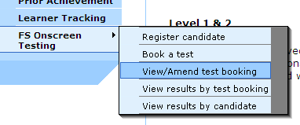

To complete the **Booking search** section, you can use as many or as few of the search criteria as you like.

When ready click **Next** to find your test booking.

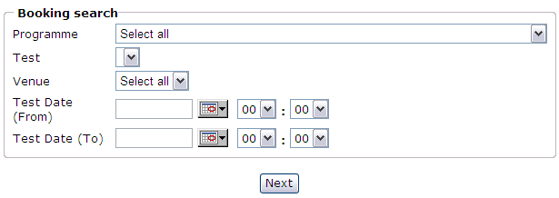

Once your booking has been located, you will be given a range of options as shown below:



To edit the test booking, simply select the **Amend** button.

You will then be given the option to edit the venue, test time and date of the booking. When you have finalised your amendments, click **Submit** to update.

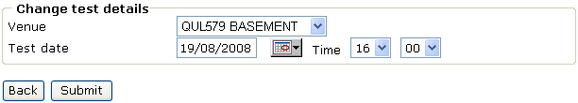

To make amendments to a specific learner, click the number under **Count of Reg**. This will direct you to the list of the learners entered for your particular test booking.



At this point it is possible to add to or delete learners from the test booking, or to edit the test booking details for an individual learner.

You also have the option to edit the venue (Promissor ID), test time and date and add or remove additional time for individual learners by clicking **Amend**. Once you have made your amendments click **Submit** to update your test booking. The Attendance Register and Learner Confirmation of Test Entry documents will be automatically updated.



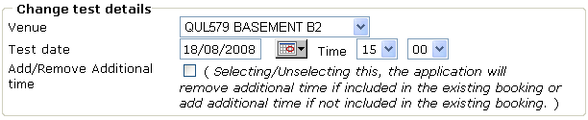

Preparation for the test

Navigate to the **Enterprise Site Manager (ESM) Server Start up** on your workstation. Select **Start** then **Browser** on the dialogue box.

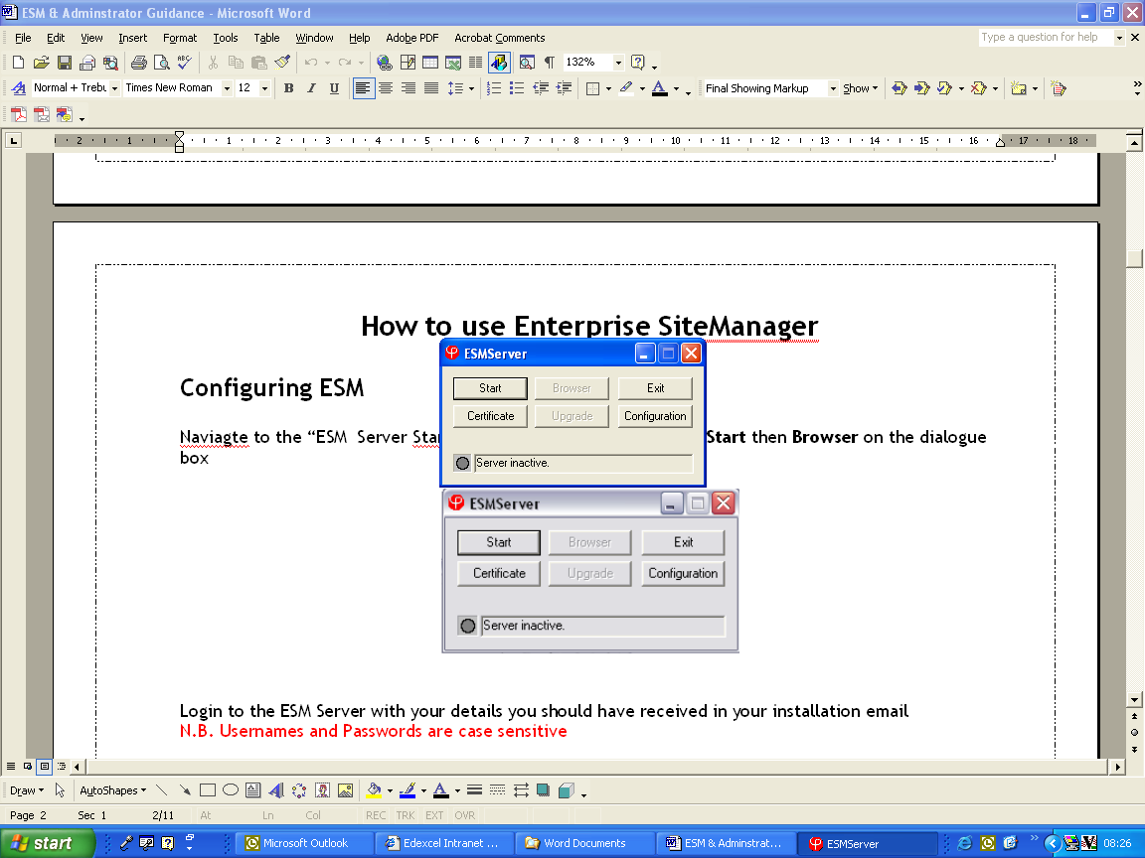

Login to the **ESM Server**. (**Please Note:** Usernames and passwords are case sensitive).

Once you have logged in, you will be in the **Inbox** (shown on the next page) where all your scheduled tests will initially first appear 3 days before the scheduled date. You must be connected to the internet to download your learner bookings.

In order to allow learners to begin testing, you will need to select the test(s) that you will be administering. This is done by clicking in the tick box next to the learner. An **Unlock** button will appear at the bottom of the page. This needs to be selected. The learner status will then change to unlock.

Learners’ tests can be unlocked up to 4 hours before and up to 4 hours after the scheduled test time. This means they can log in and take the test within the 8 hour window.

Please see the diagram below for more functions available on Enterprise SiteManager.

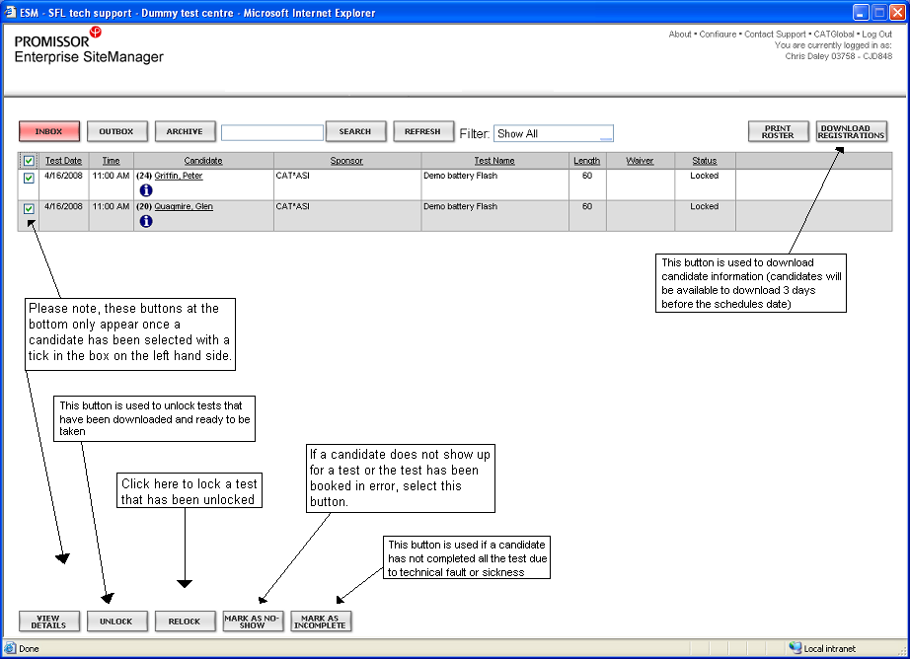

To prevent technical problems on the day, we strongly advise clearing your workstation’s cache before every test as well as taking a diagnostic test prior to the test date. As an additional measure, you should ask your IT team to make sure of the following on each learner’s workstation:

Each learner PC/login should have FULL read write permissions to the ESM_Test_Centre folder

Each learner PC/login should have FULL read/write permissions to the Administrator folder on the C:\Program Files\Promissor

Laptop testing

You can use laptops to administer the onscreen tests. You can do this by either installing both the ESM and Administrator software onto one Laptop or by using a wireless network if taking more than one laptop out at any one time. Please contact our technical support team on 0844 576 0024 for guidance on correctly installing the software.

If you intend to use the laptops to test without a connection to the internet, additional steps must be taken to ensure a successful testing session. The tests must be scheduled in advance whilst a connection is available.

Before taking your laptop offline, you will need to make some simple checks:

have learners been scheduled for the correct tests?

are all learner username and password details available?

are all tests showing in your inbox with the correct date and time?

make sure all test content is downloaded by following the instructions given below.

Log into your ESM and select **Download Registrations**.

To ensure all test content has successfully been downloaded, navigate to the top right-hand corner of your ESM and select **Configure**.

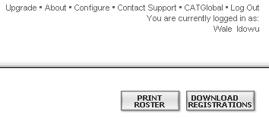

This will take you to a pop-up screen where you should then select **File Transfer**. In this screenshot click the **Download TDF** button. By clicking this button, you will see the TDF files downloading. As soon as all the TDFs say **Available**, your tests are ready to be taken offline.

Taking the test

The tests administrator must unlock the scheduled tests using Enterprise SiteManager.

Once each learner’s test has been unlocked, open up the **Administrator** software and provide each learner with their login details.

These login details can be provided using the print out from Edexcel Online.

Learners can then log in:

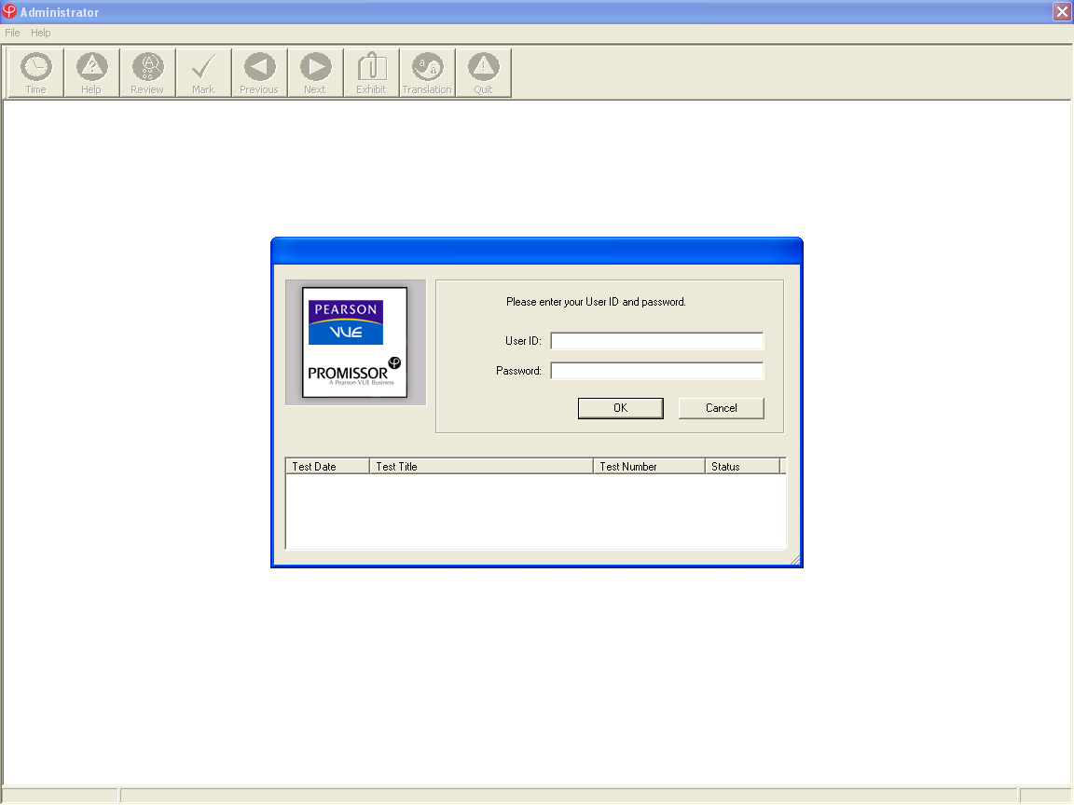

As soon as the learners are logged in they should be able to view their awaiting test.

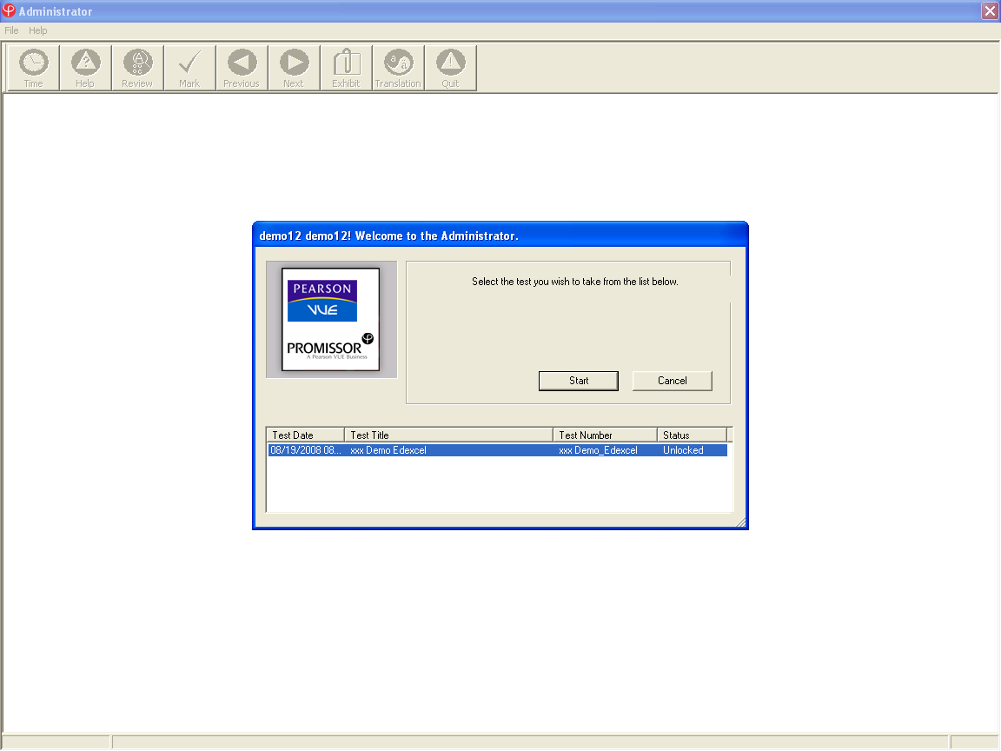

The learner will see welcome pages stating their details, the test details and any specific instructions they may need to follow.

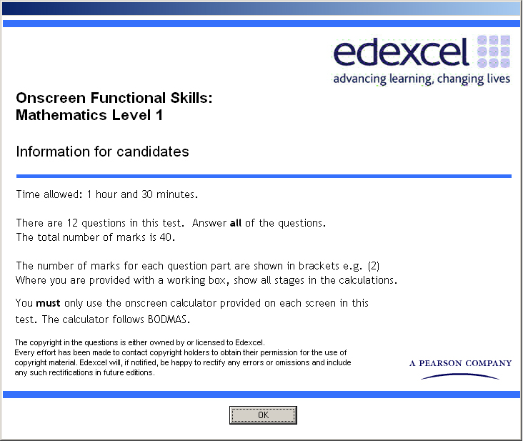

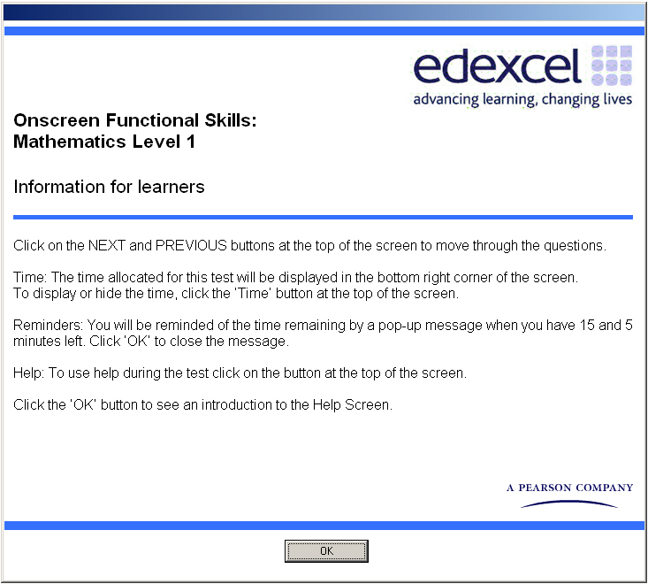

Before the learner starts, the system will show the learner a brief tutorial of all the available buttons.

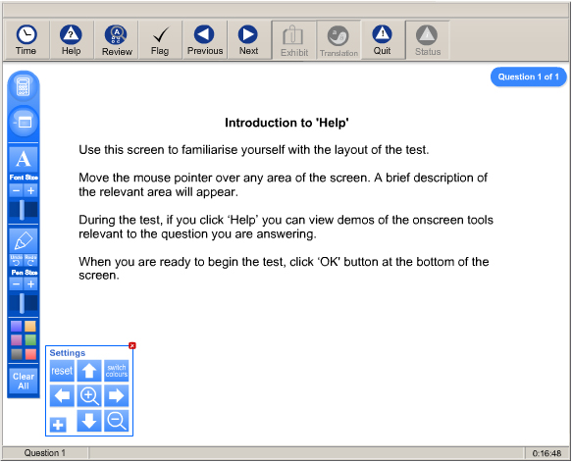

|  |  |
| --- | --- |
| Button | Description |
|  | The ‘Time’ button will show the time you have taken so far in the bottom right hand corner. Clicking this icon displays or hides the time. |
|  | The ‘Help’ button shows the help screen that you are currently using. During the test the timer continues while you are looking at this screen. |
|  | The ‘Review' button displays a window that enables you to review questions already viewed, indicating those answered and flagged.  To review all items ensure the ‘view flagged questions only’ checkbox is unchecked.  Double-click on the question number to go to the question you want to review. |
|  | The ‘Flag’ button flags the current question for review. The button appears light if the question is flagged.  The question can then be reviewed later by selecting it from the review window. |
|  | The ‘Previous’ button allows you to go to the previous question. |
|  | The ‘Next’ button allows you to go to the next question. |
| **quit** | The ‘Quit’ button enables you to exit the test at any time. Note that once you click on this button you will not be able to go back into the test, even if you had not finished it. |
| **exhibit** | The ‘Exhibit’ button displays any additional information the candidate might need, e.g. formulae lists. |

When the learner is familiar with the **Administrator** software, they can start their test.

Invigilators must ensure that learners check that their name and test details are correct before commencing the test.

During the test, learners will receive time alerts at 30mins, 15mins and 5mins remaining until the end of the test. The prompts will be displayed as follows:

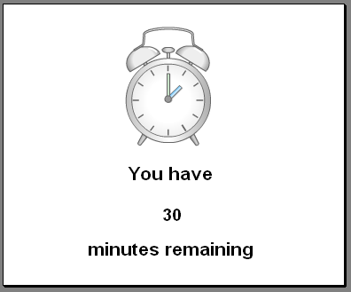 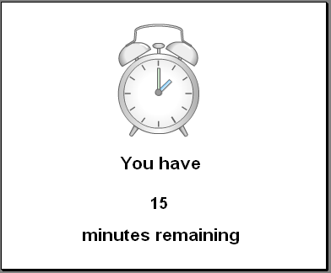 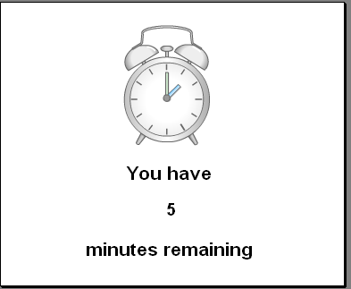

As soon as the learner finishes their test or the allotted time has expired, a summary of questions answered will be displayed. If the total time allotted for the test has not elapsed, the learner can review their answers and return to the test if they wish to change any of their answers.

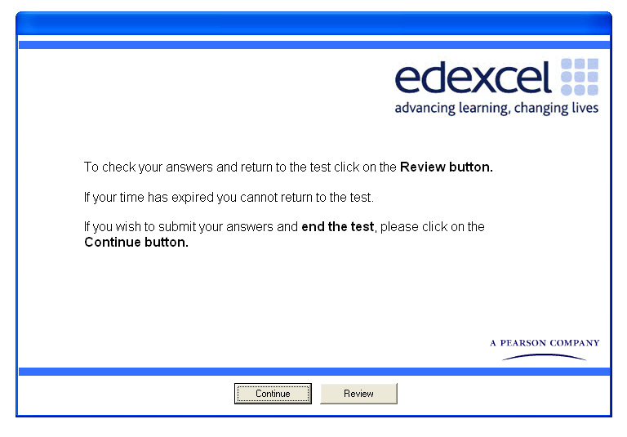

Now that all answers have been reviewed the learner should select **OK** and wait patiently for the invigilator.

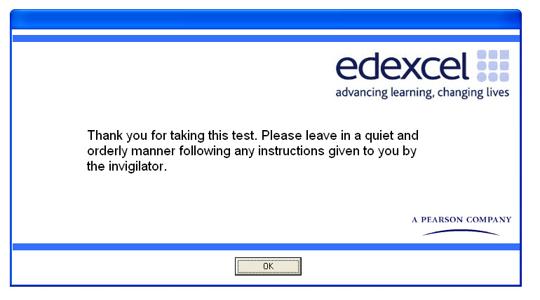

Once the test is finished, to close the **Administrator** program, you will need to select **Cancel** on the login screen followed by **File** then **Exit.**

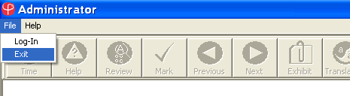

After the test

Once the Test is over, Log back into the **ESM Server**. All the tests are now in the **Outbox**. Select all of them and click **Upload Results** at the bottom of the screen. This ensures that the learners’ tests are sent to Edexcel.

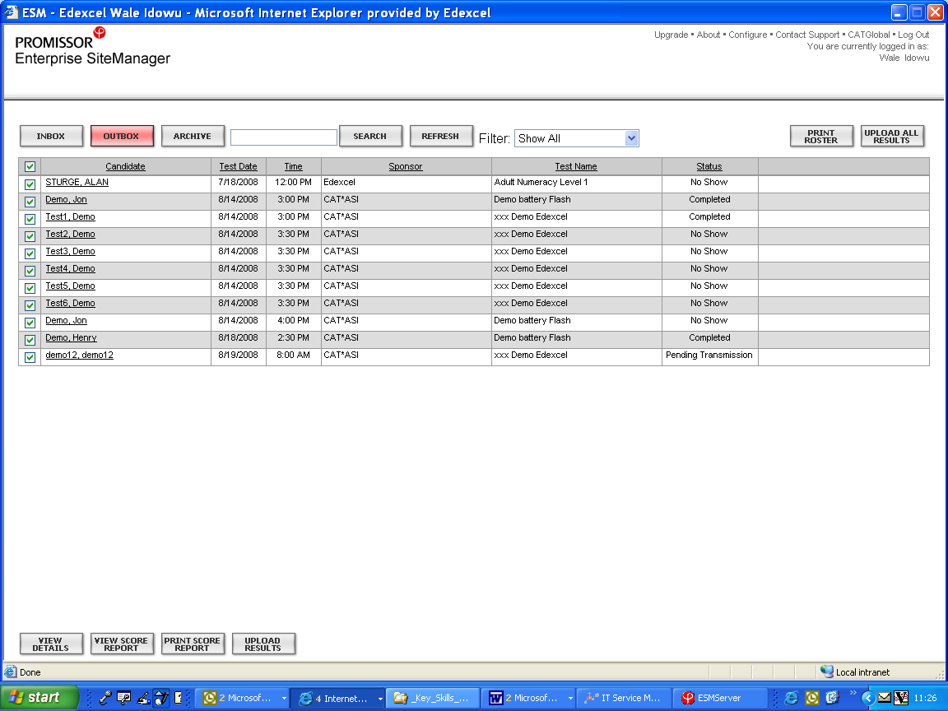

You must keep all evidence of attendance sheets that are produced at the end of the tests for every learner present. These are to be used as proof of attendance and should be stored in centres for all learners for two months after the tests. The attendance sheets may be requested at any time during this period by Edexcel.

**Please note**: Please upload all tests to us on the day of the exam, once all learners have finished. If this is not possible, please upload the tests as soon as possible or contact us on **0844 576 0024**.

Below is a print out of a **Functional Skills Evidence of Attendance**.

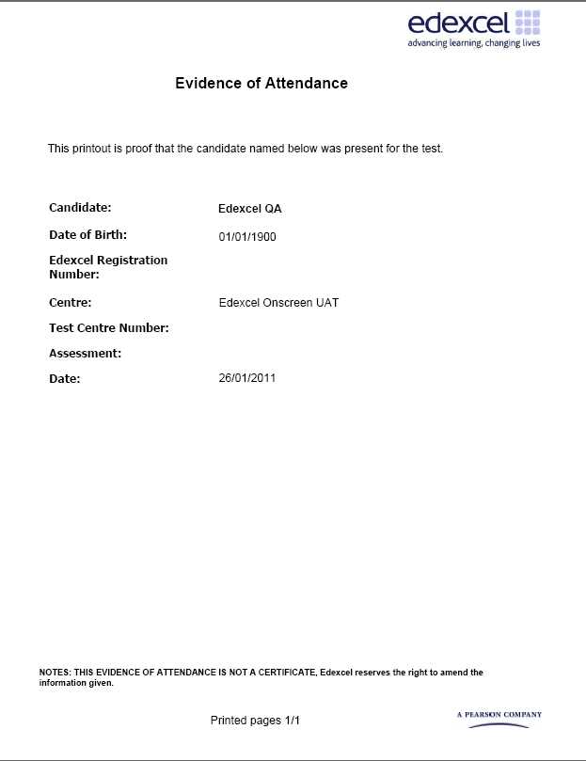

Special requirements/considerations

For our new Functional Skills onscreen tests, we ask that all Access Arrangements requests (submitted at least 5 working days before the day of the test) and all special consideration requests (submitted within 2 working days of uploading your learner’s onscreen tests) are sent to our Special Requirements team ([special.requirements@pearson.com](mailto:special.requirements@pearson.com))

As part of the onscreen test we now include a tool that allows colour filtering (working in a similar way to a coloured overlay) and a low vision aid / magnifier that some candidates may find useful. These enhancements do not replace the guidance given on the JCQ website: [www.jcq.org.uk/jcq_top_ten/index.cfm](http://www.jcq.org.uk/jcq_top_ten/index.cfm).

For learners that require Access Arrangements (including additional time over 25%) for their Functional Skills tests, the request will need to be approved by Edexcel through the relevant JCQ application process.

Fees

You are only charged for learners that complete the test. You will be charged for every test file uploaded.

Re-sits for English and Maths are priced at the cost of the original test.

Please refer to the Fees booklet located on [www.edexcel.com](http://www.edexcel.com) for information about individual units.

Invoices

We will issue invoices weekly. Both paper copy and online invoices are available. To access invoice details online please follow these instructions:

Log into Edexcel Online: [www.edexcelonline.com](http://www.edexcelonline.com)

Click ‘Home’ link at the top of the page

From the menu section (at the left hand side of the page) click ‘View Invoices’

Click ‘View Summary Invoices’

You are then presented with two ways to search for invoices. The first (default) option allows a search by invoice number. Alternatively, enter two dates to see all invoices produced during the specified period

You will be provided with a summary, including the following information:

Invoice number

Invoice description

Date issued

Date due

Amount

You can also see the contents of the invoice by clicking on the 'View' button on the relevant statement. By using this function you can view the subject, or programme, and any candidates to which the invoice applies. Any invoices showing a minus figure are credit notes.

**Please note**: this information is only available to users with the new ‘Invoice Enquiries’ profile activated. Your Edexcel Online Administrator can change user profiles if required.

Functional Skills Mathematics onscreen: entry codes

|  |  |
| --- | --- |
| Subject code | Subject title (as it appears on the certificate) |
| **MAT01** | Edexcel Functional Skills qualification in Mathematics at Level 1 |
| **MAT02** | Edexcel Functional Skills qualification in Mathematics at Level 2 |

Assessment structures for Mathematics

We **strongly advise using the onscreen calculator** as it avoids the possibility of transcription errors and means your learners have more chance of including workings in the box, therefore gaining full marks for the answers they complete. However, learners may use their own calculators if they wish to do so.

The invigilator may have rough paper and pens available to help candidates plan their answers. Candidates must request this at the start of the test. Invigilators **must** collect all rough paper in at the end of the test and ensure that all materials are shredded/securely destroyed.

Assessment structure for Mathematics onscreen test at level 1

|  |  |
| --- | --- |
| **Assessment** | One external onscreen assessment |
| **Assessment Duration** | 1 hour 30 minutes |
| **Marks** | 40 marks in total |
| **Additional Information** | Calculator is provided onscreen  All coverage and range detailed in the Level 1 Maths specification may be assessed |

Assessment structure for Mathematics onscreen test at level 2

|  |  |
| --- | --- |
| **Assessment** | One external onscreen assessment |
| **Assessment Duration** | 1 hour 30 minutes |
| **Marks** | 40 marks in total |
| **Additional Information** | Calculator is provided onscreen  All coverage and range detailed in the Level 2 Maths specification may be assessed |

Functional Skills English onscreen: unit codes

|  |  |
| --- | --- |
| Unit code | Unit title |
| **ENC01** | Level 1 Unit 1 - Speaking, Listening & Communication |
| **ENR01** | Level 1 Unit 2 – Reading |
| **ENW01** | Level 1 Unit 3 - Writing |
| **ENC02** | Level 2 Unit 1 - Speaking, Listening & Communication |
| **ENR02** | Level 2 Unit 2 – Reading |
| **ENW02** | Level 2 Unit 3 - Writing |

Once all units have been successfully completed a certificate will be automatically generated.

Assessment structures for English

The invigilator may have rough paper and pens available to help candidates plan their answers. Candidates must request this at the start of the test. Invigilators **must** collect all rough paper in at the end of the test and ensure that all materials are shredded/securely destroyed.

At both levels 1 and 2 across all subjects, the Functional Skills onscreen tests are a mixture of multiple–choice questions and free text.

Assessment structure for English level 1 speaking, listening and communication

|  |  |
| --- | --- |
| **Assessment** | Internal assessment  Edexcel will provide guidance on devising activities to meet the skill standard to you  Learners must complete two activities (formal and informal discussions) |
| **Assessment Duration** | 30 minutes |
| **Marks** | Pass or Fail |
| **Additional Information** | Learners must achieve all Level 1 criteria across the two activities at least once  One Assessment record sheet should be used to assess a learner across both activities |

Assessment structure for English reading onscreen test at level 1

|  |  |
| --- | --- |
| **Assessment** | Externally assessed |
| **Assessment Duration** | 45 minute exam |
| **Marks** | 20 |
| **Additional Information** | Learners will be given two texts based on a single context and will answer all questions on each text |

Assessment structure for English writing onscreen test at level 1

|  |  |
| --- | --- |
| **Assessment** | Externally assessed |
| **Assessment Duration** | 45 minute exam |
| **Marks** | 25 |
| **Additional Information** | Learners will be given two writing tasks with contexts  Learners will answer both tasks |

Assessment structure for English level 2 speaking, listening and communication

|  |  |
| --- | --- |
| **Assessment** | Internally assessed  Edexcel will provide guidance on devising activities to meet the skill standard to you  Learners must complete two activities (discussion and presentation) |
| **Assessment Duration** | 30 minutes |
| **Marks** | Pass or Fail |
| **Additional Information** | Learners must achieve all level 2 criteria across the two activities at least once |

Assessment structure for English reading onscreen test at level 2

|  |  |
| --- | --- |
| **Assessment** | Externally assessed |
| **Assessment Duration** | 45 minute exam |
| **Marks** | 25 |
| **Additional Information** | Learners will be given two texts based on a single context and will answer all questions on each text |

Assessment structure for English writing onscreen test at level 2

|  |  |
| --- | --- |
| **Assessment** | Externally assessed |
| **Assessment Duration** | 45 minute exam |
| **Marks** | 25 |
| **Additional Information** | Learners will be assessed on two writing tasks with contexts. Learners will answer both tasks |

Submission of learner achievement for English speaking, listening and communication (ENC01 and ENC02)

You can submit a claim for the Speaking, Listening and Communication unit provided they have registered on OSCA and been through the reference materials. For further information regarding registering on OSCA and the reference materials please see the Functional Skills Quality Assurance Handbook or log in to Edexcel Online.

You can submit marks for the speaking, listening and communication unit on Edexcel Online. You will need to click on the **FS Onscreen Testing** tab from the menu on the left and then select **Speaking & Listening Claim** from the drop down menu.

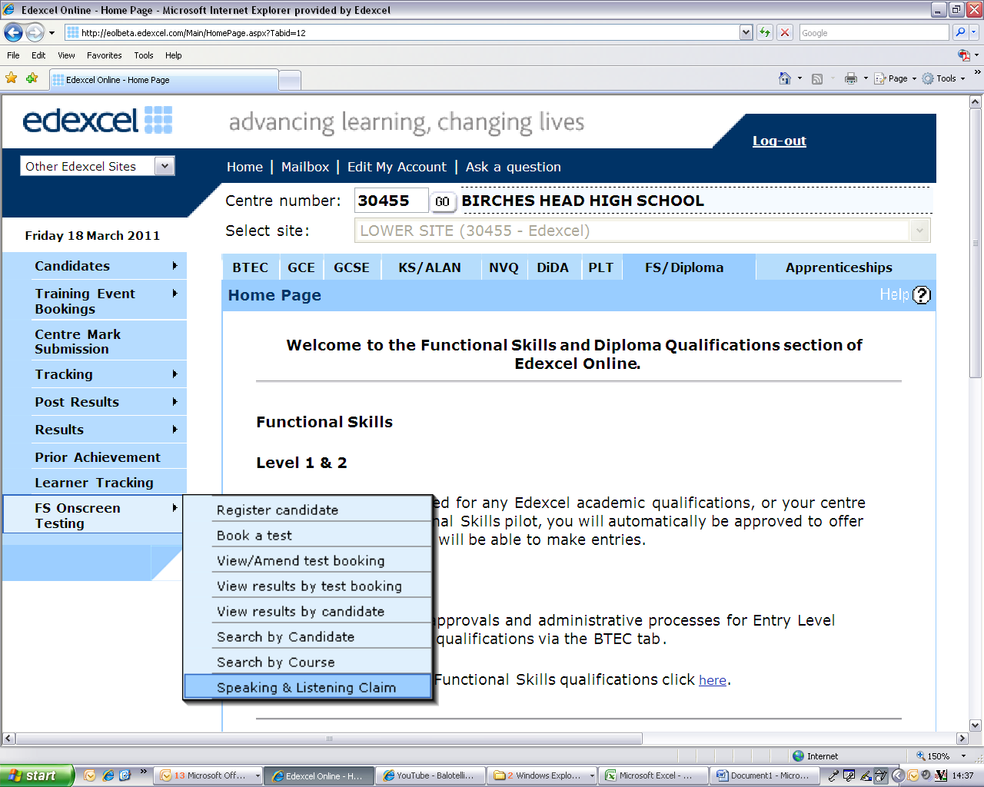

Once you have selected **Speaking and Listening Claim** from the menu, you can either search for a specific candidate or a group of candidates by level.

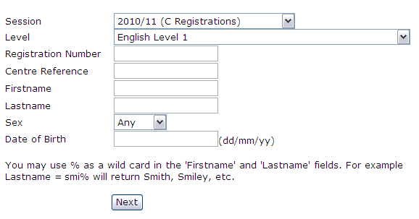

Once you have selected which candidate(s) to submit claims for, a list of candidates will appear.

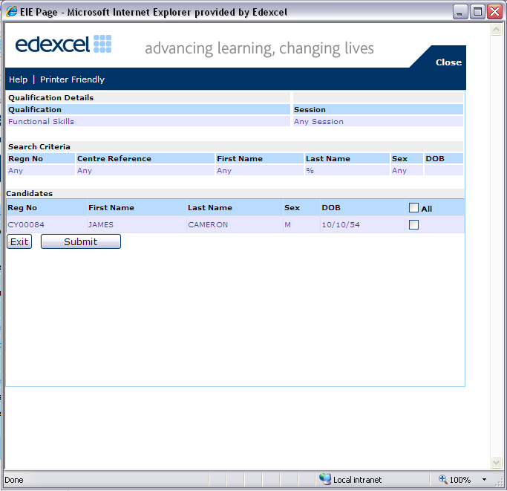



You simply need to click the box on the right of each candidate to submit a claim. Once you have submitted all your claims, a confirmation window will appear confirming the number of candidates you are making claims for.

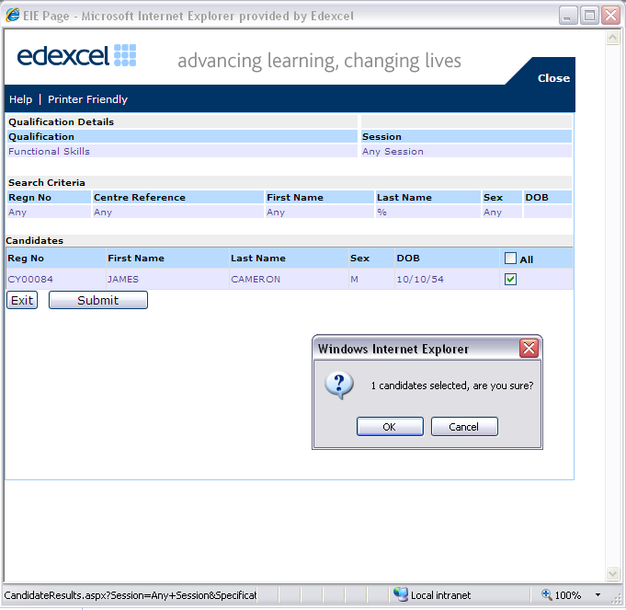

After confirming your claims, a summary window will appear.

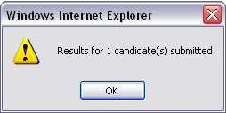

Once confirmed, all submitted learners will disappear leaving only the outstanding learners that have not had their speaking, listening and communication claims entered.

Viewing onscreen results

To view a learner’s onscreen results you will need to log in to Edexcel Online.

Select the **FS/Diploma** tab at the top of the screen.



There are two ways to view your learner’s onscreen results on Edexcel Online:

View results by test booking

View results by candidate

You will then be required to select **View results by test booking**

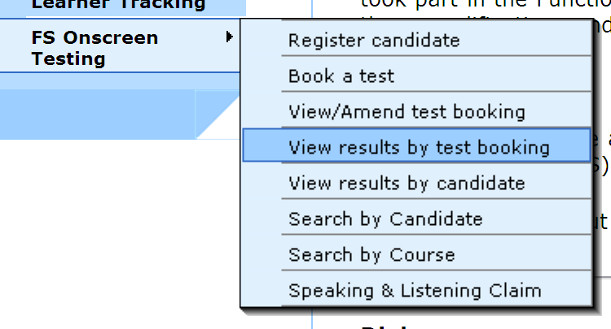

In order to view results, you will be required to complete the booking search options (similar to the fields required to schedule an onscreen test).

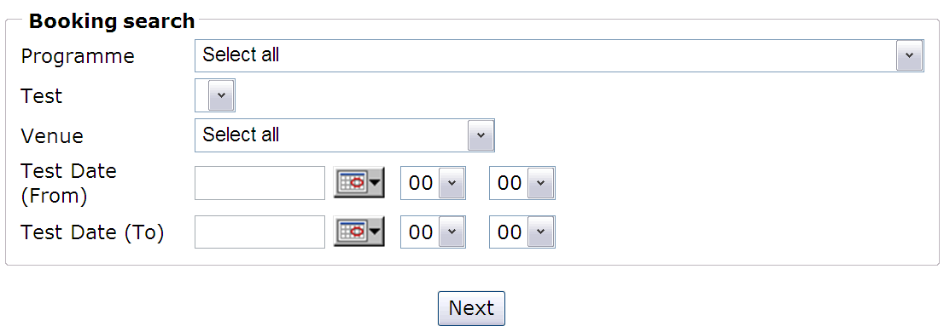

Once you have entered your desired test booking details, you will be able to view a summary of your test.

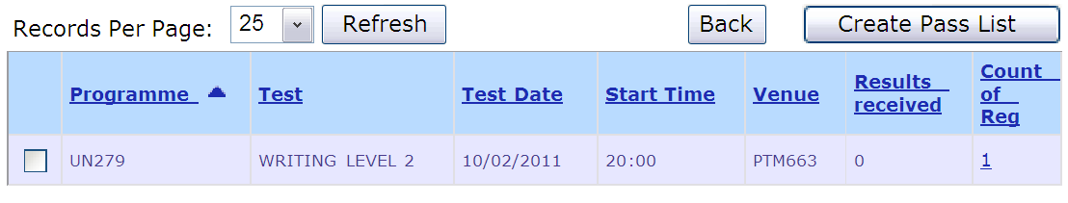

The following fields can be sorted, which should help speed up this process:

|  |  |
| --- | --- |
| Programme  Test  Test date  Start time | Venue  Results received  Count of registration |

By selecting the test booking of your choice, you will have the possibility of creating your own pass list, by clicking on the **Create Pass List** button. Another alternative is to use the **View results by candidate** facility which enables you to search all onscreen results for a specific learner.

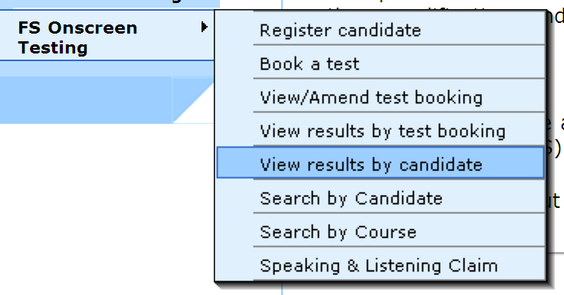

Once selected, you have the option to search for a particular learner or by a group of learners from a specified registration year or programme.

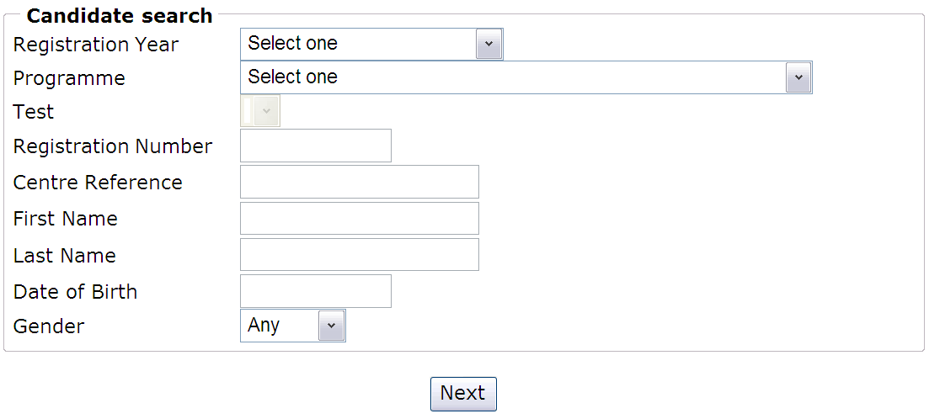

The example below has chosen to search results for all learners that have taken the Functional Skills Mathematics onscreen tests.

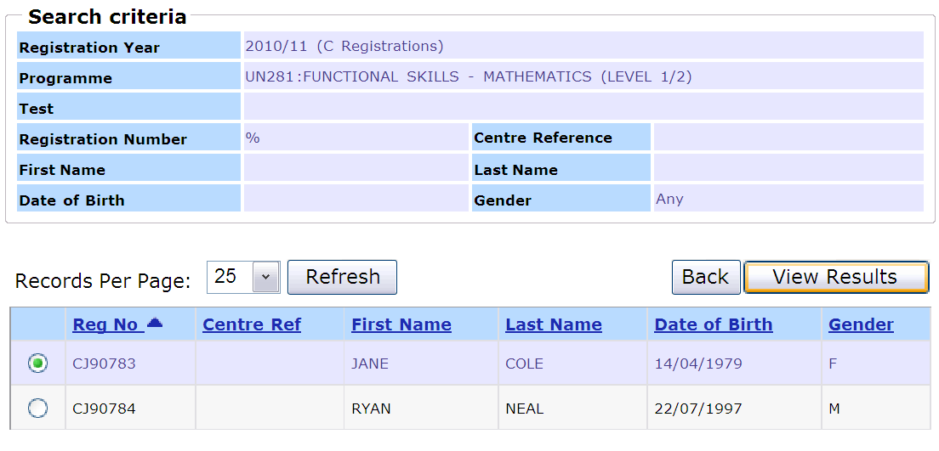



By selecting the learner of your choice, you simply have to select the **View Results** button which will then list all onscreen results for that learner. In the example below, **Jane Cole** received a score of **17 out of 40** for her **Mathematics level 1 test**.

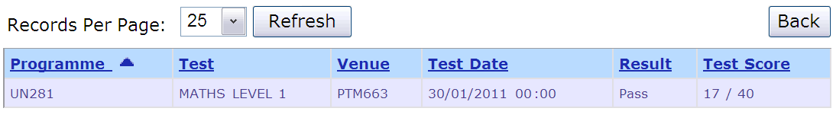

Occasionally, when a learner takes a new test version, the result status may appear as Grading, as shown in the example below.

This means that the process of grading is underway, with the result to be updated shortly.

Results

Component results

You will receive a Notification Of Performance (NOP) detailing individual component results for maths and English.

Qualification results

Learners must pass each unit to be awarded a qualification pass. For English only where no exemption has been granted, the result for the speaking, listening and communication unit must be entered on Edexcel Online to enable learners to receive their qualification result.

Test results will be available via Edexcel Online within four weeks of Edexcel receiving the test file.

Resits

Learners can be entered to re-sit on the same day the initial results are received, after that it is left open to centres wanting to book a resit prior to results otherwise.

Malpractice and plagiarism

For up-to-date advice on malpractice and plagiarism, please refer to the Joint Council for Qualifications’ **Suspected Malpractice in Examinations: Policies and Procedures** document on the JCQ website: [www.jcq.org.uk](http://www.jcq.org.uk)

Certification

Claiming certificates

Once a learner has completed and passed all the necessary units to obtain the functional skills qualification, our system will automatically issue a certificate. Certificates will normally arrive in centres within 10 working days after results have been issued on Edexcel Online.

Please note certification for English will be blocked for centres that have not completed the OSCA accreditation process. As the speaking and listening unit is internally assessed, accreditation is needed before we can accept the speaking and listening marks. For more information about completing OSCA accreditation please refer to the Quality Assurance Handbook found on the functional skills pages on: [www.edexcel.com/fs](http://www.edexcel.com/fs)

You no longer need to return uncollected certificates to Edexcel. You may destroy them, confidentially, after 12 months from date of receipt.

Spiky profile

A spiky profile is only possible for the English Functional Skills qualification and is simply where a learner has been entered for different units at different levels. For example:

|  |  |  |  |  |
| --- | --- | --- | --- | --- |
| Unit title | Unit level | Unit level | Unit level | Certification |
| **Speaking & Listening** | 2 | 1 | 1 | Level 1 |
| **Reading** | 1 | 2 | 1 | Level 1 |
| **Writing** | 1 | 1 | 2 | Level 1 |

In this scenario, the learner will achieve a pass at the lowest completed level across all units. If your centre has learners who wish to complete a spiky profile please email details to the Service Operations team ([serviceoperations@pearson.com](mailto:serviceoperations@pearson.com)).

Mixing paper and onscreen test results

If your centre has learners that wish to mix paper and onscreen results you will need to complete our Functional Skills: Merging Paper and Onscreen results form. The following details are required:

Learner details (first name, surname, date of birth)

Onscreen Functional Skills registration number

Learner’s paper based UCI number and exam session

The form can be downloaded from the website on the Functional Skills (Onscreen) webpage under Administration and Assessment. The completed form must be emailed to the System and Process Support team: eprocessing@pearson.com.

Where learners have achieved the Functional Skills qualification by combining units from the paper based test with units from the onscreen tests, certificates will not be issued automatically.

For English, where a learner has completed the reading and writing units by using a mixture of paper based and onscreen tests, you are required to submit their own Speaking and listening claims on Edexcel Online. Ops Management are unable to submit the speaking & listening claim on a centre’s behalf.

You may claim the speaking and listening unit via the FS Onscreen testing section of Edexcel Online, if at least one unit (reading/writing) was achieved using the onscreen test.

For further information please contact Ops Management: eprocessing@pearson.com.

Post-results services (Functional Skills onscreen testing)

Please note that Enquiries about Results requests can only be submitted by sending an email to: [FSonscreenPRS@pearson.com](mailto:FSonscreenPRS@pearson.com).

The email needs to include the following information:

Centre number

Registration number

Test/unit code

Date of test

The window for you to apply for the Post Results services below opens on the day a result is issued for a test and closes 10 calendar days after the result was issued.

You are advised to submit applications at the earliest opportunity, as applications cannot be made after the window has closed. All Post Results applications received outside this window will not be accepted.

The following Post Results services are available for Onscreen Functional Skills.

EAR Service 1: clerical re-check

This service constitutes a re-check of all clerical procedures which lead to the issue of a result. This service might be considered when anomalous results have been issued for one candidate, compared to the rest of the cohort.

This service includes the following checks:

all parts of the script have been marked

the totalling of marks

the recording of marks

the application of any adjustments

the application of grade thresholds.

We aim to complete the enquiry within 20 days of acknowledging the request.

The fee for this service is £10.30.

EAR Service 2: Post-results review of marking

This service will include:

the clerical re-check (EAR Service 1)

the review of marking of units/components by a senior examiner

Please note that Service 2 is available to individual candidates. Results for each candidate will be reported separately.

We aim to complete the enquiry within 30 days of acknowledging the request. The fee for this service is £23.20.

Checklist

This checklist will assist your centre in administrating your onscreen Functional Skills

Test.

Pre-test

1. Have you scheduled your learners onto the correct level and test?
2. Have you completed a demo test on your desired workstation(s)?
3. Have you printed out the entire attendance register for all learners?

During test

1. Have all tests been unlocked?
2. Is the correct learner sitting the correct test?
3. Are exam conditions being met in accordance with the Instructions for the **Conduct of Onscreen Tests (Functional Skills)**?

After test

1. Have all learners logged out of their test?
2. Have all tests been successfully uploaded back to Edexcel?

Contact us

|  |  |
| --- | --- |
| **Assessment queries:** | [fsassessment@pearson.com](mailto:fsassessment@pearson.com) |
| **Registration and Booking queries** | [serviceoperations@pearson.com](mailto:serviceoperations@pearson.com) |
| **Commercial queries** (teacher resources, initial assessment tool, work based learning, etc.) | [functionalskills@pearson.com](mailto:functionalskills@pearson.com) |
| **Subject Specific Support**  English  Maths | [TeachingEnglish@pearson.com](mailto:TeachingEnglish@pearson.com)  [TeachingMaths@pearson.com](mailto:TeachingMaths@pearson.com) |
| **Technical Support** | Onscreen Testing: +44 (0)844 576 0024 |

Please click [here](http://www.edexcel.com/Aboutus/contact-us/Pages/home.aspx) to view contact details for our various teams who work with schools and further education colleges.

Please click [here](http://pearsonwbl.edexcel.com/about-wbl/Pages/Contact-us.aspx) to view contact details for our various teams who work with work-based learning providers.