**OCR-set Assignment**

**Sample Assessment Material**

OCR Level 1/Level 2 Cambridge National in Engineering Programmable Systems Sample Set Assignment

Unit R048: Making and testing electronic circuits

This is a sample set assignment which should only be used for practice.

This assignment **must not** be used for live assessment of students.

The live assignments will be available on our secure website, ‘Teach Cambridge'.

**The OCR administrative codes associated with this unit are:**

* unit entry code R048
* certification code J824

**The regulated qualification number associated with this unit is:**

603/7088/9

##### Duration: Approximately 10 - 12 hours

ALL OF THIS MATERIAL MAY BE PHOTOCOPIED. Any photocopying will be done under the terms of the Copyright Designs and Patents Act 1988 solely for the purposes of assessment.

Contents

Information for teachers - Using this assignment 3

Scenario for the assignment 4

Your tasks and marking grids 6

Task 1 – Drawing and simulating electronic circuits 6

Task 2 – Constructing electronic circuits 8

Task 3 – Testing electronic circuits 10

Marking criteria command words 12

Teacher Observation Record 15

Teacher observation record guidance notes 16

# **Information for teachers** **Using this assignment**

You **must**:

* make sure you are familiar with the Assessment Guidance relating to the tasks. This is with the unit content in Section 4 of the [Specification](https://www.ocr.org.uk/qualifications/cambridge-nationals/engineering-programmable-systems-level-1-2-j824/).
* make sure that you have read and understood **all** the rules and guidance provided in Section 6 of the [Specification](https://www.ocr.org.uk/qualifications/cambridge-nationals/engineering-programmable-systems-level-1-2-j824/) **before** your students complete and you assess the set assignments.
* make sure that completion and assessment fully adhere to the rules and guidance provided in Section 6 of the [Specification](https://www.ocr.org.uk/qualifications/cambridge-nationals/engineering-programmable-systems-level-1-2-j824/).
* provide students with the [Engineering Programmable Systems Student guide to NEA assignments](https://www.ocr.org.uk/Images/620502-student-guide-to-nea-assignments.pdf) before they start the assignments.
* allow students approximately 10-12 guided learning hours (GLH) to complete all tasks.
* complete the Teacher Observation Record provided on page 15 for Task 2. You must adhere to the guidance given on page 16 when completing it.

You **must not**:

* change or modify this assignment in any way.

## Scenario for the assignment

Kitchen timer

A manufacturer of household timers wants to manufacture an electronic version of their mechanical kitchen timer.

The system must meet the following design specification:

* + - The timer must run for between 1 and 3 minutes
    - Power is applied to the circuit when the switch SW1 is closed
    - The circuit starts timing when the switch SW2 is pressed
    - When the time period has ended the red light-emitting diode LED1 turns on and the buzzer BZ1 sounds
    - The time period is set by adjusting the variable resistor VR1

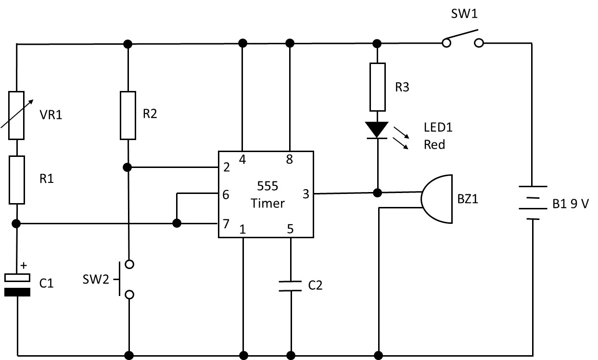**Fig.1** shows the timer schematic diagram designed for the new timer.

**Fig.1. Timer schematic diagram**

**Parts List:**

|  |  |
| --- | --- |
| 555 Timer Integrated Circuit (IC)  8pin Dual In Line (DIL) socket for IC    Resistor R1 10 K  Resistor R2 10 K  Resistor R3 330 R  Resistor VR1 – 1M variable  Capacitor C1 220 µF 16 V  Capacitor C2 0.1 µF | LED1 Red (any suitable red LED)  BZ1 Buzzer 9-12 V  SW1 Switch  SW2 Switch Push to Make  B1 9 V battery |

**Read through all of the tasks carefully, so that you know what you will need to do to complete this assignment.**

**Important:**

* You will need to refer to the marking criteria grid. Your teacher can explain the marking criteria if you need further clarification.
* You will need to draw upon relevant skills/knowledge/understanding from other units you have studied in this qualification.

## Your tasks and marking grids

### Task 1 – Drawing and simulating electronic circuits

Topic Area 1 is assessed in this task.

You are to use appropriate Computer Aided Design (CAD) software to test the circuit functions correctly, and to produce a Printed Circuit Board (PCB) layout.

You must:

* draw the circuit schematic in the CAD software.
* simulate the circuit operation to show that the circuit functions correctly.
* produce a PCB layout showing both track and component views.

Total marks for Task 1: 21 marks

**Task 1 Tips**

* Use annotated screen shots to show step by step how you have used the CAD software to draw and simulate the circuit
* Simulate the circuit by adjusting VR1 and operating SW1, making any corrections as appropriate
* Make sure you show both track and component views of the PCB layout

**Topic Area 1: Drawing and simulating electronic circuits**

|  |  |  |
| --- | --- | --- |
| **MB1: 1–2 marks** | **MB2: 3-4 marks** | **MB3: 5-6 marks** |
| Produces circuit schematic diagram with **limited** accuracy using CAD software. | Produces circuit schematic diagram with **partial** accuracy using CAD software. | Produces **fully** accurate circuit schematic diagram using CAD software. |
| **MB1: 1–2 marks** | **MB2: 3-4 marks** | **MB3: 5-6 marks** |
| Undertakes **basic** testing of the circuit, using circuit simulation and test features of CAD software prior to PCB design, to show the circuit functions correctly. | Undertakes **adequate** testing of the circuit, using circuit simulation and test features of CAD software prior to PCB design, to show the circuit functions correctly. | Undertakes **comprehensive** testing of the circuit using circuit simulation and test features of CAD software prior to PCB design, to show the circuit functions correctly. |
| Takes **few** appropriate actions based on the outcomes of testing. | Takes **some** appropriate actions based on the outcomes of testing. | Takes **fully** appropriate actions based on the outcomes of testing. |
| **MB1: 1–3 marks** | **MB2: 4-6 marks** | **MB3: 7-9 marks** |
| Uses CAD software to produce a PCB layout showing track and component views, with **limited** accuracy. | Uses CAD software to produce a PCB layout showing track and component views, with **partial** accuracy. | Uses CAD software to produce a PCB layout showing track and component views, that is **fully** accurate. |

If your work does not meet Mark Band 1 criteria, you will be awarded zero marks for this task.

### Task 2 – Constructing electronic circuits

Topic Area 2 is assessed in this task.

You are to use your PCB design from Task 1 to safely manufacture a PCB and construct a working circuit.

You must:

* Safely produce a PCB
* Safely construct the circuit by:
  + Assembling the PCB with components
  + Using tools and equipment safely and correctly
  + Wiring external connections and components to the completed PCB
* Ask your teacher to complete a Teacher Observation Record for this task

Total marks for Task 2: 21 marks

**Task 2 Tips**

* Make sure you clearly show how you have planned for and worked safely when producing the PCB and constructing the circuit
* Use annotated photos or a video to show step by step how the PCB was produced, and the circuit constructed

**Topic Area 2: Constructing electronic circuits**

|  |  |  |
| --- | --- | --- |
| **MB1: 1–3 marks** | **MB2: 4-6 marks** | **MB3: 7-9 marks** |
| Demonstrates **limited** skills to produce a PCB using an appropriate method. | Demonstrates **adequate** skills to produce a PCB using an appropriate method. | Demonstrates **effective** skills to produce a PCB using an appropriate method |
| **Dependent** upon assistance to produce a PCB. | **Assisted** to produce a PCB. | Works **independently** to produce a PCB. |
| **Dependent** upon reminders of safety requirements in order to work safely. | Worked safely with **some** reminders of safety requirements. | Worked safely at **all** times without additional instruction. |
| **MB1: 1–4 marks** | **MB2: 5-8 marks** | **MB3: 9-12 marks** |
| Demonstrates **limited** skills to populate and assemble a PCB using appropriate tools and equipment. | Demonstrates **adequate** skills to populate and assemble a PCB using appropriate tools and equipment. | Demonstrates **effective** skills to populate and assemble a PCB using appropriate tools and equipment |
| **Dependent** upon assistance to populate and assemble a PCB. | **Assisted** to populate and assemble a PCB. | Works **independently** to populate and assemble a PCB. |
| **Dependent** upon reminders of safety requirements in order to work safely. | Worked safely with **some** reminders of safety requirements. | Worked safely at **all** times without additional instruction. |

|  |
| --- |
| If your work does not meet Mark Band 1 criteria, you will be awarded zero marks for this task. |

### Task 3 – Testing electronic circuits

Topic Area 3 is assessed in this task.

On completion of the PCB and circuit construction, you must test and evaluate its construction and operation against the design specification of the kitchen timer.

You must:

* Perform a visual inspection and functional testing of the assembled PCB
* Identify any faults in your own circuit, or another circuit supplied by your teacher if yours works first time
* Produce a final evaluation of the:
  + construction of the circuit
  + operation of the circuit compared to the design specification

Total marks for Task 3: 18 marks

**Task 3 Tips**

* Use annotated photos or a video to show how you have performed visual and functional testing of the assembled PCB
* Record measured circuit parameters made when functional testing and compare against expected values
* Clearly show faults you have found in your own circuit, or other circuits provided to you using annotated photos or a video
* Don’t forget to produce a final evaluation of how well your circuit was constructed and how well it operates

**Topic Area 3: Testing electronic circuits**

|  |  |  |  |
| --- | --- | --- | --- |
| **MB1: 1–3 marks** | **MB2: 4-6 marks** | | **MB3: 7-9 marks** |
| Undertakes **basic** visual and functional testing of the operation of the electronic circuit. | Undertakes **adequate** visual and functional testing of the operation of the electronic circuit. | | Undertakes **comprehensive** visual and functional testing of the operation of the electronic circuit. |
| Undertakes **basic** fault identification in electronic circuits. | Undertakes **adequate** fault identification in electronic circuits. | | Undertakes **comprehensive** fault identification in electronic circuits. |
| **MB1: 1–3 marks** | | **MB2: 4-6 marks** | **MB3: 7-9 marks** |
| Undertakes a **basic** evaluation of final circuit construction and its operation. | | Undertakes an **adequate** evaluation of final circuit construction and its operation. | Undertakes a **comprehensive** evaluation of final circuit construction and its operation. |
| If your work does not meet Mark Band 1 criteria, you will be awarded zero marks for this task. | | | | |

## Marking criteria command words

The tables below show the command words that will be used in the NEA Marking Criteria grids. They explain the type of evidence that you should expect to see to meet each command word.

**Mark Band (MB1) Words:**

|  |  |
| --- | --- |
| **Command word** | **Meaning** |
| **Basic** | * Work includes the minimum required. It is a starting point but is simplistic and not developed. * Understanding and skills are applied in a way that partly achieves the wanted or intended result, but it would not be useable without further input or work. |
| **Brief/Briefly** | * Work includes a small number of relevant facts or concepts but lacks detail, contextualisation or examples. |
| **Dependent** | * The student can perform a task when given regular assistance or help |
| **Few** | * Work produced is restricted or narrow. It includes less than half of the information or examples expected for a full response. |
| **Inefficient** | * Outputs are produced but with great expense or effort because of poor organisation or design and not making the best use of available resources. |
| **Limited** | * Work produced is restricted in range or scope and includes only some of the information required. It evidences partial rather than full understanding. * Work produced is a starting point rather than a developed process, concept or output. |
| **Minimal** | * Includes very little in amount or quantity required. |
| **Simple** | * Includes a small number of relevant parts, which are not related to each other. |
| **Superficial** | * Work completed lacks depth and detail. |

**Mark Band (MB2) Words:**

|  |  |
| --- | --- |
| **Command word** | **Meaning** |
| **Adequate(ly)** | * Work includes the appropriate number of relevant facts or concepts but does not include the full detail, contextualisation or examples. |
| **Assisted** | * The student can perform a task with occasional assistance or help. |
| **Part(ly)/Partial** | * To some extent but not completely. * Work produced is inclusive in range and scope. It evidences a mainly developed application of understanding, performance or output needed. * Work produced results in a process, concept or output that would be useable for its purpose. |
| **Some** | * Work produced is inclusive but not fully comprehensive. It includes over half the information or examples expected for a full response. |
| **Sound** | * Valid, logical, shows the student has secured most of the relevant understanding, but points or performance are not fully developed. * Applies understanding and skills to produce the wanted or intended result in a way that would be useable. |

**Mark Band (MB3) Words:**

|  |  |
| --- | --- |
| **Command word** | **Meaning** |
| **Accurate(ly)** | * Acting or performing with care and precision. * Correct in all details. |
| **All** | * Work produced is fully comprehensive and wide-ranging. It includes almost all, or all the information or examples expected for a full response. |
| **Clear(ly)** | * Focused and accurately expressed, without ambiguity. |
| **Complex** | * Includes many relevant parts, all of which relate to each other logically. |
| **Comprehensive(ly)** | * The work produced is complete and includes everything required to show depth and breadth of understanding. * Applies the understanding and skills needed to successfully produce the wanted or intended result in a way that would be fully fit-for-purpose. |
| **Consistent(ly)** | * A level of performance which does not vary in quality over time. |
| **Critical** | * Objective analysis and evaluation in order to form: a judgement, evaluation of the evidence or effective trouble shooting/fault finding. |
| **Detailed** | * Gives point by point consideration of all the key information. |
| **Effective** | * Applies the skills required to the task and is successful in producing the desired or intended result. * The work produced is effective in relation to a brief. |
| **Efficient** | * Able to produce results or outputs with the minimum expense or effort, because of good organisation or design and making the best use of available resources. |
| **Full(y)** | * Work produced is comprehensive in range and scope. It evidences a fully developed application of understanding, performance or output needed. * Work produced results in a process, concept or output that would be fully fit-for-purpose. |
| **Independent(ly)** | * The student can perform a task without assistance or reliance on others |
| **Justify/Justified** | * The reasons for doing something are explained in full. |
| **Most(ly)** | * Includes nearly all of what is expected to be included. |
| **Wide (ranging)** | * Includes many relevant details, examples or contexts; all of which are fully detailed, contextualised or exemplified. |

Teacher Observation Record

Please read the **guidance notes** on the following page before completing this form.

|  |  |
| --- | --- |
| **Student name:** |  |
| **Qualification:** | OCR Level 1/Level 2 Cambridge National in Engineering Programmable Systems |
| **Unit number and title:** | Unit number: R048 |
| Unit title: Making and testing electronic circuits |
| **Activity observed:** | Task title: Constructing electronic circuits |
| Task number: 2 |
| **Date activity completed:** |  |
| **Additional evidence attached:** |  |

|  |  |  |  |  |  |
| --- | --- | --- | --- | --- | --- |
| **TEACHER SECTION:** | | | | | |
| **How did the student complete the activity?**  **Your response must provide details of what the student did and how this relates to the relevant marking criteria.** | | | | | |
|  | | | | | |
| **STUDENT SECTION:** | | | | | |
| I agree with my teacher’s description of how I completed this activity. | | | | | Yes ☐ |
| Additional student comments: | | | | | |
| **Student signature** |  | **Date:**  **(DD/MM/YYYY)** | |  | |
| **Teacher name:** |  | | | | |
| **Teacher signature:** |  | **Date:**  **(DD/MM/YYYY)** |  | | |

Teacher observation record guidance notes

The class teacher and student being observed are responsible for completing this form.

The Teacher Observation Record is used by the teacher to detail their observation of a student completing an activity. In order to provide sufficient evidence, the completed form must give contextualised details of what the student did and how this relates to the marking criteria. Simply providing statements from the marking criteria is not acceptable. The evidence provided must be individual to the student.

The Teacher Observation Record is also used to show that the student agrees with the teacher’s assessment of this activity.

The information given by the teacher must be shared with the student for the student to agree, or otherwise. If the student does not agree with the teacher’s comments and links to the marking criteria, they must have the chance to talk about these further with the teacher to reach an agreed outcome **before** the work is submitted for moderation.

Both the teacher and student must sign and date the form to provide evidence of this agreement.

Additional evidence of the student completing the activity must also be provided with the form. The types of additional evidence that are acceptable are detailed in Task 2.

**Teacher observation records must:**

* describe what the teacher observed the student doing
* include how well the activity was completed and the reasons for this evaluation
* include confirmation from the student that they agree with the comments and reasons
* be accompanied by additional evidence as required in Task 2

**Teacher observation records must not:**

* be a simple repeat of the grading criteria
* be completed by anyone but the teacher observing the activity and the student completing the activity
* be written by the student for the teacher to sign
* contain just a list of skills
* be used to evidence the achievement of a whole unit or task in isolation