PUBLIC FINANCE

REPUBLIC OF IRELAND

Diploma stage examination

14 December 2005

From 2.00pm to 4.00pm
plus ten minutes reading time from 1.50pm to 2.00pm

Instructions to candidates

Answer three questions in total: One question from Section A, and two questions from Section B. The marks available for each question are shown in italics in the right-hand margin.

Where a question asks for a specific format or style, such as a letter, report or layout of accounts, marks will be awarded for presentation and written communication.

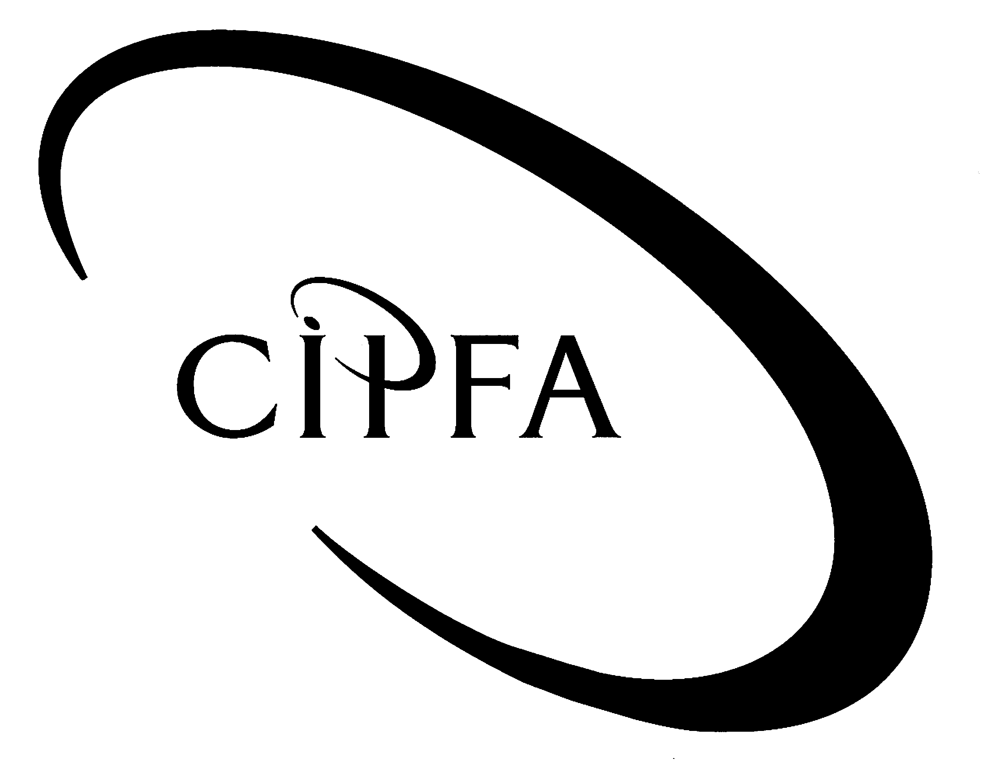

SECTION A (Compulsory)

1
The annual budget process is a key element in the financial and economic management of the State. The budget model must strive to align public spending with political priorities, fund this spending by taxation, borrowing or other means and work within the constraints of the Stability and Growth Pact. The following questions relate to Budget 2005.

- Requirement for question 1

(a) Budget 2005 was framed around a borrowing requirement amounting to €3bn. Explain the crowding out hypothesis in the context of the issue of this debt. 14

(b) The budget announced a full review of tax relief and incentive schemes. Using any relief/incentive as an example, examine its operation against the criteria of equity, efficiency and simplicity. 14

(c) How does the Stability and Growth Pact impact on budget formulation? Support your answer with examples. 12

(40)

SECTION B (Answer two questions from this section)

The present government programme – An Agreed Programme for Government – includes the commitment to “…reduce the burden of personal taxation in order to reward effort and give people an incentive to take up work”. Pressure for increased government spending is, however, making such a commitment increasingly difficult to meet.
2

- Requirement for question 2

(a) Drawing on appropriate examples, define the following forms of market failure and provide an example of government activity designed to combat the market failure:

(i) public goods 6
(ii) imperfect information 6
(iii) merit goods. 6

(b) As suggested above, pressure to increase government spending makes it increasingly difficult to maintain a low tax regime. Outline any three theories governing the cause of public expenditure growth. 12

(30)

The Accounting Officer of your Department is becoming increasingly frustrated with the additional resource requirement created by the introduction of financial management reform under the current modernisation programme. He has asked you, in the context of your CIPFA studies, to set out for him the issues associated with the introduction of such reform.
3

- Requirement for question 3

You have been requested to write a memo to the Accounting Officer to include:

(a) The three primary shortcomings of the cash-based system of financial and management reporting. 6

(b) In respect of each of the shortcomings mentioned above, an explanation of how the equivalent accruals information could contribute to improved financial management. 9

(c) An assessment of the main difficulties associated with the incorporation of performance information into the budget process. 9

(d) The advantages of financial management reform for decision-making. 6

(30)

The current government has committed to eliminating the need for exchequer borrowing in its current programme for Government.
4

- Requirement for question 4

(a) Outline the theory of Ricardian equivalence as it applies to public sector borrowing. 9

(b) Critically assess the provisions of the Stability and Growth Pact with regard to its influence on the Irish public finances. 15

(c) Briefly describe the function and operation of a Government Bond. 6

(30)

