GOVERNANCE AND PUBLIC POLICY REPUBLIC OF IRELAND

Diploma stage

December 2005

MARKING SCHEME

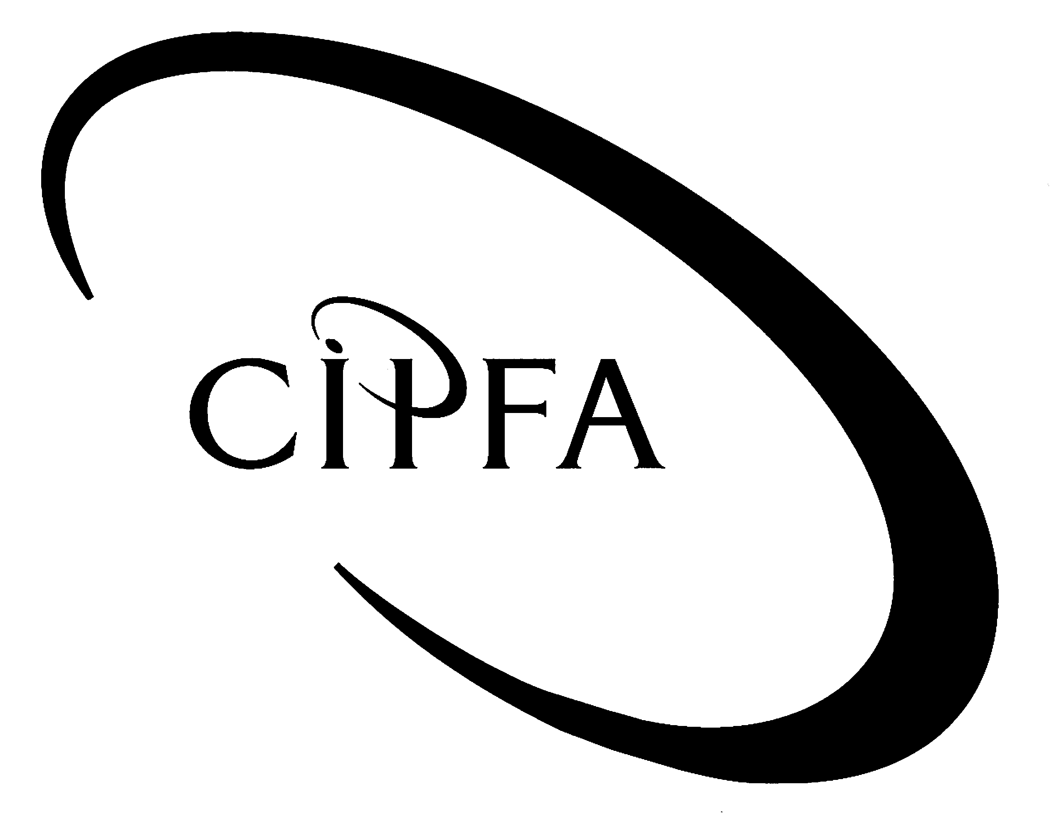

Question 1

(a) The Democracy Commission report of May 2004 considers the issue of a ‘democratic deficit’ in Ireland. What is meant by this and what are the principal symptoms of such a condition?

The ‘democratic deficit’ is a term used to describe a perceived disconnection between citizens and the institutions of government at local, national and international level. This is usually discussed with reference to low rates of voter turnout at elections and raises concerns about the legitimacy of those governing bodies. The democratic deficit is also concerned with a lack of public understanding of the role and functions of governing institutions, and has been frequently used in connection with the institutions of the European Union. A further element of the democratic deficit is the lack of accountability structures which ensure that the representative democracy reflects the wishes of the people within a constitutional and legal framework.

The principal symptoms of a democratic deficit would typically include a declining voter turnout over a number of elections. It would also be recognized through a declining membership of political parties, although this may be in contrast with increases in involvement in other forms of political organisation, such as interest groups or charity work. With regard to the European Union, a general lack of understanding of what the principal institutions of the Union do, combined with a mistrust of the influence of these institutions over domestic matters and a sense of being removed from the decision-making process, is also perceived to be symptomatic of a democratic deficit. 10

(b) Why is Dáil Éireann viewed as a key institution in tackling the democratic deficit?

As the most important representative national institution, Dail Eireann has a particularly significant function in respect of connecting citizens with the democratic process. Members of Dail Eireann are elected to represent the views of their constituents, and also to inform their constituents of decisions made in the parliamentary arena. Indeed, the term Teachta Dála (TD) translates as ‘messenger of the House’. Although government dominates the decision-making process, deliberation over Bills in parliament is central to public understanding of the legislative process, and other procedures such as parliamentary questions play an important role in keeping the public aware of the work of government. In order to prevent a democratic deficit from spreading, Dáil Éireann must continue to be a centre of policy-making and reflect the concerns of citizens. 5

(c) What do you understand by the terms representative government and liberal democracy?

Representative government occurs where a group of people elects a small number of their membership to represent their views, beliefs and wishes on their behalf. Typically, these representatives will meet in a public forum, such as a parliament, and deliberate on policies in which they can pursue matters for the benefit of the majority. The mass of the population cannot be consulted on every issue and so decision-making power is delegated to representatives to act in a democratic manner.

The origins of liberal democracy lie in the belief that it is the individual which is the unit of which society is composed, and that the State should allow each citizen the maximum freedom to pursue what they perceive to be good, within a legal framework. Liberals also believe in free trade and open markets. Today, liberal democracy is associated with individual freedom in respect of social and moral issues, and the belief that the State should not impose a set of values on the state. In particular, liberals believe in a complete separation of church and state. 5

(d) (i) What is judicial review and what are the two ways in which it can be sought within the context of the Irish Constitution?

Judicial review is mechanism for ensuring that constitutional provisions are observed and that the various political institutions act within their proper sphere of authority. It allows ordinary citizens to challenge the government and this ability is reinforced by the independence of the courts. The principal manner in which judicial review occurs is when a citizen appeals a case through the courts system to the Supreme Court where the constitutionality of an issue may be tested. However, Article 26 of the Constitution also allows the President to refer a Bill to the Supreme Court for judicial review in advance of signing it onto law. 5

(ii) How does Judicial Review protect individual social and economic rights in Ireland?

We need some arbiter or judge to decide what a constitution means and how it is to be applied in particular instances. If this job were left up to the government, there would be obvious difficulties, as the government would be asked to limit itself. The Irish Constitution does not spell out every social and economic right to which citizens are entitled, and judicial review allows for forms of constitutional development in this area in line with changes in society. After all, a constitution which cannot adapt with time is in effect ‘rule by the dead’. 5

- In recent years, Irish political parties have been accused of ‘racing to the centre’. What does this mean and what are the effects of this on voter choice and participation rates?

A ‘race to the centre’ refers to a situation where political parties all congregate around the political spaces and policies, which they believe are attractive to the largest number of voters. It is typically associated with States where there is consensus on broad matters concerning economic or social policy, and parties are reluctant to adopt ‘extreme’ positions for fear of losing electoral support. This has a negative effect on political deliberation and allows extremist parties to emerge and occupy spaces to the right and left of the political spectrum.

One of the effects of this phenomenon is that voter turnout declines as the electorate feel that they are not presented with a choice of policy options, and feel that they have little say in who will govern. As a result, participation in elections and the political process more generally will decrease. This has been a notable feature of politics in many European states in recent years. In order to reverse this trend, political parties must educate voters into supporting their viewpoints and to move away from the common ground shared with other rival parties.

- Why is it often argued that Irish local government is better described as a system of local administration? In your view, have recent reforms under Better Local Government changed this?

When compared with the range of functions performed in other European jurisdictions, the Irish system of local government appears to be relatively weak. Most of the functions it performs are prescribed by statute, leaving it very little policy or financial autonomy. The Department of the Environment, Heritage and Local Government have a strong input into what local authorities can and cannot do, and for this reason, the local government system is often referred to as a system of local administration, performing tasks that it has not decided on itself.

The recent local government reform programme, Better Local Government, has four key principles - enhancing local democracy and widening participation; better customer service; maximising efficiency; and proper resource allocation. Significant progress has been made and there has been substantial institutional reform. The emphasis on better customer service, in particular, has seen the use of corporate plans and customer service action plans, as well as the publication of performance indictors. A new accrual accounting system has also been introduced. However, critics argue that real reform of local government would involve the devolution of power from central government to local authorities. However, this has not been a feature of the modernisation process. 10

(50)

Question 2

(a) Identify and briefly describe the various types of interest group in Ireland and how we might distinguish between them.

There are many different types of interest group in Ireland. They may be institutional ie formal organisations within a government structure; protective ie trade unions which exist formally to protect the material interest of their members; or promotional ie existing to promote awareness of issues such as ecology. An interest group may also be geographic and attempt to protect the interests of people living in a particular area.

Irish interest groups are often distinguished between those that are sectional and those that are cause-based. Sectional groups are concerned with broad issues and would include the Irish Farmers Association, Irish Medical Organisation and the Law Society of Ireland. Examples of Cause centred groups would include Conradh na Gaeilge, Society for the Protection of the Unborn Child, Amnesty International, or the Society of St Vincent de Paul. 10

(b) Identify two policy areas where well-organised interest groups have managed to force government to change its mind on an issue. What are the negative sides to this form of political activism?

An example of a policy area where an interest group managed to effect a change in government policy was the opposition by the Vintners’ Federation of Ireland to proposals to introduce new café-bars which would sell alcohol. Another example would be the influence of the Pro-Life Amendment Campaign which forced the government to introduce a stronger ban on abortion in the Constitution in 1983, and which has since been reversed.

The negative side to such activism is that it can undermine the concept of representative democracy, and allow a minority to have a disproportionate influence on the government. However, in a pluralist society competition between interest groups is viewed as necessary. If interest groups are seen to have too much influence on the decision-making process, it can result in voter disengagement with elections and political parties. 6

(c) Describe why social partnership in Ireland is often regarded as usurping traditional parliamentary forms of government.

Social partnership agreements have occurred every three years since 1987. As they have occurred, the number of partners has tended to expand and has meant that more and more decisions are taken in the agreements, away from the national parliament. Also, as the approval of neither House of Parliament is necessary for the agreements, it gives the government a particularly strong hand in negotiations. However, it is argued that this does undermine the concept of parliamentary democracy. 4

(20)

Question 3

(a) Identify the different types of parliamentary committee and what roles do they perform? Why are governments reluctant to grant them too much independence?

There are four different types of parliamentary committee. Standing committees are permanent features of parliament and are automatically established with a new parliament. With some exceptions such as the Public Accounts Committee, they are mainly concerned with house-keeping issues. Select committees consist of members of one House only and are concerned with processing legislation. Joint Committees consists of members of both Houses and can propose legislation, take evidence from witnesses, and write reports. Special committees can be established for particular functions such as reviewing an article of the Constitution.

Governments have traditionally been reluctant to grant them too much power in case they undermine its prerogative. In particular, the government will not want a committee to create difficulties for it in terms of legislation, or by publicly criticising it. For these reasons committees tend to have government majorities. 7

(b) Using examples, identify recent examples of a committee’s inquiry that was viewed as a success, and another that failed? What were the principal factors that determined the different outcomes in each case?

The Public Accounts Committee’s inquiry into tax evasion was viewed as a success as the institutions it investigated, the banks, admitted their guilt in the affair and paid substantial fines to the exchequer. However, the Committee’s success was possible because of the non-political nature of the work and the fact that a preliminary report into the affair had been conducted by the Comptroller and Auditor-General. Also, the Committee’s work was aided by the fact that the banks did not challenge their work in the courts.

The Joint Committee on Justice, Equality and Law Reform’s inquiry into the shooting by police of a man at Abbeylara was viewed as a committee inquiry that failed. The Joint Committee’s work was successfully challenged in the courts by the police, and the Sub-Committee established to pursue the investigation went outside of its terms of reference. The failure of this inquiry has raised serious issues about the ability of committees to pursue inquiries. 8

(15)

Question 4

(a) How have structural and cohesion funds been managed in Ireland and what will the likely consequences be of Ireland’s conversion to net contributor status within the EU?

Structural and cohesion funds are allocated according to the provisions of the National Development Plan, which usually covers a seven-year period, eg 2000-6. This Plan is the framework for creation of infrastructure and social services for the State. It is managed by the Department of Finance, and the Department of the Taoiseach also has strong input into the Plan. Ultimately, the use of structural and cohesion funds is monitored principally by local authorities, even though they are not centrally involved in deciding on the ways in which it should be spent.

Ireland’s conversion to net contributor status will see a further reduction of funds from the EU to the exchequer, although some structural and cohesion funds will still be received. However, the current National Development Plan is 90% financed by the State and the shortfall might be met through new financing arrangements such as Public Private Partnerships or joint venture companies. Local authorities will also have to improve their ability to apply for EU funding for particular projects. 9

- What are the roles of the European Central Bank (ECB)? What are the arguments against ceding control of interest rates and monetary policy to the ECB?

The European Central Bank’s main task is to monitor use of the euro and to maintain its purchasing power and therfore price stability in the euro area. Since 1999 it has been in charge of monetary policy in the 12-state euro area, which includes setting interest rates. It also has functions in relation to statistics, banknotes and some legal matters.

The principal arguments against ceding control of monetary policy and interest rates to the ECB include the fact that it leaves individual states exposed to interest rate fluctuations in the larger 12-state area. The loss of control over these matters means that individual governments must adjust their policies in line with the decisions taken outside of their direct jurisdiction. It also means that member states can be penalised for failing to accept the ECB decisions. 6

(15)

Question 5

(a) What are the various definitions of accountability and why is it viewed as central to ‘good governance’?

One of the more accepted definitions of accountability is ‘for what, to who and how’. However, the term is now used in a variety of contexts and includes public accountability, parliamentary accountability, professional accountability and even ethical accountability. Accountability is often defined as meaning responsibility, transparency or scrutiny. In terms of ‘good governance’ and reform of the public sector, adequate lines of accountability are regarded as central in terms of the performance of functions on behalf of an agent. Traditionally, problems have tended to arise in those institutions that did not have clear accountability mechanisms and where little external oversight was provided. Much of public sector reform involves establishing clear mechanisms of accountability that are understood by all and which allow for public scrutiny. 7

(b) It has been argued that there are now too many oversight institutions in the public sector. Do you agree? Give examples in your answer.

Public sector reform in Ireland has witnessed a significant increase in the amount of new bodies designed to increase information flows between the public and institutions of government. However, the more of such bodies there are, the greater the likelihood of duplication and overlap there is. For example, the Office of the Ombudsman examines the work of the public administration, yet this is a role also performed by parliamentary committees. Similarly, it may be argued that the freedom of information legislation overlaps with the role of parliamentarians in asking parliamentary questions and discovering information on aspects of the public service. Certain sectors also have several oversight bodies such as the environmental sector, where central and local bodies perform oversight work along with the Environmental Protection Agency.

Disagreeing with this statement, it is possible to argue that the growth of the public sector requires commensurate oversight bodies as part of good governance within that sector. Problems have occurred in the past where inadequate oversight mechanisms have resulted in poor control of services and activities. Therefore, the more oversight agencies there are, the better it is for the scrutiny of public expenditure and policy-making. 8

(15)

