FINANCIAL REPORTING IN LOCAL GOVERNMENT

Professional 2 examination
5 December 2000

From 10.00 am to 1.00 pm
plus ten minutes reading time from 9.50 am to 10.00 am.

Instructions to candidates

Answer four questions in total: both questions from Section A, and two questions from Section B. The marks available for each question are shown in italics in the right-hand margin.

All workings should be shown. Where calculations are required using formulae, calculators may be used but steps in the workings must be shown. Calculations with no evidence of this (for example, using the scientific functions of calculators) will receive no credit. Programmable calculators are not permitted in the examinations room.

Formula sheets, statistical tables, graph paper and cash analysis paper are available from the invigilator, where applicable.

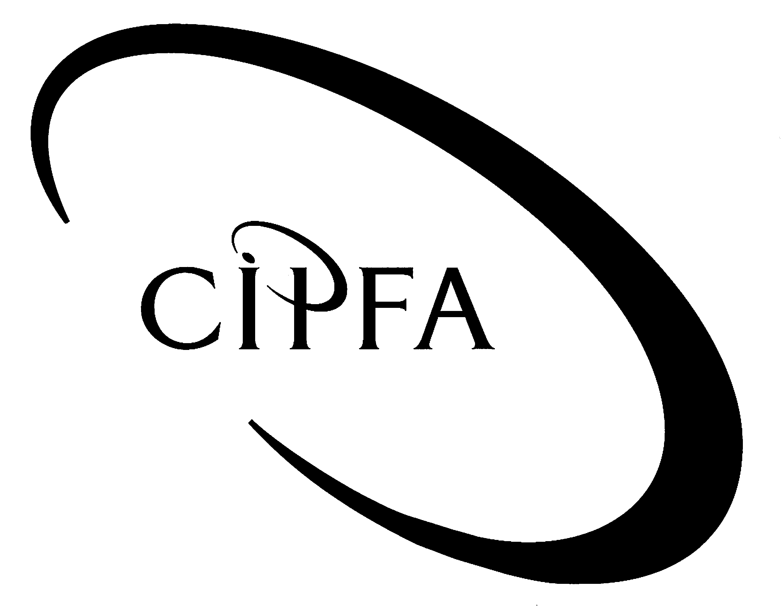

SECTION A (Answer both questions)

1The following balances relate to Hillsdown Metropolitan Borough Council for the year ended 31 March 2000.

 | £000 |  | £000
Gross service expenditure
Education, libraries & arts | 500,550
Social services | 355,910
Highways & transport | 46,900
Planning & development services | 15,460
Environment services | 14,320
Leisure and other services | 5,800
Housing revenue account | 281,400
Net fixed assets (tangible) | 1,690,800
Fixed asset restatement reserve |  |  | 4,000
General fund reserve |  |  | 11,500
Long term investments | 85,000
Stock & WIP | 40,500
Long term borrowing |  |  | 1,705,000
Creditors |  |  | 6,600
Overdraft |  |  | 1,500
Usable capital receipts |  |  | 6,000
Capital financing reserve |  |  | 77,450
Revenue support grant |  |  | 309,000
Debtors | 52,175
Cash in hand | 125
Interest received |  |  | 5,850
External interest paid | 127,875
1999/2000 DSO surplus |  |  | 50
Housing revenue account reserve |  |  | 3,500
DSO reserve |  |  | 2,000
Earmarked reserves |  |  | 150
Precepts paid to parish councils | 60
Council tax |  |  | 162,500
National non-domestic rates |  |  | 208,175
Service income
Education, libraries & arts |  |  | 200,600
Social services |  |  | 175,000
Highways & transport |  |  | 10,000
Planning & development |  |  | 4,300
Environment services |  |  | 2,600
Leisure & other services |  |  | 3,100
Housing revenue account |  |  | 318,000
 | 3,216,875 |  | 3,216,875

Additional information

(i) Capital charges have been calculated and are shown below. No entries have been made in the accounts for these figures.

 | Depreciation  £000 | Notional interest  £000
Education, libraries & arts | 15,210 | 66,890
Social services | 14,330 | 17,314
Highways and transport | 2,450 | 1,050
Planning & development services | See Note (ii)
Environment services | 1,500 | 5,660
Leisure & other services | 2,000 | 7,800
Housing revenue account | See Note (iii)

(ii) The following information is available relating to the fixed assets of Planning & development services:

- Fixed assets at 1 April 1999 had a gross current replacement cost of £10,050,000, and accumulated depreciation of £4,020,000. These assets are being depreciated straight line over 25 years.

- During the year fixed assets costing £550,000 were purchased (included within the trial balance). The assets were initially financed from cash however a government grant of £300,000 is due for 1999/2000 to finance a proportion of the assets. As at 31 March 2000 this grant had not yet been received. The remainder of the fixed assets are to be financed from useable capital receipts. The useful economic life of the new assets is estimated to be 5 years.

- It is the policy of Hillsdown MBC to charge a full year’s depreciation in the year of acquisition and none in the year of disposal. Notional interest is calculated based on balances at the start of the year, adjusted for acquisitions, disposals and depreciation during the year.

(iii) Debt charges have been calculated for the housing revenue account as £37,600,000 for 1999/2000. This figure is made up of MRP of £5,600,000 and interest of £32,000,000. The debt charges have not yet been accounted for either in the housing revenue account or the asset management revenue account. Depreciation on housing assets has been calculated as £3,500,000 for 1999/2000 but has not been accounted for.

(iv) MRP for General Fund has been calculated at £57,000,000 for 1999/2000.

- Requirement for question 1

(a) Prepare the asset management revenue account for the year ended 31 March 2000. 6

(b) Prepare the consolidated revenue account for the year ended 31 March 2000 together with the consolidated balance sheet as at that date in respect of Hillsdown MBC. 19

(25)

2The following information relates to the collection fund of Henfield District Council for the year ended 31 March 2000:

(i) Prepayments

Amounts prepaid by taxpayers were as follows:

 | 1 April 1999 | 31 March 2000
 | £000 | £000
Council tax | 11,360 | 8,740
National non-domestic rates (NNDR) | 3,620 | 4,500

(ii) Arrears

Amounts owed to the Collection Fund by taxpayers were as follows:

 | 1 April 1999 | 31 March 2000
 | £000 | £000
Council tax | 55,800 | 67,900
NNDR | 32,450 | 29,800

(iii) Receipts

Amounts received by the Collection Fund were as follows:

 |  | £000
Council tax payers |  | 750,200
Council tax benefit |  | 106,700
Non-domestic ratepayers |  | 674,150

(iv) Payments

Amounts paid by the Collection Fund were as follows:

 | £000
County Council precept | 650,900
District Council demand | 198,600
Parish Council precepts | 26,000

(v) Losses and reductions

The following amounts reduce the debit for the year:

 |  | £000
Council tax | - Exemptions | 66,300
 | - Reduced assessments | 12,410
 | - Prompt payment discounts | 5,400
 | - Write offs | 1,100
NNDR | - Rateable value reductions | 25,700
 | - Mandatory relief | 16,880
 | - Write offs | 350

(vi) Other information

The following information is available:

the fund balance brought forward from 1998/99 was a deficit of £650,000;

- the provision for uncollectable income at 31 March 2000 should be £2,750,000;

- the allowance for collection of NNDR for the year ended 31 March 2000 is £3.5 million;

- the provision for uncollectable debt at 1 April 1999 was £2,500,000;

- the total amount of council tax and NNDR that should be transferred to the income and expenditure account is calculated after losses and reductions.

- Requirement for question 2

- Prepare the collection fund income and expenditure account and the supporting notes in respect of:

- Council tax income for the year;
- NNDR income collectable for the year;
- Payment to the national pool for NNDR; and
- Bad debt provision. 12

- Explain how a surplus/deficit on the collection fund would impact upon the accounts of the District Council. 3

- Outline the main sources of revenue income to a local authority and explain how each is determined. Identify the main controls which central government has over the revenue spending of local authorities. 10

(25)

SECTION B (Answer two questions)

3You are preparing the 1999/2000 final accounts for Highport City Council. It is May 2000 and much of the work has already been completed. A trainee is assisting you and has sought your advice on the following issues:

- How the Financial Reporting Standards (FRSs) and Statements of Standard Accounting Practice (SSAPs) apply to the Council.

- Whether local authorities are required to provide a ‘true and fair view’ in the same way as companies are required to by the Companies Acts.

The following items are outstanding and the trainee is unsure how to treat them in the accounts.

- Goods valued at £24,000 were received by the Council on 27 March 2000. £5,000 worth of these were used immediately, and the remaining goods were placed in stores. The invoice has not yet been received.

- The Council sells maps of the borough for £1.50 to local residents and visitors to the area. Income of £8,000 in total has been raised in this way for the financial year and this has been netted off against the cost of printing the maps.

- Investigation of disputed debtor invoices has identified that a total of £27,000 of income will not be paid.

- A grant has been received from the Government to fund capital expenditure of £800,000 incurred during 1999/2000. The life of the asset is estimated to be 10 years. In addition the Government is to provide some funding for the running expenses and a grant of £60,000 has been received for this purpose.

- During 1999/2000 additional pension costs of £39,000 have been incurred in respect of eight members of staff from Social Services Department who took early retirement in 1997/98. These costs are not covered by the Pension Fund.

- During the year the Council has leased a number of assets. The majority of these are operating leases, however one of the leases has been classified as a finance lease. The following information is available relating to the finance lease:

- The equipment acquired has a fair value of £240,000. The lease term is six years and the annual payment is £45,000. The annual payment for 1999/2000 has been credited to the bank account and debited to a suspense account. No other entries in the accounts have been made.

- A claim is being made against the Council in respect of the education of a child with special needs. The outcome of the claim is unknown but it is likely that the Council will have to pay compensation in the region of £200,000.

- Requirement for question 3

(a) Respond to items (i) and (ii), explaining how FRSs and SSAPs and the ‘true and fair view’ requirement are applied to local authorities. 5

(b) For items (iii) to (ix):

- Explain how the items should be treated and show any entries which would be required in the accounts.

- Justify your treatment, making reference to any relevant accounting standards where appropriate. 20

(25)

4Heddon City Council are currently involved in the process of tendering two services: cleaning and internal audit. The cleaning contract is in the early stages of the tendering process and the interested parties must now be financially vetted. Bids have already been received for the internal audit service and now need to be evaluated.

Three companies have expressed an interest in the cleaning contract. They must meet the requirements for admission to the City Council’s approved contractors list, although they need not be on the list currently. To achieve this the contractor must supply three years’ audited accounts to demonstrate:

- reasonable liquidity over the three years;

- that they have made a profit in each of the last three years.

Reasonable liquidity for the industry has been independently assessed as a current ratio of 1:1 or better, and a quick (or acid test) ratio of 0.9:1 or better. For the purposes of financial vetting each company is awarded points for the number of these requirements that it is able to satisfy. A company is awarded one point for each requirement it meets and there are nine points available – one for each liquidity ratio for each of the last three years, and one for earning post-tax profits for each of the last three years. To be accepted the contractor must achieve at least two thirds of the available points. Extracts from the accounts of the three companies are attached.

Three tenders have been submitted for the internal audit contract. Each tender is to be evaluated on both financial and non-financial criteria. There are two non-financial factors:

(i) The ratio of qualified to unqualified staff. It is considered that at least 20% of the audit staff should be qualified. The following have been submitted as the numbers of staff and their qualifications:

X Ltd Y Ltd Z Ltd

Unqualified staff 24 49 78
Qualified staff 6 10 21

Weightings are to be attributed and marked as follows:

0 points if <15% of the audit staff are qualified

5 points if 15-20% of the audit staff are qualified

10 points if >20% of the audit staff are qualified

(ii) The number of other contracts they are currently operating. This is considered important as an indicator of not only experience and ability but also capacity. The following have been submitted as the number of contracts they operate:

X Ltd Y Ltd Z Ltd

No of internal audit contracts 2 15 10

Weightings are to be attributed and marked as follows:

0 points if 0-2 contracts

5 points if 3-6 contracts

10 points if 7-10 contracts

5 points if >10 contracts

The prices submitted by the companies are as follows:

X Ltd Y Ltd Z Ltd
Price £225,375 £241,095 £283,530

For price they are to be scored out of a total of 30 points. Half of the available points are achieved at the mean price. For prices below the mean, add 2% of the total points for each percent below the mean price, and for prices above the mean, deduct 2% of the total points for each percent above the mean price.

Requirement for question 4

- For the cleaning contract, evaluate the three companies financially and recommend which should be invited to tender. 11

- For the internal audit contract, evaluate the bids and recommend who should be awarded the contract. 7

- Detail the client responsibilities in relation to the tendering process. 7

(25)

Extracts from the accounts of the three companies for the cleaning contract:

 | 1999/2000  £000 | 1998/99  £000 | 1997/98  £000
Company A:
Turnover | 1,090 | 1,135 | 1,024
Profit after tax | 105 | 112 | (69)
Stock | 22 | 18 | 28
Debtors | 65 | 68 | 73
Cash & bank | 49 | 32 | 17
Current liabilities | 123 | 132 | 113
Company B:
Turnover | 1,350 | 1,302 | 1,180
Profit after tax | 52 | 41 | 38
Stock | 30 | 28 | 26
Debtors | 59 | 52 | 48
Cash & bank | 28 | 24 | 28
Current liabilities | 89 | 90 | 84
Company C:
Turnover | 2,580 | 2,700 | 2,100
Profit after tax | 72 | 75 | 69
Stock | 35 | 34 | 30
Debtors | 68 | 74 | 61
Cash & bank | 29 | 24 | 24
Current liabilities | 91 | 108 | 92

- 5Requirement for question 5

- Explain the main role and responsibilities of the Chief Financial Officer of a local authority. 15

- What is meant by devolved financial management? 2

- What are the advantages and disadvantages of devolved financial management? 4

- Consider the impact of devolved financial management on the role of the Chief Financial Officer. 4

(25)

