FINANCIAL ACCOUNTING

Foundation stage examination

11 June 2002

From 10.00 am to 1.00 pm
plus ten minutes reading time from 9.50 am to 10.00 am.

Instructions to candidates

Answer five questions in total. All four questions from Section A, and one of the two questions from Section B. The marks available for each question are shown in italics in the right-hand margin.

All workings should be shown. Where calculations are required using formulae, calculators may be used but steps in the workings must be shown. Calculations with no evidence of this (for example, using the scientific functions of calculators) will receive no credit. Programmable calculators are not permitted in the examinations room.

Formula sheets, statistical tables, graph paper and cash analysis paper are available from the invigilator, where applicable.

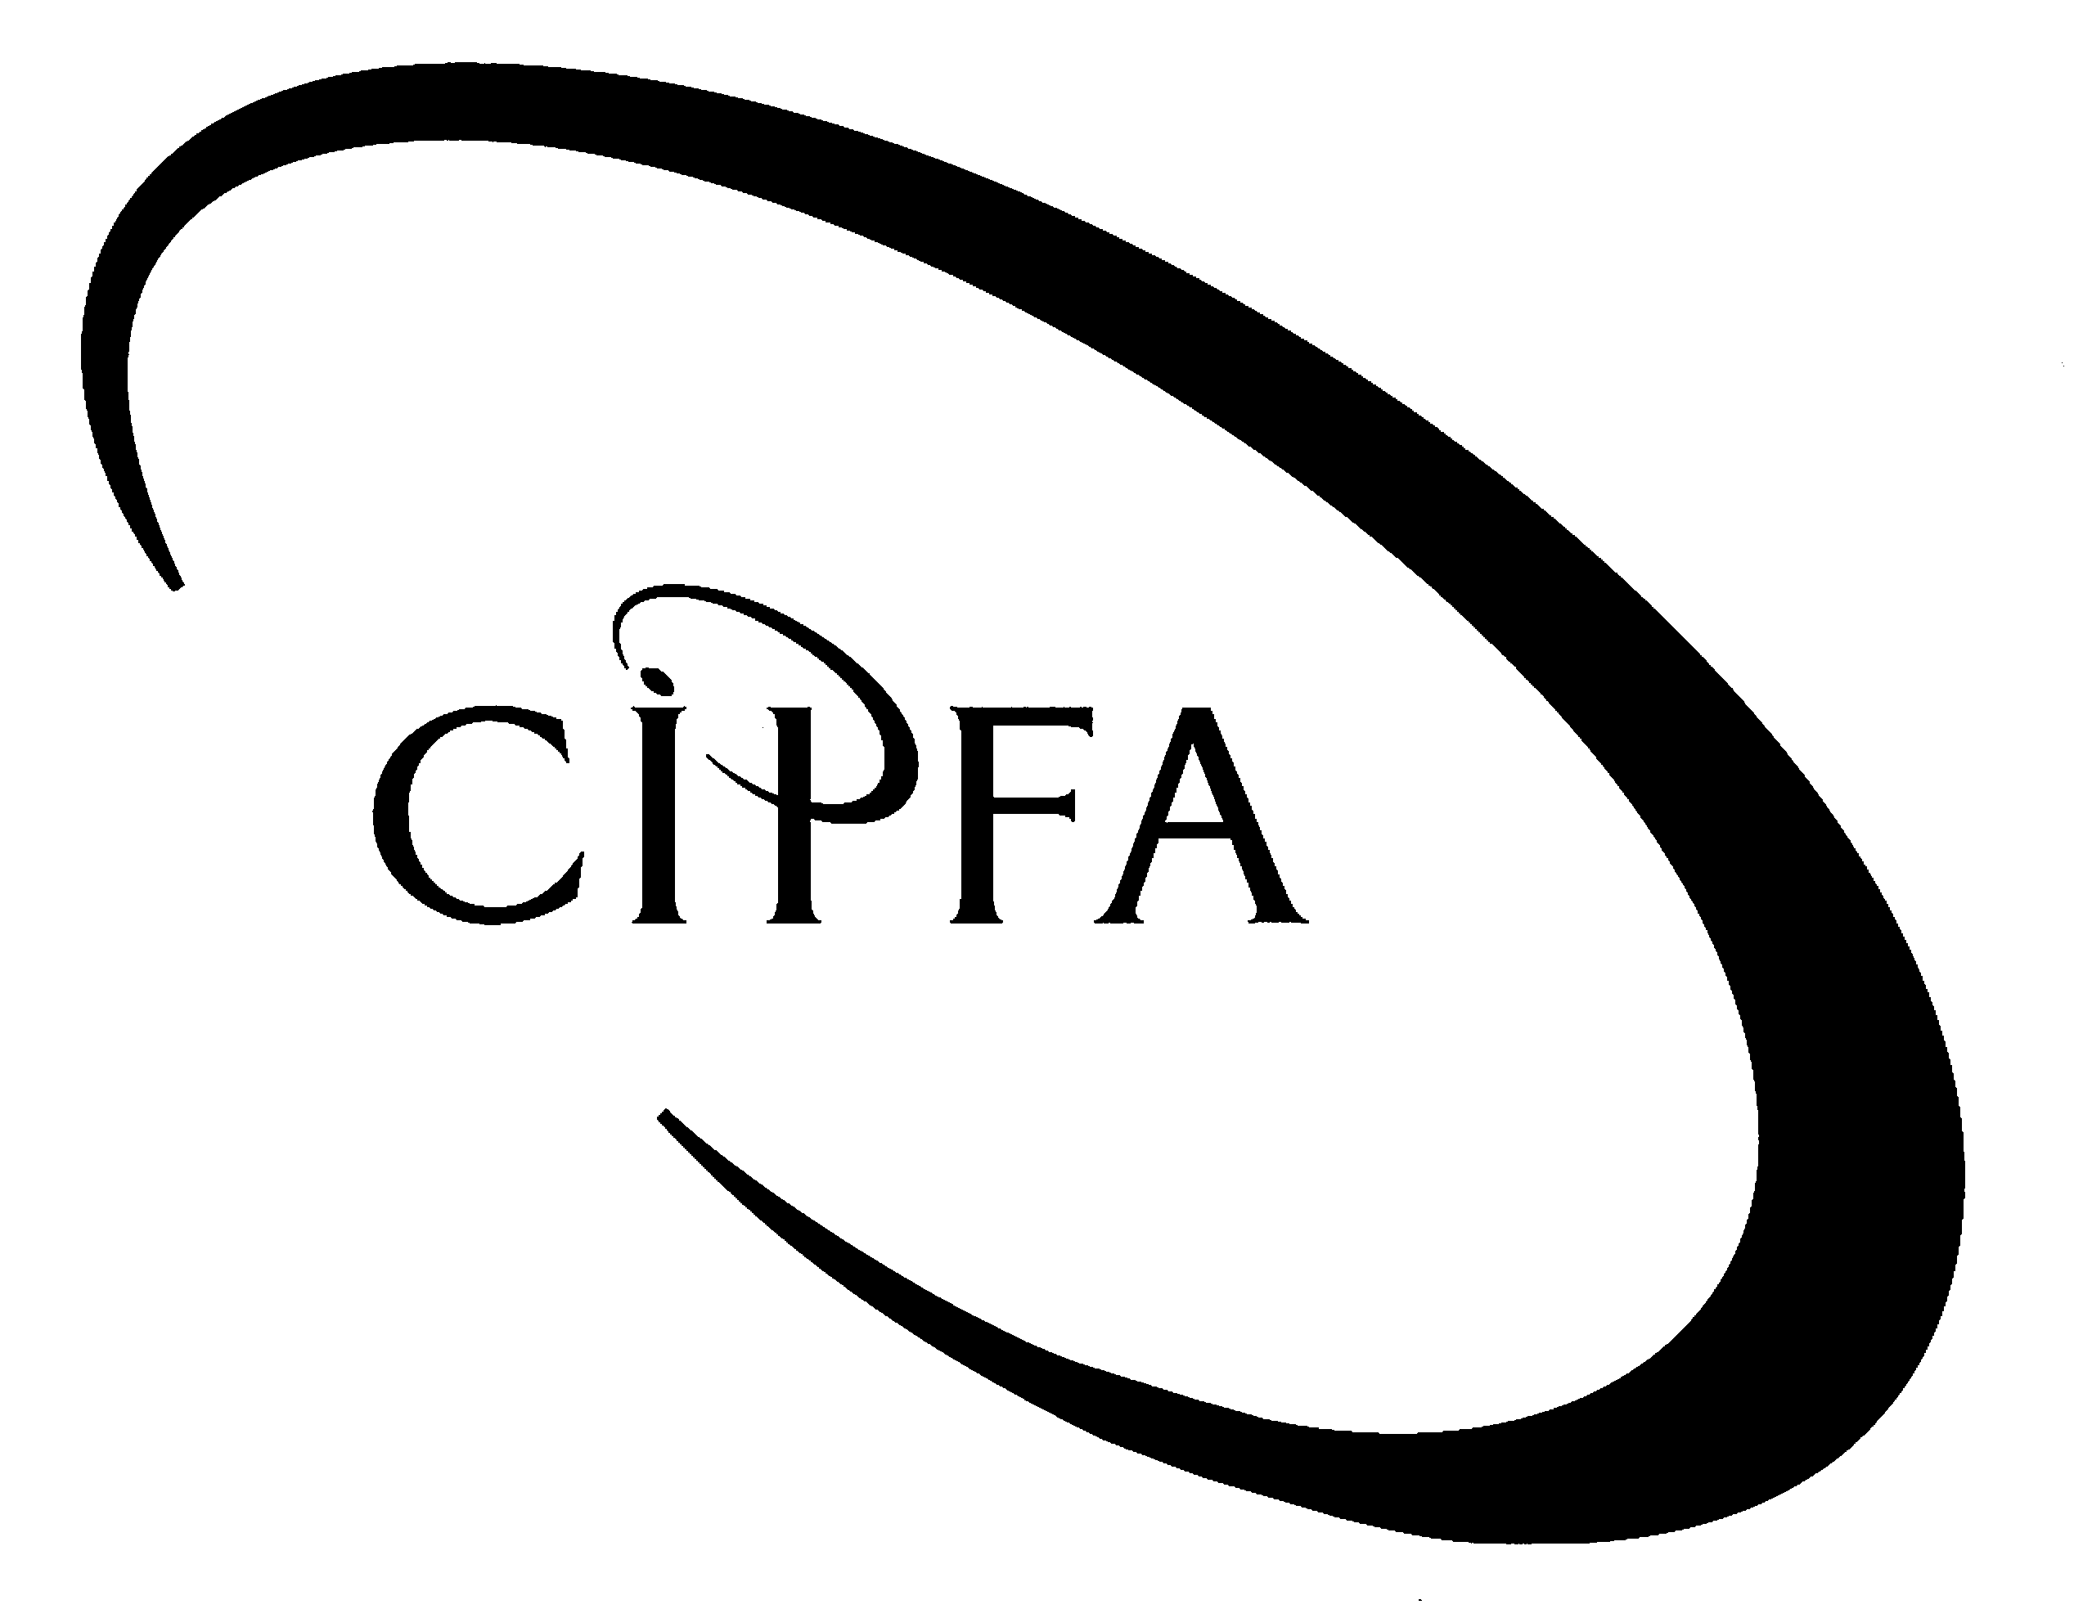

SECTION A (Answer all questions)

1
The trial balance of Drummond Ltd as at 31 March 2002 is as follows:

 | £ |  | £
Bank balance | 47,510
Bank interest received |  |  | 5,850
Corporation tax | 2,870
7% Debentures 2006 |  |  | 200,000
Debenture interest paid | 14,000
Distribution equipment at cost | 96,500
Dividends received |  |  | 2,400
Fixed asset investments at cost | 50,000
Freehold property at cost | 250,000
General administrative expenses | 209,780
General distribution costs | 120,940
General reserve at 1 April 2001 |  |  | 130,000
Interim dividend paid | 32,000
Motor vehicles at cost | 129,680
Ordinary shares of 25p each |  |  | 80,000
Prepayments and accruals | 5,770 |  | 16,890
Profit and loss account at 1 April 2001 |  |  | 3,220
Profit on sale of motor vehicle |  |  | 830
Provisions for depreciation:
Distribution equipment |  |  | 37,200
Motor vehicles |  |  | 61,930
Purchases and sales | 701,110 |  | 1,351,810
Rent received |  |  | 10,000
Stock at 1 April 2001 | 156,620
Suspense account |  |  | 50,000
Trade debtors and creditors | 110,270 |  | 159,970
Wages and salaries | 183,050
 |  | 2,110,100 |  | 2,110,100

Additional information:

1 The freehold property is to be revalued at £330,000.

2 During the year, a motor vehicle used for distribution purposes with an original cost of £25,000 (accumulated depreciation to 31 March 2001 £12,500) was sold for £13,330. This disposal was fully accounted for before extracting the above trial balance. There were no other fixed asset disposals during the year.

3 Depreciation charges for the year to 31 March 2002 are still to be calculated. Motor vehicles are depreciated at 25% per annum using the straight line method assuming zero residual value. Distribution equipment is depreciated at 30% per annum using the reducing balance method. In each case, it is company policy to charge a full year’s depreciation in the year of acquisition and none in the year of disposal. None of the fixed assets had been fully depreciated by 31 March 2001.

4 The motor vehicles are split equally between administration and distribution.

5 Wages and salaries are split 60:40 between administration and distribution.

- Stock at 31 March 2002 is valued at £141,500.

7 On 1 January 2002, 125,000 ordinary shares of 25p each were issued at a premium of 15p per share. The company’s book-keeper was unsure how to deal with this transaction and therefore the proceeds of the issue were debited to the bank account and credited to a suspense account.

8 The balance on the corporation tax account consists of an underprovision for the year to 31 March 2001. The estimated liability for the year to 31 March 2002 is £17,500.

9 The directors of the company propose to transfer £10,000 from the general reserve and then to pay a final dividend of 8p per share on all of the shares in issue at the end of the accounting year.

10 During the year, the company undertook a fundamental reorganisation of its structure at a cost of £37,200 and incurred an unusually large bad debt of £26,000. Both of these amounts are included in general administrative expenses and are regarded as material.

11 The company intends to make a one-for-one bonus issue in August 2002, financed as far as possible out of capital reserves. Any shortfall will be made up out of the general reserve.

• Requirement for question 1

(a) Insofar as the information permits, prepare the company’s profit and loss account for the year to 31 March 2002 and a balance sheet on that date, in a form which is suitable for publication. Formal notes to the accounts are not required but workings should be shown. 21

(b) Write the journal entry for the proposed bonus issue. Explain why a company might make such an issue. 4

(25)

Derek prepares accounts to 31 December each year. All of his sales and purchases are on credit. He has a manual book-keeping system and maintains both sales and purchase ledger control accounts. The control accounts form part of his double-entry system and the control account balances are shown each year in his trial balance. The individual debtor and creditor accounts are held as memorandum records only.
2

The trial balance extracted at 31 December 2001 showed that total credit balances exceeded total debit balances by £5,765. Furthermore, the balance on the purchase ledger control account was £23,274 whilst the total of a list of creditors extracted from the purchase ledger was only £18,998. However, the balance on the sales ledger control account agreed with the total of a list of debtors extracted from the sales ledger.

Despite these discrepancies, Derek proceeded to prepare draft financial statements for the year to 31 December 2001. The trial balance difference was held in a suspense account and the balance on this account was treated as an expense in the draft profit and loss account (which showed a net loss of £6,190).

On investigation, the following errors were discovered:

1 Capital introduced of £5,000 had been credited to the sales account.

2 Contras of £1,738 had been entered on the wrong side of the purchase ledger control account.

3 A purchase invoice of £322 had been omitted from the purchase daybook.

4 Bank interest received of £75 had been entered only in the cashbook.

5 The debit side of a supplier’s account in the purchase ledger had been undercast by £200.

6 The credit side of the purchase ledger control account had been overcast by £1,000.

7 Discounts allowed of £482 had been credited to the discounts received account.

8 Sales returns for December 2001 totalling £310 had not been recorded anywhere in the accounting records.

9 The rates prepayment of £400 at 31 December 2000 had not been brought down in the rates account.

10 A cheque payment to a supplier of £1,460 had been recorded in the cashbook as £1,640.

• Requirement for question 2

- Prepare journal entries to correct the above errors (narratives are not required) and write up the suspense account. 11

(b) Prepare an amended purchase ledger control account and reconcile the balance on this account to the corrected total of the purchase ledger balances at 31 December 2001. 5

(c) Calculate Derek’s corrected net profit or loss for the year to 31 December 2001. 4

(20)

Denise has been trading since 1 May 1995 and has always prepared accounts to 30 April each year. Her ledger included the following balance at 1 May 2001:
3

 | £ | £
Office equipment at cost:
Acquired 1 May 1995 | 12,750
Acquired 1 November 1997 | 8,400
Acquired 1 February 1999 | 7,600 | 28,750

Denise depreciates office equipment on the straight line basis over a 5-year period assuming a residual value of £nil. She makes part-year depreciation charges in the years of acquisition and disposal.

On 1 August 2001, Denise sold office equipment which had been originally acquired on 1 May 1995 (at a cost of £5,000) and on 1 November 1997 (at a cost of £2,400). The sale proceeds totalled £700. On the same date, she bought new office equipment costing £9,600.

• Requirement for question 3

(a) Calculate the balance on the provision for depreciation of office equipment account in Denise’s ledger at 1 May 2001. 3

(b) Calculate the depreciation charge for the year to 30 April 2002 and write up the following ledger accounts: 10

- Office equipment at cost
- Provision for depreciation of office equipment
- Disposal of office equipment
- Depreciation expenses (office equipment)

(c) Explain what is meant by the term “depreciation”. Also, explain the purpose of charging depreciation in the accounts of a business and the meaning of the net book value shown in the balance sheet for a partly-depreciated asset. Indicate how a business should choose a method for calculating depreciation. 7

(20)

Mrs Danvers has recently inherited a sum of money and is considering investing in the shares of either X plc or Y plc. Both companies prepare accounts to 31 March annually and both are in the same line of business. Key figures taken from the accounts of the two companies for the year to 31 March 2002 are shown below.
4

 | X plc | Y plc
 | £000 | £000
Profit and loss account items:
Turnover | 1,620 | 1,860
Cost of sales | 1,210 | 1,270
Operating profit | 270 | 400
Interest payable | 40 | 75
Taxation charge | 80 | 110
Balance sheet items:
Net book value of fixed assets | 1,250 | 1,430
Stock | 1,280 | 330
Debtors | 390 | 290
Cash at bank | nil | 120
Current liabilities | 1,060 | 650
Long-term loans | 570 | 450

As a trainee accountant and a friend of Mrs Danvers, you have been asked to write her a report analysing the above figures and suggesting which of the two companies might prove the better investment.

• Requirement for question 4

(a) Calculate appropriate accounting ratios on which you will base your report. 9

(b) Write your report, highlighting any limitations of your analysis and indicating any further information which you would need to conduct a fuller analysis. 11

(20)

SECTION B (Answer question 5 or question 6)

The published accounts of limited companies are required to comply with the provisions of the Companies Acts 1985 and 1989 and with all relevant accounting standards.
5

• Requirement for question 5

(a) Identify the body charged with the task of promoting good financial reporting and its main operating committees, outlining the functions of each of these committees. 9

(b) Explain the purpose of accounting standards and describe the relationship between accounting standards and company law. 6

(15)

In its Statement of Principles for Financial Reporting, the Accounting Standards Board identifies the objective of financial statements and suggests that this objective can usually be achieved by concentrating on the needs of investors, who are described as the “defining class of user”.
6

- Requirement for question 6

(a) State the main objective of preparing financial statements. 3

(b) Identify the main users of financial statements and provide an example for each user group of the reasons for needing these statements. Do you agree with the ASB that the needs of all users can usually be met by concentrating on the needs of investors? 9

(c) Explain the main limitations of financial statements. 3

(15)

