BUSINESS STRATEGY IN CENTRAL GOVERNMENT AND AGENCIES

Professional 2 examination
6 December 2000

From 10.00 am to 1.00 pm
plus ten minutes reading time from 9.50 am to 10.00 am.

Instructions to candidates

Answer five questions in total. Question 1 from Section A, two questions from Section B and both questions from Section C. The marks available for each question are shown in italics in the right-hand margin.

All workings should be shown. Where calculations are required using formulae, calculators may be used but steps in the workings must be shown. Calculations with no evidence of this (for example, using the scientific functions of calculators) will receive no credit. Programmable calculators are not permitted in the examinations room.

Formula sheets, statistical tables, graph paper and cash analysis paper are available from the invigilator, where applicable.

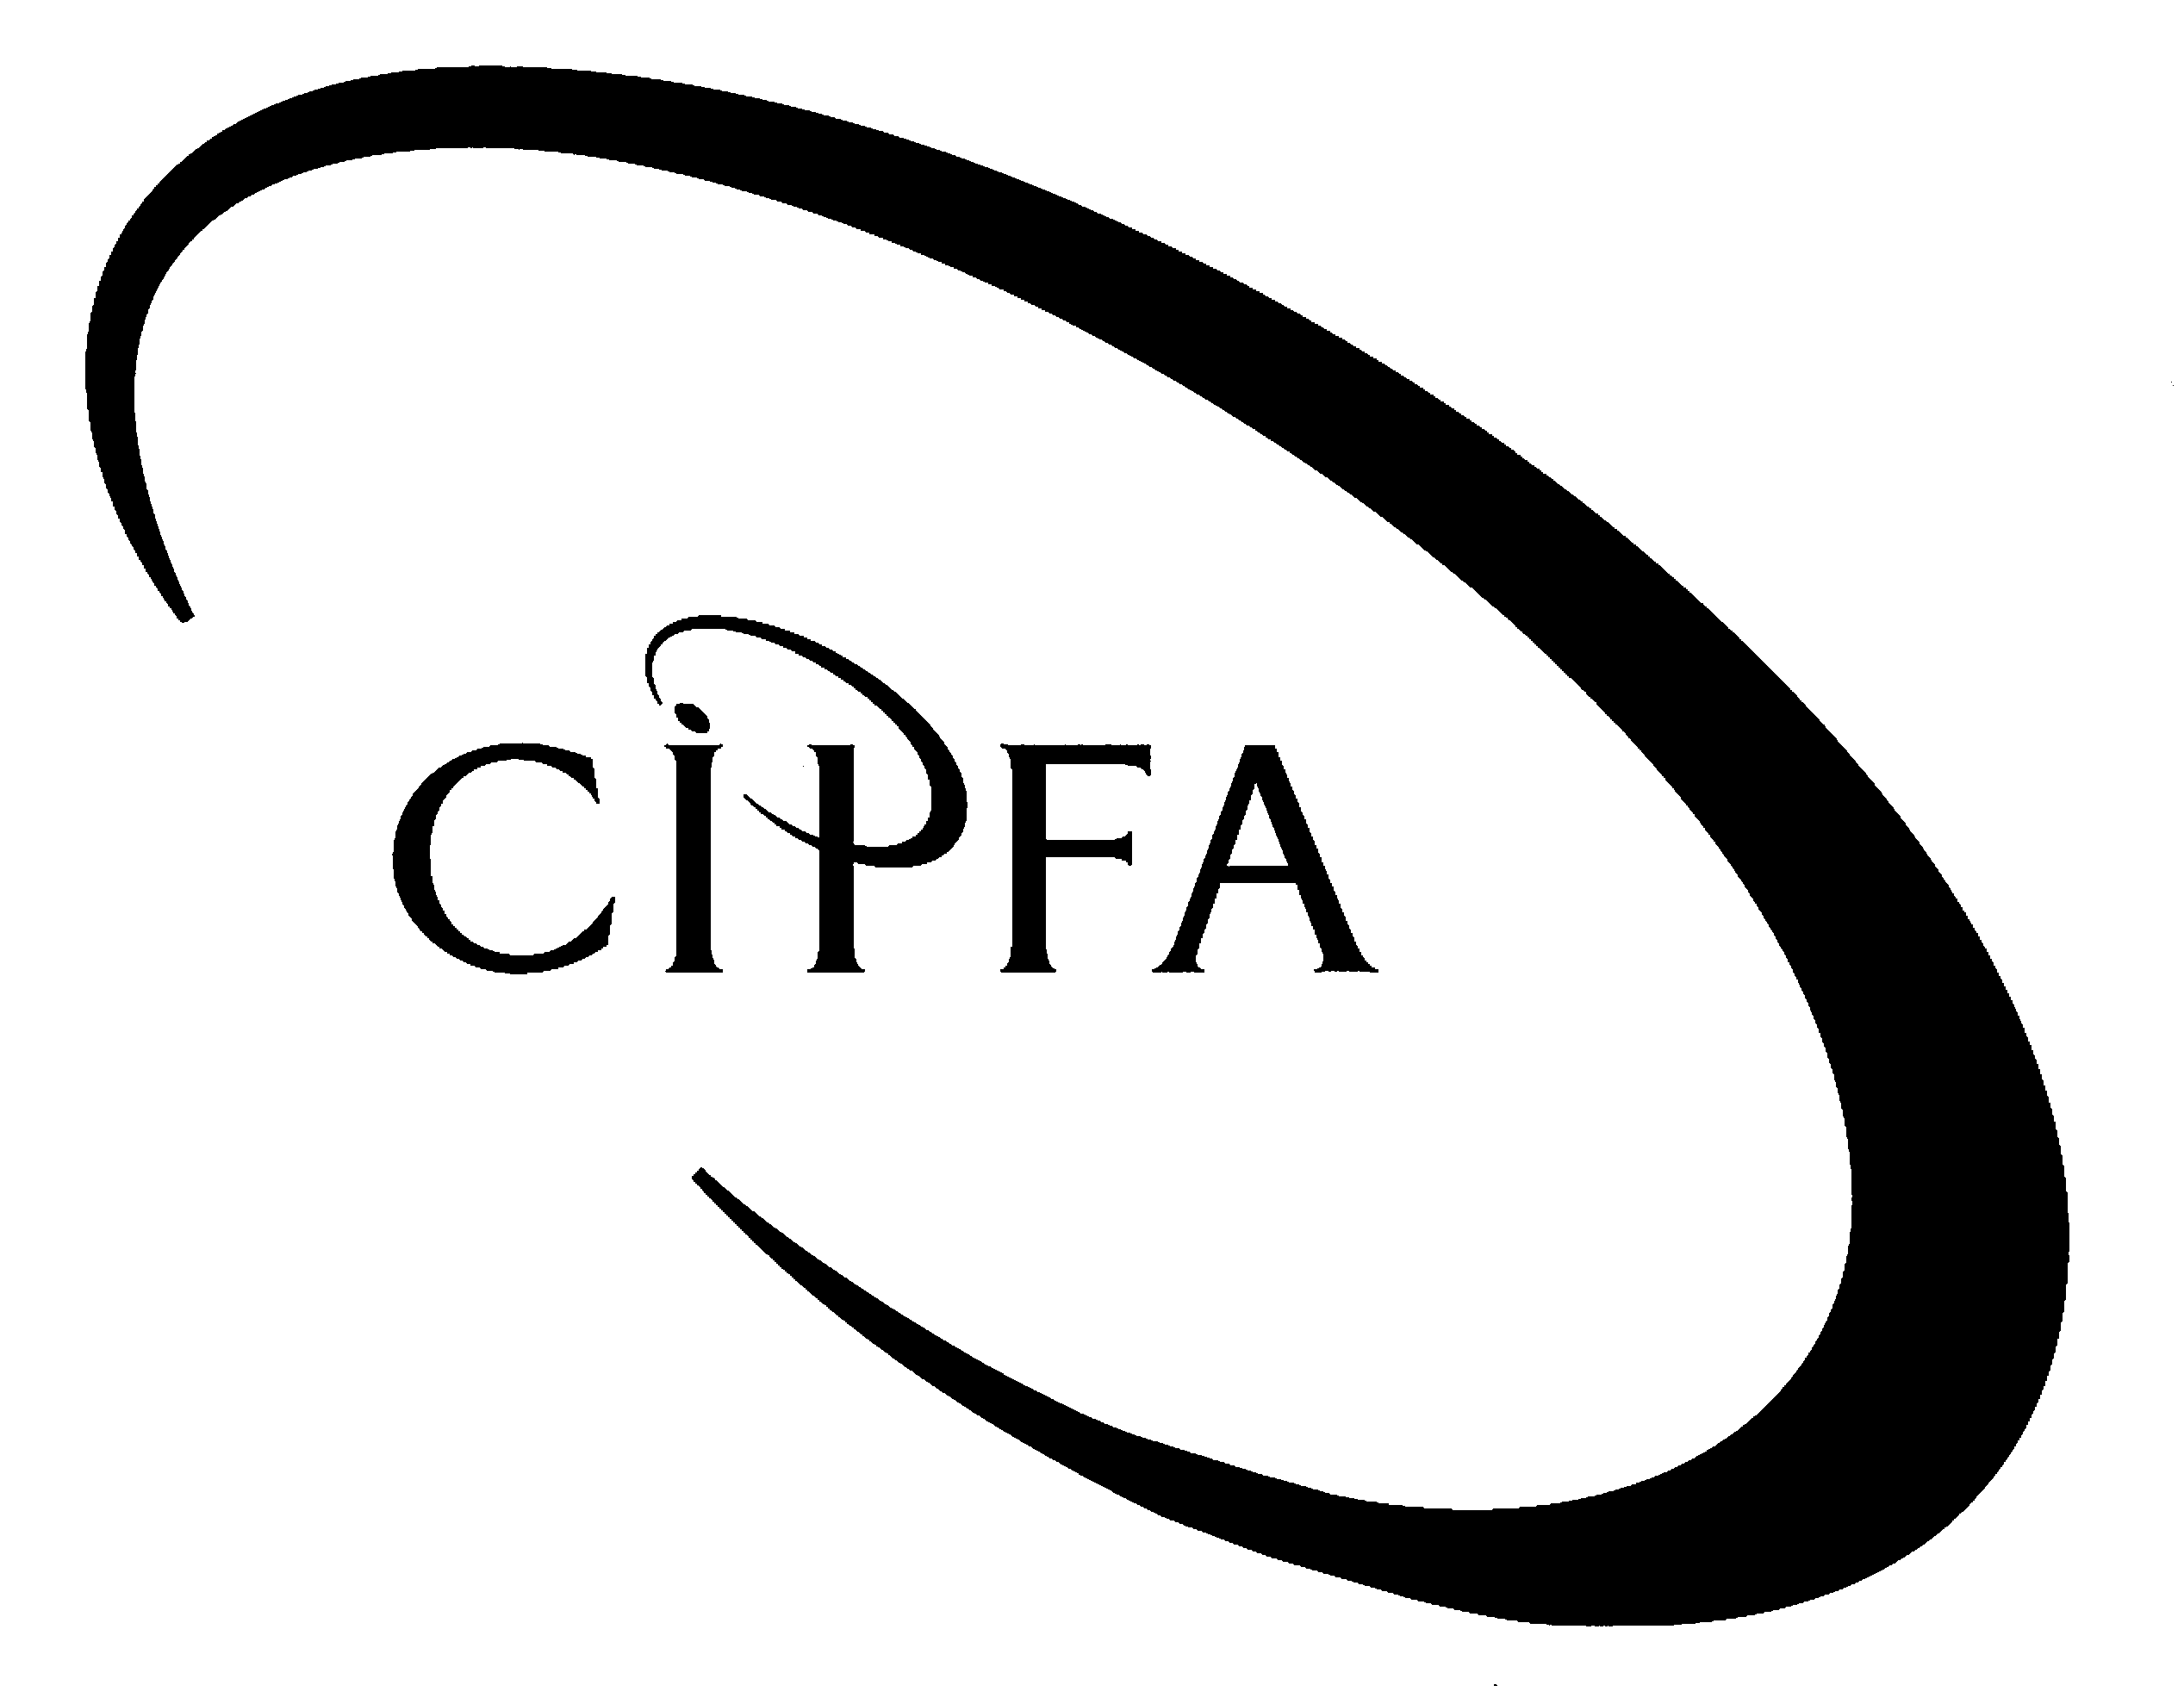

SECTION A (Compulsory)

1“The Financial Management Initiative … gave a big push towards greater use of output and performance measures in central government. It laid particular stress on the three Es of efficiency, effectiveness and economy.”

(CIPFA Open Learning Material, Business Strategy in Central Government and Agencies)

- Requirement for question 1

(a) Define briefly the concept of value for money, and discuss the advantages and disadvantages of using performance measures and indicators to seek to facilitate the achievement of value for money by central government organisations. 9

(b) Define what is meant by benchmarking and outline briefly the different ways in which benchmarking can be approached. 5

(c) HM Customs and Excise have reported their experience of using a technique they call ‘hybrid benchmarking’. Describe the main stages of this technique. 4

(18)

2SECTION B (Answer two questions)

It has been suggested that organisations gain strategic success by achieving a match between the demands of their environment and their own distinctive strategic capabilities. One technique whereby an organisation’s strategic capability can be analysed is value chain analysis.

- Requirement for question 2

(a) Illustrate the technique of value chain analysis by drawing and labelling the value chain. Show what form the value chain’s primary activities could take in a strategic business unit in your sector. 8

(b) Identify the main contributions that value chain analysis can make to resource analysis. 4

(c) For the value chain for which primary activities were identified in part (a), give practical examples of how the management of activities might be informed by value chain analysis. 6

(18)

3There is much debate among academics and practitioners as to the usefulness of having a mission statement. Research by academics, including Piercy and Morgan, has proved inconclusive, but has succeeded in identifying some features and activities, which, when present, improve the effectiveness of a mission statement.

- Requirement for question 3

(a) Outline the role of a mission statement. 2

(b) Identify and explain reasons why some mission statements fail to fulfil this role. 6

(c) Drawing upon the analysis of Piercy and Morgan, and others, describe good practice in mission statement development, which can be expected to generate effective mission statements. 10

(18)

4The first stage in the process of strategic choice is to generate strategic options available to the organisation. It is generally accepted that three methods are available to do this, each of which has its merits.

- Requirement for question 4

(a) Explain the ‘competitive strategy’ approach to option generation, defining the meaning of each element. 11

(b) Outline what is meant by the ‘strategic issues’ approach to option generation, and identify the merits and problems associated with it. 3

(c) Brainstorming sessions are often used in option generation, although in reality they often lack focus and generate vague outcomes. Outline the factors which need to be present for successful brainstorming. 4

(18)

SECTION C (Answer both questions)

5Five years ago, most of the public sector organisations in the regions of Truckshire formed a group entitled ‘Partnership for the Public’ (PP) to look at where skills could be shared and the interests of the public furthered. The first output from the group was the idea for the creation of ‘Interject Audit Services’ (IAS) which is planned to be an experiment in the delivery of internal audit and consultancy services across a range of public service organisations. It is planned that the new service will begin from April 2001.

Sir Goahead, who leads the PP and is the deputy Chief Executive Officer (CEO) of Truckshire County Council, recently decided that the group needed a report from each member on how the proposed change was considered in their organisation, and each member of the group reported as follows:

Sir Goahead explained that the County Council management are split on the idea. The CEO is neutral, and the Treasurer and Chief Internal Auditor are against it due to the specialist expertise required to audit the diversity of services delivered. The Leader of the Council, who is also a Governor at Truckford University, is enthusiastic. Staff in the audit section are generally not in favour of any change, and the external auditors, currently PKAM, are reportedly ‘keeping an interested eye on developments’.

Lady Lancelot is Vice Chair of the PP and sits on the Board of the local NHS Acute Trust. She reported that the Trust’s audit section is very keen, and the Chief Internal Auditor has begun preparations. Some of the Trust’s Directors are less keen and have voiced the opinion that ‘the values of the NHS are complex, and staff outside of it will not be able to contribute positively’. She also reported that the other local NHS (Community) Trust has yet to appoint a replacement to the PP after their last representative retired, so she is unsure as to the viewpoint of that organisation.

Lady Largebrain, Pro-Vice Chancellor of Truckford University, reported that in her experience, such changes would never be implemented if the views of all were sought. She suggested that the plans are simply implemented and was confident that her staff would react positively when the time came.

Sir Houseall, who represents the local Housing Association, was concerned that this would not be appropriate for his organisation as the budget was very tight and more audit fees were not what was wanted. For this reason he had not consulted, but was sure his organisation would be against any such development.

Sir Truck, the local MP, has stated his firm support for the idea, which he sees as a move towards joined up government. He has pointed out his feelings that such an audit and consultancy service could be of use to the Executive Agencies in the region, some of whom have large offices nearby.

A letter recently appeared in the Truckford Herald from a constituent concerned at the IAS plan. In particular, concerns relate to the reduction of public sector specialisation in audit skills, the potential loss of stewardship, and the probability of imminent outsourcing for short term cost savings. Some debate has since erupted in the letters page on the loss of public services over the past two decades.

You have recently been appointed to assist Sir Goahead in creating IAS and telephoned round some colleagues across the partnership to collect additional intelligence. You have discovered that the current Chief Internal Auditor (CIA) of the Acute Trust trained with the County Council audit section, who were surprised at his appointment to the Trust, and some antipathy has developed. The Finance Department of the County Council holds a firm centralised control over the other departments, and the Treasurer tends to have the greatest input to decisions. It has also become apparent that the relationship between Lady Lancelot and the Community Trust has broken down. Lady Lancelot is, however, a good friend of the County Council CEO. A recent disagreement over land has arisen between the Housing Association and the University, and as a by-product Sir Houseall is refusing to work with Lady Largebrain, who is the sister-in-law of Sir Truck.

- Requirement for question 5

You have been asked to write a paper which:

(a) Evaluates the forces involved in the change. 10

(b) Outlines and critiques potential management styles, in order to evaluate which would be most appropriate to ensure the successful implementation of IAS. 8

(c) Identifies other issues which may be important to the successful implementation of IAS. 5

(23)

6The Leisure Agency introduced their business planning process in 1995. Tony Elwood, the then Chief Executive, felt that it was important to introduce the process incrementally and not make excessive demands upon his service managers in its early days. Consequently in 1995 the following process was developed:

(i) The formulation of agency wide objectives by Tony Elwood, which were submitted to the Department of Cultural Affairs for approval.

(ii) The circulation of a business planning pro-forma to all unit managers, requiring that they identify:

- Resources available to them over the three year business planning period
- The main opportunities and threats facing their business unit
- Objectives that they planned for the unit

(iii) The return of the pro-formas to the Chief Executive one month before the finalisation of the agency’s budget.

This process continued until 1998 when a new Chief Executive, Fiona Shrimpley, was appointed.

One of her first actions was to introduce a formal strategic planning process which would generate a corporate wide plan to act as the starting point for the individual unit business plans. The first strategic plan has recently been published. She has also stated that she feels that the units’ business planning processes should become more participative, and the objectives of the business plans should be integrated with the existing performance monitoring regime. She has also announced that, while wanting to review the content of the actual business plans, she does not currently propose any changes.

Having been appointed manager of the agency’s communications unit in 1998, you have cautiously welcomed the changes as you felt that the planning process had lacked the rigour of that of your previous employer. However, as your staff have shown signs of significant work over-load and stress in the last six months, you are concerned about the suggestion that the business planning process should become more participative. More positively you are keen to link your business plan objectives to your performance monitoring regime, particularly as you have become increasingly concerned about the unit’s failure to respond consistently to enquiries from the public.

- Requirement for question 6

(a) Identify the benefits of a more participative approach to business planning and suggest what form such an approach might take. 5

(b) Identify the criteria to which objectives should conform if they are to contribute effectively to performance monitoring, and construct an objective which conforms to such criteria for the area of responses to enquiries from the public. 5

(c) Suggest amendments that could have been made to the content of the business planning process introduced in 1995. 5

(d) Identify the main stages in any process of performance review and comment briefly on three different methods of review and monitoring. 8

(23)

