AUDIT

Professional 1 examination
14 June 2002

From 2.00 pm to 5.00 pm,
Plus ten minutes reading time from 1.50 pm to 2.00 pm.

Instructions to candidates

Answer four questions. Question 1 from Section A and three questions from Section B. The marks available for each question are shown in italics in the right-hand margin.

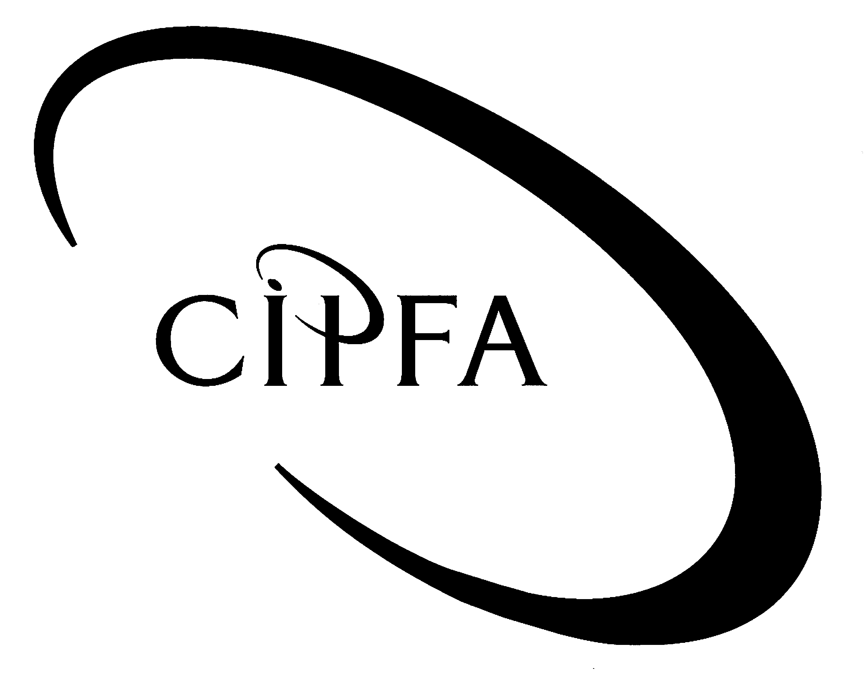

SECTION A (Compulsory)
1
As a result of passing your CIPFA exams you have been promoted to Assistant Audit Manager with a large national audit organisation. One of your new audit assignments is the ‘Old Celtic Charity for Pensioners’, which provides extra pensions to needy pensioners in a specific geographical area. Money contributed and gifted to the charity is invested in various stocks and shares by a board of Trustees.

You have initial meetings with the Director of Finance of the charity and have to decide an audit strategy. The Senior Partner of your audit organisation has stressed to you the importance of good and thorough planning prior to the commencement of the detailed audit work.

In line with your recent promotion, the Senior Partner has also asked you to explain the contents and importance of audit working papers to unqualified audit staff who have recently joined your audit firm. Your audit firm has a standardised method of organising and referencing working papers within each audit file.

The draft summarised Income & Expenditure Account for the year ended 30 September 2002 has been passed to you by the Treasurer of the charity and is given below.

Old Celtic Charity for Pensioners

Draft Income & Expenditure Account
for the year ended 30 September 2002

 | £ |  | £

Income
Grants & donations |  |  | 43,695
Fund raising events |  |  | 6,420
Bank deposit account interest |  |  | 230
 |  |  | 50,345

Expenditure
Pensions | 20,000
Salaries | 10,798
Rent, rates, heat & light | 12,530
Telephone | 558
Insurance | 753
Refreshments | 941
Repairs to equipment | 168
Depreciation of equipment | 2,883
Auditors’ fee | 50
Miscellaneous | 435
 |  |  | 49,116
Net Surplus |  |  | 1,229

- Requirement for question 1

(a) As part of the audit planning process you hold a preliminary meeting with the Director of Finance of the charity. Describe the issues you would discuss at that meeting. 5

(b) Discuss the factors you must consider in developing an audit strategy for your new client, highlighting the areas which you think would be particularly problematic. 5

(c)

(i) Describe the reasons why auditors use working papers to record their work and consider whether it is necessary for auditors to record all their audit work. 4

(ii) List and briefly describe the contents of the Permanent Audit File and the Current Audit File. 4

(iii) Discuss the advantages and disadvantages of standard Internal Control Questionnaires (ICQs). 8

(d) Describe the audit work you would carry out:

(i) To verify that pensions are paid to authorised pensioners. 6

(ii) To verify the income and expenditure account. 8

(40)

SECTION B (Answer three questions)
2
Overall audit risk is determined by the following equation:

Inherent Risk × Control Risk × Detection Risk

Audit risk can never be eliminated no matter how strong the audit evidence and how careful the auditors. The auditor’s aim is to discover acceptable or normal risk parameters and to minimise the potentially adverse consequences.

Requirement for question 2

(a) Define the terms:
- Inherent Risk
- Control Risk
- Detection Risk 6

(b) Outline the factors that would indicate that:

- audit risk is normal
- audit risk is higher than normal

and describe how the auditor would approach his/her audit as a result. 8

(c) For the following organisations, identify possible inherent risk factors which would require consideration by an auditor in assessing inherent risk:

(i) An ice cream manufacturer.
Small manufacturing base in Glasgow; makes all his own ice cream and owns three vans for delivery and sale in the street.

(ii) A trader in heavy construction equipment.
Equipment of high quality but expensive; supplied from the USA; customers mainly Welsh local authorities and construction companies.

(iii) Manufacturer and seller of fashionable knitwear.
Based in Yorkshire and selling through own outlets throughout England, and by mail order overseas. 6

(20)

Fraud is a deliberate act by an individual or group of individuals, and is therefore always intentional and dishonest. The Government continually publishes anti-fraud activities and new policy initiatives in an attempt to combat fraud, although many frauds occur because of inherent factors within public sector organisations.
3

- Requirement for question 3

(a) For fraud to occur in an organisation, a particular set of environmental conditions will normally exist. Describe the organisational and personal factors which tend to make fraud more likely. 8

(b) When fraud occurs it can be categorised as ‘Employee Fraud’ or ‘External Fraud’. Give three illustrations of each category of fraud. 6

(c) Outline the auditor’s responsibility for the prevention and detection of fraud. 6

(20)

Value for Money auditing is defined as ‘an audit methodology in which auditors are either required, or exercise discretionary power, to satisfy themselves by examination of the accounts, or otherwise, that the organisation has made proper arrangements for securing economy, efficiency and effectiveness in the use of resources’.
4

Value for Money (VFM) auditing is also carried out in the private sector via internal audit work, management letters from external auditors and consultancy work by external firms.

Requirement for question 4

(a) Describe the economic, efficient and effective aspects which the auditor would consider in each of the following key functions of an organisation:

- Ordering and tendering
- Land and property letting
- Internal audit 9

(b) Outline the criteria which the auditor will wish to take into account in deciding the VFM areas to be studied within an organisation. 5

(c) In light of your discussion at part (b), select a topic for VFM investigation within your own organisation or one well known to you. Explain why you have chosen the particular area of VFM investigation and describe the information you would seek to collate as part of your study. 6

(20)

Computer audit is the name given to a range of activities that support and supplement general audit work where the organisation under audit is computerised.

- Requirement for question 5
5

(a) Identify five of the major topics with which computer audit is concerned. 5

(b) Computer audit is often described as a subset of general audit. Discuss how the two areas interact. 5

(c) For small organisations which perhaps cannot justify the cost of a full-time computer audit specialist, a number of alternatives may exist.

(i) Describe the various alternatives which are open to organisations to ensure adequate computer audit coverage. 5

(ii) Outline the problems which could occur as a result of implementing these alternatives. 5

(20)

