AUDIT

Professional 1 examination
8 December 2000

From 2.00 pm to 5.00 pm,
plus ten minutes reading time from 1.50 pm to 2.00 pm.

Instructions to candidates

Answer four questions. Question 1 from Section A and three questions from Section B. The marks available for each question are shown in italics in the right-hand margin.

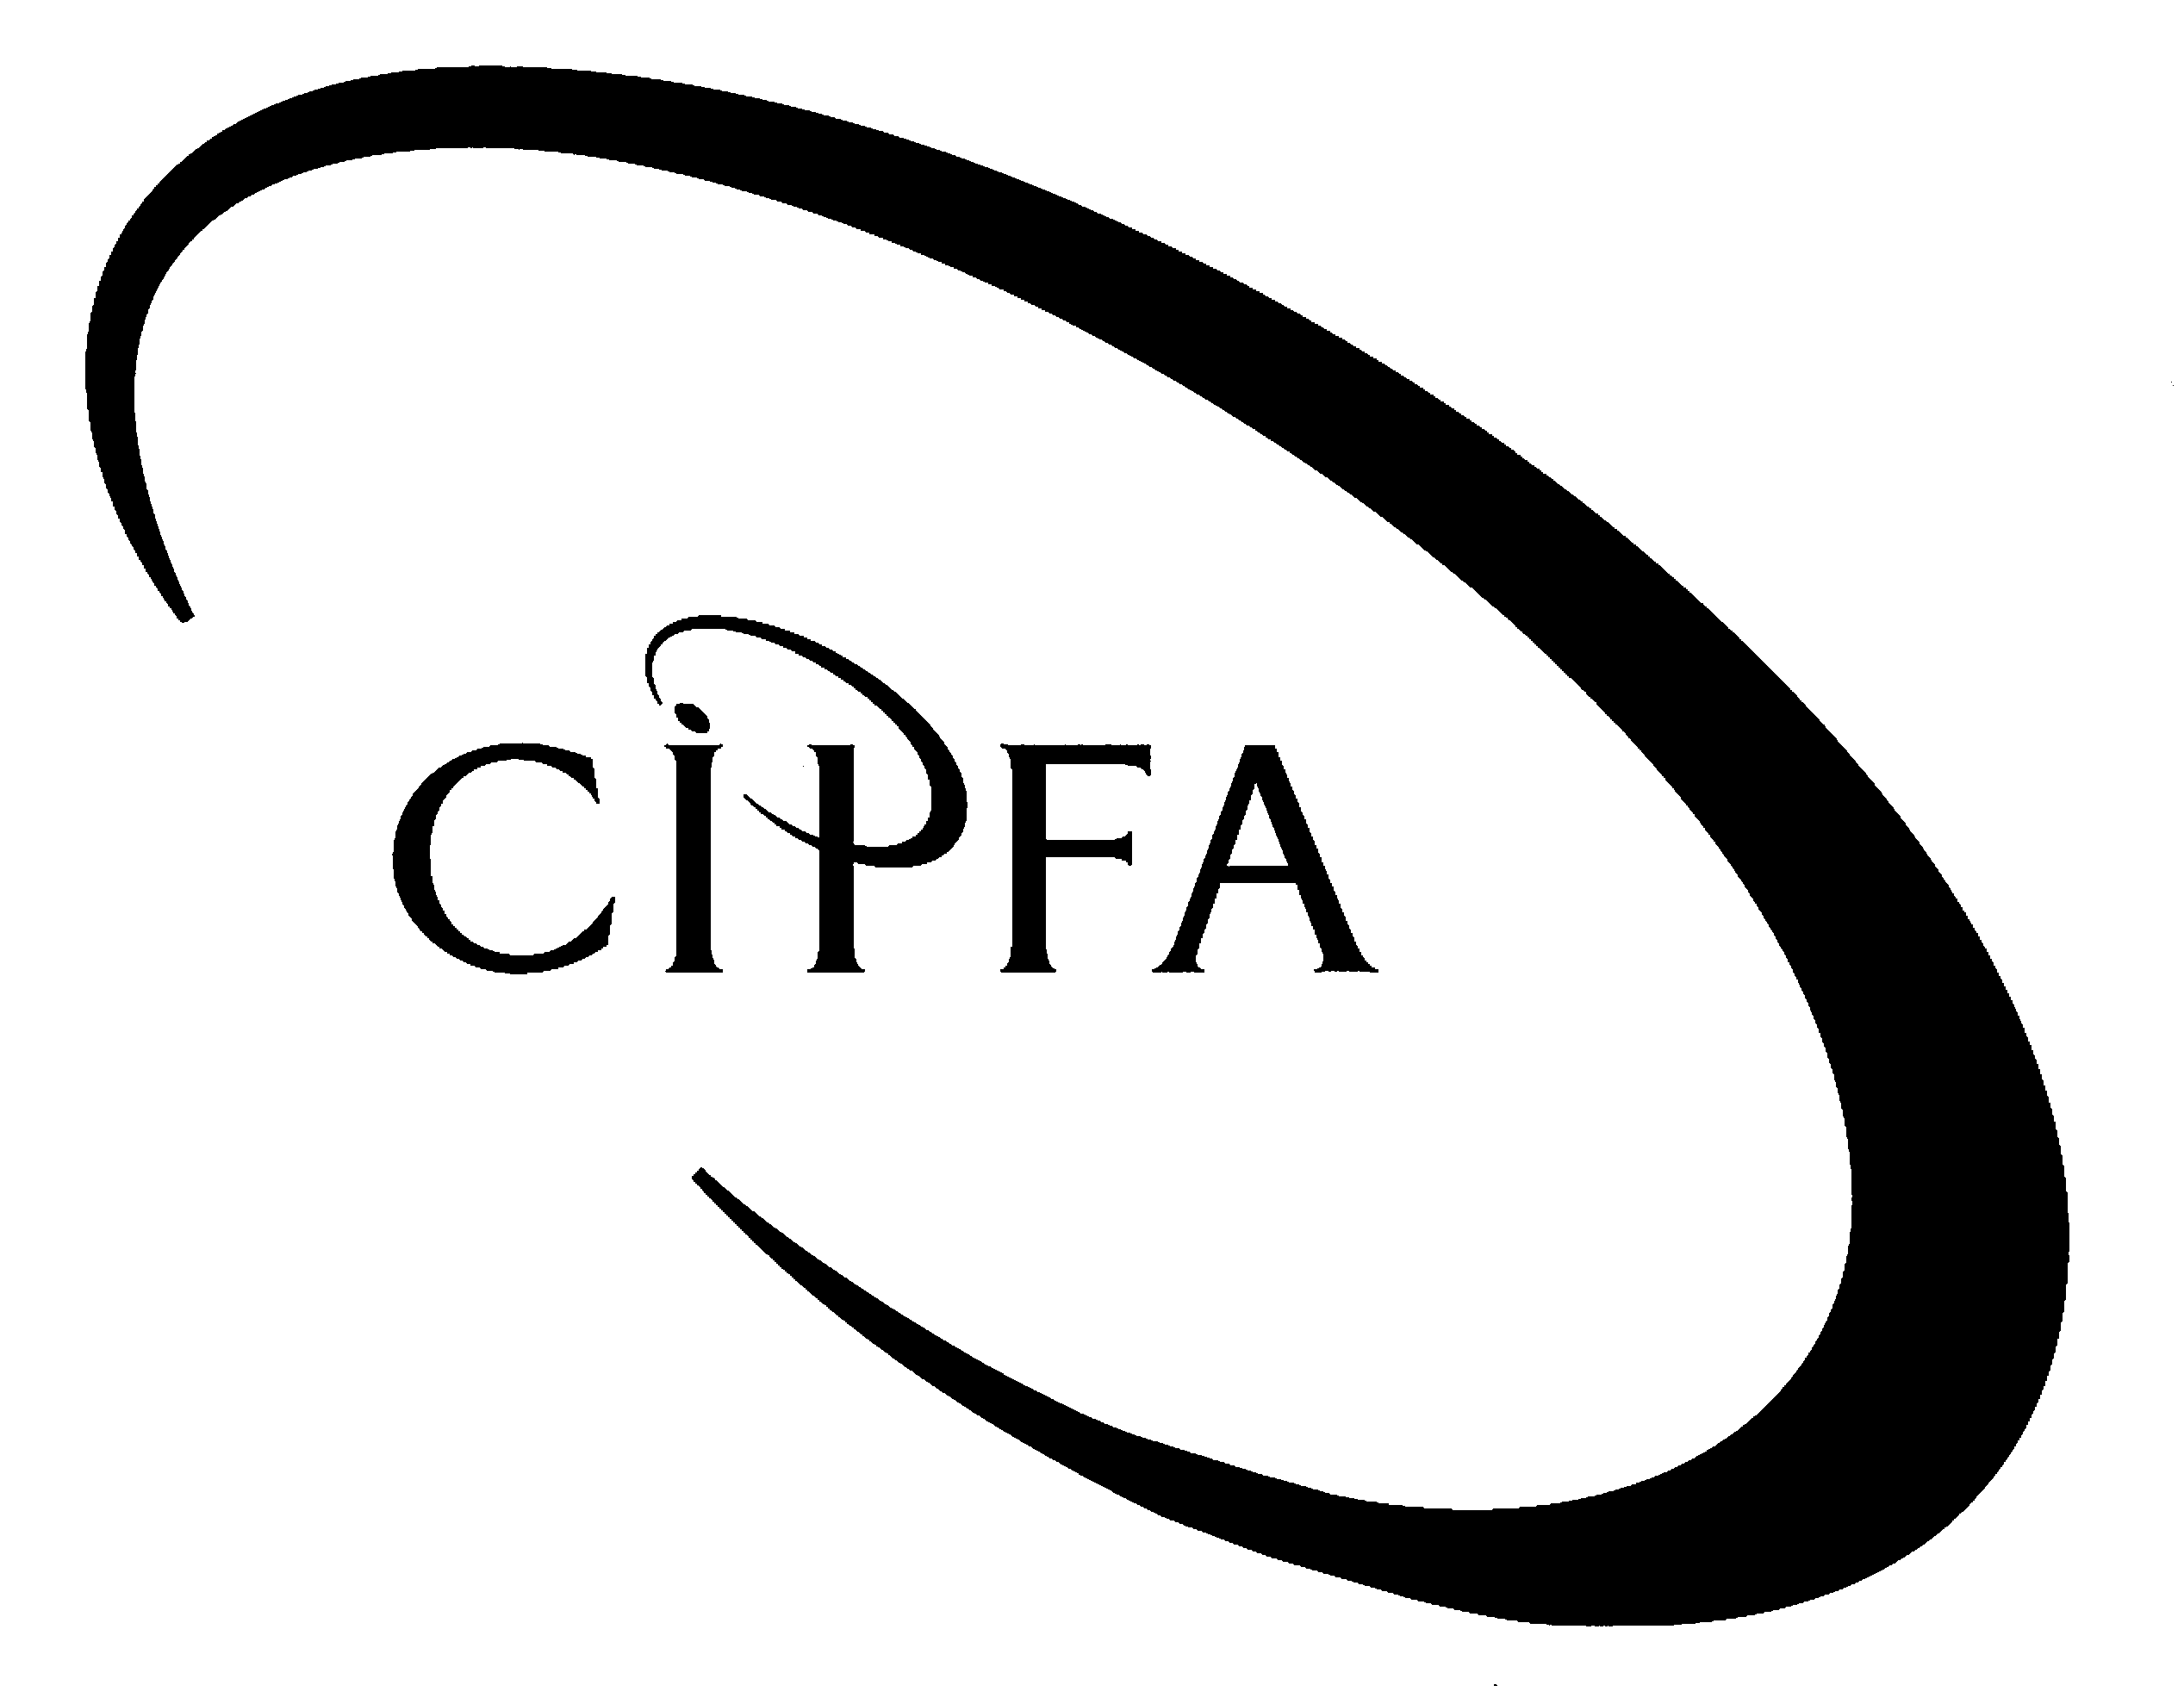

SECTION A (Compulsory)
1

You are a recently qualified CIPFA accountant who has just moved to the Internal Audit Section of a large local authority. Your Chief Internal Auditor calls you in to a meeting to discuss an e-mail he has just received from Councillor White. It appears that the Councillor has just returned from a public sector auditing conference where the terms ‘value for money’ and ‘internal control’ were referred to and he is keen to know more about these topics. He also appears to be interested in the arrangements for public sector audit. On a separate issue he is also looking for some advice to help him in serving in an advisory capacity to a new Information Technology Working Group.
The e-mail reads as follows:

Kelly, Patrick

From: Councillor White

Sent: 01 December 2000 17:06

To: Patrick Kelly, Chief Internal Auditor

Subject: General Audit Queries

I’ve just returned from a conference on public sector auditing and admit that I found the whole thing rather confusing. I only went because I’ve just joined the Finance Committee and was hoping to get a greater understanding of the public accountability process.

Over coffee there appeared to be a large discussion about ‘value for money’. What exactly does this term mean? Could this technique be used to evaluate our staff canteen service? At meetings of the Full Council we are always debating the cost of providing this service and before we make any decisions, it would be helpful to know how to assess the viability of the operation.

Although I’ve only been back in my office for two days, it has been brought to my attention that there have recently been a number of problems at the Transport Depot and many suspicions of irregularity. I seem to remember that some of my conference colleagues emphasised the importance of sound internal control and how this can play a key role in minimising fraud and irregularity. If there is something inappropriate going on in the Depot, then what should we be looking for and how could we follow it up?

The conference was full of individuals from public sector organisations from all over the UK, all of whom seem to have different external auditors. I thought it was just a case of picking a firm of Chartered Accountants from the local yellow pages to fulfil the external audit requirement. Can you clarify this?

I’ve been invited to contribute to an Information Technology Working Group looking at the general computer controls which should be central to any organisation. Do you have any advice which you could offer?

I’m off to another conference next week, so an early response would be appreciated.

Cheers.

At the end of the meeting, your boss asks you to carry out certain tasks which will help him plan a response to Councillor White.

- Requirement for question 1

Prepare a response for your Chief Internal Auditor which addresses the following issues:

(a) (i) Explain what is meant by the term ‘value for money’ and why it has more
relevance to the public sector than the private sector. 6

(ii) Describe the factors which need to be taken into account in achieving value for money in the running of a staff canteen service. 6

(b) (i) What is the definition of ‘internal control’? 3
What are the internal control procedures you would hope to find concerning:
- the purchase of vehicles 3
- the running costs of the fleet 3
at the Transport Depot?

(ii) Assuming you discover the possible existence of fraud, describe the steps you would take to interview cases of suspected fraud. 6

(c) Identify the key players involved in the external audit of the public sector and outline the public sector organisations that each key player is responsible for auditing. 6

(d) Detail the scope and purpose of ‘general controls’ and describe the various ‘general controls’ which auditors may concentrate on in evaluating the implementation of any new computerised system. 7
(40)
SECTION B (Answer three questions)
2

You have recently applied for the position of Chief Internal Auditor in a large NHS health authority and have just received notification that you have been successful following a lengthy interview process.

The outline of the job description for the post includes the establishment of an internal audit function, which has not previously existed. Responsibility would be to the Chairman of the Board of Management, who spends about half his time on the affairs of the organisation.

It becomes apparent during your preliminary discussions and meetings with senior members of the management of the organisation that there is some uncertainty concerning the possible scope of internal audit and its desirability. The Director of Finance in particular is believed to be sceptical about the establishment of an internal audit function and to regard the proposal as an unnecessary overhead, making the comment that “things are all right as they are”.

The Chairman of the Board, keen to have an internal audit function established as soon as possible, has asked you to provide him with a statement, justifying the existence of internal audit.

- Requirement for question 2

Prepare a statement of your views for the Chairman in a form, which he could, if he so decides, give to the Board. In this statement you should:

- Explain why, in the light of the Cadbury Committee and subsequent Committees’ recommendations, the establishment of an internal audit function can be seen as an essential part of the internal control function; 6

- Explain more generally how an internal audit function can contribute to the overall efficiency and profitability of an organisation; 6

- Discuss the options available to an organisation for providing an internal audit service. 8

(20)

You are the audit manager of a large firm of registered auditors, which has four offices and thirty partners, and a variety of public sector clients. You have recently been given the responsibility for quality control and the partner in charge, who believes quality control to be an important issue, has asked you to provide guidance on quality control under the following headings:
3

- The importance of quality in audit work
- Training of audit staff
- Monitoring the performance of audit staff
- Reviews of audit work

- Requirement for question 3

Write a memo to the senior partner of your audit firm on quality control, addressing each of the four issues in (i) to (iv) above.

The marks will be awarded as follows:
4 marks for points related to each of (i)-(iv) above.
4 marks for presentation and general comments on quality control.
(20)

Kirsty is a recently qualified CIPFA member and is a new employee in the Internal Audit section at Yipee Unitary Authority. After her first week in the job she is seconded to the head office of the Housing Department to review their payments procedures for housing benefit. All accounting information relating to housing benefit payments is kept on a mainframe computer at the head office. Access to the computer is through terminals at the local area housing offices. It is her first day in the job and her Supervisor offers to introduce Kirsty to people in the department.
4

First, Kirsty meets the office Secretary who informs Kirsty that after she meets everyone in the department, she needs to go down to Human Resources and fill out a bunch of forms to allow her access to housing benefit systems. The Secretary says to Kirsty, “Don’t worry about reading any of it, just tell them you want automatic everything and you can be back in time for us to take you to lunch”.

While walking down the hall to meet the next person, Kirsty asks her Supervisor about department policies and procedures, especially those that relate to payments procedures. The Supervisor informs her that there are not any department policies and procedures and that she should just look around her office and figure out the way everyone does their job. The Supervisor says to Kirsty, “I think we have something called “Yipee Rules and Regulations” but I’ve never seen them. If you have a question, ask me and I’ll call Frank Wise. He’s been with this place for years and he knows all the ways to get around the bureaucracy around here”.

Next, Kirsty meets the Departmental Accountant. As she walks into the Accountant’s office, she notices that he is playing a golf game on his computer. Obviously embarrassed, he explains that he just got the game from a guy in Information Resources. As he exits the program, she notices that an Inland Revenue income tax return pops up on the screen. He explains that he does a few personal income tax returns on the side to make a few extra pounds. “After all,” he explains, “they don’t pay a person what he’s really worth around here”.

After meeting several other people in the office, she meets the Director of the department. He seems very nice and apologises for not being able to go to lunch with her and everyone else. He explains that he has made lunch plans to meet an old buddy who is bidding on one of the department’s contracts for a new software package on housing benefit calculations.

After filling out the forms in Human Resources, Kirsty returns to the office and finds that everyone is waiting for her to go to lunch. Kirsty explains that she brought her lunch and that she needs to cash a cheque to go out for lunch. The office Secretary says, “Don’t worry, Kirsty, just get £20 out of the petty cash fund for your lunch. It’s an unofficial benefit for first day employees. I’ll write it up as a ‘miscellaneous expense’”. Kirsty is stunned; she does not know what to do.

Requirement for question 4

- Identify everything in the above case study that contributes negatively to the Department’s control environment. 8

- Describe the controls that can be used to control access to the main computer from terminals at local offices and consider the effectiveness of each of them. 6

- In advising Kirsty what to do next, outline for her the six fundamental principles which she is expected to observe in dealing with ethical dilemmas as depicted by CIPFA in their ‘Guideline on Ethics for Institute Members’ – April 1994. 6

(20)

As a trainee internal auditor with Windlestrae Housing Association you have been asked by your senior auditor to outline the various aspects of the work you will carry out in auditing the organisation’s wages system. In particular you have been asked to concentrate on ‘Windlestrae Windows’, a trading division of Windlestrae Housing Association, which manufactures Upvc windows for supply to housing association properties.
5

Employees of Windlestrae Windows are paid on the basis of hours worked and quantities produced. The hours worked are recorded on clock cards and the quantities produced are confirmed by the foreman. Wages are paid in cash each Friday for the previous week’s work. The cashier is separate from the wages department. Appointment of employees is authorised by the managing director, and the personnel department maintains employees’ records and their rates of pay.

Previous years’ audits have highlighted weaknesses in internal controls in the company’s wages system. This has allowed an employee in the wages department to perpetrate a fraud by creating fictitious employees on the payroll and misappropriating the wages. Thus, some of your audit tests should be designed to detect whether this fraud is still taking place.

- Requirement for question 5

- State the principal controls you would expect to exist in a cash wages system and explain their purpose. 6

- Suggest other techniques you would use to check the existence of employees, apart from attending the wages payout. 5

- Describe how you would carry out a starters and leavers test to ensure that employees are not paid before they commence employment or after they have left. 4

(d) Describe the analytical review techniques you can use in auditing the wages system. This should include suggesting any ratios you would calculate. 5

(20)

