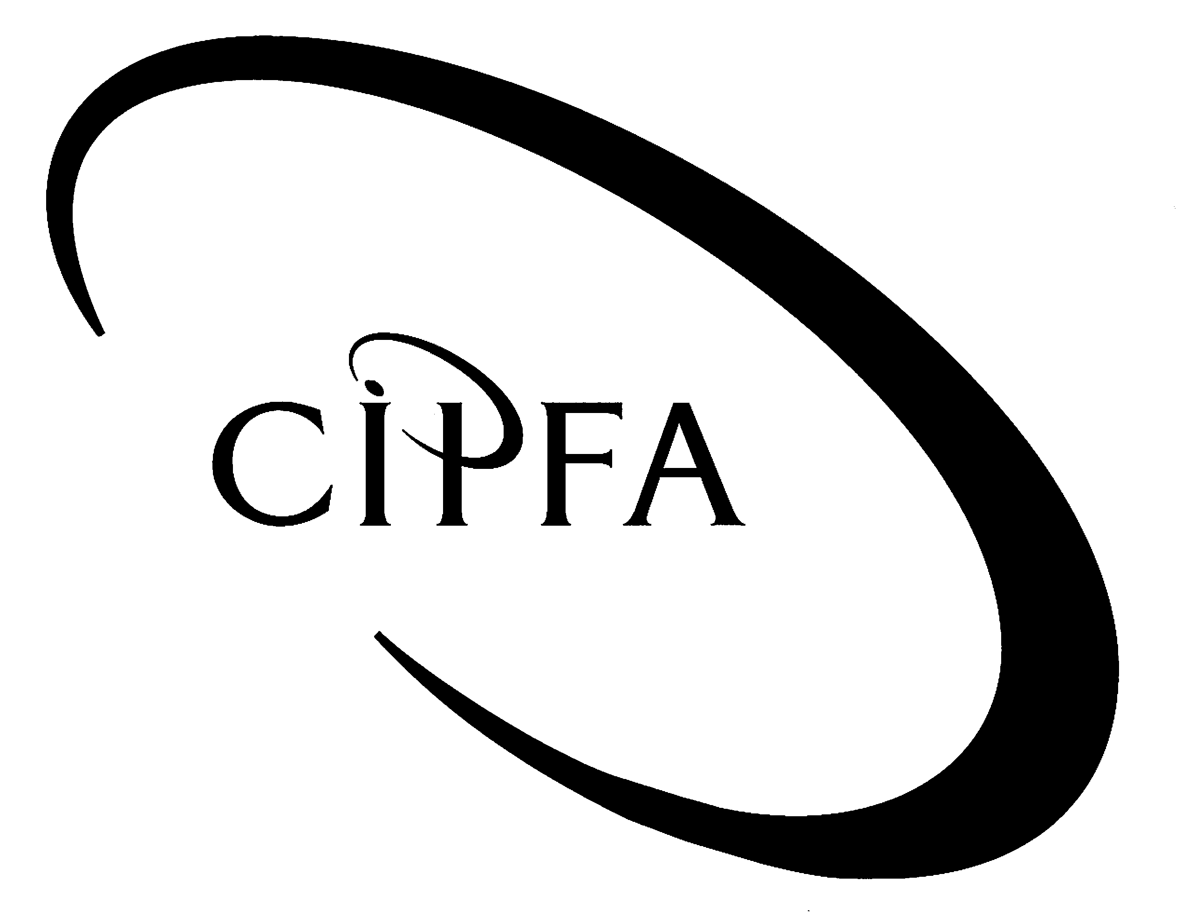

AUDIT AND ASSURANCE

Diploma stage examination

9 December 2005

From 2.00 pm to 5.00 pm
plus ten minutes reading time from 1.50 pm to 2.00 pm

Instructions to candidates

Answer four questions in total: One question from Section A and three questions from Section B. The marks available for each question are shown in italics in the right-hand margin.

Where a question asks for a specific format or style, such as a letter, report or layout of accounts, marks will be awarded for presentation and written communication.

SECTION A (Compulsory)

1
You are the manager of the team carrying out the external audit of a large rural county council. The Council has adopted a devolved management and budgetary approach to many of its services which are delivered via eight locally based Area Offices (AOs). Heads of AOs have operational responsibility and manage the budgets for all front-line services and some support services (eg accommodation, printing and copying, minor capital spending up to £2,000). They are supported in this by small, locally based finance teams of 2 or 3 staff, few of whom have any formal training in finance or accountancy. Area offices are set quarterly operational and financial performance targets.

Other functions such as bill paying, central financial accounting, budget setting and information technology are controlled centrally, although some of these (eg bill paying and financial accounting) are reliant on information flows from the AOs.

Some of the AOs have a very high level of staff turnover and vacancies due, in part, to their location away from the main centres of population in the county. The Council has also had a difficult time in recent years with wage disputes over the Council’s refusal to offer additional travel expenses for staff working at AOs.

You have received the following memo from your audit director.

INTERNAL MEMO:

From: Director of Audit
To: Audit Manager
Subject: Audit Plan for 2005/06

I have just got back from a meeting at County Hall with the Director of Finance to discuss this year’s audit plan. As you know, he is new to the job, having recently arrived from the private sector. He is very sharp but is a bit lacking in knowledge with regard to audit in Local Authorities. I said I would give him a rundown on our statutory powers, especially as compared to the private sector.

He was a bit surprised when I mentioned the various rights and powers that electors have and the fact that some electors are more than willing to use them. It’s not a situation he was used to with shareholders – I think we should give him something on that too.

He also made some comments about the problems of running an organisation with such a high level of devolved control. I know that is something we have thought about in the past, but I can’t see anything in the plan where we go into this in detail. Perhaps you could think about it?

On the subject of things which are or aren’t detailed in the plan I particularly want to make sure we’re covered on fraud. The Director told me he knew of a number of organisations in the public and private sectors where frauds have occurred, which he thought the auditors really should have spotted. I know the standards only require us to plan our work so as to have a reasonable expectation of finding material frauds (if they exist), but I would like to see some sort of assessment in the plan of the risks of fraud in general and at the Council in particular.

This last point didn’t actually come up in the meeting, since I didn’t show him any detailed audit test programmes, but I think our testing of creditors needs to be looked at again. I am not sure we are getting sufficient, appropriate evidence on all our audit objectives in this area.

Have a look at these matters please and let me have your response as soon as you can, preferably by the end of today. Thanks.

- Requirement for question 1

(a) Draft a letter to the Council’s Director of Finance (to be sent by your Director) covering the points raised in the Director’s memo, in particular:

(i) List the powers of external auditors of local authorities indicating, which are common to and which go beyond the powers of external auditors of limited companies. 6

(ii) Explain what powers local electors have in the context of local authority financial statements and records. 3
(Marks for presentation 1)

(b) What particular risks do organisations with a high degree of devolved management face? 7

(c) (i) List some of the organisational factors which may increase the likelihood of misconduct within an entity? 8

(ii) Which of these factors do you think might be present in the Council? 4

(d) (i) What should your detailed audit objectives be with regard to your audit of the creditors figure in the balance sheet? 6

(ii) Give examples of a substantive procedure which you would carry out to provide evidence for each of these objectives. 5

(40)

SECTION B (Answer three questions from this section)

The role of the external auditor in the last 100 years has progressed significantly from that of simply providing an opinion on the published financial statements of an entity. There are now a number of roles and functions which external auditors perform. Nevertheless, these roles still tend to focus primarily on financial systems and outputs.
2

More recently the tasks undertaken by auditors in general have gone well beyond the traditional boundaries. This expansion, combined with the growth in other inspection and performance regimes, especially in the public sector, means that many public service bodies are finding it hard to make the distinction between audit, inspection and performance reporting.

- Requirement for question 2

(a) Outline the main types of work in which external auditors are likely to be involved. 8

(b) Distinguish between:
- Audit;
- Inspection; and
- Performance reporting. 3

(c) Briefly explain some of the issues that arise with regard to inspection and performance reporting in comparison with the traditional roles and responsibilities of auditors. 9

(20)

You are the head of the Information Technology (IT) audit section of the internal audit department of an NHS Hospital Trust. The Trust has recently embarked upon a large- scale update of its entire IT system and it has formed a steering committee of line managers, finance staff and IT specialists to oversee the project. As part of your audit function’s policy on involvement in IT development projects, you have been appointed as an advisory member of the committee.
3

The head of the steering committee has asked you to attend a working party meeting between her and some of the design team to discuss aspects of the proposed system which are causing her some concern. She has given you a list of the areas where she would like you to advise her.

i. The design team has suggested that the costs of running the system could be reduced if operational staff were to be given responsibility for carrying out routine system upgrades.

ii. The draft system specification assumes that business continuity arrangements will remain unchanged, ie using the spare capacity of a neighbouring trust on a reciprocal basis.

iii. The plan contains a proposal to allow patients on-line access to view their own appointment schedules and medical records to speed up waiting times for out-patient appointments.

iv. Most of the software will be bespoke packages tailored specifically to the Trust’s needs. Line managers will have the ability to purchase and install items of proprietary software on office desktop computers.

v. Owing to the advances in data compression since the last system was installed, the existing, purpose built, file storage area is much larger than the Trust needs. It will therefore be re-designated as a staff recreation area and the files kept in an old store room next to the hospital heating plant.

- Requirement for question 3

(a) Explain what is meant by the term ‘general controls’ in the context of IT audit and explain the various categories of general controls of which auditors should be aware. 8

(b) In anticipation of your meeting with the steering committee chair, identify the possible risks to the Trust involved in the situations described above and suggest how management might address those risks. 12

(20)

You work as an audit team leader for a private sector firm which supplies internal audit services to a number of clients within both the public and private sectors. Two new clients, one a public limited company and the other a central government sponsored non-departmental public body (NDPB), have recently asked for some advice on what they should be doing to ensure that their corporate governance arrangements comply with best practice.
4

The limited company has a year end of October 2005 and this will be the first year that they are required to comply fully with the Combined Code on Corporate Governance. The Director of Finance is reasonably confident that the company has taken all necessary steps to comply with the Code, but would like internal audit to provide him with assurance on a few outstanding items:

- The company has a number of committees with various responsibilities. Each is required to carry out an annual review of its own performance and decision making.

- The Director of Finance reviews and approves all correspondence with shareholders, including the annual report and interim profit statements.

- Fifteen per cent of the company’s shares are owned by a venture capital company. Representatives of the venture capital company attend the annual general meeting of the company.

- The board consists of eight directors, two of whom are non-executive, one of whom is an independent non-executive.

The NDPB is required by central government guidance to establish an audit committee, which it has done. The committee has been in place for a number of years and the Accounting Officer (the Chief Executive) is concerned that some practices may have built up over time which do not comply with current best practice. In particular:

- The committee consists of four board members, none of whom have any operational responsibility for any part of the body. They are mostly academics or professionals with experience in the NDPB’s field of activity.

- Two years ago, in order to save time, the committee decided to reduce the quarterly meetings it had with the internal and external auditors to a once a year review of audit work carried out.

- A proposal to introduce a staff “Whistle-blowing” hotline has not been considered by the committee on the grounds that adequate protection is given by the Public Interest Disclosure Act 1998.

- The committee have recently hired a qualified accountant (as an independent consultant) to carry out, on their behalf, a review of the annual financial statements before they are approved by the accounting officer.

- Requirement for question 4

(a) Briefly set out the main points of the Combined Code on Corporate Governance published in July 2003 with regard to the appointment and remuneration of directors. 6

(b) Write letters to:

(i) the Finance Director of the company; and 6

(ii) the Accounting Officer of the NDPB 6

to be sent by the engagement partner in your firm, addressing their queries and, where they are not complying with best practice, suggesting improvements that might be made.
(Marks for presentation 2)

(20)

You have very recently started working for an internal audit consortium as an audit manager. Six months ago the consortium took on a new client for whom you are now responsible. The first audit report on one of the client’s operational departments has just been received by them. The final report was dispatched shortly before you took up post and the line manager of the audited department has sent you the following e-mail.
5

From: Phil Archer Sent: Friday 9 December 2005/09.30
To: Internal Audit Manager
Subject: Internal audit report – November 2005
I have just finished reading the audit report your firm issued on my department and felt I had to let you know just how unhappy I was about the report in particular and about the whole way the audit was conducted generally.

It was never adequately explained, either to myself or my staff, what the purpose of the audit was and your staff constantly bombarded mine with requests for information, some of which took a long time to prepare. There was a distinct lack of communication, not only at the outset but right the way through the audit.

As for the report itself, I can just about make sense of it since I know something about the system, but heaven only knows what the audit committee will make of it. Page after page of densely packed paragraphs is not the way to get your message across, I would suggest.

In some places the report is factually incorrect. As it happens, none of the mistakes are major, but they could have been. What is more, some of the recommendations you make are simply not practical. My staff have neither the time nor the experience to implement some of your suggestions.

I realise that you personally are not responsible for this report, but it strikes me that there ought to be a system in place that would prevent these kinds of things from happening. I would be grateful if you could let me know what you will be doing in future to avoid a repetition of something like this.

Phil Archer

- Requirement for question 5

(a) List some of the items of information which a client and auditor might exchange, whether on a formal or informal basis, during the course of an audit. 6

(b) What advantages would a formal communications strategy have in helping to prevent some of the problems which occurred in this instance? 4

(c) Draft a response to the Director’s e-mail in which you explain how you intend to address each of his concerns. 9
(Marks for presentation 1)

(20)

