AUDIT AND ASSURANCE/ FINANCIAL REPORTING

December 2005
AAT Fast-Track

MARKING SCHEME

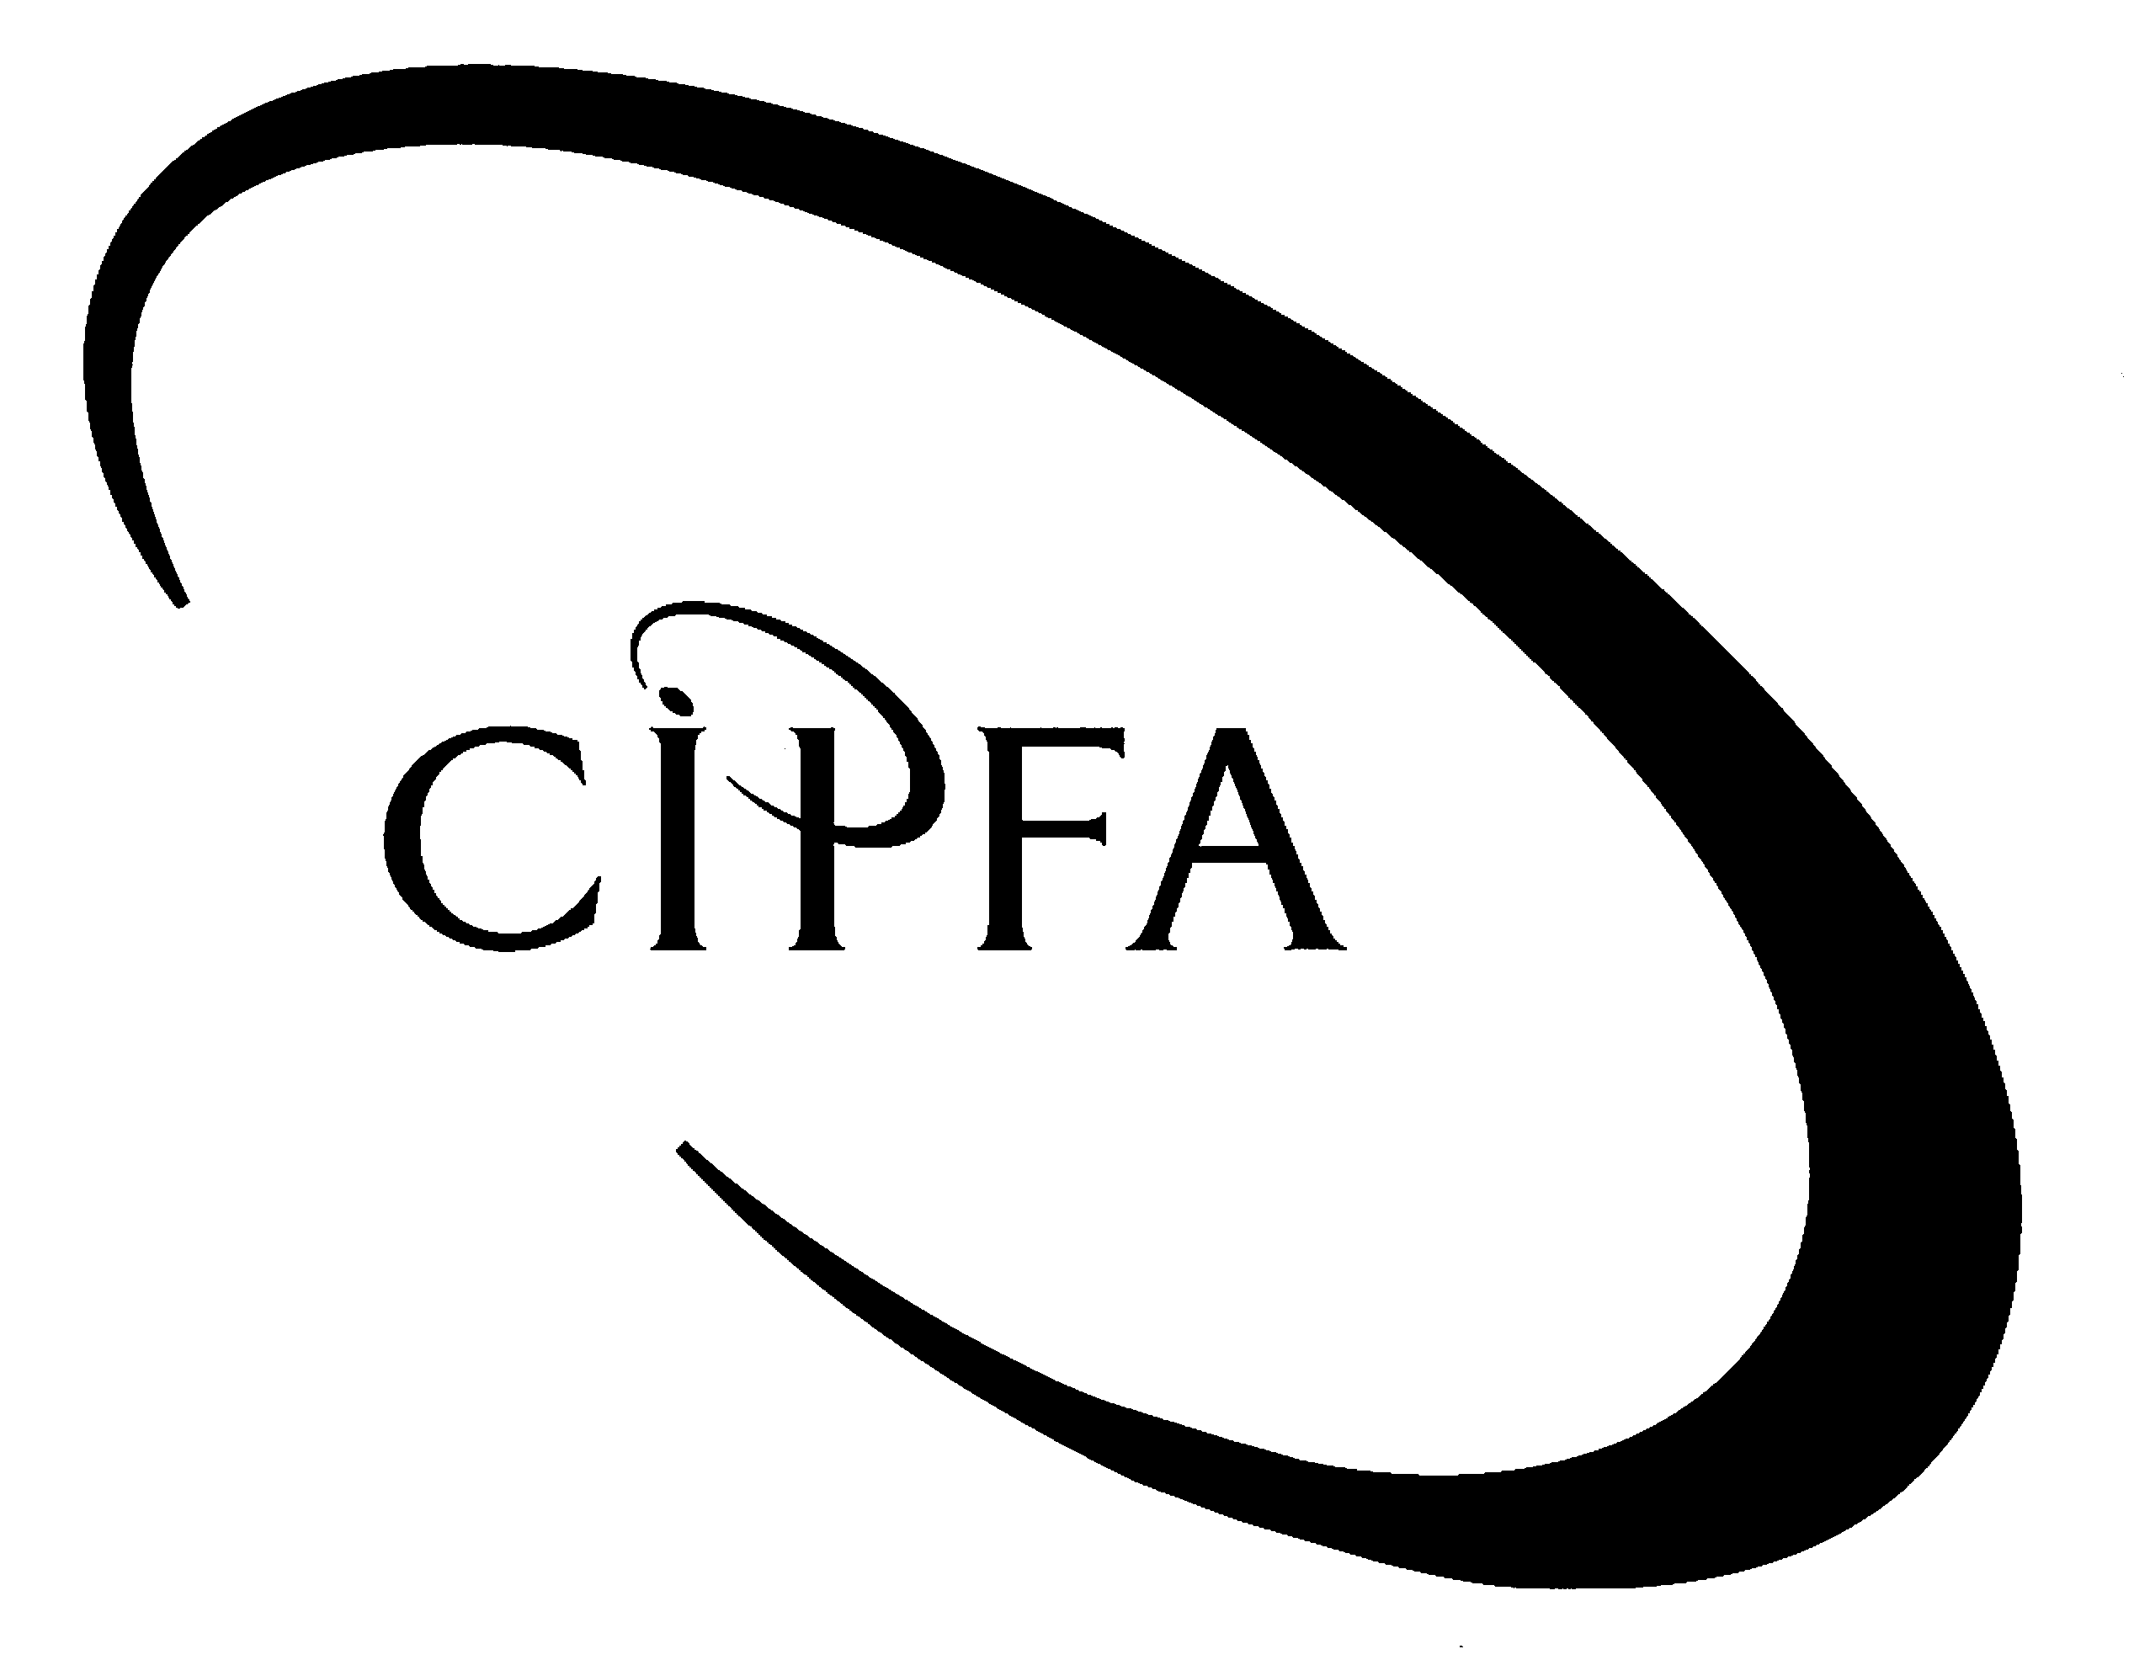

Question 1

(a) (i) Comptroller and Auditor General/National Audit Office
- Audit Commission/Private Firm
- Private Firm
- Audit Scotland/Private Firm

1 mark per answer to a maximum of 4 marks
“Private firm” answer to be allocated only ½ mark if used more than once
4

(b) Internal audit needs to be independent to be effective. Therefore anything which increases independence tends to improve status.

The reporting line of internal audit must be to a senior level as well as to an audit committee composed of independent members.

The Head of Internal Audit must have seniority within the organisation.

Internal audit should ideally be independent of the Finance function.

Internal audit’s status and rights of access must be protected by its internal regulations.

Internal audit should have sufficient resources to undertake its role effectively and must project a professional image.

Internal audit must also cultivate constructive working relationships, so that its independence is tempered with an ability to provide a valuable service to the organisation.

1 mark per point and up to 2 marks for fully developing a point up to a maximum of 6 marks

(c) Risks

Inability to meet the technical demands of customers.
Failure to complete jobs on time.
Failure to keep costs under control.
Lack of customers arising from inefficiency leading to inflated prices.
Wastage on jobs.
Escalating costs of raw materials.
Loss of suppliers.
Breakdown of machinery losing productive time.

Controls

Regular meetings with customers to discuss requirements.
Clear specifications for jobs.
Staff training in use of machinery.

Detailed budgets and clear job costing.
Regular monitoring of budgets to see all are on target.
Attendance at trade shows to keep up to date with new technology.
Budgeted surplus earmarked in part to pay for new equipment.
Good supplier base with alternative suppliers for all key items.

1 mark for each of these and any other relevant points to a maximum of 12 marks

(d) The board is responsible for internal control and ensuring that its system is effective in managing risk.
- Management, not internal audit, are responsible for effective internal control.
- Internal control to be taken seriously needs to be a Board level responsibility.
- Board should set policies on internal control and seek regular reassurance of their implementation.

Internal control should be embedded in the company and be capable of reporting quickly.
- All management and staff need to be aware of risk and internal control concepts.
- Internal control should be part of normal business processes.
- Internal control should be “embedded” in the company.
- Internal control should respond quickly to evolving business processes.

Internal control effectiveness should be monitored and subject to regular review by the board.
- Board should review internal control regularly.
- Board should not rely upon others to confirm that all is well with internal control.
- Review will be major part of work of audit committee.
- Board should make formal annual assessment of control.

Companies, which do not have an internal audit function, should from time to time review the need for one.
- No legal requirement for internal audit function in private sector.
- Internal audit best way of providing assurance on risk and control.
- Decision to have/not have internal audit must therefore take into account the benefit of improved controls.
- Alternative means of assurance on risks/controls if internal audit not in place.
- Annual reconsideration of need for internal audit if none in place.
- Board should annually review the scope of internal audit work where a function exists.
1 mark for each of points in bold
1 further mark for each of supplementary points up to a maximum of 4 marks
(8)

(30)

Question 2

Mercator plc |  |  |  |  |  |  |  | ½
Profit and loss account
for the year ended 31 October 2005 |  |  |  |  |  |  |  | ½
 |  |  | Continuing |  | Discontinued |  | Total
 |  |  | Operations |  | Operations
 |  |  | £ |  | £ |  | £ | ½
Turnover |  |  | 11,820,000 |  | 7,880,000 |  | 19,700,000 | 1
Cost of sales |  |  | (10,560,770) |  | (5,815,000) |  | (16,375,770) | 2 ½
Gross profit |  |  | 1,259,230 |  | 2,065,000 |  | 3,324,230 | 1
Distribution costs |  |  | (341,570) |  | (73,000) |  | (414,570) | 2 ½
Administrative expenses |  |  | (866,910) |  | (160,000) |  | (1,026,910) | 5 ½
Operating profit |  |  | 50,750 |  | 1,832,000 |  | 1,882,750 | ½
Loss on sale of operation |  |  |  |  |  |  | (203,500) | 1
Income from fixed asset investments |  |  |  |  |  |  | 16,900 | 1
Interest payable and similar charges |  |  |  |  |  |  | (74,300) | 1
Profit on ordinary activities |  |  |  |  |  |  | 1,621,850 | ½
Tax on profit on ordinary activities |  |  |  |  |  |  | (604,100) | 2
Profit on ordinary activities after taxation |  |  |  |  |  |  | 1,017,750 | ½
Dividends paid and proposed |  |  |  |  |  |  | (383,000) | 2
Amount set aside to reserves |  |  |  |  |  |  | 634,750 | ½
 |  |  |  |  |  |  |  | (23)

Marks as above: 23
Appropriate disclosure of discontinued operations:
Analysis of turnover 1
Analysis of cost of sales 1
Analysis of gross profit 1
Analysis of distribution costs 1
Analysis of administrative expenses 1
Analysis of operating profit 1
Style and presentation 3

(b) Basic earnings per share = 39.4 pence

Workings |  |  | £
Profit after tax |  |  | 1,017,750
Preference dividend |  |  | 33,000
Available for ordinary shareholders |  |  | 984,750
Number of shares |  |  | 2,500,000
EPS |  |  | 39.39

Calculation of profit attributable to ordinary shareholders 1 ½
Number of shares ½
Earnings per share in pence 1
(3)

Workings

Cost of sales |  |  | £
per trial balance |  |  | 16,154,000 |  | ½
Production director's remuneration |  |  | 47,770 |  | 1
Depreciation |  |  | 174,000 |  | 1
 |  |  | 16,375,770
Distribution costs
per trial balance |  |  | 304,600 |  | ½
Sales director's remuneration |  |  | 37,470 |  | 1
Depreciation |  |  | 72,500 |  | 1
 |  |  | 414,570
Administrative expenses
per trial balance |  |  | 666,000 |  | ½
exclude overdraft interest |  |  | (4,300) |  | 1
Bad debts |  |  | 216,700 |  | 1
Directors' remuneration (47,770+ 46,840) |  |  | 94,610 |  | 1
Depreciation |  |  | 43,500 |  | 1
Audit and accountancy fees |  |  | 10,400 |  | 1
 |  |  | 1,026,910
Interest payable and similar charges
Debenture interest |  |  | 70,000 |  | ½
Bank overdraft interest |  |  | 4,300 |  | ½
 |  |  | 74,300
Tax on profit on ordinary activities
Corporation tax |  |  | 625,500 |  | ½
Transfer from deferred taxation |  |  | (21,400) |  | 1
 |  |  | 604,100
Dividends paid and proposed
Preference paid |  |  | 16,500 |  | ½
Preference proposed |  |  | 16,500 |  | ½
Ordinary paid |  |  | 150,000 |  | ½
Ordinary proposed |  |  | 200,000 |  | ½
 |  |  | 383,000

Question 3

(a)
Catzen Ltd
Cash flow statement for the year ended 31 October 2005
 |  |  |  |  |  | £000
Net cash inflow from operating activities |  |  |  |  |  | 2,095 |  | 8
Returns on investments and servicing of finance
Interest paid |  |  |  |  |  | (147) |  | 2
Taxation
Corporation tax paid |  |  |  |  |  | (23) |  | 2
Capital expenditure
Payments to acquire tangible fixed assets |  |  |  |  | (240) |  |  | 1
Receipts from sales of tangible fixed assets |  |  |  |  | 67 |  |  | 1
 |  |  |  |  |  | (173)
 |  |  |  |  |  | 1,752
Financing
Issue of ordinary share capital |  |  |  |  | 280 |  |  | 1
Issue of debentures |  |  |  |  | 600 |  |  | 1
Repayment of debentures |  |  |  |  | (350) |  |  | 1
 |  |  |  |  |  | 530
Increase in cash |  |  |  |  |  | 2,282 |  | (17)

Reconciliation of operating profit to net cash inflow from operating activities
 |  |  |  |  |  | £000
Operating profit |  |  |  |  |  | 1,597 |  | 1
Profit on sales of fixed assets |  |  |  |  |  | (23) |  | 1
 |  |  |  |  |  | 1,574
Depreciation
on Equipment |  |  |  |  | 358 |  |  | 1
on Motor vehicles |  |  |  |  | 104 |  |  | 1
on Development costs |  |  |  |  | 55 |  |  | 1
Amortisation of goodwill |  |  |  |  | 40 |  |  | 1
 |  |  |  |  |  | 557
Increase in stock |  |  |  |  |  | (122) |  | 1
Increase in trade creditors |  |  |  |  |  | 86 |  | 1
Net cash inflow from operating activities |  |  |  |  |  | 2,095 |  | (8)

(b)

Catzen Ltd
Balance Sheet as at 31 October 2005
Fixed assets |  |  | £000 | £000
Intangible assets, net book value (W1) |  |  |  | 390 |  | 2
Tangible assets, net book value (W1) |  |  |  | 962 |  | 2
 |  |  |  | 1,352
Current assets
Stock, at cost |  |  | 997 |  |  | ½
Cash and bank (W2) |  |  | 1,947 |  |  | 1
 |  |  | 2,944
Creditors: amounts falling due within one year
Trade creditors |  |  | 642 |  |  | ½
Taxation |  |  | 368 |  |  | ½
Accrued interest |  |  | 8 |  |  | ½
 |  |  | 1,018
 |  |  |  | 1,926
Total assets less current liabilities |  |  |  | 3,278
Creditors: amounts falling due in more than one year
8% Debentures |  |  |  | (600) |  | 1
Provisions for liabilities and charges
Deferred taxation |  |  |  | (211) |  | 1
 |  |  |  | 2,467
Share capital and reserves
Ordinary shares of £1 each |  |  |  | 1,400 |  | 1
Share premium account |  |  |  | 360 |  | 1
Profit and loss account (W3) |  |  |  | 707 |  | 1
 |  |  |  | 2,467
 |  |  |  |  |  | (12)

Workings

1 Fixed assets |  |  |  | Cost | Accumulated | Net book
 |  |  |  |  | depreciation | Value
 |  |  |  | £000 | £000 | £000
Intangible:
Goodwill |  |  |  | 400 | 120 | 280
Development costs |  |  |  | 220 | 110 | 110
 |  |  |  | 620 | 230 | 390
Tangible:
Equipment |  |  |  | 1,790 | 932 | 858
Motor vehicles |  |  |  | 520 | 416 | 104
 |  |  |  | 2,310 | 1,348 | 962

2 Closing cash and bank balance | £000
Opening balance (overdrawn) (345 – 10) | (335)
Increase in cash per cash flow statement | 2,282
Closing balance | 1,947

3 Profit and loss account |  | £000
Balance b/f |  | (499)
Retained profit for the year |  | 1,206
Balance c/f |  | 707

(c)
- Catzen started the year with significant accumulated losses in its profit and loss account and a significant bank overdraft.
- It also looks as though the company has not been paying dividends to its shareholders and there seem to be arrears of interest paid on borrowing.
- By the end of the year the profit and loss account was in credit and there was a significant positive balance on the company’s bank account.
- Given the debit balance on profit and loss account at the start of the year capital gearing may be on the high side. By the end of the year this had improved.
- All the above represent a significant improvement in liquidity. This is confirmed by the cash flow statement which shows a large increase in cash for the year of £2,282,000.
- The increase came mainly from outstanding trading results for the year, with high margins being earned on sales and tightly controlled overheads.
- The other main source of cash over the year was financing. The company raised significant amounts by issuing shares and debentures. This allowed the company to replace higher interest rate borrowing with lower rate borrowing. The new ordinary shares were issued at a premium.
- The changes in financing may have been an achievement by the company given the poor state of the company’s finances at the start of the year. However, the confidence that investors have shown in the company seems to have paid off given the excellent trading results for the year. However, the company continues to pay no dividends on its shares.

(1 mark per valid point to a maximum of 6)

(35)

Question 4

(a)
 | Egas Contract
 | £000
Contract value | 300
Costs to date | 70
Estimated future costs | 140
Estimated profit | 90 | 1
Percentage complete: | 90 / 300
 | = 30%
Attributable profit: | 27 | 1
Profit and loss account figures:
 | £000
Turnover | 90 | 1
Cost of Sales (balance) | 63 | 1
Profit | 27
Balance sheet figures:
 | £000
Work in progress: |  | 1
Costs to date | 70 | 1
Transferred to Cost of Sales | 63 | 1
 | 7
Amounts recoverable on contracts: |  | 1
Turnover | 90 | 1
Value of work invoiced | 72 | 1
 | 18
Trade debtors: |  | 1
Value of work invoiced | 72 | 1
Payments received | 60 | 1
 | 12
 |  | (13)

(b) (i) A permanent difference is a one-off difference between reported net profit and taxable profit. For example, an item may have been reported as an expense in the profit and loss account, but if the expenditure is not allowable for tax purposes, eg some entertainment expenses, this would cause taxable profit to be higher than reported profit. Permanent differences affect one year only.

Timing differences cause differences between reported net profit and taxable profit but affect more than one financial year. Timing differences originate in one or more financial years and reverse in one or more following financial years. A common example is the difference between the depreciation charged in the financial statements and the capital allowances charged for tax purposes.

Descriptions 2 x 1 = 2
Examples 2 x 1 = 2
(4)

(ii) The flow through approach is where no deferred taxation is provided for, ie taxation delayed or accelerated because of timing differences is not recognised.

Full provision is where deferred taxation is provided for, on all material originating timing differences irrespective of whether or not the timing difference is expected to reverse in the foreseeable future.

Partial provision is where deferred taxation is provided for on material originating timing differences only to the extent that those originating timing differences are expected to reverse within the foreseeable future, ie only if a taxation liability is expected to crystallise.
Flow through – 1
Full provision – 2
Partial provision – 2
(5)

(iii) The full provision method is the method required in the UK under FRS 19 Deferred Taxation (or under IAS 12 Income Taxes for UK listed companies applying international accounting standards).
Method – 1, justification – 1 = 2

(iv)
Profit and loss account extract
 |  |  | £
Net profit |  |  | 18,560,400
Taxation
Corporation tax |  | 4,938,120
Transfer to deferred taxation |  | 756,000
 |  |  | 5,694,120
Net profit after taxation |  |  | 12,866,280

Workings
Net profit – given
Corporation tax – 30% of taxable profit of £16,460,400 = £4,938,120
Transfer to deferred taxation = 30% of the timing differences of £2,520,000 = £756,000

Net profit – ½
Corporation tax – 1
Deferred taxation transfer – 1
Profit after tax – ½
(3)
(v)
Balance sheet extract
 |  |  | £
Creditors: amounts falling due within one year
Corporation tax |  |  | 4,938,120
Provisions for liabilities and charges
Deferred taxation |  |  | 2,016,000

Workings
Corporation tax – as provided for in the profit and loss account
Deferred taxation = balance b/f of £1,260,000 + transfer for the year of £756,000 = £2,016,000

Accurate headings – ½ and 1 = 1 ½
Corporation tax = ½
Deferred taxation = 1
(3)

