LEADERSHIP AND MANAGEMENT

Diploma stage examination

14 June 2005

From 10.00am to 1.00pm
plus ten minutes reading time from 9.50am to 10.00am

Instructions to candidates

Answer all three questions. The marks available for each question are shown in italics in the right-hand margin.

Where a question asks for a specific format or style, such as a letter, report or layout of accounts, marks will be awarded for presentation and written communication.

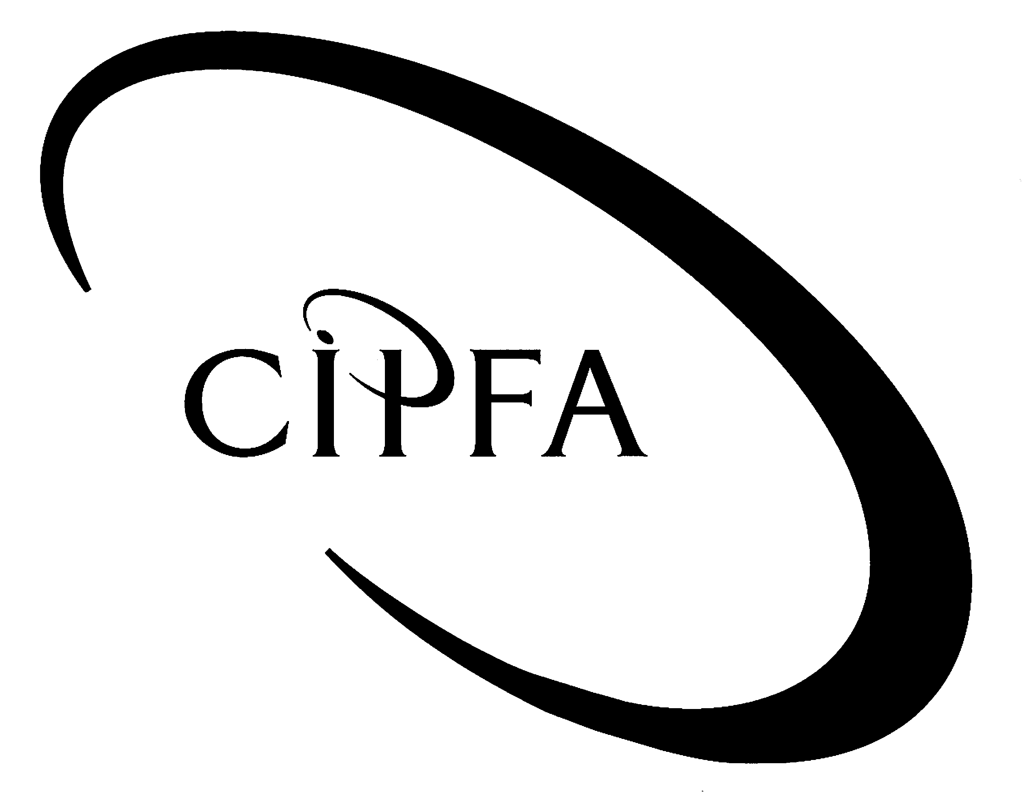

At the conclusion of the recent long-running firefighters’ industrial dispute in the UK in 2003, the firefighters returned fully to work with an agreed settlement that fell short of their initial aspirations. The local authority employers had wanted, on the basis of the Bain review of 2002, to link future pay levels to the introduction of ‘radical modernisation’ measures and increases in job flexibility. The employees’ main trade union, the FBU (Fire Brigades Union), expressed misgivings from the outset, despite the Bain review’s proposal to link an 11% pay increase over two years with the implementation of the modernisation plans.
1

Relations between the FBU and the employers deteriorated and as they did so, the union tried to put pressure on the employers to agree the generous pay settlement with less than full implementation of Bain’s other proposals. They did this partly by cultivating public sympathy and support, but as a number of national strikes came into effect, public support ebbed somewhat. The employers and the Office of the Deputy Prime Minister in Whitehall became increasingly vocal in their condemnation of the union’s behaviour whilst the FBU called the employers intransigent.

In the war of words that accompanied the dispute, the FBU said that ‘modernisation’ was ‘code for cuts’ and employers must agree a ‘fair pay deal’ before they would agree to any more changes to the service. The employers, in turn, made a point of publicising some of the aspects of the firefighters’ practices that they thought might interest the public such as firefighters’ refusal to use heart defibrillators at accidents and their reluctance to change a shift system that, it was argued, discouraged women from joining the service.

A year after the end of the initial stages of the dispute - in May 2004 - some of the rancour of the previous two years was still in evidence. One firefighter from London said that, “I can honestly say that in my 17 years of experience, even after all the misery of the picket lines, the morale of the ‘modernised’ firefighter is at an all-time low. The result of this failing morale is an overwhelming sense of apathy. Across the board, you see glum faces where once there was a reasonably happy working atmosphere. There is very little pride left in our day-to-day work any more.”

The chairwoman of the London Fire Authority believed that the firefighters had never really accepted the modernisation proposals and that progress towards full modernisation was still being hampered by the FBU. She told the BBC that, "some of the changes we are making are probably in the face of opposition from the union but we are doing what is right for the 7.4 million people of London… The union have never wanted to change and that has always been the blockage."

- Requirement for question 1

(a) Define and describe the nature of the psychological contract that exists between public servants such as firefighters and their employers. 10

(b) How might a dispute such as that described affect both sides of the psychological contract? 8

(c) Discuss the extent to which the causes of the firefighters’ dispute can be understood in terms of the radical (neo-Marxist) perspective. 8

(d) With reference to the case scenario, describe the types (or ‘sources’) of resistance to change in organisations and how these relate to the situation of introducing ‘modernisation’ in the fire service. 14

(40)

“It’s always an excruciating decision whether or not to take a child into care,” said Beverley Ord, an experienced social worker at Castlecliff local authority. She was speaking at a case conference with other social workers, health professionals and community workers where the situation of a young girl (‘Vashti’) was being considered. The girl’s father had deserted and the mother, with whom Vashti was staying, had recently found it difficult to cope due to a number of drug and health related issues.
2

“I can see both sides of the case,” Beverley said. “It might be good for Vashti and the mother to get a bit of respite from each other for a while but I’ve seen these situations go both ways – sometimes they work out for the youngster, sometimes not. In Vashti’s case, her mother finds it hard to cope, Vashti often gets neglected and in the interest of the child I think we should recommend a temporary care order.”

Bill Lee, a community worker, took a different view. “I believe it is always best to leave the child with the mother. Even a bad parent is still a parent. Vashti’s mother will love her more than a state institution ever can. Systems and procedures are no substitute for being with a mother, however imperfect she may be. What would happen if we placed a child in care every time there was a bad parent involved?”

Pete Gollings, the social work team leader and chair of the meeting felt there was some validity in both Beverley’s and Bill’s opinions. “I’m not sure how useful hard-and-fast rules are in situations like this. You can have any number of written down guidelines, procedures and protocols for situations like this but sometimes you just have to rely on experience and gut-feeling.”

- Requirement for question 2

(a) Using the case of Vashti as a basis for your answer, define and distinguish between deontological and teleological ethical perspectives. 10

(b) Define and discuss the relevance of both explicit and tacit types of knowledge to a complex decision such as that relating to Vashti. 12

(c) Discuss the advantages and disadvantages of adopting a case conference (‘committee’) approach to a complex decision such as that relating to Vashti compared to an individual making the decision alone. 8

(30)

Following an internal review of degree programme delivery at Bigtime Business School (a faculty of the University of Great Expectations), it was decided to revert to the functional structure that the organisation had worked under previously. A consultation with staff and unions had highlighted limitations with the existing matrix structure although this (the matrix structure) was preferred by Paul Mates, the head of faculty.
3

“When we run – as we do – a dozen undergraduate degrees and half that number of MA and MSc courses and while modules run on several degrees at once, I think the matrix approach allows us the maximum flexibility to address the needs of each degree course and more importantly, the expectations of each student,” said Paul at a recent Business School executive meeting. “Functional structures look neater on paper but they encourage tribalism and do not reflect the inter-departmental nature if our work. More organic, less mechanistic – that’s the way forward and a matrix helps us achieve that”.

“And culture is just as important as structure,” Paul continued. “If we can get the culture ‘right’ – fitted to our strategy – we will become more organic anyway. I can live with a functional structure if we all remember that networks and relationships are more important than lines on a chart”.

- Requirement for question 3

(a) Define, and briefly remark on the advantages and limitations of:

(i) functional structures; 5
(ii) matrix structures. 5

(b) Critically evaluate Paul Mates’s statement: “more organic, less mechanistic – that’s the way forward...” Your answer should briefly define ‘mechanistic’ and ‘organic’ in context and discuss their relevance to organisations seeking to deliver complex services such as universities. 10

(c) Paul Mates mentioned the importance of culture and its fit with strategy. Briefly describe Handy’s four culture types and briefly provide an example of one of those types in a public sector service provision context. 10

(30)

