LEADERSHIP AND MANAGEMENT

June 2005
Diploma stage

MARKING SCHEME

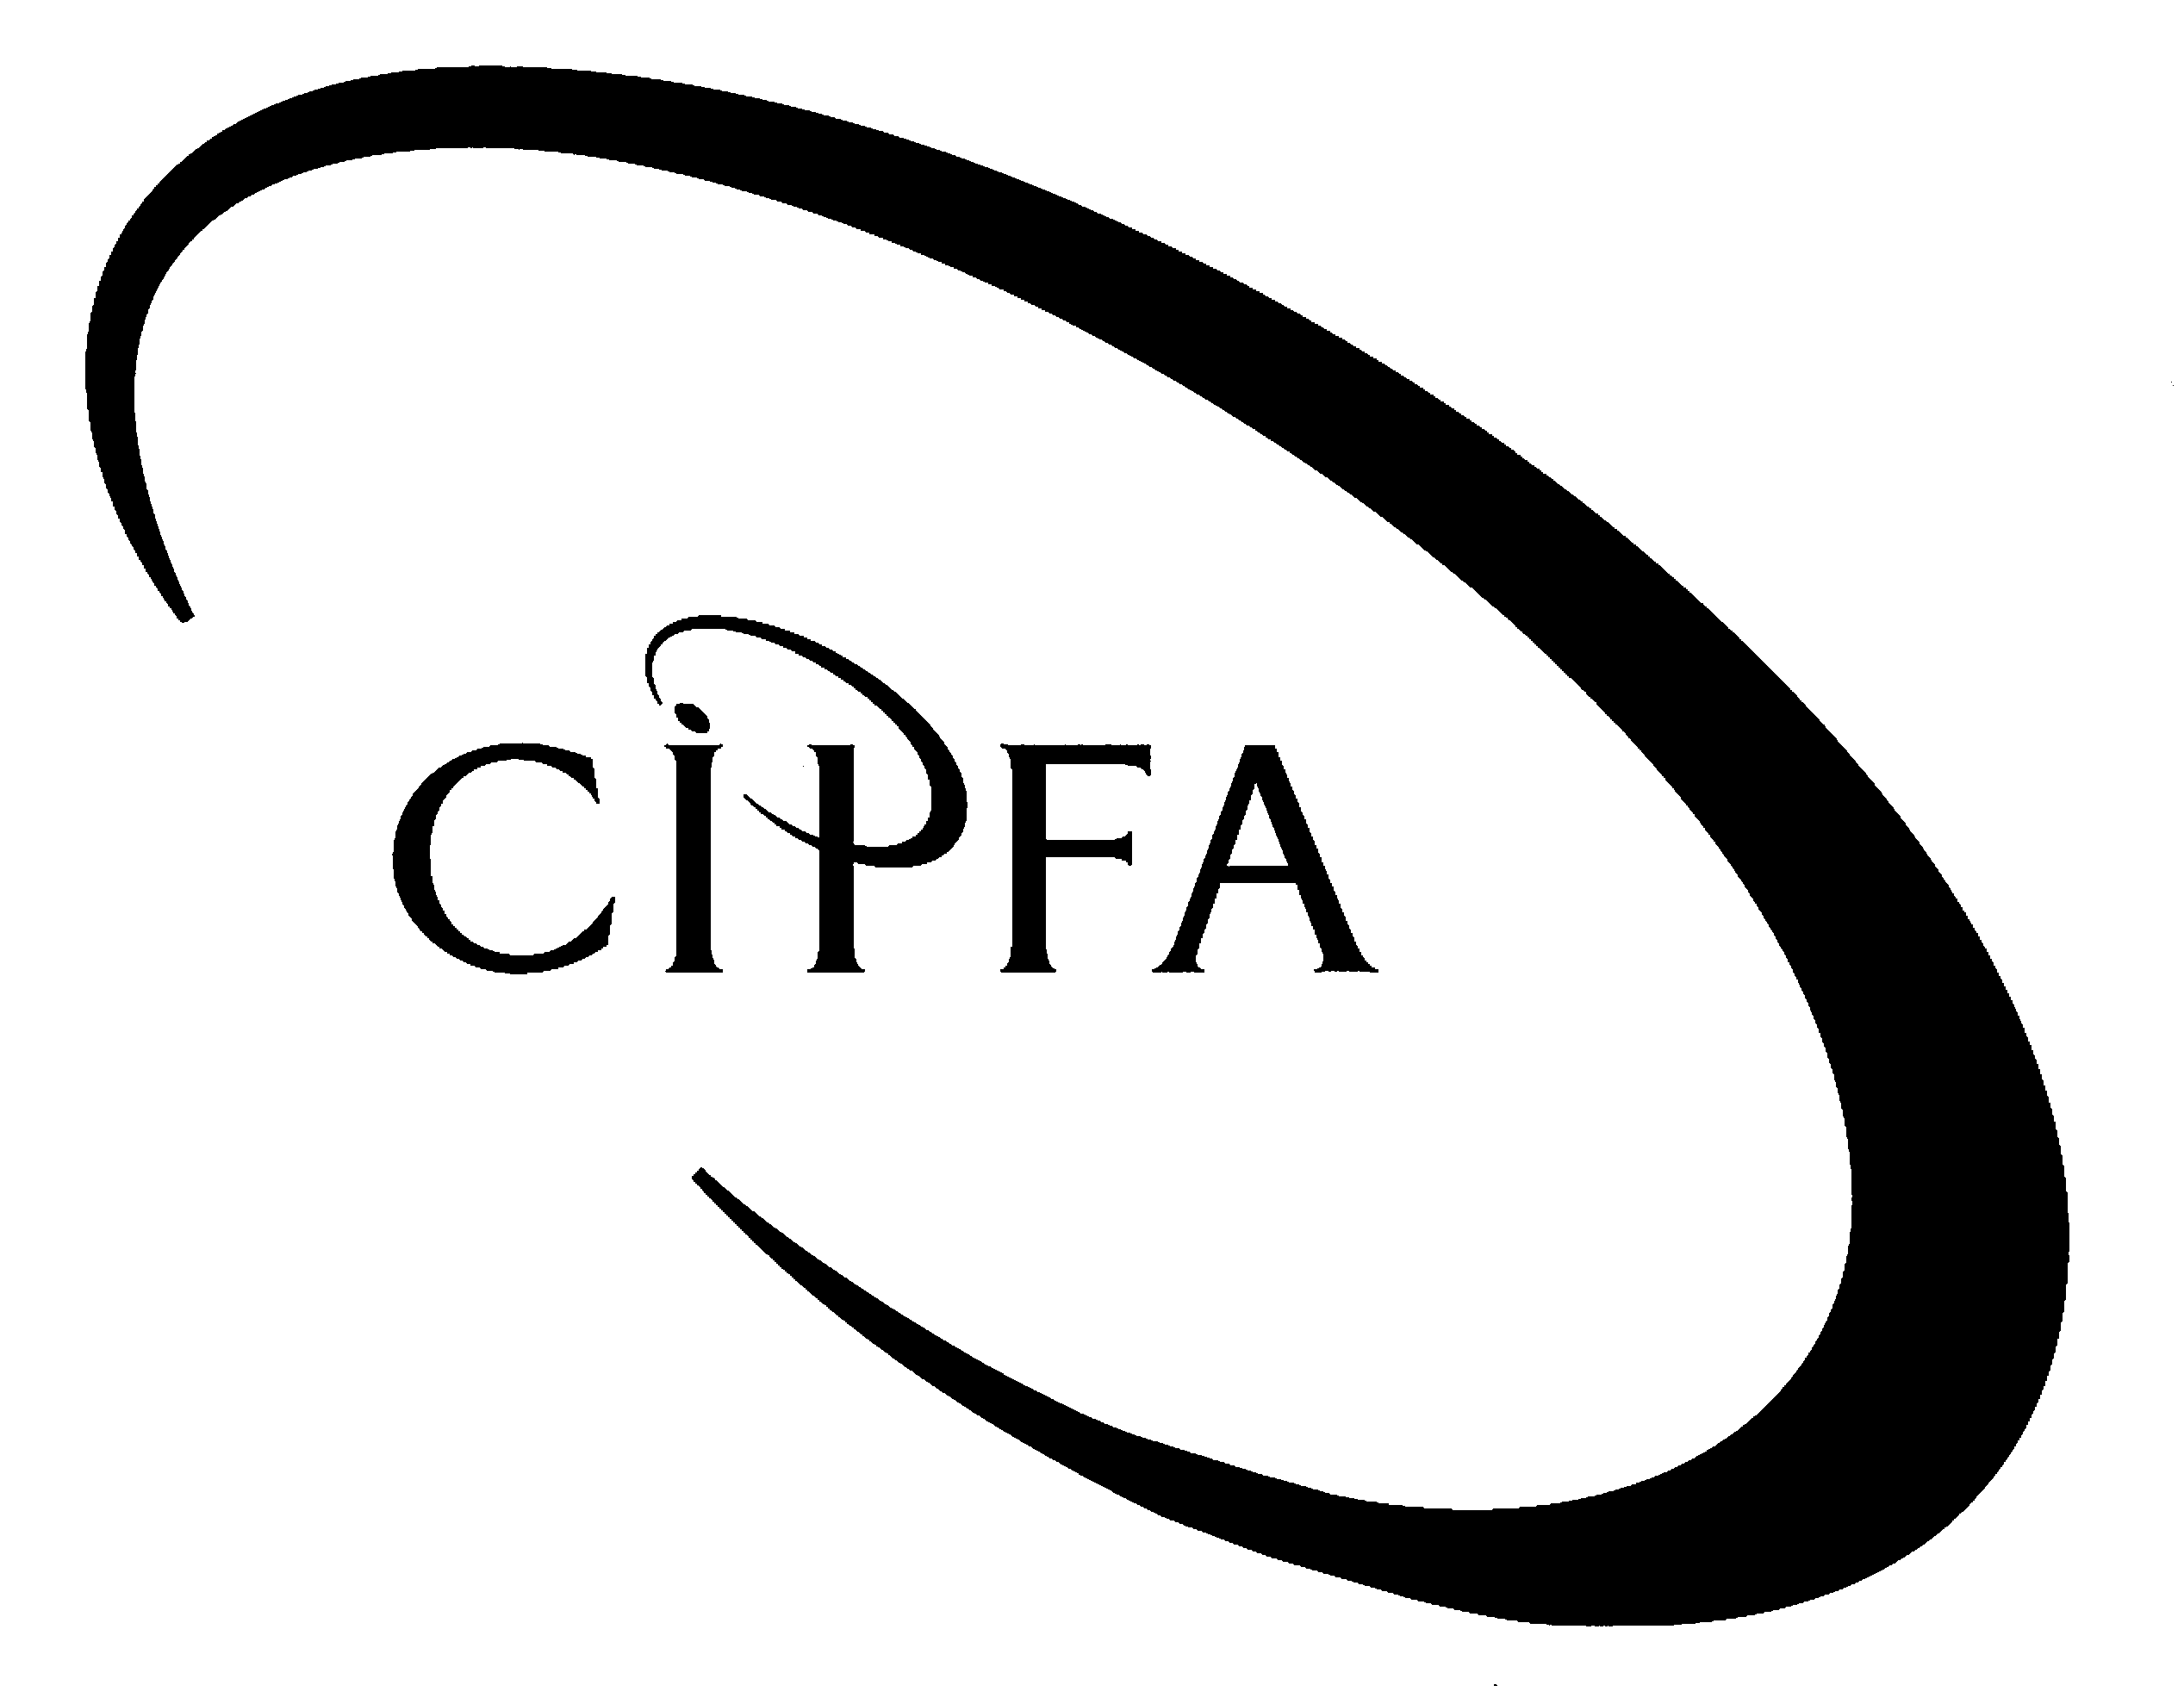

Question 1

(a) Define and describe the nature of the psychological contract that exists between public servants such as firefighters and their employers. (Syllabus area C1, OLM 8). 10

Definition of psychological contract (up to 4 marks).

Relevant points are likely to include:
- unwritten agreement
- binds both sides to act fairly and honestly with the other;
- goes ‘above and beyond’ normal contractual terms and conditions;
- covers a series of mutual expectations that cannot be easily expressed in legal terms.

Describe the nature of the psychological contract as it affects public servants and their employers: (up to 6 marks). Relevant points are likely to include the following.

Employees/individuals implicitly agree to:
- show integrity and professionalism;
- work hard;
- not abuse goodwill shown;
- observe reasonable standards;

Employers/organisations implicitly agree to:
- provide a safe and hygienic work environment;
- deal fairly and honourably with workforce;
- try to provide interesting and stimulating employment;
- provide job security as far as possible;
- show loyalty and not betray trust.

(b) How might a dispute such as that described affect both sides of the psychological contract? (Syllabus area C1, OLM 8.3) 8

Marks will be awarded for an analysis of the ways in which industrial disputes such as the firefighters’ dispute can erode mutual trust and goodwill.

Relevant points are likely to, but need not, include (up to 2 marks each for up to 4 relevant points made and discussed):
- erosion of firefighters’ willingness to ‘go the extra mile’ (or equivalent point);
- employers’ belief that firefighters (and the FBU) are unwilling to change the terms of the contract to account for the needs of modernisation;
- increase in inflexibility on both sides;
- reductions in morale and hence productivity.

(c) Discuss the extent to which the causes of the firefighters’ dispute can be understood in terms of the radical (neo-Marxist) perspective. 8

This question draws on content from the OLM on pages 439 and 461. Relevant points are likely, but need not, include the following – up to 2 marks for each:

Themes from the radical perspective relevant to the firefigthers’ dispute include:
- power disparities (asymmetries) between employers and employees resulting in the relatively powerless seeking to increase their relative power;
- class and role distinctions that (the radical perspective suggest) are prominent causes of conflict;
- conflict is a natural part of the class struggle and ultimately necessary to facilitate change (principally from the viewpoint of the assumedly subjugated);
- the design of organisational structures and systems can be a cause of conflict. Several examples are given in the case;
- lack of attention to ‘organic’ factors such as relationships and the balancing of worker and organisational needs can generate conflict.

(d) Describe the types (or ‘sources’) of resistance to change in organisations and how these relate to the situation of introducing ‘modernisation’ in the fire service. (Syllabus area F, OLM 17.3) 14

Describing the types of resistance to change: up to a maximum of 9 marks. Relevant points are likely to include (up to 3 marks for describing each ‘type’):
- individual resistance
- group resistance;
- organisational resistance.

Relating these to the introduction of ‘modernisation’ in the fire service: up to 5 marks. Relevant points are likely to include a brief note on how resistance from all three types can affect the acceptance of ‘modernisation’.

Question 2

(a) Using the case of Vashti as a basis for your answer, define and distinguish between deontological and teleological ethical perspectives. (10 marks) (Syllabus areas A3, B3, OLM 6.3)

Descriptions of ‘deontological’ and ‘teleological’ in context: up to 6 marks (up to 3 marks for each). Relevant points are likely to include:

Deontological perspectives:
- based on Kantian (categorical imperative) ethics;
- the rightness of an action is judged by its intrinsic virtue (absolute and not situational);
- an action is right if it would, by its general adoption, be of net benefit to society.

Teleological perspectives
- based on utilitarian ethics;
- the rightness of an action is judged by the quality of the outcome;
- ethics are therefore situational and not absolute.

Relating the answer to the case: up to 4 marks. Relevant points are likely to include:
- Beverley Ord demonstrated a teleological perspective (“and in the interest of the child”).
- She viewed the decision over Vashti to be based on how well it would work for her (“It might be good for Vashti and the mother to get a bit of respite from each other”).
- Bill Lee demonstrated a deontological perspective.
- He viewed the decision over Vashti partly as a matter of principle (“It is always best to leave the child with the mother… What would happen if we place a child in care every time there was a bad parent involved?”).

(b) Define and discuss the relevance of both explicit and tacit types of knowledge to a complex decision such as that relating to Vashti. (12 marks) (Syllabus area C2, OLM 9).

Definitions of tacit and explicit knowledge: up to 6 marks in total (up to 3 marks for each). Relevant points are likely to include (from Nonaka’s work, described in Mullins, Chapter 10):

Explicit knowledge:
- easily communicated – resident in written form or similar;
- quantifiable;
- systematic and easy to disseminate.

Tacit knowledge:
- inarticulate;
- hard to describe;
- difficult to disseminate and resident in people.

Discuss the relevance of both explicit and tacit types of knowledge: up to 6 marks in total (up to 3 marks for each). Relevant points are likely to include:

Explicit knowledge includes the formal “written down guidelines, procedures and protocols” and expresses the condensed wisdom – as far as it possible in written communication – for dealing with complex decisions. They are likely to be aimed at creating fairness and consistency in decision-making wherever possible.

Tacit knowledge includes “experience and gut-feeling”. It can’t be written down but can be more useful than explicit knowledge in complex situations. The possession of tacit knowledge is one of the qualities valued in all professionals (including those in the public sector) whose job it is to make complex and sometime far-reaching decisions.

(c) Discuss the advantages and disadvantages of adopting a case conference (‘committee’) approach to a complex decision such as that relating to Vashti compared to an individual making the decision alone. (8 marks) (Syllabus area C3, D, draws upon content in OLM 4, 6 and 10).

Advantages (up to 4 marks) are likely to, but need not, include the following:
- all perspectives are likely to be included in the consultation (case mentions ‘social workers, health professionals and community workers’);
- decision is likely to be more legally robust in the face of challenge than if made by a single individual;
- discussion of the issue may highlight concerns that an individual working alone may overlook;
- enfranchises all relevant stakeholders resulting in an outcome ‘owned’ by most or all of the affected parties (especially if the committee is bound by ‘cabinet government’ rules).

Disadvantages (up to 4 marks) are likely to, but need not, include the following:
- the consultation and discussion process is likely to result in a slower decision;
- different voices on a committee can result in a solution designed to appease everybody to some degree but offend none (‘a camel is a horse designed by a committee’);
- different ethical perspectives can be aired diluting a given perspective that may not be appropriate in all cases (had either Beverley or Bill had made the decision alone, a different outcome would have resulted – can both be ‘right’?);
- in some cases, perhaps where an individual would be put at risk by a delay, waiting until the committee can be fully convened could result in harm to a child (or other vulnerable person).

Question 3

(a) Define, and briefly remark on the advantages and limitations of:
(i) functional structures; 5
(ii) matrix structures. 5

Syllabus area D1, D2, OLM 12 and 13.

Relevant points are likely to include:

Functional structures:
- based on division of labour into specialisms;
- specialisms are typically contained in divisions or departments
- specialisms can be by function, product or geographic;
- creates departmental environments which stimulate specialisation and the development of expertise;
- can result in ‘ghetto-isation’ and a lack of appreciation of the wider organisational context.

Matrix structures:
- based on cross-functional teams and networked relationships;
- specialisms are shared between parts of the organisation;
- less emphasis on hierarchy and more on relationships;
- allows for greater organisational flexibility and multi-tasking;
- obfuscates unity of command and creates ambiguity of reporting.

(b) Critically evaluate Paul Mates’s statement: “more organic, less mechanistic – that’s the way forward…” Your answer should briefly define ‘mechanistic’ and ‘organic’ in context and discuss their relevance to organisations seeking to deliver complex services such as universities. (Syllabus area D2, OLM 13.1). 10

Description of ‘mechanistic’ and ‘organic’ in the context of Burns & Stalker’s work: up to 6 marks (3 marks for each).

Mechanistic systems are:
- rigid and most appropriate in highly bureaucratised organisations;
- involve a high degree of specialisation and standardisation;
- useful in stable environments.

Organic systems are:
- flexible and allow people to work with more independence;
- less hierarchical;
- based more on competences and networks than bureaucracy.

Critical evaluation of Paul Mates’s statement (ie discussion of their relevance to organisations seeking to deliver complex services such as universities): up to 4 marks. Relevant points are likely to, but need not, include:
- some degree of mechanistic approach is necessary to support formal systems (eg admissions, awards, marking schemes, etc.);
- too much organic approach can lead to the disintegration of mechanistic systems and this could affect quality;
- some flexibility in service delivery is likely to enhance the quality of service provision – too much adherence to formal systems can be deleterious to quality;
- there is a balance to be struck between mechanistic and organic systems and the ‘right’ balance is likely to depend on a number of internal and external factors and influences.

(c) Up to 2 marks for each type briefly discussed:
- power culture;
- role culture;
- task culture;
- person culture. 10

Up to 2 marks for brief discussion illustrating one or more of the above in a public sector context.

