LEADERSHIP AND MANAGEMENT

December 2004

Diploma stage

MARKING SCHEME

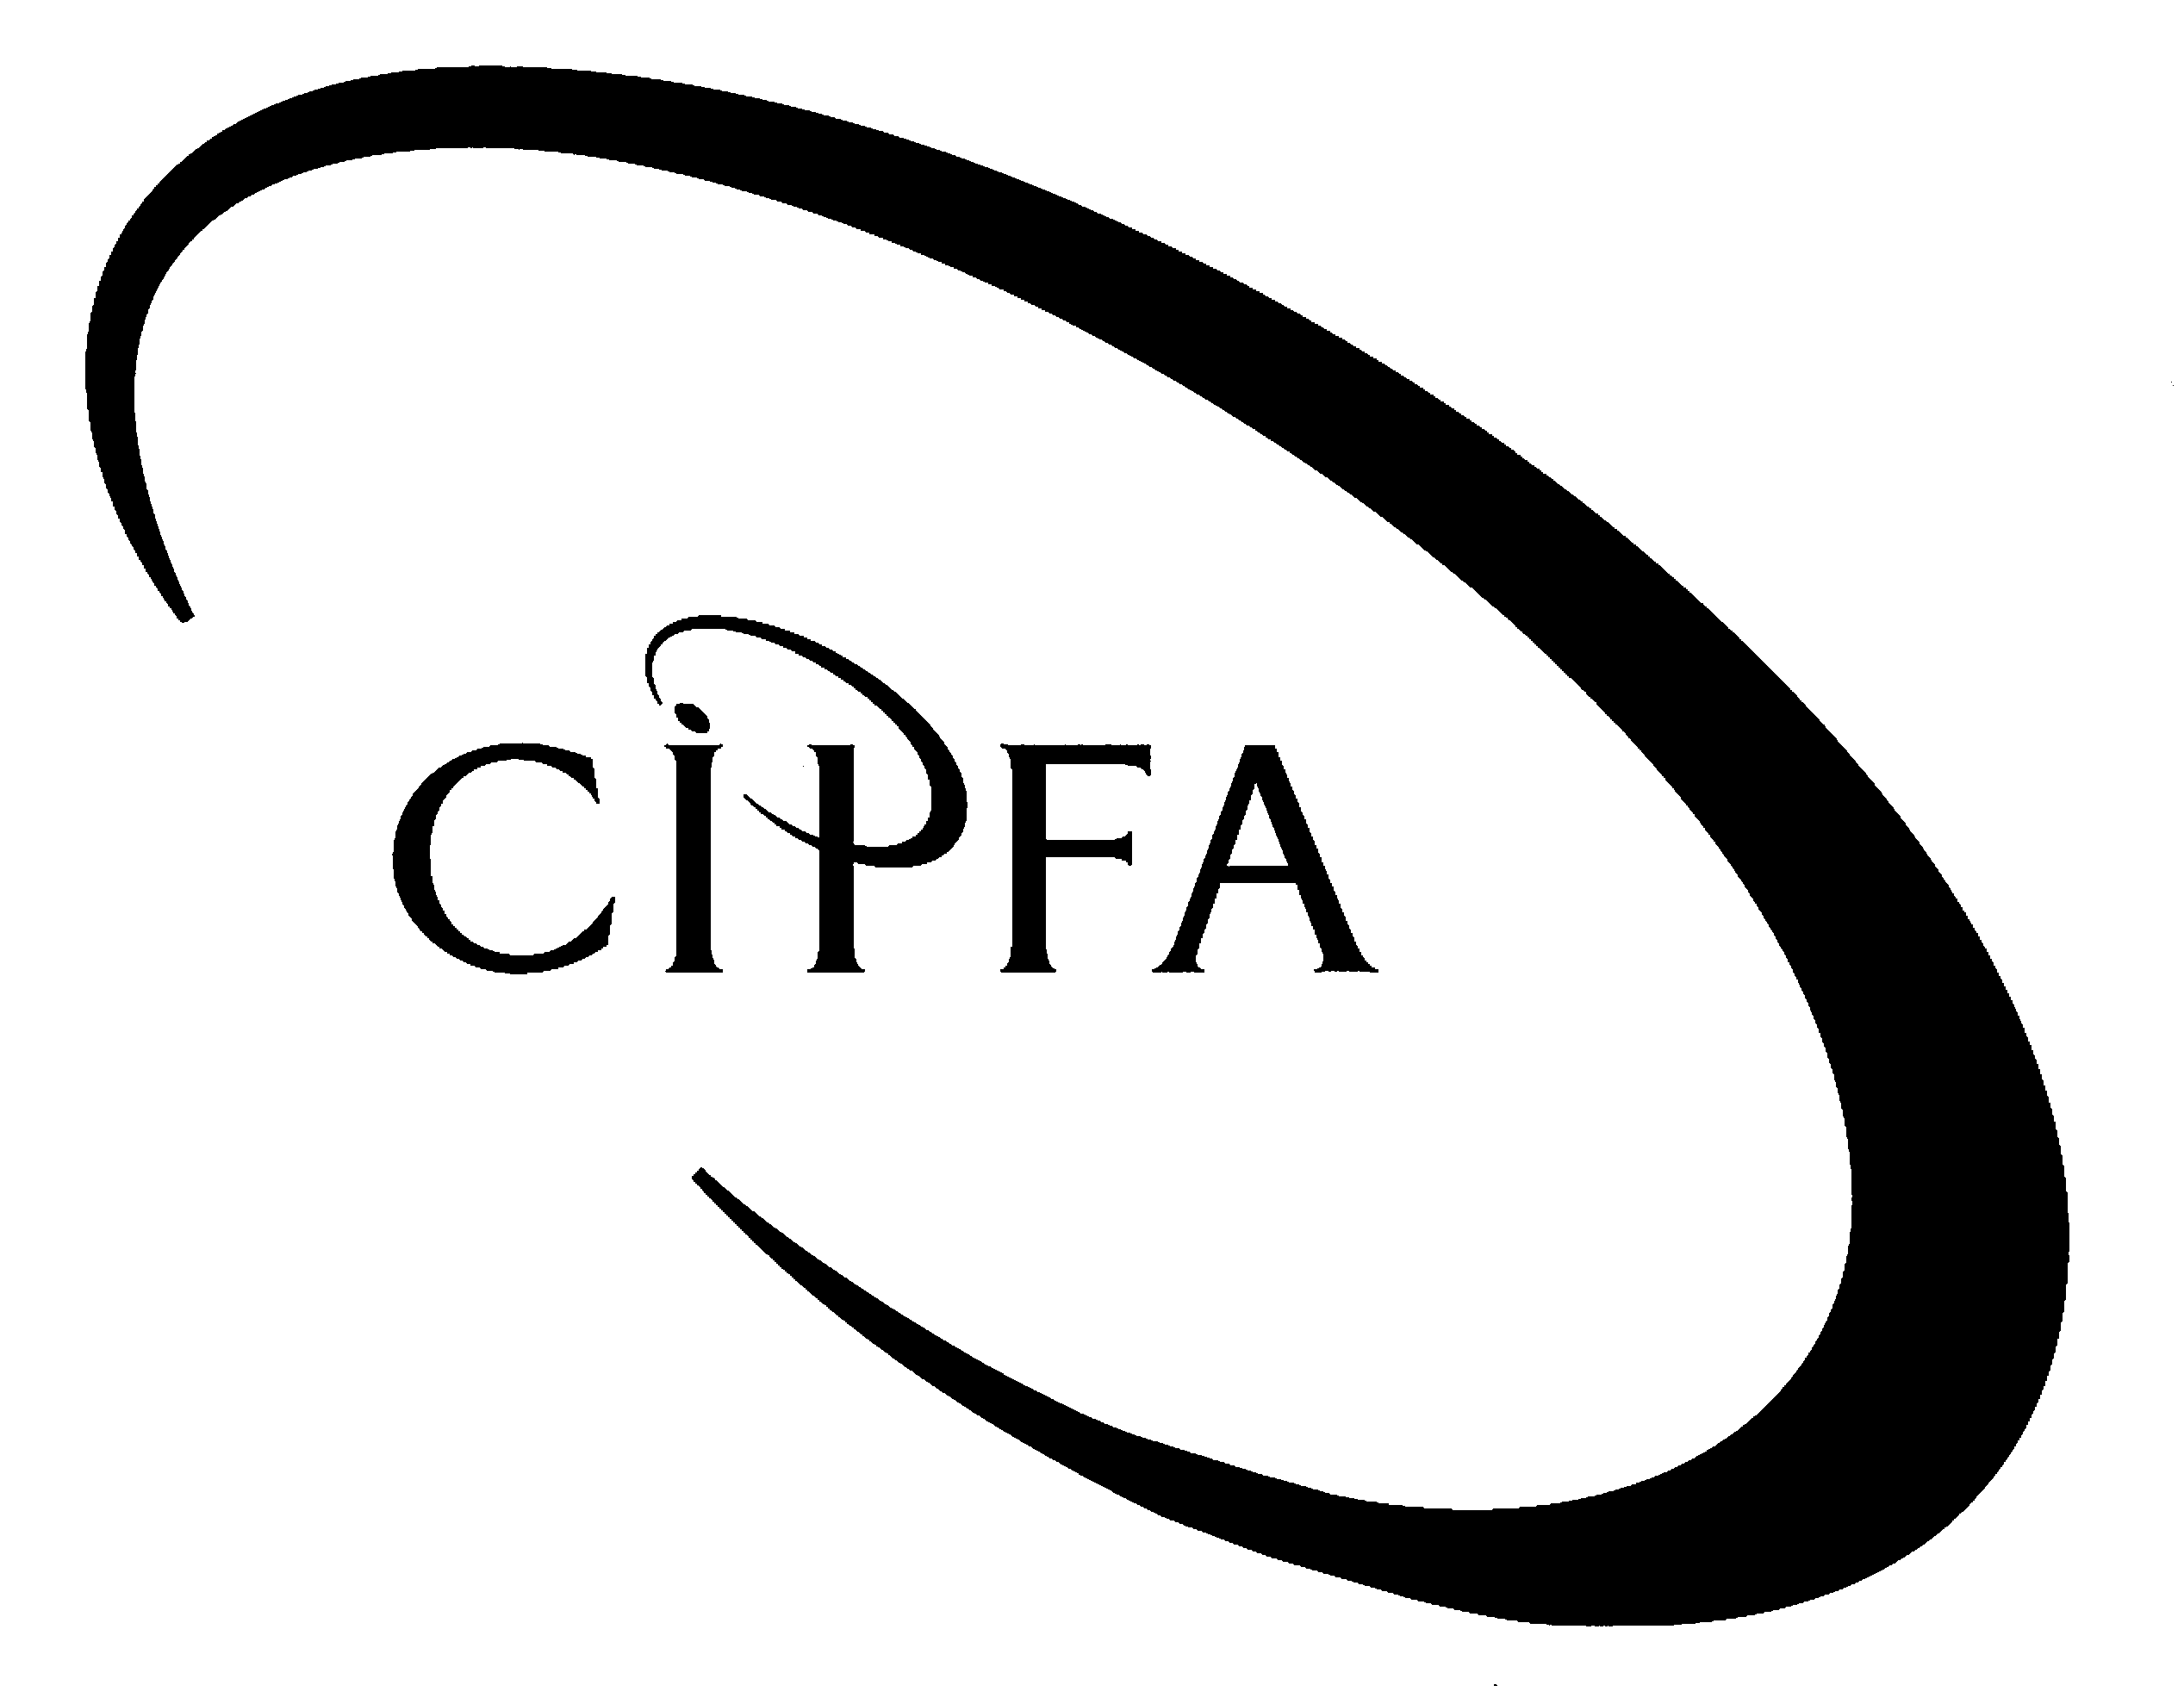

Question 1

(a) Explain the causes of Sharon’s stress. (10)
OLM study session 7

One mark for each relevant point made. One further mark for describing how each cause mentioned might increase Sharon’s stress up to a maximum of two marks in total per cause described. Relevant points are likely to include the following:

- Overwork – all tasks centralised around Sharon;
- Inability/unwillingness to delegate;
- Tension/conflict with Ray;
- Recent change of job and working environment without consultation;
- The felt need to control everything (perhaps a function of Sharon’s personality);
- Largely unsupportive and non-consulting superior (Alan).

(b) Advise Sharon of the benefits to both herself and her subordinates of delegation. (10)
OLM study session 4.

One mark for each relevant point made, or point made that is capable of interpretation as such up to a maximum of one mark per point made. Relevant points may include those described below.

For Sharon:

- Relief from some of her workload;
- Able to spend more time planning and engaged in strategic thinking (and less in mundane matters);
- The department will be able to perform many more tasks than if Sharon was to do everything herself;
- The development of a stronger sense of team spirit that, in turn, may further enhance the department’s productivity;
- The personal satisfaction that she is able to successfully lead a multi-tasked team of people to achieve worthwhile objectives.

For the subordinates:

- Personal and skill development of subordinates;
- The motivational effects that a delegated task successfully achieved can bring about;
- The increase in self esteem that delegation can bring about when a manager shows sufficient confidence in a subordinate to trust him or her with an important task;
- The increase in subordinate’s feelings of ‘belonging’ to the team or organisation as a whole and thus a strengthened loyalty and commitment;
- Subordinates will feel less controlled by Sharon and more trusted.
(c) What measures should chief executive Alan Murray take to manage the tension between Sharon and Ray? (8)
OLM study session 11.

Up to two marks per relevant point described which may but need not necessarily include the following:

- Redefine Ray’s and Sharon’s job roles to disambiguate who does what;
- Persuade Ray to be more supportive of Sharon (such by offering ‘carrots’ or ‘sticks’ – using compensatory or condign control mechanisms);
- Move either Sharon or Ray to another department to separate them;
- Attempt to create a warmer relationship by offering counselling or team-building exercises (possibly with others as well).

Alternatively, acceptable answers may be based around Mullins’ discussion of strategies for managing conflict if they are applied to the context outlined in the case. A simple list of Mullins’ points should attract a low mark. Conflict resolution is associated with: clarification of objectives; resource distribution; personnel policies and procedures; non-monetary rewards; development of interpersonal process skills; group activities; leadership (in this case by Alan); organisational process and socio-technical approach. One mark for each relevant point introduced up to a maximum of two marks per point made and described.

(d) Explain, with reference to theory as appropriate, what Ray meant when he said, “Sharon has got to unfreeze the way she’s done things in the past.”
Provide examples of what Sharon might ‘unfreeze’ in the way she works. (12)
OLM study session 20.

Contextualising ‘unfreezing’ as part of the three step model of change management and describing the meaning of ‘unfreezing’ in the context of the model.

- Describing ‘unfreezing’ as involving examining the need for change, preparation for change and abandoning previous practice. Up to three marks.
- Describing ‘unfreezing’ in the context of the three-step model of change management. One mark for correctly identifying the order and one each for identifying ‘move’ and ‘refreeze’ as the latter two stages up to a total of three marks.

Providing examples of how Sharon might ‘unfreeze’ the way she’s done things in the past:

Up to one mark for each relevant point made, which may but need not necessarily include the following:

- Become less of a ‘control freak’;
- Relinquish control of the more mundane matters such as coffee ordering;
- Consider delegating more tasks (such as appraisals);
- Involving Ray (and possibly others) more in the management of the department;
- Consider a better ‘work-life’ balance such as by going home earlier;
- Be rather less autocratic in her management style.

Question 2

(a) Explain what Ranjana meant by, “getting the person specifications right.” (8)
OLM study session 14.

Defining and describing ‘person specification’. 4

Of which:

- That it describes the characteristics of the perfect occupant of a position and how it relates to other elements of the appointment process - two marks;
- That attributes are described in terms of essential and desirable criteria – one mark for each.

Explaining ‘getting the person specification right’ by reference to how it can be wrong. 4

Of which:

- Description of under specification – two marks;
- Description of over specification – two marks;

(b) Advise Ranjana on the series of procedures involved in making a new appointment. (12)
OLM study sessions 14 and 15.

For correctly identifying each stage of the process in approximate order. 6
For a brief description of the content of each stage. 6

A maximum of two marks for each relevant stage identified and described which may but need not necessarily include the following (differences in emphasis may arise depending upon which textbook was studied):

Job analysis;

Job description;

Person specification (inc reward package design);

Advertise position in appropriate medium for the job;

Shortlist according to candidates’ conformance to the person specification;

Select the most appropriate candidate using selection techniques and persuade them to accept the job.

(c) Describe the issues that need to be taken into account when designing a reward package for the position of departmental manager. (10)
OLM study sessions 14 and 15.

Correct identification of five issues that need to be taken into account. 5
Description of five points (with some reference to the job in question). 5

A maximum of two marks for each relevant issue identified and described. Relevant points are likely to include the following:

- Type of labour market the organisation is buying in from (local, regional, national, international);
- Skills and qualifications of the specified person;
- Proportion of basic to performance related rewards;
- Proportion of the reward to be offered ‘in kind’ or extrinsically;
- The strategic importance of the individual or position to the organisation and its strategy.
- Stakeholder opinions on the level of the reward (eg existing colleagues or taxpayers).

Question 3

(a) Compare and contrast Frank and Matthew’s differing leadership styles with reference to the democratic/autocratic (subordinate-centred/boss-centred) continuum approach to understanding leadership styles. (10)

Your answer should identify Frank and Matthew’s respective positions on the continuum with supporting evidence from the case and a brief discussion of the management issues raised by their positions. OLM study sessions 4 and 5.

Identification of Frank and Matthew’s respective positions on the continuum with supporting evidence from the case (two marks for each up to a maximum of four).

- Frank identified as boss-centred ([my job]…”is to see the big picture, take all variables into account and make the decisions. Then I inform people of what is going to happen.”)
- Matthew identified as subordinate-centred (“I always get people’s opinions and we approach and consider all big decisions together.”)

Description of the democratic/autocratic continuum and the issues raised by leadership styles at the two ends of the continuum.

Autocratic leadership (‘tells’) is:

- Decisive;
- Can be perceived as ‘strong’; but,
- Disenfranchises subordinates.

Democratic leadership (‘joins’):

- Gains the support of an enfranchised organisation or group; but,
- Decision-making can be slower;
- May be perceived as ‘weak’ or indecisive.

One mark for each relevant point made with regard to either position up to a maximum of 6 marks.

- Frank Burnett seems to believe that the only management performance measure of any importance is whether or not his department meets its performance targets. Describe other measures of management performance that might be relevant to Frank’s managerial situation. (10)
OLM study sessions 4 and 5.

Discussion of alternative general measures of management performance.

Answers may be based on an application of Drucker’s criteria to the case (market standing, innovation, productivity, resource management, financial profitability, management development, worker performance, public responsibility) or may be drawn from candidates’ own experience.

Up to two marks for each relevant point made, or point made that is capable of interpretation as such up to a maximum of ten marks. In the case of the management of a clinical unit, examples may but need not necessarily include:

- Quality of patient care (perhaps using a measure of patient satisfaction);
- Quality of patient experience (eg therapeutic ‘success’ rates);
- Loyalty of subordinates;
- Rate of key staff turnover (eg clinical and nursing people);
- Team-building competence;
- Budget negotiation;
- Ability to manage and balance tensions between budget constraints and cost-incurring decisions.

(c) Discuss the proposition, using examples and drawing on theory as appropriate, that the leadership style adopted will depend upon features of the situation in which the leadership takes place. (10)
OLM study session 1

Recognition that issues raised in this question relate to the contingency approach to leadership styles and description of contingency theories. Up to four marks.

Description of the contingency approach (with reference, where appropriate, to Fiedler’s determining ‘dimensions’):

- Leader-member relations;
- Task structure;
- Position power.
(Rose & Lawton, p. 155).

Two marks for each relevant point made and briefly described up to 6 marks in total.

Discussion of two or more situations (by way of example as required by the question) requiring differing approaches to management, eg in the military or in a university. Up to 6 marks in total for each contrast successfully described.

Total adds up to more than 10 to allow for ‘cross-marking’ where candidates may not structure their answer as suggested by the marking scheme.

