LEADERSHIP AND MANAGEMENT/ FINANCIAL MANAGEMENT, SYSTEMS AND TECHNIQUES

June 2005

AAT Fast-Track

MARKING SCHEME

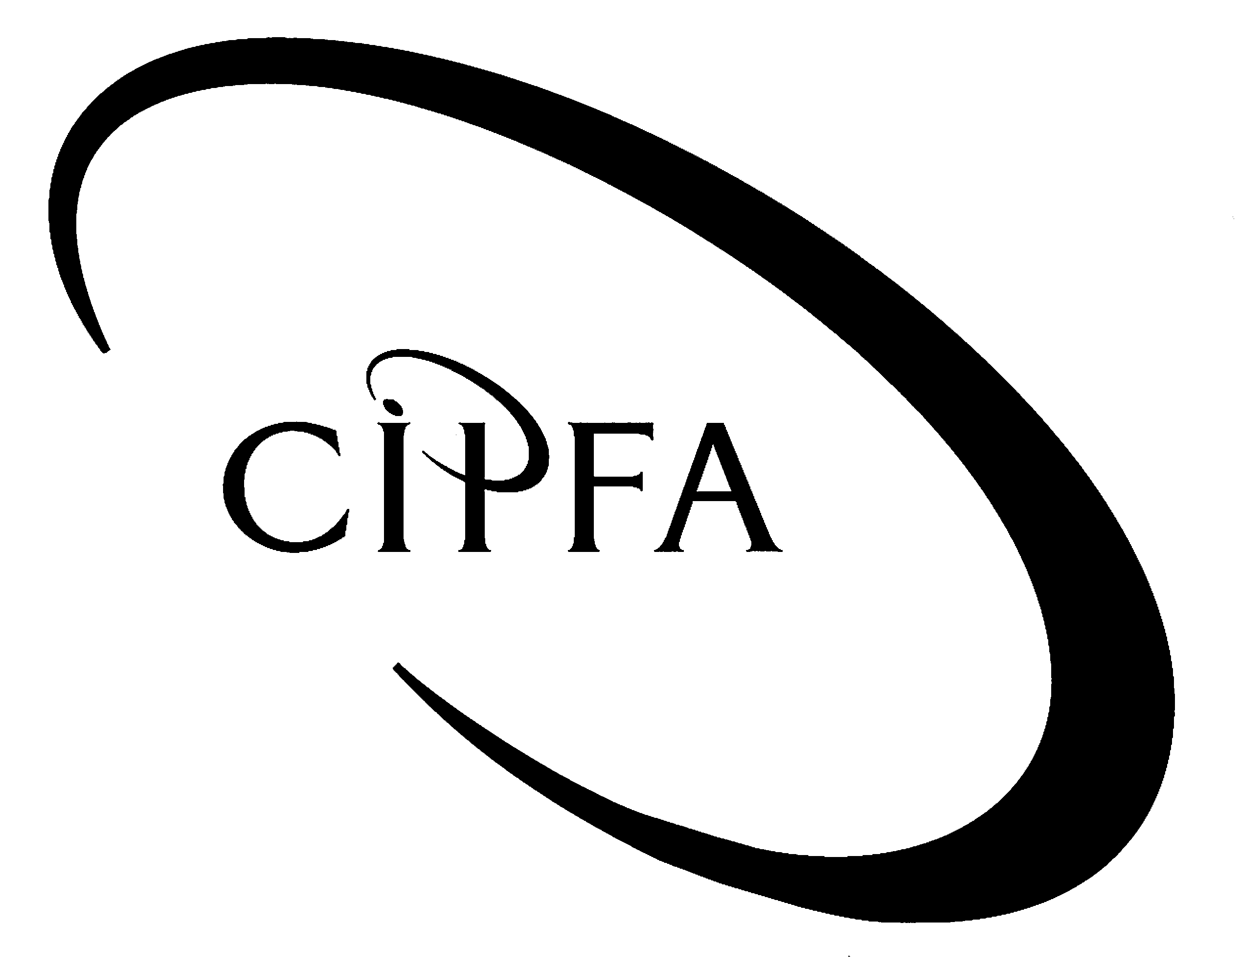

Question 1

(a) Define and distinguish between functional and matrix structures. (Syllabus areas C1, C2. OLM 6, 7) 10

Define functional and matrix structures:
Brief definition of each type – 1 mark each (maximum of 2)

Distinguish between the two

Up to 2 marks each for each valid point made up to a maximum of 4 for each structure type

Relevant points are likely to include:

Functional structures:
- Based on division of labour into specialisms by division or department;
- Specialisms can be by activity, function, product or geographic;
- Hierarchy is observed and emphasized;
- Unity of command is practiced.

Matrix structures:
- Based on cross-functional teams and less-hierarchically-organised networked relationships;
- Specialisms and resources are shared between parts of the organisation;
- Hierarchy less important than flexibility and relationships;
- Ambiguous reporting lines.

- Identify and describe the feature of functional structure that Alice Murray was referring to when she said, “We like the idea that we specialists work together”? (Syllabus areas C1, C2. OLM 6, 7) 8

Recognition and description of specialisation by department as the feature referred to: up to 2 marks for each point made.

Relevant points are likely to include:
- Functional structures are based on the containment of specialists within divisions or departments.
- Specialism can be defined in various ways – by activity (eg accounting, HR, etc) product, geographic, customer type, etc.
- Each department of division is then organised hierarchically where greater expertise in the specialism is the most valued and rewarded by the organisation.
- Synergy is maximised when all specialisms are co-ordinated at the strategic level.

(c) Alice seems to value the group cohesion of the people in her veterinary department. Explain the importance of groups in organisations. (Syllabus area B1, OLM 3) 4

Advantages of groups/teams in organisations (OLM p. 90). One mark for each point made.
- Synergy effects (the productivity of an effective team is likely to be far greater than the same individuals could achieve working independently).
- Quality and innovation are likely to improve when team members share and discuss their work.
- Staff will feel more confident (eg in using new technology) if they feel they have the support of other team members.
- Motivation and commitment will increase, provided the team members work well together.

(d) Define ‘culture’ and explain how it can affect the effectiveness of an organisation as Bill Rogers implied. (Syllabus area B1, OLM 2) 8

Definition of culture up to 4 marks
Relevant points may include:
- that culture is about norms and unquestioned conventions;
- that it concerns the ‘feel’ and ‘smell’ of a situation
- that it varies according to the situation and the personalities of the group
- that it has been defined by Handy as the ‘way we do things round here’

Explain how culture can affect the effectiveness of an organisation such as Save the Cats. up to 4 marks
Relevant points are likely to include:
- Culture is a crucial part of strategic implementation – it should be congruent (ie it should ‘fit’) the overall strategy.
- Culture can affect recruitment and retention of key staff that, in turn, (especially in a smallish organization) can affect performance. An unhelpful or unsupportive culture can be a ‘turn off’ for staff.
- It can affect teamwork and group cohesion which, especially in matrix situation, can be crucial to normal functioning.
- It can affect staff morale, loyalty and commitment that, in turn, can affect the strength of the psychological contract between staff and employer.

(e) Distinguish between Alice’s role as a professional vet and also a manager in Save the Cats. How might tension arise between the two roles? (Syllabus area B2. OLM 5). 10

Distinguish between the two up to 6 marks
Relevant points are likely to include the following.

As a manager, Alice:
- … is part of the hierarchy of an organisation;
- … is subject to orders from a hierarchy;
- … is accountable to the principals of the organization (for a charity, it’s trustees).

As a professional, Alice:
- … is obliged to maintain the high standards of her profession (as a veterinary surgeon);
- … is required to co-ordinate her staff so as to maximise clinical benefit to cats;
- … is accountable to her professional body

Areas of tension up to 4 marks
- Direction of primary accountability.
- Ethical queries – is loyalty primarily to Save the Cats or as a vet?
- Hypothetical example or situation described – up to two marks (question asks, “How might…”)

Question 2

(a) Prepare a presentation for Astrid to present to the staff of Direct-serve that includes the following content.

(i) Define what an appraisal is and the areas for discussion an appraisal meeting typically contains (Syllabus area D1. OLM 9). 8

Brief definition of appraisal – up to 2 marks.

Typical contents (OLM 9.1). One mark for each area mentioned.
- Give and discuss feedback with each individual.
- Allocate rewards on the basis of performance.
- Define new subordinate objectives.
- Discuss individual development plans.
- Clarify what training the individual needs.
- Use the information gathered to improve future performance.

(ii) The importance, in principle, of appraisals to both the organisation and its staff. (Syllabus D1. OLM 9) 10

Importance to the organisation
- Translation of organisation goals to responsibility units (departments or individuals).
- Increasing individual accountability for objectives.
- Helping to ensure strategic goal congruence between levels in the company.
- Can help to break collective bargaining deals that, some have argued, can hide inefficiencies and ‘dead wood’.
- Can motivate staff and hence stimulate performance.

Importance to the staff
- More able and committed individuals can earn higher rewards.
- Feeling of better communication with management.
- Training and development needs can be better identified and followed upon.
- Individual marketability can be enhanced.
- Career planning will be helped for ambitious people.

(b) Explain the force field analysis model and how it can help to explain the process of introducing appraisals at Direct-serve. (Syllabus areas B1, D2. OLM 10). 10

Explanation of force field analysis model up to 6 marks
Relevant parts of the answer are likely to include:
Discussion of the force field as a model as a change management – up to 2 marks.
Correctly-annotated diagram – up to 2 marks.
Discussion of the two sides of the force field and mechanisms of moving the force field – up to 2 marks.

Application to Direct-serve.
Description of for-change forces in Direct-serve and their motivations – up to 2 marks.
Description of restraining forces in Direct-serve and their motivations – up to 2 marks.

(c) Explain what Astrid meant by ‘resource gap’ in respect to human resources and describe the benefits of human resource planning to an organisation such as Direct-serve? (Syllabus D1. OLM 8) 12

Definition of ‘resource gap’ – up to 4 marks. Relevant points are likely to include:
- Labour as a key resource input into an organization (along with others such as finance, land, etc.)
- Resource gaps can be positive or negative – an excess or a deficit in a given skill or resource need. Essential part of HR is identifying HR gaps and proposing ways to fill the gaps.
- Resource deficits can be filled by recruitment or retraining.
- Resource surpluses can be addressed by disposals, redeployments, redundancies and similar.

Description of benefits of HR planning process (p. 315 of OLM) – up to 8 marks. Up to 2 marks for each relevant point made.
- It encourages employers to develop clear and explicit links between their business and human resource plans, and so integrates the two more effectively.
- It allows for much better control over staffing costs and numbers employed.
- It enables employers to make more informed judgements about the skills and attitude mix in the organisation, and prepare integrated HR strategies.
- It provides a profile of current staff (in terms of age, gender, race and disability, for example) which is necessary for moves towards an equal opportunities organisation.

Question 3

This question relates to learning objective E1 and is covered in Study session 11 (pages 482, 484-488, 490 and 491) of the learning materials.

- How would you judge the success or failure of projects? What do you understand by the terms hard and soft criteria? Give examples of each. Are organisations too concerned about establishing and meeting hard success criteria? Illustrate your answer with reference to two examples of projects known to you.

The determination and use of success criteria can help to judge whether projects have been a success or a failure. Project outcomes need to be compared with a view of what success would look like.

1 mark for reference to and explanation of success criteria
(1)

Hard success criteria are those which can be measurable in quantitative terms whilst soft criteria are more qualitative in nature. Examples of each would be:

Hard criteria:
- Deadlines.
- Budgets.
- Resource constraints.
- Performance and output specifications.

Soft criteria
- Image.
- Co-operation within project team.
- Commitment.
- Ethical behaviour.
- Risk appreciation.

1 mark for distinction between hard and soft plus ½ mark for each of the
criteria up to a maximum of 4 marks
(5)

Organisations may find it easier to concentrate upon hard criteria as by their very nature they can be quantified and measured and used as clear targets. Hard criteria do measure some very important aspects of projects but they should not be used as the only bases for judging performance. Hard criteria are about what is achieved and soft criteria are about how it is achieved and both are important. Examples should be used to illustrate these points.

1 mark for each relevant point up a to maximum of 2 plus 2 marks for
relevant and appropriate use of examples
(4)

- What are the main sources of project failure? Choose two of these sources and explain how they might relate to a PFI project. What could you do to manage this?

The main sources of project failure are:

- Lack of clear goals and objectives.
- Poor communication with key stakeholders.
- Changing of specifications, goals and objectives.
- Highly complex project with conflicting objectives.
- Poor resourcing of project.
- Lack of effective project sponsor.
- Poor management of lifecycle (all aspects).
- Irreconcilable political differences within organisation.
- Lack of technical expertise and capability.
- Inability of team to work together.
- Unrealistic and unachievable expectations in terms of goals and objectives.

1 mark for each source of failure up to a maximum of 6 marks

Two of the above sources of failure should be chosen and explained further. They should then be related to the specific aspects of PFI projects. The project management issues which may relate to PFI are listed on page 488 of the learning materials. These issues should be related to the chosen sources of failure. Finally there should be an indication of how potential problems could be managed. Answers to this section will vary depending upon the topics chosen for discussion.

2 marks for each source of failure chosen with 1 of the marks for explaining the
relationship to a PFI project and 1 mark for suggesting how it could be managed
(4)

(20)

