GOVERNANCE AND

PUBLIC POLICY

Diploma stage

June 2005

MARKING SCHEME

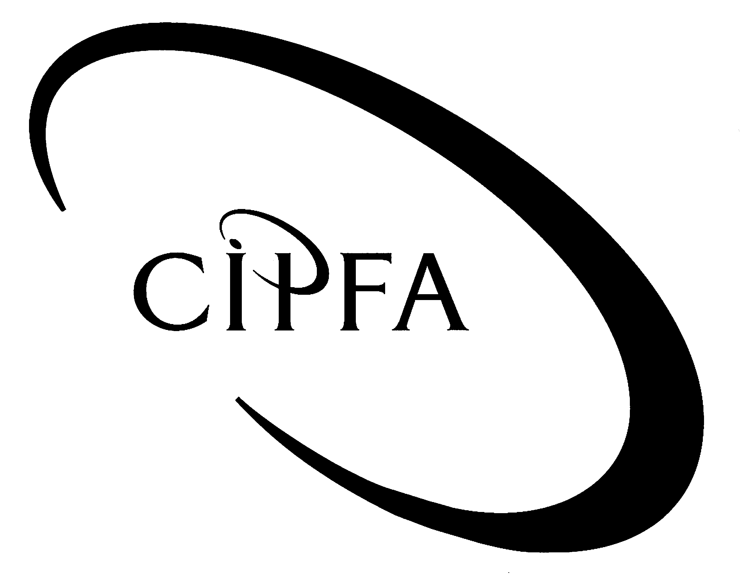

Question 1

(a) (i) Fiscal Policy involves management of an economy through the manipulation of taxation and public spending.

In the UK, it is the Government (largely the Treasury/Chancellor of the Exchequer) that determines fiscal policy. Although the UK Budget is concerned with fiscal policy, policy decisions also take into account the current monetary policy climate. 2

(ii) Since the early 1980s, the role of fiscal policy in the UK has effectively been “relegated”/limited by most governments to securing a balanced budget over the medium-term.

However, the current New Labour government has, to some extent reinstated the traditional role of fiscal policy by massively increasing public spending in the early years of the 21st century in order to stimulate economic activity, even though this resulted in significantly enlarged budget deficits. 2

- Fiscal policy, prior to the 1980s, was traditionally associated with demand management (Keynesian) policies whereby governments intervened in the economy to correct such problems as high unemployment, balance of payments deficits, inflation and budget deficits. Prior to the 1980s, fiscal policy was the main tool of economic management. But its role changed from the early 1980s because of rising concern about its ability to deliver its traditional objectives (especially that of delivering low inflation, even at times of high unemployment) in increasingly global and market-driven economies. 3

(iv) Prior to the 1980s, fiscal policy (a key element of demand management – Keynesian – policies) was the prime tool of economic management used to try and deliver the traditional key economic objectives of steady sustained growth, low inflation, low unemployment and a balanced current account on balance of payments.

Changes in world economic structures made it increasingly difficult for fiscal policy to deliver these objectives. This prompted the emergence in the early 1980s, in the UK and most other advanced economies, of monetarism, a key element of supply-side policy. Since the early 1980s, monetary policy has become the dominant tool of UK economic management. It, along with other supply-side policies, aims to create a free market, low inflation environment for private sector organisations. 3

(10)

(b) (i) Direct Taxation 3

Direct taxation is where the formal and effective incidences of tax are designed to be the same (the formal incidence refers to those who formally pay over the tax to the authorities; the effective incidences refers to those who bear the cost of the tax).
Examples include income tax, capital gains tax and corporation tax.
Direct Taxes are administered by the Inland Revenue.

Indirect Taxation 3

Indirect taxation is where the formal and effective incidences of tax are designed to be different.
Examples include VAT and excise duties on petrol.
Indirect Taxes were administered by HM Customs and Excise, but the 2004 Budget announced that HM Customs and Excise was to be merged with the Inland Revenue.

(ii) Progressive Taxes 2
Progressive taxes tend to be direct taxes such as UK income tax. They are progressive because the average rate of tax payable increases as income rises.
There are two reasons why income tax is progressive. Firstly, tax allowances account for a larger proportion of a poor person’s income than a rich person’s. Secondly, above certain levels of income, higher marginal rates of tax have to be paid.

Regressive Taxes 2
Regressive taxes tend to be indirect taxes such as UK VAT. They are regressive because the average rate of tax falls as income rises.
The reason for this is that the rich tend to spend a smaller proportion of their income than the poor. The poor cannot afford to save, the rich can.
(10)

(c) (i) The UK government has specified two key fiscal rules
The golden rule: over the economic cycle, the government will borrow only to invest and not to fund current spending which must be covered by tax revenue; and the sustainable investment rule: public sector net debt as a proportion of GDP will be held over the economic cycle at a stable and prudent level. 2

(ii) The main objective of these “fiscal rules” is to provide a framework within which fiscal policy can be prudently managed.
The fiscal rules provide benchmarks against which the performance of fiscal policy can be judged. The Government will meet the golden rule if, on average over a complete economic cycle, the current budget is in balance or surplus. The Government also believes that, other things equal, a modest reduction in net public sector debt to below 40 per cent of GDP over the economic cycle is desirable. 3

(iii) The estimates are considered to be consistent with the Chancellor’s fiscal rules because:
The first fiscal rule is that over the cycle the current budget is balanced. Having accumulated surpluses at the start of the economic cycle, the first (golden) rule was met. In fact there has, over the whole cycle, been an average annual surplus – and an overall margin or surplus of £11 billion. In addition, the current budget moves back to balance by the end of the forecast period. The average current budget for the first four years of the next cycle is not just in balance but in surplus. So having met our rule in this cycle, the Government is also on track to meet it in the next. 2

The second rule is the sustainable investment rule, demonstrating the Government’s ability (or otherwise) to borrow for investment. The national debt reported in the Budget was just 33 per cent of national income. The rule is that debt should be kept below 40 per cent of national income and in future years it will be 34, 35, 36, 36 and 36 per cent. This compares with debt of 44 per cent in 1997. Hence, the second rule is also met both over the cycle and in every year, and by a margin in excess of £50 billion. 2

(iv) The “fiscal rules” under the Eurozone’s currently suspended Stability and Growth Pact are that:
Members’ annual budget deficits must not exceed 3% of their GDP.
Members’ cumulative public debt must not exceed 60% of their GDP. 2

(v) Rigidly “balancing” the budget year on year (as in the Stability and Growth Pact) means that fiscal policy cannot support monetary policy over the cycle and, even in low debt countries, the debt to GDP ratio would fall year on year even when it is obvious that more investment is important to the long-term strength of the economy.

The UK fiscal rules - to keep the debt to GDP ratio low and stable while balancing the current budget over the economic cycle - allows the government to borrow for investment every year of the cycle and these rules have now been tested and have succeeded at every stage of the economic cycle. The Chancellor has made it clear that he will not neglect the need for long-term investment and impose an annual balanced budget rule - which would cut spending regardless of the debt level or the economic cycle. Such a policy - whether imposed by a future government or a rigid interpretation of the European Union Stability and Growth Pact - would, in fact, be an exact repeat of the mistakes of Britain's “stop-go” past and put at risk British stability and growth. 3

(14)

(d) (i) Economic stability is a situation where economic policy produces steady growth, low inflation and strong investment over a lengthy period. Previously erratic economic cycles are smoothed out (ie annual variations in real economic growth become narrower) and economic cycles become longer (ie the time lengthens between the beginning and end of cycles. 2

(ii) For decades after 1945, Britain repeatedly relapsed into recession, moving from boom to bust. But since 1997 Britain has achieved sustained growth not just through one economic cycle but through two economic cycles, without suffering the old British disease of “stop go” - with overall growth since 2000 almost twice that of Europe and higher even than that of the United States.
According to the Chancellor’s Budget speech, Britain is enjoying the longest period of sustained economic growth for more than 200 years.

Policy decisions have underpinned stability that, over the past 4 years has delivered real GDP growth averaging 2.5 per cent in Britain. This compares with economic growth in Germany averaging just 0.9 per cent; Japan 1.4 per cent; Italy 1.4 per cent; France 1.8 per cent; the Eurozone 1.6 per cent; and the United States 2.4 per cent. And growth in Britain has been accompanied, consistently, with the lowest inflation for 30 years, the lowest interest rates for 40 years and the highest levels of employment in history.

In the past Britain has been first in, worst hit and last out of world recessions. But in recent years, in contrast to the previous two world downturns in both the early 1980s and in the early 1990s:
- employment this time has not fallen but risen with Britain today closer to full employment than for a generation;
- inflation which rose to 20 per cent in the 80s downturn, and to almost 10 per cent in the early 90s has this time averaged 2.4 per cent;
- interest rates which peaked at 16 per cent in the 80s downturn and at 15 per cent in the 90s are today 4 per cent; and mortgage rates which rose to around 15 per cent in both the early 1980s and early 90s are 5 per cent today, still the lowest for forty years. 6

(8)

(e) Successive governments choose to increase the duty rates on the three groups of products for three main reasons.

Firstly to try and reduce consumption. Reduced consumption of fuel oil is environmentally desirable whilst reduced consumption of tobacco and alcohol should improve the health of the nation and, in the long-term, reduce the strains on the NHS. 2

Secondly, increases in duty rates are effectively price increases and there is much empirical evidence to show that the price elasticity of demand for fuel oil, alcohol and tobacco are price inelastic. Hence demand is unlikely to significantly decline in response to a price increase for these products and total revenue following a duty increase should, at worst, remain unchanged but would probably rise. 2

Thirdly, because duties on these three products are effectively taxes on expenditure, they are easy and cheap/cost-effective to collect. 2
The first two above motives are contradictory. One seeks to reduce consumption through price increases whilst the other assumes that price increases will not reduce consumption. 2

(8)

(50)

Question 2

(a) Arguments for ethical approaches to governance are based on the importance of the public interest. 1

Finance is central to many activities in personal, business and public life. The integrity of the finance function, in its widest sense, is essential if business and government is to operate properly. That integrity is largely in the hands of the accountancy profession. 1

The accountancy profession’s public includes taxpayers, direct clients, employers, employees, governments, investors, debtors and creditors and those within the business and public service communities who rely on the independence and integrity of financial information. 1

The need to maintain the collective well being of the community of people and institutions served by the accountant imposes a responsibility on the accountancy profession and gives the accountant an important role and position in society. 1

The accountancy profession can remain in this privileged position, of continuing to provide the public with their unique services and being held in high regard, only if it is seen to be regulated and can demonstrate that its services are provided to high levels of performance, in accordance with ethical standards designed to maintain public confidence that the accountancy profession will always act in the public interest and not in its own. 2

(6)

(b) Overall Objectives

CIPFA’s SOPP on ethics recognises that the objectives of the accountancy profession are to work to high standards of professionalism, to attain high levels of performance and generally to meet the public interest requirement set out above. 1

In order to achieve these objectives, three basic needs must be met:

Credibility
In the whole of society there is a need for credibility in information and information systems. 1

Quality Services
There is a need for assurance that all of the services obtained from members are carried out to high standards of performance. 1

Confidence
Users of the services of members should be able to feel confident that there exists a framework of professional ethics and technical standards which governs the provision of those services and which will not be compromised. 1

(4)

(c) The Fundamental Principles

CIPFA’s SOPP on ethics identifies a number of fundamental principles that members must observe and be seen to observe. These are:

Integrity
Members must be trustworthy, truthful and honest. 1

Objectivity
Members must at all times maintain their professional independence. They must be fair and must not allow prejudice or bias, conflict of interest or influence of others to override their judgement and actions. 2

Competence and Due Care
Members must perform professional services with due care, competence and diligence, and have a continuing duty to maintain their professional knowledge and skill at a level required to ensure that an employer or client receives the advantage of competent professional service based on up-to-date developments in practice, legislation and techniques. 2

Confidentiality
While there is a need to conduct all activities in as open and transparent a manner as possible, members must respect the proper confidentiality of information acquired during the course of performing professional services. They should not use or disclose any such information without specific authority unless there is a legal or professional right or duty of disclosure. 2

Proper Conduct
Members must act in a manner consistent with the good reputation of the profession and the Institute and refrain from any conduct which might bring discredit to either body or to themselves in their professional capacity. They should also promote and support these fundamental principles by leadership and example. 2

Technical and Professional Standards
Members must carry out professional services in accordance with the relevant technical and professional standards. 1

(10)

(20)

Question 3

(a) Traditional Public Administration/Liberal Democratic Model 2

Ministers are responsible for policy formulation and to parliament for the conduct of their departments.
Civil servants are answerable to ministers and provide neutral advice to them and implement ministerial policy.

Liberal Bureaucratic/New Administration Model 2

Does not exclude the possibility that a minister may dominate and impose his/her will on a department.
But seeks to reflect greater civil service power. It suggests a variety of factors (eg numbers, permanence, expertise, control of information, etc) tilt the balance of power in favour of civil servants.
It portrays a fundamentally adversarial relationship between civil servants and ministers where civil servants often obstruct and/or sabotage ministerial decisions.

“Whitehall Village” Model 2

The relationship is more complex here.
Relationships are both cooperative and adversarial and operate across departments as well as within them.
Civil servants, through their common culture and networks of contacts, prepare the grounds for ministerial decisions.

Power-Bloc Model 2

Seeks to portray civil servants as an “establishment” veto group, reflecting that the composition/structure of the civil service has traditionally been dominated by individuals from privileged economic backgrounds.
Civil servants deploy their administrative expertise and exploit their permanency in order to facilitate reactionary policy and thwart radical policy.

Bureaucratic Over-Supply Model 2

This model is linked to the right-wing critique of “Big” Government, prevalent since 1970.
It proposes that self-interested civil servants seek to maximize their own interests (eg relative to status, pay, other employment conditions) and to exploit sources of power in their relationships with ministers.
This has led to the creation of an excessively large, bureaucratic civil service.

(b) The doctrine of collective responsibility is a convention of government that requires all ministers to support publicly decisions of Cabinet and its committees, or alternatively to resign.

Practical implications of the doctrine are:

Cabinet solidarity – ministers may disagree until a decision is made, but are then expected to support it publicly or, at least, not express their lack of support for it. If they feel they must dissent publicly, they are expected to resign – if they fail to resign, it falls to the Prime Minister to “dismiss” them. The purpose of this is to create and maintain the authority of the Cabinet which would otherwise be damaged by the public squabbling between ministers.

Cabinet secrecy – a precondition of Cabinet solidarity is that Cabinet discussion is secret. Ministers need to feel free to speak their minds, secure in the knowledge that their views will not be divulged to the media. Ministers who are known to disagree with policy may be expected to have little commitment to it, with well-publicised disagreements having potential damaging consequences for public confidence in government.

Cabinet resignation if defeated on a Commons’ vote of no confidence. The convention requires that the Cabinet (and thus entire government) should resign if defeated in the Commons on a vote of no confidence. This aspect of the convention still operates unambiguously, such as when the Labour Government dissolved parliament in March 1979 immediately following defeat on a vote of confidence. But such events are rare because governments only infrequently lack an overall majority in the Commons.
5

(15)

Question 4

(a) (i) Federal or Unitary
In unitary states, power is concentrated in one supreme body. 1
In federal states power, supreme power is distributed between different levels of government and the courts usually have to be used to resolve conflict between these bodies. 1

Codified or Uncodified
Countries with codified constitutions encapsulate the main body of their constitutional law in a single document. 1
Countries with uncodified constitutions may have many elements of their constitutional law recorded in writing, but this constitutional law is not codified into a single document. 1

Flexible and Inflexible
Codified constitutions are usually more inflexible than uncodified ones. 1
This is because the procedure for amending codified constitutions normally involves special procedures whereas uncodified constitutions can normally be amended by the same process as ordinary law. 1

N.B. candidates who use the terms “written/unwritten” rather than “codified/uncodified” should be given credit provided they explain these terms appropriately. (6)

(ii) The British Constitution

Unitary
Despite devolution to Scotland and Wales (and, from time to time, Northern Ireland), parliament is the supreme governing body and there is no federal structure in the UK. 1

Flexible
The UK constitution is uncodified and is therefore flexible. 1

Partly written but uncodified
Much of the UK constitution is written (eg statutory legislation) but much is a matter of custom and convention and there is no single codified constitution document. 1

(b) Ministerial responsibility is a ministerial convention by which each minister is responsible to Parliament for the conduct of his/her department. 2

The convention implies and assumes that civil servants are anonymous, responsible to their ministers alone and without any wider accountability to parliament or the general public, and that their advice to ministers is secret. 2

The convention denotes that:

Ministers have an obligation to explain and defend the work of their departments in Parliament (answerability). 1

Ministers are responsible for their own and their officials’ conduct and for departmental policy and should resign if serious faults are revealed in any of these matters (accountability). 1

(15)

Question 5

(a) An exchange rate is the price of one currency in terms of another (eg US$ 1.80 = £1.00). 2

(b) Economic tests for UK membership of EMU (the single currency) are as follows.

It will have to promote economic growth and jobs. 1

It must demonstrate its capacity to cope with economic shocks. 1

The business cycles and economic structures between Britain and Europe must be compatible. 1

It must create better conditions for companies to invest in the UK. 1

Its effect on the UK services industry (especially financial services) will have to be assessed. 1

(c) Arguments for.
Eliminate uncertainty caused by exchange rate fluctuations/devaluations (although these will continue between the euro and other countries). 1

Increase trade within the Eurozone by reducing costs associated with different currencies (eg currency conversion, hedging). 1

Make price differences between international competitors more transparent, acting as a stimulus to price competition. 1

Mean that the ECB becomes responsible for monetary policy and interest rates, leading to greater monetary stability. 1

Arguments against.
The EU is not an optimal currency zone (ie significant economic differences between member countries mean it is not suitable for a single currency). 1
The imposition of a single currency could lead to significant widening of economic differentials, regional unemployment and migration. 1
The single currency severely reduces Members’ economic policy discretion; fiscal policy is the only remaining macro-economic policy tool. 1
The perception that membership of the euro is a significant step along the path to greater European integration/federalism which many see as undesirable. 1

Other arguments for/against membership may be cited. If plausible, candidates should be given credit for such points, subject to an overall maximum of 8 marks for 5 (c)

(15)

