FINANCIAL REPORTING AND ACCOUNTABILITY

Professional 2 examination

4 December 2003

From 10.00 am to 1.00 pm
plus twenty minutes reading time from 9.40 am to 10.00 am.

Instructions to candidates

Answer five questions in total. The compulsory question from Section A, one question from Section B, one question from Section C, and two questions from Section D.

All workings should be shown. Where calculations are required using formulae, calculators may be used but steps in the workings must be shown. Calculations with no evidence of this (for example, using the scientific functions of calculators) will receive no credit. Programmable calculators are not permitted in the examination room.

Where a question asks for a specific format or style, such as a letter, report or layout of accounts, marks will be awarded for presentation and written communication.

Formula sheets, statistical tables, graph paper and cash analysis paper are available from the invigilator, where applicable.

Candidates may use the proforma sheets provided in the separate booklet and submit them as part of their answer.

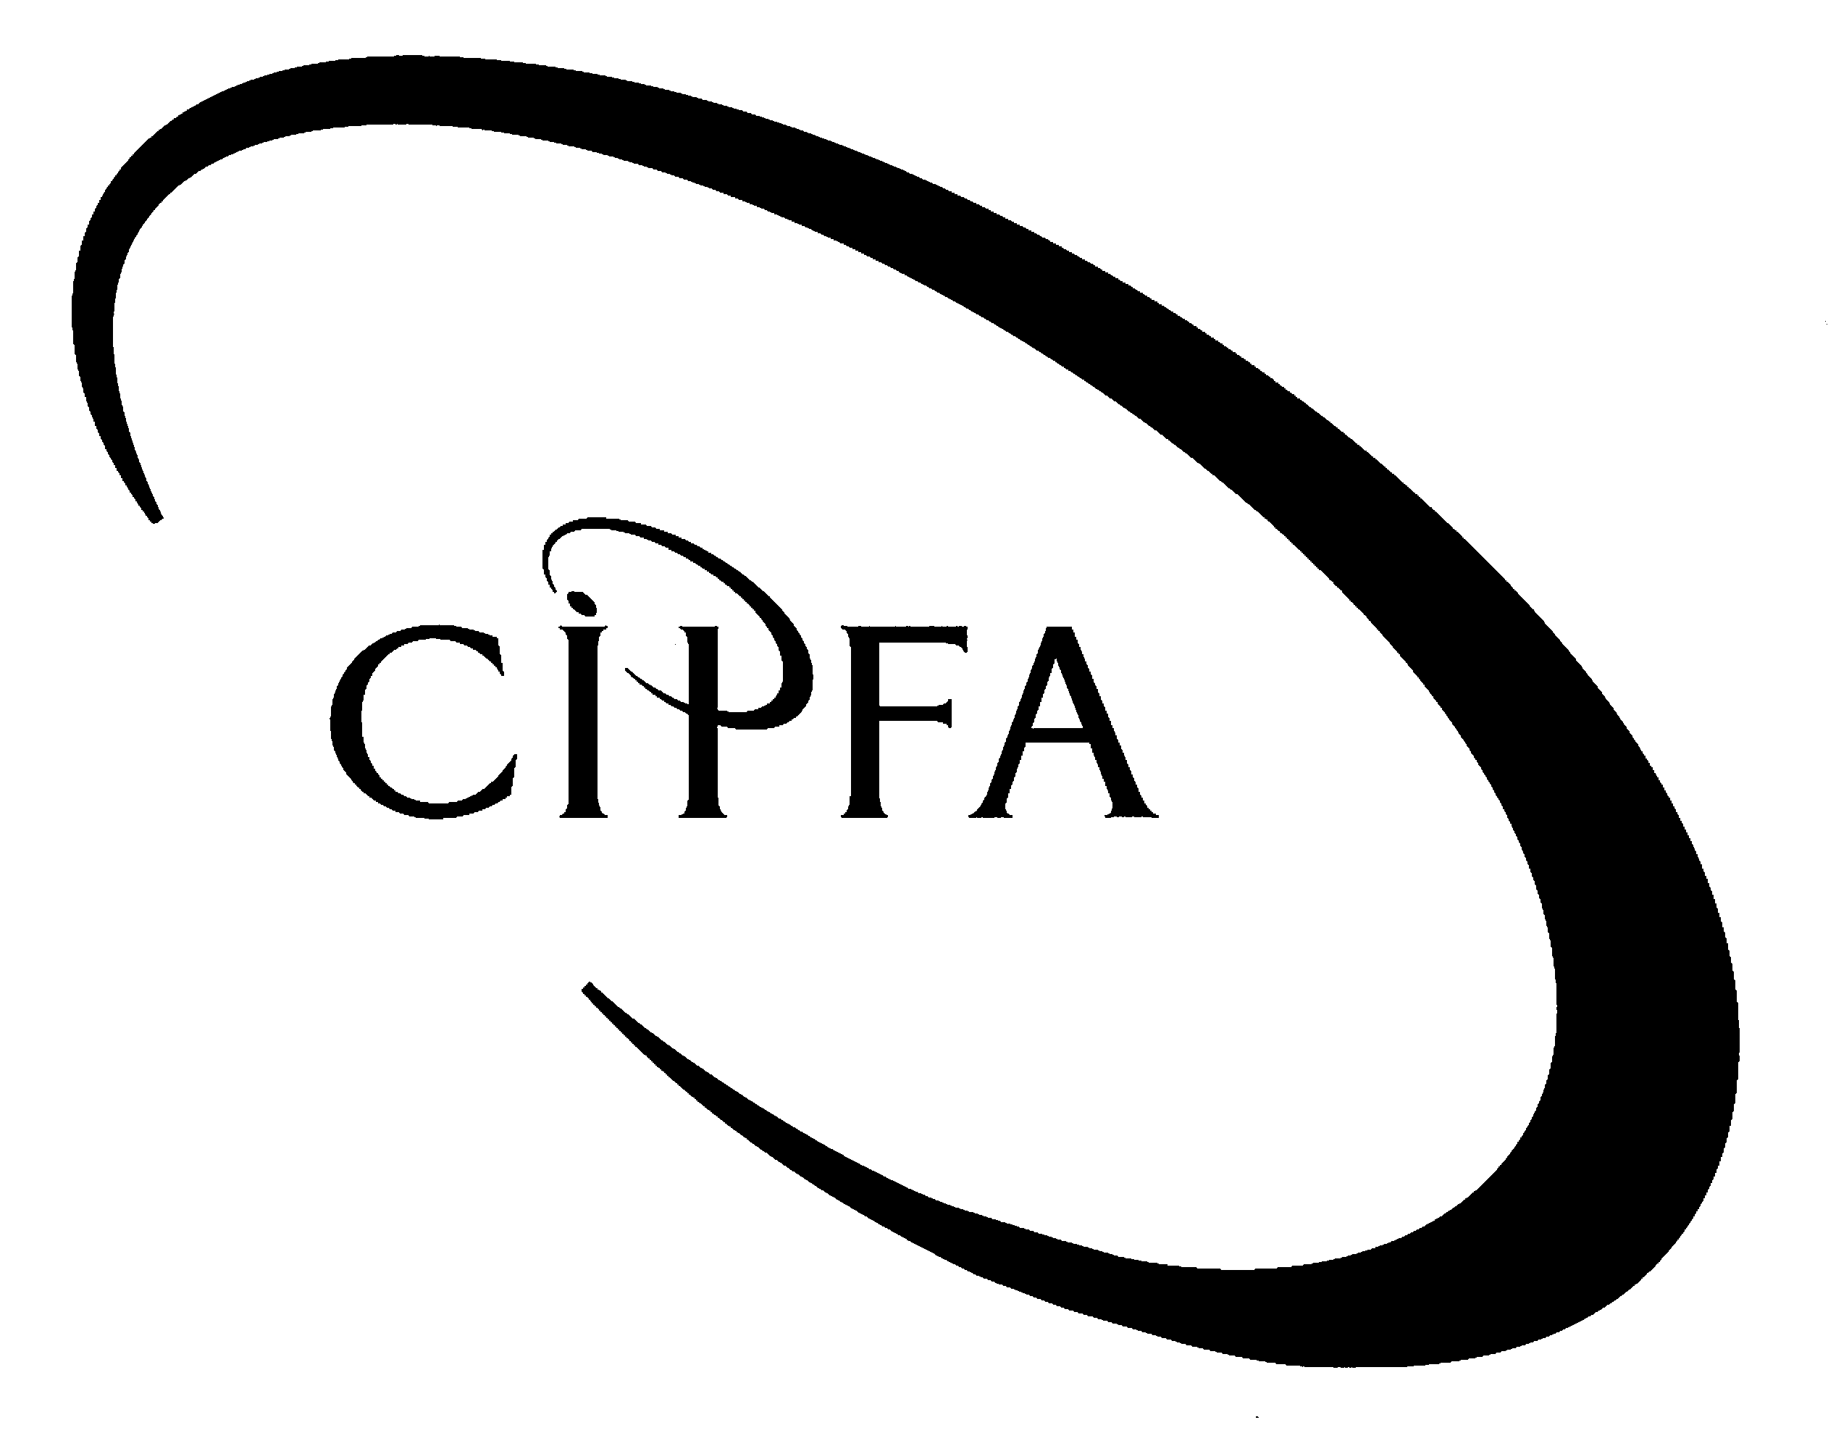

SECTION A (Compulsory)
1
1

The following information relates to the accounting statements published by the companies within the H&S retail group.

Balance Sheet as at 30 September 2003
 |  | H Ltd |  |  |  |  | S Ltd
 | £000 | £000 | £000 |  |  | £000 | £000 | £000
Fixed assets |  |  |  |  | Fixed assets
Land and buildings | 320 | (50) | 270 |  | Land and buildings | 190 | (35) | 155
Plant and machinery | 160 | (70) | 90 |  | Plant and machinery | 65 | (25) | 40
Vehicles | 85 | (30) | 55 |  | Vehicles | 40 | (25) | 15
 |  |  | 415 |  |  |  |  | 210
Investments |  |  | 152
 |  |  | 567
Current assets |  |  |  |  | Current assets
Stock | 62 |  |  |  | Stock | 45
Debtors | 92 |  |  |  | Debtors | 26
Current a/c S Ltd. | 20 |  |  |  | Cash | 8
Cash | 10 |  |  |  |  |  | 79
 |  | 184
Creditors due within one year |  |  |  |  | Creditors due within one year
Creditors | (45) |  |  |  | Creditors | (29)
Dividends | (63) |  |  |  | Current a/c H Ltd | (16)
 |  |  |  |  | Dividends | (9)
 |  | (108) |  |  |  |  | (54)
 |  |  | 76 |  |  |  |  | 25
 |  |  | 643 |  |  |  |  | 235
Creditors: amounts due over one year |  |  |  |  | Creditors: amounts due over one year
Debentures 8% |  |  | (150) |  | Debentures10% |  |  | (80)
 |  |  | 493 |  |  |  |  | 155
Capital and reserves |  |  |  |  | Capital and reserves
Ordinary £1 Shares |  |  | 200 |  | Ordinary 20p shares |  |  | 50
5% £1 Preference shares |  |  | 60 |  | 10% £1 Preference shares |  |  | 40
Share premium |  |  | 30 |  | Share premium |  |  | 0
Revaluation reserve |  |  | 62 |  | Revaluation reserve |  |  | 10
Profit and loss balance |  |  | 141 |  | Profit and loss balance |  |  | 55
 |  |  | 493 |  |  |  |  | 155

Additional information

- H Ltd acquired the following investments in the ordinary and preference share capital of S Ltd on 1 October 1999:

  - 200,000 ordinary shares at a cost of £90,000
  - 20,000 preference shares at a cost of £22,000

- At 1 October 1999 S Ltd had a revaluation reserve of £8,000 and a profit and loss balance of £23,000.

- On 1 October 1999 the fair values of S Ltd’s assets and liabilities were all equal to net book value except in respect of land and vehicles. Land had a fair value of £30,000 in excess of its net book value and vehicles had a fair value of £6,000, less than their net book value.

- Vehicles are depreciated on a straight line basis and had a remaining life of three years on 1 October 1999.

- On 1 October 2002 H Ltd purchased £40,000 of debentures in S Ltd at par.

- H Ltd sold goods costing £100,000 to S Ltd during the year ended 30 September 2003 for £150,000. S Ltd had £45,000 of these goods in stock at the year end.

- S Ltd sent a cheque for £4,000 to H Ltd on 30 September 2003.

- Goodwill is to be amortised over 10 years.

- The dividends of £9,000 included in creditors due within one year in the balance sheet of S Ltd consist of a final proposed ordinary dividend of £5,000 and the preference dividend payable for the year of £4,000. H Ltd has accounted for its share of these dividends.

- Requirement for question 1

Prepare the consolidated balance sheet for the H&S retail group as at 30 September 2003.

(20)

SECTION B (Answer one question)

2

The balance sheets of Groanham University for the last two financial years are shown below. The University, previously the Groanham Polytechnic, is classified as a new university and as such relies upon student generated income rather than external research grants.

Groanham University - Balance Sheet as at 31 July

 | 2003 |  | 2002
Tangible fixed assets: | £000 | £000 | £000 | £000
Land – valuation |  | 16,800 |  | 16,500
Buildings – valuation | 12,800 |  | 9,200
Buildings – accumulated depreciation | (4,500) | 8,300 | (2,300) | 6,900
Plant and equipment - cost | 4,000 |  | 4,800
Plant and equipment - accumulated depreciation | (2,900) | 1,100 | (3,000) | 1,800
 |  | 26,200 |  | 25,200
Endowment asset investments: |  | 2,500 |  | -
Current assets:
Stocks | 1,267 |  | 1,465
Debtors | 992 |  | 768
Investments | 500 |  | 500
Bank and cash | 1,551 |  | 1,007
 | 4,310 |  | 3,740
Creditors – amounts falling due within one year:
Creditors | 1,724 |  | 1,500
Taxation | 526 |  | 800
Accrued interest (long term loans) | 90 |  | 90
 | 2,340 |  | 2,390
Net current assets |  | 1,970 |  | 1,350
Creditors – amounts falling due after more than one year:
Long term loans |  | (6,700) |  | (4,400)
 |  | 23,970 |  | 22,150
Financed by:
Endowments – specific |  | 2,500 |  | -
Revaluation reserve |  | 14,000 |  | 13,700
Income and expenditure account |  | 7,470 |  | 8,450
 |  | 23,970 |  | 22,150

Additional information:

- During the year the University received investment income amounting to £254,000 and paid interest of £396,000. It also paid corporation tax of £700,000 during 2002/03 to the Inland Revenue in respect of its trading undertakings.

- During the year ended 31 July 2003, all additions to buildings and equipment were paid for in cash, other than the final equipment purchase on 30 July 2003 of £100,000 that is still to be paid. Accordingly the creditors balance incorporates this figure. There were no physical transactions of land in the year 2002/2003.

- Buildings with a net book value of £570,000, originally costing £600,000, were sold during the year ended 31 July 2003. Shortly after buying these buildings a change in local circumstances resulted in an increased valuation. Accordingly the value was increased by £200,000 with no depreciation charged between purchase and revaluation. The transaction resulted in a profit of £100,000.

Plant and equipment with a net book value of £1,000,000, originally costing £1,500,000, was sold during the year ended 31 July 2003 at a profit of £50,000.

4. The current asset investment relates to an annual bond renewable on 1 December 2004. The bond has a current market value of £600,000.

5. During the year ended 31 July 2003 the University was fortunate enough to receive an endowment of £2,500,000 which will be used to extend the Business School facilities in forthcoming years. Until that time the amount has been placed on investment.

6. The increase in debtors is primarily down to outstanding accommodation charges to final year undergraduate students.

Requirement for question 2
- Prepare a reconciliation of net surplus or deficit to net cash flow from operating activities. 8
- Prepare a cash flow statement for the University for the year ended 31 July 2003. (Notes to the cash flow statement are not required). 9
- Governors, in general, find the presentation of separate statements showing income and expenditure and cash flow confusing. Two of your Governors have complained that they do not understand why you produce a statement reconciling operating surplus/deficits to operating cash flows. Additionally, they question the need for cash flow statements as they believe their governance responsibilities are best served by understanding the income and expenditure statement and balance sheet. Prepare notes in readiness for a meeting with the Governors where their concerns will be discussed. 8
(25)

Denby NHS Trust prepares its financial statements to 31 March each year. The balance sheets of the Trust as at 31 March 2002 and 31 March 2003 are detailed below along with additional relevant data.
3
Denby NHS Trust
Balance Sheet as at 31 March
 |  |  |  |  |  | 2003 |  |  | 2002
 |  |  |  |  |  | £000 | £000 |  | £000 | £000
Tangible fixed assets:
Land and buildings |  |  |  |  |  |  | 52,740 |  |  | 50,350
Plant and equipment |  |  |  |  |  |  | 7,345 |  |  | 5,995
 |  |  |  |  |  |  | 60,085 |  |  | 56,345
Current assets:
Stocks and work in progress |  |  |  |  |  | 2,168 |  |  | 2,200
Debtors (operating) |  |  |  |  |  | 3,245 |  |  | 2,665
Cash |  |  |  |  |  | 1,885 |  |  | 900
 |  |  |  |  |  | 7,298 |  |  | 5,765
Creditors - amounts falling due within one year:
NHS creditors (operating) |  |  |  |  |  | (1,880) |  |  | (2,105)
Other creditors |  |  |  |  |  | (120) |  |  | 0
Bank overdraft |  |  |  |  |  | 0 |  |  | (390)
 |  |  |  |  |  | (2,000) | 5,298 |  | (2,495) | 3,270
Creditors - amounts falling due after more than one year:
Provisions for liabilities and charges |  |  |  |  |  |  |  | (120) |  | (120)
 |  |  |  |  |  |  | 65,263 |  |  | 59,495
Financed by:
Public dividend capital (PDC) |  |  |  |  |  |  | 39,000 |  |  | 38,000
Revaluation reserve |  |  |  |  |  |  | 15,000 |  |  | 14,000
Income and expenditure account |  |  |  |  |  |  | 8,680 |  |  | 7,495
Donation reserve |  |  |  |  |  |  | 2,583 |  |  | 0
 |  |  |  |  |  |  | 65,263 |  |  | 59,495

Additional Information:

1. Incorporated in the figure for land and buildings is the value for land of £21,000,000 in both years.

2. Buildings with a net book value of £7,300,000, were sold during the year ended 31 March 2003. This resulted in a surplus of £1,220,000.

3. Plant and equipment with a net book value of £650,000 and opening gross current cost of £1,240,000 were sold during the year ended 31 March 2003 incurring a deficit of £120,000.

4. During the year to 31 March 2003, all additions to buildings were paid for in cash, while £120,000 in respect of additions to plant and equipment remained unpaid at the year-end and is shown as ‘other creditors’.

5. Depreciation of £1,640,000 is chargeable on buildings in respect of the year ended 31 March 2003. Accumulated depreciation on equipment increased by £800,000 during the year from £2,105,000 at 31 March 2002.

6. At the beginning of the year the buildings were increased in value by £800,000 and equipment by £200,000. Ignore any effect on depreciation.

7. During the year the Trust received bank interest of £540,000.

8. The Trust was required to pay £2,000,000 in PDC dividends during the year although changes in the NHS planning guidelines and regional strategy have indicated that this figure was too high. To compensate, and to ensure the Trust kept within expected targets, additional public dividend capital was granted.

9. A mobile theatre was donated to the Trust in March 2003. This represented the only donated asset to the Trust during 2002/2003.

10. The Trust’s external financing limit for the year was £2,500,000 and its capital resource limit was set at £3,200,000.

- Requirement for question 3

(a) Prepare a reconciliation of operating surplus/(deficit) to net cash flow from operating activities. 7

- Prepare a cash flow statement for Denby NHS Trust for the year ended 31 March 2003. 8

(c) Calculate, and comment on, the Trust’s performance against its statutory financial targets. 10

(25)

SECTION C (Answer one question)

4
The following balances, for the year ended 31 March 2003, have been estimated from the records of Sheen County Council, a rural council in the west of England. The accounts have yet to be completed but due to the financial situation the Councillors urgently need to understand the availability of reserves for next year’s budget. The Council has been steadily reducing its general fund balance over the last three years to ensure continuity of services but has been advised to expect a reduction in general government grant next year of around 5% and that the maximum increase in council tax permitted will be 10%.

£000 £000
Net tangible fixed assets | 893,161
Education | 626,543 | 98,722
Social Services | 224,010 | 26,524
Cultural, Environment and Planning | 109,952 | 10,379
Highways, Roads and Transport | 17,555 | 623
Central Services | 8,339 | 523
Interest | 23,977 | 9,333
Stock | 867
Debtors | 31,098
Short term investments | 123
Cash in hand | 6,124
Creditors due within one year |  | 95,238
Long term borrowing |  | 267,000
Provision for liabilities and charges |  | 12,000
Fixed asset restatement reserve |  | 326,888
Capital financing reserve |  | 123,499
Useable capital receipts |  | 30,000
General fund |  | 12,863
Council tax |  | 174,008
General government grants |  | 650,487
National non-domestic rates |  | 107,662
Capital suspense account | 4,000
 | 1,945,749 | 1,945,749

The following information is also available:

1. Capital charges have been calculated as follows but have not yet been charged to the service departments:

 | Depreciation | Notional interest
 | £000 | £000
Education | 11,699 | 29,821
Social Services | 6,600 | 19,854
Cultural, environment and planning | 2,873 | 12,753
Highways, roads and transport | 2,444 | 9,334
Central Services | 3,221 | 3,001

2. The minimum revenue provision for 2002/03 is estimated to be £40,000,000.

3. On 31 March 2003 Highways, Roads and Transport are expected to complete on the development of an Integrated Regional Transportation Centre in Groanham.

The Centre will cost £32,000,000 and will be funded from the following sources:

New Loans £16,000,000
Direct Revenue Financing £4,000,000
EU Grant £12,000,000

The external funding has been received and payment for the centre transferred from the County Council bank account on the 31 March 2003. However, these transactions have been posted to the capital suspense account instead of the appropriate financing and asset account.

It is not Council policy to charge assets rentals on assets purchased in the last three months of the financial year.

4 The balances shown above include an inter-service debt of £3,000,000 owed to Social Services from Education. Additionally Cultural, environment and planning are holding a debt of £2,500,000 which is unlikely to be paid.

- Requirement for question 4

(a) Prepare the Asset Management Revenue Account for 2002/03. 4

(b) Prepare the consolidated revenue account and balance sheet for the year ended 31 March 2003. Show all relevant workings and the journal entries required to clear the capital suspense account. 15

(c) Critically analyse the draft accounts for the Councillors, in particular consider the potential impact of the changes outlined in item 3 above. 6

(25)

5
- Requirement for question 5(a)

The Resource Accounting Manual that governs resource accounting in central government states that its policies:

“follow generally accepted accounting practice (GAAP) in the UK, to the extent that it is meaningful and appropriate in the public sector context.”
(Source: FRA Textbook.)

Explain this statement. In your answer you should:

- give examples of elements of UK GAAP that do apply;
- identify and explain elements that are not appropriate; and
- identify and explain other sources of accounting guidance in central government. 14

- Requirement for question 5(b)

FRS 18 identifies Going Concern and Accruals as two key concepts to be applied when determining accounting policies.

Explain how each of these is applied in central government. 3

- Requirement for question 5(c)

A government department has received grant funding from the European Union (EU) as follows:

- £20 million to fund a new IT system to help administer EU grants in the UK (the system is expected to have a life of 5 years);
- £200 million revenue grant which is distributed to UK businesses in respect of language training initiatives for UK employees; and
- the department may keep £1 million to cover their own administration costs.

Explain the appropriate accounting treatment for these transactions. Your answer should include the appropriate accounting entries, relevant accounting standards and how this income would appear in the Operating Cost Statement for the year. 5

- Requirement for question 5(d)

The defence department, one of the largest government departments, has just completed the year end stock take which revealed the following:

- £2,500 of administration stocks that are damaged beyond repair;
- £2 million of military equipment for use by the army that can now be purchased on the open market for 10% less than the cost of these supplies.

Explain the appropriate accounting treatment for these transactions under SSAP 9. 3

(25)

SECTION D (Answer two questions)

The accounting statements of Deanhill Housing Association are presented below. The Association’s role is to provide affordable housing within the town of Deanhill and the surrounding countryside. They may potentially assume responsibility for Deanhill District Council Housing Stock.
6

Income and expenditure account for year ended:

31 March 2002 |  |  | 31 March 2003
£000 |  |  |  | £000
28,300 | Turnover |  |  | 27,553
(24,293) | Operating costs |  |  | (25,667)
4,007 | Operating surplus |  |  | 1,886
0 | Profit on sale of fixed assets |  |  | 3
400 | Interest receivable |  |  | 400
(1,200) | Interest payable |  |  | (1,967)
3,207 | Surplus for the year |  |  | 322
0 | Less: transfers to designated and restricted reserves |  |  | 0
3,207 | Surplus for the year after transfers to reserves |  |  | 322
9,049 | Revenue reserves brought forward |  |  | 12,256
12,256 | Revenue reserves carried forward |  |  | 12,578

Balance sheet as at:
31 March 2002 |  | 31 March  2003
£000 | Fixed assets | £000 | £000
382,197 | Housing property |  | 382,339
(228,998) | Less: Social Housing Grant (SHG) |  | (228,778)
153,199 |  |  | 153,561
14,977 | Non housing fixed assets |  | 12,933
168,176 |  |  | 166,494
 | Current assets
2,699 | Debtors | 3,815
3,455 | Cash at bank and in hand | 1,101
6,154 |  | 4,916
(2,331) | Less: credits < one year | (2,997)
3,823 | Net current assets |  | 1,919
171,999 |  |  | 168,413
 | Creditors > one year
800 | Recycled capital grant fund |  | 700
149,797 | Loans |  | 145,899
150,597 |  |  | 146,599
800 | Provisions for liabilities and charges |  | 890
 | Capital and reserves
1 | Share capital |  | 1
7,345 | Designated reserves |  | 7,345
1,000 | Restricted reserves |  | 1,000
12,256 | Revenue reserves |  | 12,578
171,999 |  |  | 168,413
The potential for working with the District Council has resulted in strategic and operational focus being diverted from the on-going provision and development of low cost social housing. Board members are concerned that planned grants receivable will be deferred by the grantees due to the uncertain financial results of the Association. The Association is expecting a significant grant to cover the cost of a new housing development providing it can contribute £6,000,000 to the project. No reserves have been designated for this purpose.

Included in the loans are £10,000,000 of deferred interest advances which begin to incur a 2% interest charge next year.

- Requirement for question 6

You have been asked by the Board to prepare a short report for the next Board meeting. Your report is to be a critical evaluation of the financial position of the Association.

The Board recognises that you may not be able to reach any firm or clear conclusion and has indicated that it expects to see THREE key questions identified and explained in your report that will, when answered, assist the Board in their ultimate consideration of the financial position of Deanhill Housing Association.

(15)

The examples of Enron and Worldcom have re-opened the debate about the quality of financial reporting and the need for effective governance arrangements within the public sector as well as within the private sector.
7

- Requirement for question 7

(a) Discuss the role and function of accounting standards in achieving good governance in the UK public sector. 6

(b) Explain the objectives of FRS 5 (Reporting the substance of transactions) and FRS 11 (Impairment of fixed assets and goodwill) and discuss their relevance to a public service sector of your choice, including their relationship with governance principles. 9

(15)

8
- Requirement for question 8

Compare and contrast TWO public service sectors of your choice:

(a) Discuss the extent to which your freedom as an accountant, in the production of published statements, is enhanced or constrained by accounting regulation, guidance and legislation. 8

(b) Discuss the extent to which entity theory is appropriate to accounting and financial reporting in your chosen sectors. 3

AND in relation to your own sector:

(c) How can accounting policies impact upon performance measurement? 4

(15)

