FINANCIAL AND PERFORMANCE REPORTING

Diploma stage examination

7 June 2005

From 2.00pm to 5.00pm
plus ten minutes reading time from 1.50pm to 2.00pm

Instructions to candidates

Answer five questions in total: Two questions from Section A, and three questions from Section B. The marks available for each question are shown in italics in the right-hand margin.

All workings should be shown. Where calculations are required using formulae, calculators may be used but steps in the workings must be shown. Calculations with no evidence of this (for example, using the scientific functions of calculators) will receive no credit. Programmable calculators are not permitted in the examination room.

Formula sheets, statistical tables, graph paper and cash analysis paper are available from the invigilator, where applicable.

Where a question asks for a specific format or style, such as a letter, report or layout of accounts, marks will be awarded for presentation and written communication.

Candidates may use the proforma sheets provided in the separate booklet and submit them as part of their answer.

The questions in this examination are based on the 2003/2004 financial year and should be answered as such. Candidates are being provided with the most recent version of all UK Accounting Standards – those extant as at 30 April 2004. Candidates should assume that these Accounting Standards are relevant to the 2003/2004 financial year for the purposes of this examination paper.

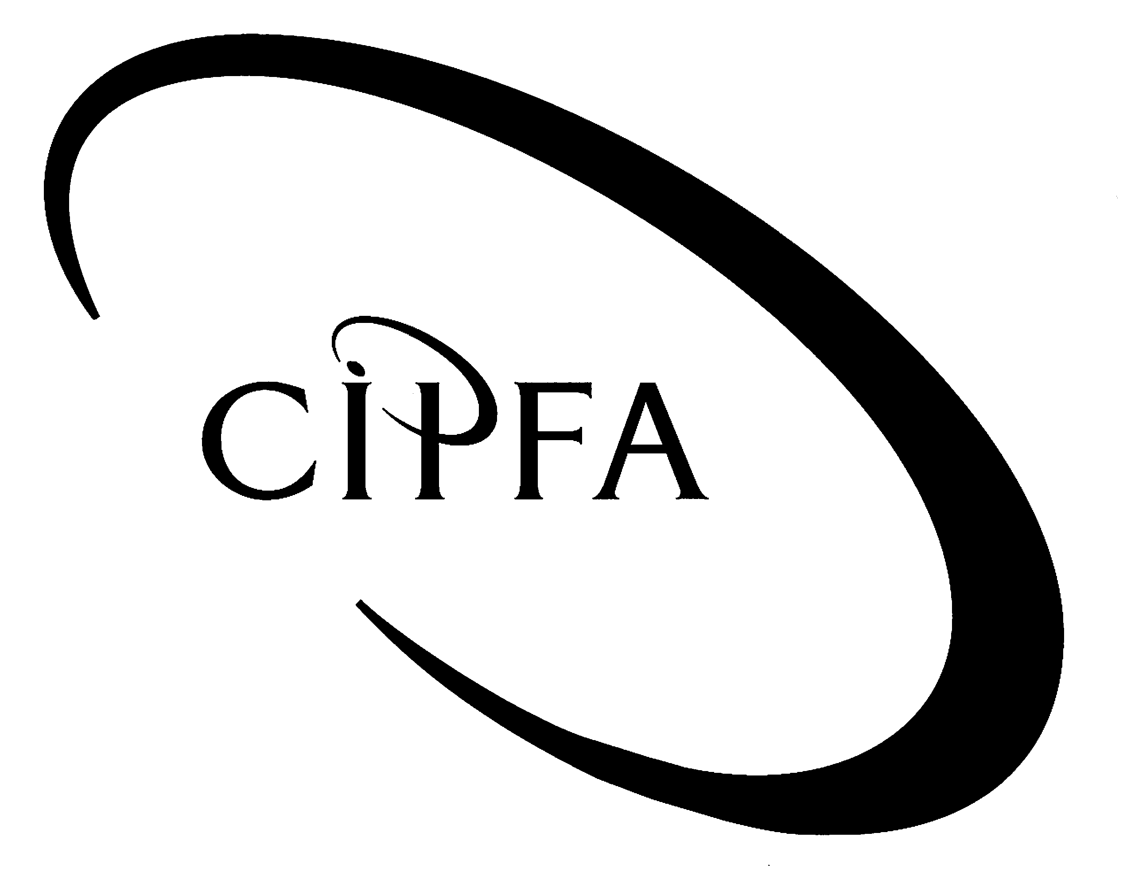

SECTION A (Compulsory)

1
The following information has been taken from the trial balance of Baudelaire NHS Trust, a multi-service NHS Trust, for the year ending 31 March 2004.

 | £000 |  | £000
Land | 5,750
Buildings | 60,230
Plant and equipment | 20,575
Plant and equipment - depreciation |  |  | 5,400
Vehicles | 750
Vehicles - depreciation |  |  | 495
Debtors | 7,930
Cash | 275
Creditors due within one year |  |  | 3,900
Public dividend capital |  |  | 80,000
Revaluation reserve |  |  | 3,720
Income and expenditure reserve |  |  | 50
Income from commissioners |  |  | 120,790
Private patient income |  |  | 3,500
Other income |  |  | 4,740
Salaries | 85,900
Supplies and services | 29,000
Premises | 6,590
Establishment | 1,310
Interest received |  |  | 15
PDC Dividends | 4,050
Stock | 250
 | 222,610 |  | 222,610

Additional information.

- No adjustments have been made to fixed assets for the year. Indexation needs to be applied at the following rates:

Land | 6%
Buildings | 6%
Plant and equipment | 2%
Vehicles | 3%

Assets are to be depreciated using the following useful economic lives.

Buildings | 40 years remaining useful economic life
Plant and equipment | 10 years
Vehicles | 5 years

- Included in the trial balance is a hospital minibus which was disposed of in February 2004 for £7,000. The minibus is included in the trial balance at a cost of £15,000 with accumulated depreciation of £10,000.

- A review of debtors has been completed at year end. It has been decided that £25,000 of private patient debts are irrecoverable. In addition one of the Trust’s commissioners has disputed £150,000 during the reconciliation of NHS debtors and creditors.

- The historical value of depreciation charges for the year have been calculated as follows.

Buildings | £1,000,000
Plant and equipment | £2,000,000
Vehicles | £145,000

- Requirement for question 1

(a) Prepare the income and expenditure account and balance sheet for Baudelaire NHS Trust for the year ending 31 March 2004. 14

(b) Comment on Baudelaire NHS Trust’s performance against its statutory break even target for the year ending 31 March 2004. 2

(c) Mental health services have been subject to a review. The Trust’s mental health services will transfer to a new specialist NHS Trust from 1 April 2004. Income and expenditure included in the trial balance above which relates to this service is £20,000,000 and £21,500,000 respectively. The net assets associated with the mental health service have been assessed to have a net book value of £18,000,000.

Comment on how the transfer of mental health services should be accounted for and disclosed. You should refer to appropriate accounting standards in your answer. 4

(20)

The following balance sheets are available for Sunny Unitary Authority:
2

 | 2003/04 | 2002/03
 | £000 | £000
Fixed assets
Land | 17,900 | 20,900
Buildings | 76,437 | 75,000
Other fixed assets | 39,840 | 37,840
 | 134,177 | 133,740
Current assets
Stock | 1,010 | 1,020
Debtors | 6,500 | 4,000
Cash | 10,140 | 410
 | 17,650 | 5,430
Current liabilities
Creditors | (5,430) | (9,050)
Creditors due greater 1 year
Deferred government grants | (3,150) | (3,500)
Long term borrowings | (110,890) | (109,500)
Total net assets | 32,357 | 17,120
Financed by
General fund | 4,270 | 1,200
Fixed asset restatement reserve | 10,217 | 8,530
Capital financing reserve | 6,230 | 4,500
Useable capital receipts | 11,640 | 2,890
 | 32,357 | 17,120

Additional information

- Analysis of the consolidated revenue account has provided the following information:
Asset rentals | £9,681,000
Credit transfer from Asset Management Revenue Account to the Consolidated Revenue Account | £731,000
Interest payable | £4,300,000

- The minimum revenue provision for the year was £4,380,000.

- Fixed assets were revalued by £6,687,000 in year.

- The Authority’s fixed asset programme included £750,000 financed by revenue and £1,250,000 financed by usable capital receipts. The remainder of capital additions were financed through long term borrowing. Sunny Unitary Authority does not currently reserve capital receipts for the repayment of debt.

- Loans of £3,000,000 were repaid in year.

- Cash flows for the year have been identified as follows:
£000
Payments to employees | 355,750
Payments to other suppliers | 299,890
Council tax received | 220,700
Revenue support grant received | 250,900
National Non Domestic Rate contributions received | 173,160
Other grants received | 10,510
Fees and charges raised | 4,670
Interest received | 2,090

- A note from Count Olaf, the leader of the council, has been passed to you:
“At last the sale of Council’s surplus depots has been completed! I am keen to see that we can demonstrate to Sunny’s population that we use this money to really make a difference to their lives. We could reduce council tax bills dramatically and I am determined that having finally sold these disused depots we should finally put behind us these claims of financial mismanagement and demonstrate that we really can get our finances in shape and in this election year. I am keen to know how we can use the proceeds from the depot sale to lower council tax.”

- Requirement for question 2

(a) Prepare the cash flow statement and note 1 to the cash flow statement (other notes are not required). 14

(b) Prepare notes for a meeting with Count Olaf to discuss the issues raised in the note above proposing how to use the capital receipt received. 6

(20)

SECTION B (Answer three questions form this section)

3
Financial reporting in the private sector is influenced by the requirements of the UK GAAP and International Accounting Standards.

- Requirement for question 3

(a) Explain what is meant by UK GAAP. 2

(b) Assess why some elements of UK GAAP apply to the public services in general and some areas of UK GAAP do not. 4

For two public service organisations of your choice:

(c) Compare and contrast the extent to which UK GAAP applies to your chosen organisations. You should illustrate your answer with two different examples from UK GAAP per organisation. 8

(d) Explain why international accounting standards are being adopted in the private sector and discuss whether these should be adopted in the public sector. 6

(20)

The draft accounts of the Quagmire Agency are shown below:
4

Quagmire Agency: Net Operating Cost Statement for the year ending 31 March 2004
 | £000
Staff costs | (12,650)
Other costs | (4,385)
 | (17,035)
Other income | 18,675
Net operating cost for the year | 1,640

Quagmire Agency: Balance sheet as at 31 March 2004
 | £000
Fixed assets – Buildings | 16,758
Current assets
Stock | 35
Debtors | 4,580
Cash | 1,230
 | 5,845
Creditors due within one year | (3,500)
Total net assets | 19,103
Taxpayers' equity
General Fund | 17,055
Revaluation reserve | 2,048
 | 19,103

On review it has been discovered that the following adjustments have not been accounted for:

- No depreciation for buildings has been included in the accounts on the grounds that with a remaining 45 year useful economic life, no charge need be made.

- Notional charges have not been accounted for. The following need to be included in the financial statements:

Cost of capital charged at 3.5% of average relevant net assets. The revaluation reserve as at 1 April 2003 totalled £1,250,000. No cash was held at the start of the year.

Insurance:
1% of the closing NBV of fixed assets
2% of staff costs

Audit fee: £75,000

- Parliamentary funding has been included within miscellaneous income received. The amount of parliamentary funding drawn down in the year totalled £17,430,000.

- Requirement for question 4

(a) Prepare a revised balance sheet and net operating cost statement for the Quagmire Agency accounting for the adjustments outlined above. 9

(b) Explain why the three adjustments above are required. 4

(c) Identify ways in which the Quagmire Agency’s financial performance could be measured. 2

- Explain the purpose of the general fund and how it differs from the general fund account held in a Local Authority balance sheet. 5

(20)

5
Management of the public services has become ever more focused on reporting against performance targets. With the increasing involvement of private sector money and increasing financial freedoms it is time for the public services to adopt a more private sector approach to their financial and performance reporting.

- Requirement for question 5

(a) Compare and contrast the purpose of financial and performance reporting in the public and the private sectors. 6

(b) Identify how financial performance and non financial performance is assessed in a further and/or higher education institute and a housing association. Explain whether the ways identified provide useful information for users of the organisations’ services and recommend changes if needed. 8

(c) Discuss whether the assumption above, that increasing private sector money and increasing financial freedoms, should lead to a private sector style of financial reporting in the NHS and Local Government. 6

(20)

The following summarised financial statements have been extracted from the draft accounts of Mortmain Primary Care Trust (PCT) for the year ending 31 March 2004. These accounts have not yet been formally adopted by the PCT’s Board or submitted to the Department of Health:
6
Mortmain PCT: Operating cost statement for the year ending 31 March 2004
 |  | £000
Commissioning
Gross operating costs |  | (210,000)
Operating income |  | 1,795
Net operating costs |  | (208,205)
Providing
Gross operating costs |  | (14,950)
Operating income |  | 10,450
Net operating costs |  | (4,500)
Net operating costs before interest |  | (212,705)
Interest payable |  | (25)
Net operating costs for the year |  | (212,730)

Mortmain PCT: Summarised Balance Sheet as at 31 March 2004
 | £000
Fixed assets | 18,840
Net current assets | 572
Creditors greater than 1 year | (92)
Total net assets | 19,320
Taxpayers' Equity
General fund | 13,068
Revaluation reserve | 4,155
Donation reserve | 2,097
 | 19,320

Mortmain PCT: Cash flow statement for the year ending 31 March 2004
 |  | £000 | £000
Net cash outflow from operating activities |  |  | (210,735)
Returns on investment and servicing of finance
Interest Paid |  | (25)
 |  |  | (25)
Capital activities
Payments to acquire fixed assets |  | (150)
Receipts from the sale of fixed assets |  | 10
 |  |  | (140)
Financing
Finance lease principal paid |  | (75)
Parliamentary funding received |  | 210,870
 |  |  | 210,795
Decrease in cash |  |  | (105)

Additional information

- The following additions and disposals of fixed assets took place in 2003/04:

Additions (At cost) | £000
Phase 1 of new rehabilitation wing | 150
Medical equipment (purchased) | 30
Medical equipment (donated by League of Friends) | 50
 | 230
Disposals (At NBV)
Medical equipment | 12

- Mortmain PCT’s main community hospital site was subject to a revaluation review. The District Valuer determined that the hospital site had fallen in value by £250,000 and that this value was unlikely to be regained in future years. A revaluation reserve of £175,000 was held in respect of this asset. Funding is available to support the impairment loss.

- The PCT’s commissioning arm made non cash limited payments to GPs totalling £3,500,000. Services to the value of £4,500,000 were commissioned from the PCT’s own provider arm.

- The PCT was set the following financial targets by the Department of Health for 2003/04:
  - Cash limit: £215,000,000
  - Revenue resource limit: £208,500,000
  - Capital resource limit: £350,000

    - Requirement for question 6

(a) Explain why there are financial statutory targets within the NHS. 2

(b) Identify and explain the financial targets that the PCT needs to disclose. 9

(c) Calculate and comment on the PCT’s performance against these targets as far as information allows. You should make recommendations where appropriate. 9

(20)

