FINANCIAL AND PERFORMANCE REPORTING

Diploma stage examination

8 December 2004

From 10.00 am to 1.00 pm
plus ten minutes reading time from 9.50 am to 10.00 am

Instructions to candidates

Answer five questions in total: Both questions from Section A, and three questions from Section B. The marks available for each question are shown in italics in the right hand margin.

All workings should be shown. Where calculations are required using formulae, calculators may be used but steps in the workings must be shown. Calculations with no evidence of this (for example, using the scientific functions of calculators) will receive no credit. Programmable calculators are not permitted in the examination room.

Formula sheets, statistical tables, graph paper and cash analysis paper are available from the invigilator, where applicable.

Where a question asks for a specific format or style, such as a letter, report or layout of accounts, marks will be awarded for presentation and written communication.

Candidates may use the proforma sheets provided in the separate booklet and submit them as part of their answers.

The questions in this examination are based on the 2003/2004 financial year and should be answered as such. Candidates are being provided with the most recent version of all UK Accounting Standards – those extant as at 30 April 2004. Candidates should assume that these Accounting Standards are relevant to the 2003/2004 financial year for the purposes of this examination paper.

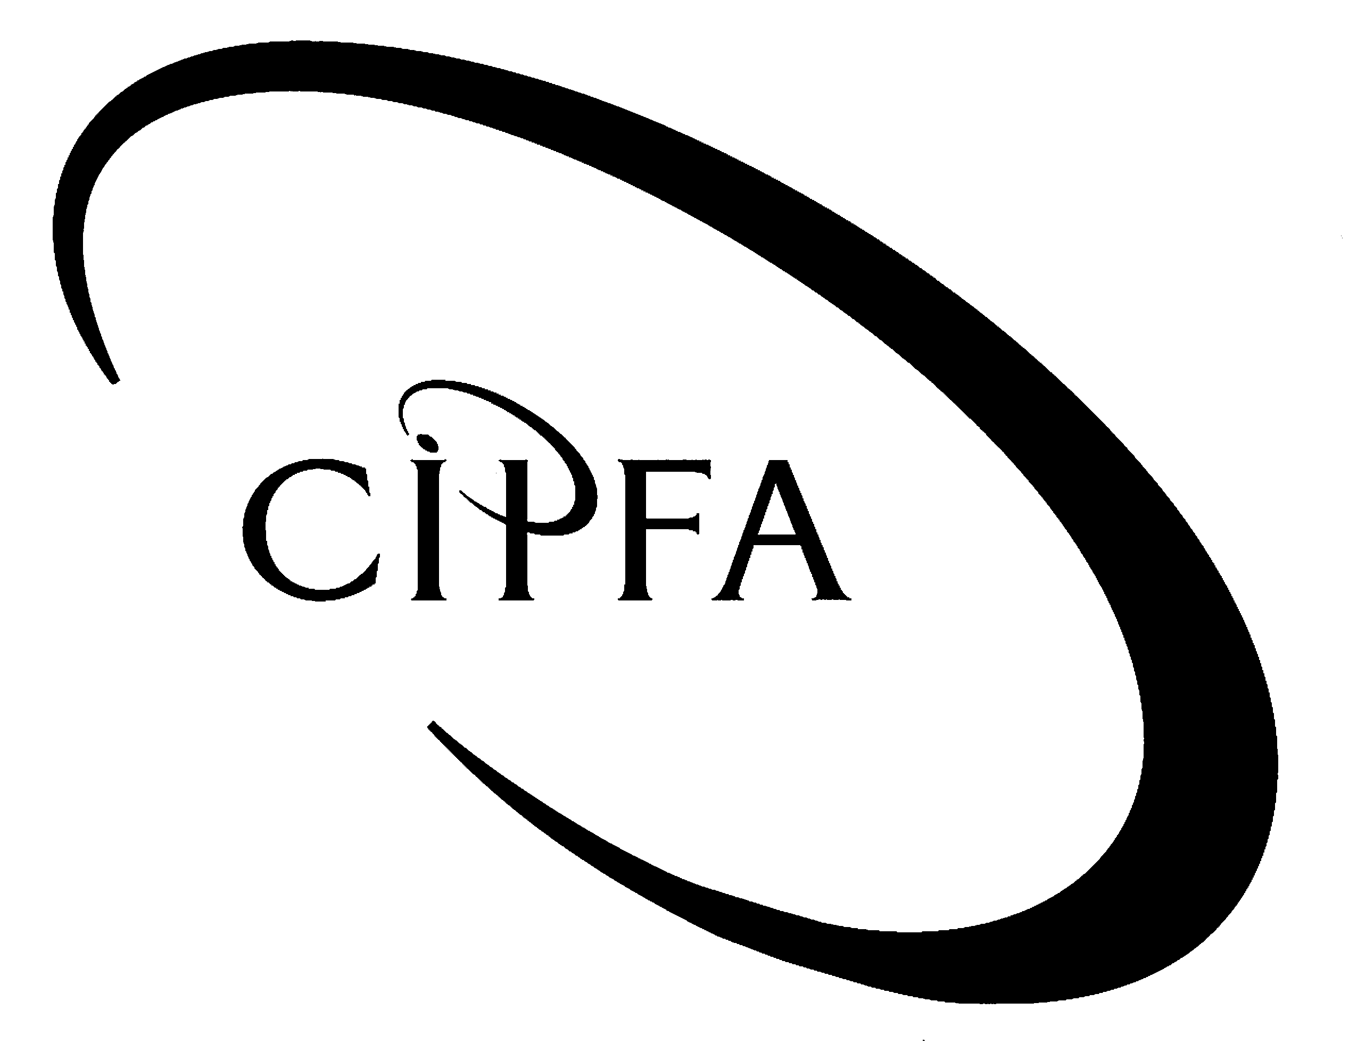

SECTION A (Answer both questions)

1
The following balance sheets have been extracted for Glass Unitary Authority as at 31 March.

 | 2003/04 |  | 2002/03
 | £000 | £000 | £000 | £000
Fixed assets (net book value) |  | 134,763 |  | 130,750
Current assets
Stock | 550 |  | 900
Debtors | 5,980 |  | 4,960
Investments | 1,075 |  | 1,500
Cash | 4,390 |  | 2,300
 |  | 11,995 |  | 9,660
Current liabilities
Creditors |  | (3,200) |  | (7,500)
Net current assets |  | 8,795 |  | 2,160
Total assets less current liabilities |  | 143,558 |  | 132,910
Long term borrowing |  | (42,400) |  | (48,000)
Deferred Government Grants |  | (1,800) |  | (2,000)
Total assets less liabilities |  | 99,358 |  | 82,910
Financed by:
Fixed asset restatement reserve |  | 21,380 |  | 19,380
Capital financing reserve |  | 62,346 |  | 50,650
UCR |  | 2,000 |  | 5,890
General fund |  | 13,632 |  | 6,990
 |  | 99,358 |  | 82,910

The following additional information is available.

- Asset rentals charged to services in the consolidated revenue account totalled £11,879,000. Of this, £6,988,000 related to depreciation. The Asset Management Revenue Account adjustment included in the Consolidated Revenue Account was a debit balance of £859,000.

- The minimum revenue provision for the year was calculated to be £9,873,000.

- Glass’ capital programme for 2003/04 was financed as follows:

Direct revenue financing | £2,500,000
Capital receipts | £5,000,000

The remaining balance of the capital expenditure for the year was financed from loans.

- Fixed assets with a net book value of £1,000,000 were disposed of in the year.

- An analysis of debtors and creditors has identified the following:

 | 2003/04 |  | 2002/03
 | £000 |  | £000
Interest receivable | 50 |  | 30
Operating debtors | 5,930 |  | 4,930
Total debtors | 5,980 |  | 4,960
Interest payable | 150 |  | 500
Operating creditors | 3,050 |  | 7,000
Total creditors | 3,200 |  | 7,500

- Long term borrowing of £7,600,000 was repaid in the year.

- The following cash flows have been identified for the year ending 31 March 2004:

 | £000
Cash Inflows
Council Tax | 250,550
Fees and charges | 11,350
Interest received | 270
NNDR received | 93,450
Other grants | 50,980
Revenue support grant | 133,330
 | 539,930
Cash outflows
NNDR collected | 75,435
Payments to creditors | 175,630
Payments to staff | 259,980
Precepts raised | 8,540
 | 519,585

- Requirement for question 1

Prepare the cash flow statement and associated notes for Glass Unitary Authority for the year ended 31 March 2004. (20)

The Wildlife and Wetlands Protection Agency is a supply financed Central Government Agency. Its trial balance for the year ended 31 March 2004 has been extracted and is below:
2

 | £000 | £000
Income from consultancy |  | 10,200
Other income |  | 2,500
Staff costs | 12,500
Other operating costs | 3,500
Land | 3,675
Buildings | 22,355
Buildings: Accumulated depreciation |  | 7,355
Equipment | 3,519
Equipment: Accumulated depreciation |  | 1,275
Stock | 50
Debtors | 500
Cash | 375
Creditors |  | 650
Revaluation reserve |  | 9,969
General fund |  | 14,525
 | 46,474 | 46,474

The following adjustments need to be accounted for before the financial statements are prepared for the year ended 31 March 2004:

- Land and equipment and equipment accumulated depreciation have been indexed. The net indexation for these assets totalled £219,000 and is included in the revaluation reserve above. No indexation has been accounted for on buildings. The rate for the year is 4%.

- Depreciation for the year is still to be accounted for. Buildings are depreciated over a 50 year life. Equipment is depreciated over a 10 year life. The Agency calculates depreciation on a straight line basis and charges a full year’s depreciation on assets held at the beginning of the year.

- Equipment was sold in the year. The sale generated £5,000 of proceeds which were collected in April 2004. The equipment sold is included in the trial balance at a cost of £41,000 with accumulated depreciation held of £30,600.

- Notional expenditure is to be included at the following rates:

Cost of capital | 3.5% of average relevant net assets
Insurance | 2% of operating costs, prior to depreciation and notional costs
Audit fee | £85,000

- Cash held at the start of the year totalled £50,000.

- A backdated pay award for 2003/04 was paid to staff in April 2004. This amounted to £125,000.

- Other income includes rent paid to the Agency by third parties. An additional £75,000 was owing to the Agency at the year end.

- £2,000,000 of Parliamentary Funding has been drawn down in 2003/04 and included in the general fund balance above.

- The Agency’s parent department has set an income recovery target for the Agency for its consultancy work. The Agency should recover 25% of its gross operating costs from its consultancy income.

- The Agency is considering applying for Trading Fund status.

- Requirement for question 2

(a) Prepare the operating cost statement and balance sheet as at 31 March 2004 and identify if the agency met its income recovery target. 15

(b) Assess whether the Agency should apply for Trading Fund status, considering its performance against its financial targets and other relevant financing issues. Recommend if the Agency should look to receive approval for Trading Fund status. 5

(20)

SECTION B (Answer three questions from this section)

You are the financial accountant at Candle NHS Trust. It is May 2004 and you are preparing the financial accounts for the year ending 31 March 2004 with the help of the finance assistant.
3

The finance assistant has raised a list of queries about how certain items should be accounted for.

- A review of year end debtors has identified that there are £350,000 of private patient debtors and £400,000 of NHS debtors where the amounts outstanding at the year end are not expected to be collectable.

- An impairment review has been completed on the Trust’s new hospital wing which was brought into use in February 2004. The District Valuer has determined that the wing is worth £100,000 less than the value it transferred into operational assets on the balance sheet. A revaluation reserve of £15,000 is held against this asset.

- The Trust has received new equipment through a finance lease. The equipment became operational in April 2003 and has a fair value of £150,000. The lease term is five years and the lease payment is £40,000 per annum, paid each September. No accounting entries have been completed for this equipment.

- During 2003/04 the Trust has hosted shared services on behalf of the local health economy. The Trust receives income under a service level agreement with three local primary care trusts to provide finance, human resources and estates services.

- Income received for the HR shared service has been netted off expenditure. Income receivable for the 2003/04 financial year totalled £2,500,000.

- A provision for £75,000 has been brought forward from last year’s balance sheet. The provision was discounted as at 31 March 2003 over 3 years. No unwinding of the discount has taken place this year.

- Requirement for question 3

Prepare a briefing note which identifies for items 1-6 above:

- Applicable accounting standards or other regulation that determines the accounting treatment of these items.

- Where applicable, the accounting treatment, including disclosure of these items required to complete the draft accounts.
(20)

The concept of corporate governance was developed in the private sector and has also been applied to the public services.
4

- Requirement for question 4

(a) Identify the key developments in corporate governance in the private sector and outline how these have been applied to the public services in general. 12

(b) Discuss with reference to Housing Associations how Corporate Governance has been applied to ensure that good governance is in place. 8

(20)

5
You are the financial controller of Olive College. Olive College is a higher education college located in an urban area. It is located close to another higher education college, Thyme College, which offers similar courses to students. Olive College has retained all its non teaching and research activities as in house services and has not set up arms’ length organisations to manage these. Charging fees to students has been kept to a minimum in the past and there is scope to increase the level of fees charged.

The Head of the Governing Body has asked that a report is produced that analyses the College’s financial performance for the year ended 31 July 2004. There is a general concern that the College’s financial sustainability is decreasing and the Governors need to clearly understand the financial performance for the year and the risks they face to achieve financial balance in the future.

The following information is available to you to complete this task.

Olive College: Consolidated income and expenditure
account for the year ending 31 July 2004
 | £000 |  | £000
Income
Funding council grants | 35,960
Tuition fees and education contracts | 16,500
Research grants and contracts | 10,750
Other income | 25,670
Endowment and investment income | 15,750
Total income |  |  | 104,630
Expenditure
Staff costs | (65,890)
Exceptional restructuring costs | 0
Other operating expenses | (22,050)
Depreciation | (3,750)
Interest payable | (2,790)
Total expenditure |  |  | (94,480)
Surplus on continuing operations after depreciation of tangible fixed assets at valuation and before tax |  |  | 10,150
Profit on disposal of fixed assets |  |  | 2,570
Surplus on continuing operations after depreciation of tangible fixed assets at valuation and disposal of assets but before tax |  |  | 12,720
Taxation |  |  | 0
Surplus on continuing operations after depreciation of tangible fixed assets at valuation, disposal of assets and tax |  |  | 12,720
Transfer to accumulated income within specific endowments |  |  | (10,975)
Retained Surplus for the financial year |  |  | 1,745

Olive College: Consolidated balance sheet as at 31 July 2004
 | £000 | £000 | £000
Fixed assets
Tangible fixed assets |  |  | 70,500
Investments |  |  | 5,670
Total fixed assets |  |  | 76,170
Endowment assets |  |  | 105,900
Current assets
Stock | 250
Debtors | 9,560
Investments | 2,570
Cash at bank and in hand | 100
 |  | 12,480
Creditors due within one year |  | (10,950)
Net current assets/(liabilities) |  |  | 1,530
Total assets less current liabilities |  |  | 183,600
Creditors: Due greater than 1 year |  |  | (45,000)
Provisions for liabilities and charges |  |  | (1,250)
Net assets |  |  | 137,350
Financed by:
Endowments
Specific |  | 65,400
General |  | 40,500
 |  |  | 105,900
Revaluation reserve |  |  | 27,705
General reserve |  |  | 3,745
Total |  |  | 137,350

- Historically Olive College has had three key financial performance targets.

- The retained surplus for the year should be at least 1.5% of operating income to allow for future investment in its services.
- Its non teaching and research services are expected to make a contribution towards the College’s costs.
- Conference facilities are also expected to make a gross profit margin of at least 25%.

- An analysis of other income has been completed as follows:

 | £000
Income from renting student accommodation | 2,000
Income from catering services | 3,600
Income from conference facilities | 12,000
Miscellaneous income | 8,070
 | 25,670

- Miscellaneous income includes a one off grant of £1,500,000 from a Local Authority to provide English as a Second Language courses. The college has incurred £500,000 additional costs as a result of providing these courses. The grant will not be received next year.

- Expenditure directly attributable to the college’s non teaching and research activities has been identified as follows:

 | £000
Renting accommodation | 2,200
Catering services | 3,500
Conference facilities | 10,000
 | 15,700

- A memo has been left for you by a governor. This extract catches your eye:

“Given our failing financial performance, why don’t we sell off some of our endowment investments. I don’t see the point in us holding shares when we could use the income from the sale to help fund pay rises for our demotivated lecturing staff. As far as I can see these endowments are costing us nearly £11 million pounds this year - why we’re transferring money to increase their value is beyond me!”

- Requirement for question 5

Prepare a report to the Governing Body in which you:

(a) Assess the extent to which Olive College has met its financial targets for the year ended 31 July 2004. You should make recommendations or suggestions as to how the Governing Body could improve the long term financial sustainability of the College. 12

(b) Answer the Governor’s comment identified in note 5 above. 5

(c) Identify any other factors that should be considered when assessing the performance of the College. 3

(20)

Public service organisations are required to demonstrate compliance with UK GAAP in their financial reporting. This need is made more complex by the need to also concur with sector specific legislation and regulation.
6

- Requirement for question 6

(a) With reference to FRS 15, compare and contrast how a public service organisation inside the Resource Accounting Boundary and a Local Authority will account for their fixed assets. Your answer should refer to relevant legislation and regulation where departures from UK GAAP are made. 12

(b) For a Local Authority and an organisation within the Resource Accounting Boundary, identify the accounting entries that would be needed to account for a grant funded asset received this year with a book value of £100,000 and a useful economic life of 10 years. (Assume cost of capital is 3.5% and that a full year’s depreciation is charged and the residual value is nil). 8

(20)

