

Professional Examination 3 28 November 2001

FINANCE AND MANAGEMENT CASE STUDY

Time allowed - ½ hours From 12.40 p.m. to 1.10 p.m.

Candidates will be allowed five minutes reading time from 12.35 p.m. to 12.40 p.m.

The case study has been prepared on the assumption that candidates will not necessarily have a detailed knowledge of the type of organisation to which it refers. No additional merit will be accorded those candidates displaying such knowledge.

The weightings for each question are indicated in the parentheses at the end of the question.

Candidates will be allowed to submit, as part of their script, work performed in the morning session, but they should distinguish clearly between work supporting their script and that which is to be considered a part of it.

NOTES TO CANDIDATE

(i) Answer to be prepared as on 28 November 2001 by G. Emtee, Accountant.
- The question below is intended to test the candidate's understanding of the situation in the case.

QUESTIONS

- Draft a briefing note in accordance with the attached memorandum for the Chief Executive who has to appear on local TV today to respond to a highly critical newspaper article in the Pendulum Record. (20%)

(Copyright)


PENDULUM COMMUNITY HOMES
COMMUNITY HOMES FOR PENDULUM? – IT’S ABOUT TIME!

Memorandum

From: Len Ditude (Chief Executive)

To: Tim Poral (Chief Finance Officer)
Date: 28th November 2001

Subject: Pendulum Record article – Annylog Estate

My worst fears that the problems at Annylog might turn into a public relations disaster were realised yesterday. Last night’s Pendulum Record carried a full page article attacking PCH’s record since taking control over the Annylog Estate. The tone of the article was extremely critical, and calls for dismissals. All aspects of the problems at Annylog are now attracting widespread hostile comment in the local media. I have had to agree to appear on local television at short notice this afternoon to respond to the allegations made in the Pendulum Record article (attached).

As I feel very much on the spot, I need a clear and succinct summary of the position, telling me what to say so that I can refute or defuse the allegations made in the Pendulum Record article. Clarity is at a premium, as I will need to be able to access information very quickly. The briefing note must be readily accessible, as the television broadcast will be transmitted live.

I feel that G. Emtee is the person with the most knowledge of all the aspects of what has been happening at Annylog, and so would be the best person to draft the briefing note at this short notice.

Please ensure that the briefing note reaches me by 1.10 p.m. today.

Len Ditude

Chief Executive

Pendulum Record
Tuesday, 27 November, 2001 Number 36,093 Page 3
Blundering Housing Bosses Face Axe Over Annylog Estate Fiasco

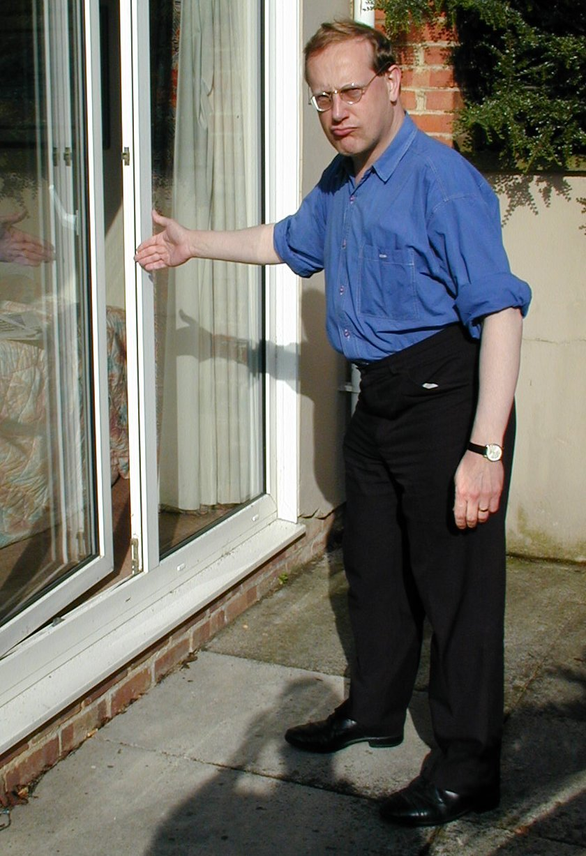
By Tim Table

Red-faced bosses at Pendulum Community Homes (PCH) who have presided over the Annylog Estate fiasco face the axe.

Angry Ministers intend to send in a Government hit squad to probe the blundering mismanagement of Annylog Estate since the hapless PCH took control in 2000. Mounting concern over a series of scandals that have rocked the high crime Annylog Estate since PCH took control triggered the Ministry probe in January 2002. Concerned local resident Jack Strap stormed “It’s been downhill all the way since those comedians at PCH took over”.

- The Estate suddenly needed £25 million of repairs that PCH will pass on to tenants in higher rents.
- The contractor PCH picked to do the repairs has gone bust, leaving 1,100 tenants living in uninhabitable half-finished properties. “The work that PCH have done is rubbish – windows and doors that won’t shut and plumbing that doesn’t work” fumed Independent Tenants Group Chairman Jack Strap. “Sorting out this mess will cost a fortune and add a further £5 a week onto rents for long-suffering tenants”.
- Annylog Estate’s StreetScene Community Improvement Programme is run by PCH – and has achieved nothing for local residents. All the money given to PCH has been wasted. Jack Strap angrily complained “They are only interested in rewarding young tearaways for making our life a misery. What about the silent long-suffering majority of older people on this estate? We pay our
Concerned tenant Jack Strap shows The Record the poor standard of repair work by PCH

taxes and sky high rents, and what do they do for us? Nothing.” The Minister is expected to pull the plug on StreetScene after the January 2002 inspection and spend its budget elsewhere. Worried tenants don’t see why they should suffer because of PCH’s blunders when there is so much that needs to be put right.
- Police are investigating the bankrupt PCH-run tenants association after reports of illegal loans to managers, tax fiddles and the use of public money to pay for personal spending by association bosses.
The Minister has the power to sack the PCH board. The Record says the sooner the better. Long-suffering Annylog tenants deserve better. Now.

Professional Examination 3 28 November 2001

FINANCE AND MANAGEMENT CASE STUDY

Time allowed - 3 hours From 2.00 p.m. to 5.00 p.m.

Candidates will be allowed five minutes reading time from 1.55 p.m. to 2.00 p.m.

All questions must be answered.

The case study has been prepared on the assumption that candidates will not necessarily have a detailed knowledge of the type of organisation to which it refers. No additional merit will be accorded those candidates displaying such knowledge.

The weightings for each question are indicated in the parentheses at the end of the question.

Candidates will be allowed to submit, as part of their script, work performed in the morning session, but they should distinguish clearly between work supporting their script and that which is to be considered a part of it.

NOTES TO CANDIDATE

(i) Answers to be prepared as on 28 November 2001 by G. Emtee, Accountant.
- The questions below are intended to test the candidate's understanding of the situation in the case.

QUESTIONS

- Prepare a set of accounts for the Annylog Tenants Association and a report to the ATA Management Committee on the issues arising, as required by the memorandum of 1 November 2001 from the Chief Finance Officer (page 4). (40%)
- Draft a report, with supporting papers, to the PCH Board of Directors analysing the options for the completion of the Annylog Estate Phase 1 renovation contract, as requested in the memorandum of 15 November 2001 from the Chief Finance Officer (page 15) as amended by instructions in the Chief Executive’s memorandum of 27 November 2001 (page 29). (25%)
- Draft a briefing note to the Chief Executive on behalf of the Chief Finance Officer on the progress of the multi-agency partnership StreetScene Project and the management and control issues arising as requested in the memorandum of 19 November 2001 from the Chief Finance Officer (page 18). (15%)
(Copyright)

