FINANCIAL ACCOUNTING

Certificate stage examination

8 June 2004

From 10.00 am to 1.00 pm
plus ten minutes reading time from 9.50 am to 10.00 am.

Instructions to candidates

Answer five questions in total. All three questions from Section A, and two of the three questions from Section B. There are 20 marks available for each question.

All workings should be shown. Where calculations are required using formulae, calculators may be used but steps in the workings must be shown. Calculations with no evidence of this (for example, using the scientific functions of calculators) will receive no credit. Programmable calculators are not permitted in the examination room.

Formula sheets, statistical tables, graph paper and cash analysis paper are available from the invigilator, where applicable.

Where a question asks for a specific format or style, such as a letter, report or layout of accounts, marks will be awarded for presentation and written communication.

Proforma profit and loss account, balance sheet, cash flow statement and statement of total recognised gains and losses are appended to this paper and may be submitted as part of an answer.
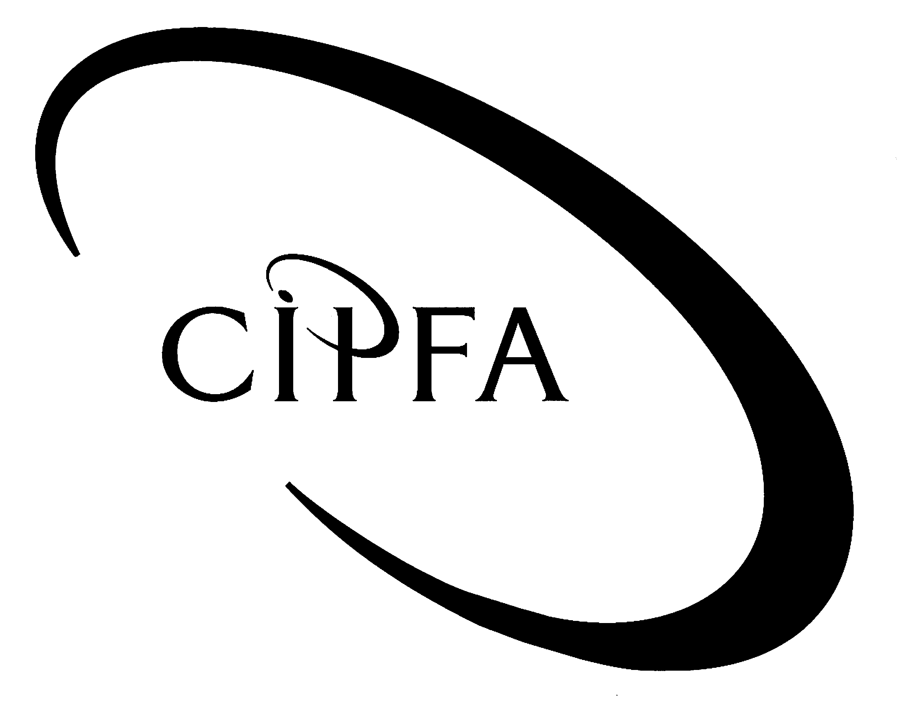

SECTION A (Answer all three questions)

1
Hazel is a sole trader. She runs a small shop (operating from rented premises) and prepares accounts to 31 October each year. Her business records consist solely of a cashbook in which she records amounts paid into and out of her business bank account. The following information relates to the year ended 31 October 2003:

1 Nearly all of Hazel's sales are to customers who pay her immediately, but some customers have an account with Hazel and pay her once a month.

2 Each week, Hazel uses part of her takings to pay certain business expenses and then banks most of the remainder. However, she retains a small amount of cash in her till. The expenses paid out of takings in the year to 31 October 2003 were as follows:

 | £
Wages to part-time sales assistant | 5,840
Hazel's own wages as shop manager | 13,000
Sundry expenses | 1,170

3 A summary of the cashbook for the year to 31 October 2003 is as follows:

 | £ |  | £
Bank balance at 1 November 2002 |  |  | 1,470
Add: Takings paid into bank | 80,710
Premium Bond prize paid in | 1,000 |  | 81,710
 |  |  | 83,180
Less: Cheques to suppliers | 61,890
Shop rent | 8,400
Business rates | 1,250
Insurance | 1,570
Electricity | 1,090
Sundry expenses | 880
Bank charges and interest | 340
New shop display cabinet | 3,600 |  | 79,020
Bank balance at 31 October 2003 |  |  | 4,160

4 The October bank statement shows a closing balance at 31 October 2003 of £5,380. Hazel has compared her cashbook with the statement and has prepared the following reconciliation:

 | £ |  | £
Bank balance per cashbook |  |  | 4,160
Add: Cheque payments shown in cashbook
but not yet shown on bank statement |  |  | 1,420
 |  |  | 5,580
Less: Items not recorded in cashbook:
Bank charges 25 October 2003 | 30
Dishonoured cheque 2 October 2003 | 170 |  | 200
Bank balance per bank statement |  |  | 5,380

5 Shop equipment is depreciated at 25% per annum on the straight line basis, with a full year's charge in the year of acquisition and no charge in the year of disposal. All of the shop equipment owned by Hazel at the start of the year to 31 October 2003 had been acquired in 1998 or earlier. One item of equipment was sold for scrap during the year. Hazel gave the proceeds of £50 to her son as a present.

6 Apart from the bank balance and the shop equipment, Hazel's only business assets and liabilities at the start and end of the year to 31 October 2003 were as follows:

 | 31 October 2002 | 31 October 2003
 | £ | £
Stock of goods at cost | 9,430 | 10,160
Amounts owed by customers | 610 | 550
Amounts owed to suppliers | 4,920 | 5,280
Cash float | 250 | 270
Accrued electricity charges | 210 | 180
Prepaid business rates | 400 | 490

The figure of £550 shown for amounts owed by customers at 31 October 2003 is before accounting for the dishonoured cheque of £170 (see Note 4 above). The customer concerned seems to be in financial difficulties and Hazel has decided to provide in full for this doubtful debt.

The stock figure of £10,160 at 31 October 2003 includes £120 for the cost of certain items of damaged stock. In their undamaged state, these items could have been sold for £175 but their expected sale value is now only £80.

7 During the year to 31 October 2003, Hazel took stock items costing £490 from the shop for her own use. She did not reimburse the shop for these goods.

- Requirement for question 1

(a) Prepare Hazel's trading, profit and loss account for the year to 31 October 2003. 11

(b) Prepare Hazel's balance sheet as at 31 October 2003. 9

(20)

In the Statement of Principles for Financial Reporting (published in 1999) the UK Accounting Standards Board (ASB) stated the main objective of preparing financial statements, identified the users of financial statements and explained the limitations of financial statements.
2

- Requirement for question 2

(a) State the purpose of the Statement of Principles and explain why the ASB felt that such a statement was necessary. 5

(b) State the main objective of preparing financial statements. 3

(c) Identify the main users of financial statements and indicate why each class of user might be interested in the information provided in financial statements. 9

(d) Explain the limitations of financial statements. 3

(20)

Hitesh is a sole trader who prepares accounts to 30 September each year. He uses a manual double-entry book-keeping system and maintains sales ledger and purchase ledger control accounts. The balance on the purchase ledger control account at 30 September 2003 was £24,791 (credit). However, the list of balances which was extracted from the purchase ledger on that date showed totals of £24,312 (credit balances) and £185 (debit balances).
3

On investigation, the following errors were found:

1 A batch of purchase invoices totalling £2,755 and received in early September 2003 had not been recorded in the books at all.

2 The credit side of a supplier's account in the purchase ledger had been overcast by £100.

3 The debit side of the purchase ledger control account had been undercast by £1,000.

4 A debit balance of £57 had been listed as a credit balance in the list of balances extracted from the purchase ledger.

5 A cheque to a supplier of £1,570 had been entered in the cashbook and supplier’s account as £1,750.

6 A discount of £231 received from a supplier had been entered on the wrong side of the supplier's account in the purchase ledger.

7 Contras amounting to £340 had been recorded correctly in the individual supplier accounts in the purchase ledger but had not been recorded at all in the purchase ledger control account.

Hitesh is now thinking of switching to a computer-based accounting system and he hopes that this will eliminate errors such as those listed above.

- Requirement for question 3

(a) State and briefly explain the principle of duality on which double-entry book-keeping systems are based. 2

(b) Prepare an amended purchase ledger control account and reconcile the balance on this account to the corrected total of the purchase ledger balances at 30 September 2003. 10

(c) If Hitesh transfers to a computer-based accounting system, will the types of errors that have occurred during the year to 30 September 2003 be eliminated? If not, why not? 4

(d) Briefly explain the advantages and disadvantages of computer-based accounting systems. 4

(20)

SECTION B (Answer two from three questions)

Hartington Ltd prepares accounts to 31 March each year. The company's balance sheets at 31 March 2003 and 2004 were as follows:
4

 | Balance sheet as at |  |  | Balance sheet as at
 | 31 March 2003 |  |  | 31 March 2004
 | £000 | £000 |  | £000 | £000
Tangible fixed assets:
Cost | 430 |  |  | 400
Depreciation to date | 160 | 270 |  | 175 | 225
Current assets:
Stocks | 175 |  |  | 140
Trade debtors | 250 |  |  | 210
Bank balance | - |  |  | 70
 | 425 |  |  | 420
Current liabilities:
Trade creditors | 80 |  |  | 70
Corporation tax | 75 |  |  | -
Proposed dividends | 50 |  |  | -
Bank balance | 130 |  |  | -
 | 335 |  |  | 70
Net current assets |  | 90 |  |  | 350
 |  | 360 |  |  | 575
10% debentures | 60 |  |  | 60
6% debentures | - | 60 |  | 100 | 160
 |  | 300 |  |  | 415
Capital and reserves:
Ordinary shares |  | 100 |  |  | 240
Share premium account |  | 20 |  |  | 45
General reserve |  | 140 |  |  | 100
Profit and loss account |  | 40 |  |  | 30
 |  | 300 |  |  | 415

The following information is also available:

1 Tangible fixed assets which had cost £100,000 in 1997 were sold for £30,000 during the year to 31 March 2004. The written down value of these assets at the time of disposal was £25,000.

2 The 10% debentures were issued in 1998. The 6% debentures were issued on 1 October 2003. In both cases, interest is due every six months on 31 March and 30 September and has been paid on the due dates.

3 Bank overdraft interest paid in the year to 31 March 2004 was £4,000.

4 No dividends were paid or proposed in relation to the year to 31 March 2004.

5 The corporation tax liability for the year to 31 March 2003 was underestimated by £2,000.

- Requirement for question 4

(a) Deduce the company’s operating profit or loss for the year to 31 March 2004. 4

(b) Prepare a cash flow statement for the company for the year to 31 March 2004 in accordance with the requirements of accounting standard FRS1 (Revised) using the indirect method. The reconciliation to movement in net debt is not required. 10

(c) Explain how and why the company's cash position has changed during the year to 31 March 2004. 4

(d) Briefly explain why the preparation of a cash flow statement is in accordance with the Statement of Principles for Financial Reporting published by the UK Accounting Standards Board. 2

(20)

The term "UK Generally Accepted Accounting Practice" (UK GAAP) is used to refer to accounting methods and treatments which are approved by those who regulate accounting in the UK and which have substantial support amongst preparers and users of financial statements. In particular, UK GAAP includes:
5

- accounting legislation, as embodied in the Companies Acts
- accounting standards
- accounting concepts (or conventions).

Some of the more important accounting concepts are enforced through company law or accounting standards. The ASB Statement of Principles also gives its approval to certain accounting concepts.

- Requirement for question 5

(a) Explain the purpose and the legal status of accounting standards. 3

(b) Identify the main bodies involved in the process of setting and monitoring accounting standards and outline the functions of each of these bodies. 7

(c) List FIVE of the most important accounting concepts and explain the way in which each concept influences financial accounting. Provide at least one example of the operation of each concept. 10

(20)

Henry (a retired man) has decided to invest his life savings in the ordinary shares of either ABC plc or XYZ plc. The two companies are broadly similar in size. They both operate in the same sector of industry and both prepare accounts to 31 December each year. Extracts from their financial statements for the year to 31 December 2003 are given below.
6

 | ABC plc | XYZ plc
 | £000 | £000
Profit and loss account items:
Turnover | 7,250 | 8,470
Cost of sales | 5,680 | 6,770
Operating profit | 1,020 | 1,050
Exceptional items | - | -
Interest receivable | - | -
Interest payable | 170 | 220
Taxation | 240 | 250
Dividends paid and proposed | - | 300
Balance sheet items:
Net book value of fixed assets | 5,270 | 6,440
Current assets:
Stock | 1,150 | 2,410
Trade debtors | 1,190 | 1,720
Bank balance | 30 | 10
Creditors due within one year:
Trade creditors | 940 | 1,690
Taxation | 240 | 250
Proposed dividends | - | 150
Creditors due after more than one year:
Long-term loans | 2,000 | 2,500

Henry has turned to you for advice on this important investment decision.

- Requirement for question 6

Write a report to Henry analysing the financial information given above and suggesting which of the two companies might be the better investment. In your report, be sure to stress any limitations to which your analysis is subject. Also indicate any further information which you would need to conduct a more comprehensive analysis. (20)

PROFORMA PROFIT AND LOSS ACCOUNT

Continuing acquisitions discontinued total
operations
£ £ £ £

Turnover

Cost of sales

Gross profit or loss

Distribution costs

Administration costs

Other operating income

Operating profit or loss

Exceptional items

Profit or loss on ordinary activities
before interest

Interest receivable

Interest payable

Profit or loss on ordinary activities before tax

Taxation

Profit or loss for the financial year

Dividends

Retained profit for the financial year

PROFORMA BALANCE SHEET

Fixed assets
intangible assets

tangible assets

investments

Current assets
stock
debtors
investments
cash at bank and in hand

Prepayments and accrued income

Creditors: amounts falling due within one year
trade creditors
tax
loans
dividends
other creditors
accruals and deferred income

NET CURRENT ASSETS

TOTAL ASSETS LESS CURRENT LIABILITIES

Creditors: amounts falling due after more than one year

Provisions for liabilities and charges

CAPITAL AND RESERVES
Called up share capital

Share premium account

Revaluation reserve

Other reserves

Retained profits
PROFORMA CASH FLOW STATEMENT

Net cash inflow from operating activities

Returns on investments and servicing of finance

Taxation

Capital expenditure

Equity dividends paid

Management of liquid resources

Financing

Increase in cash

PROFORMA STATEMENT OF TOTAL RECOGNISED GAINS AND LOSSES

Profit for the financial year

Revaluation reserve arising during the year

Exchange adjustments

TOTAL RECOGNISED GAINS AND LOSSES FOR THE FINANCIAL YEAR

Prior year adjustments

TOTAL GAINS AND LOSSES RECOGNISED SINCE LAST ANNUAL REPORT

