FINANCIAL ACCOUNTING

Foundation stage
December 2003

MARKING SCHEME

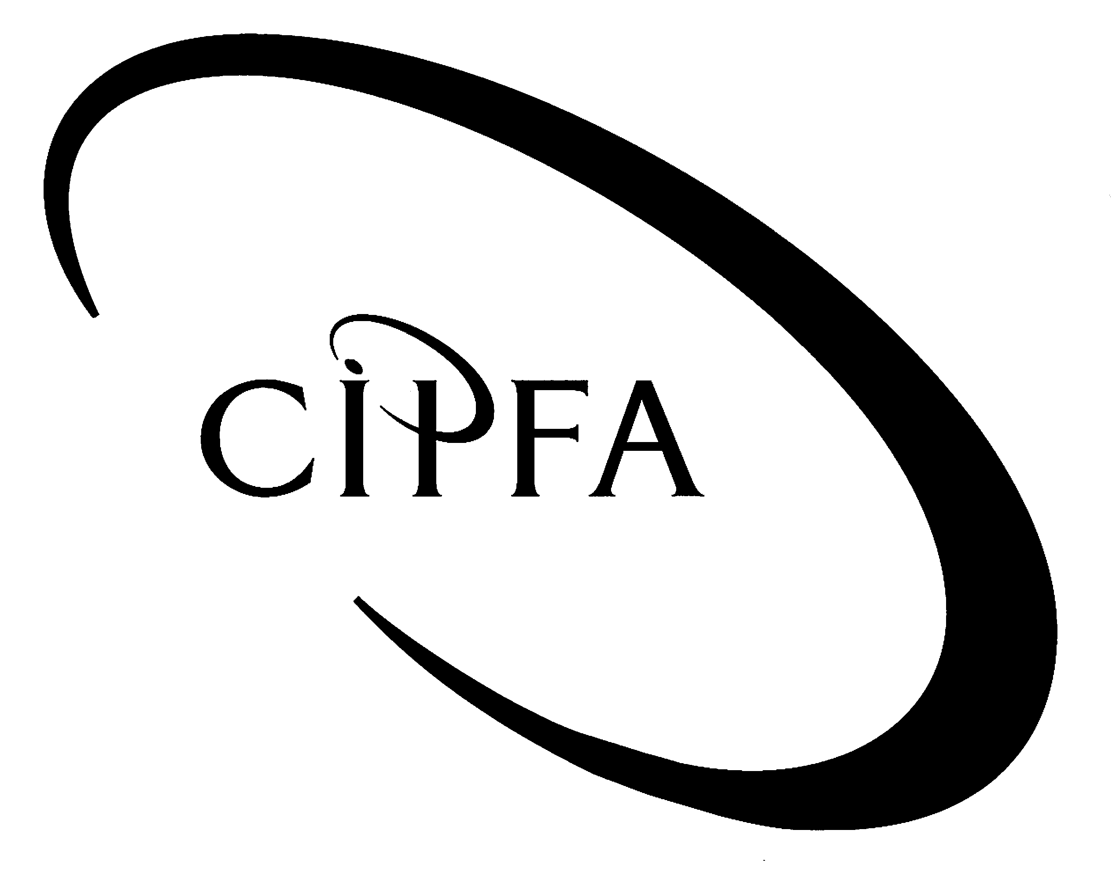

Question 1

(a)
Gamma Ltd

Profit and Loss Account for the year to 30 September 2003

 | Working | £ | £
Turnover |  |  | 942,490
Cost of sales (131,110 + 371,060 - 146,920) |  |  | 355,250 | ½
Gross profit |  |  | 587,240
Distribution costs | W1 | 174,710 |  | ½
Administrative expenses | W2 | 292,780 | 467,490 | 2
Operating profit |  |  | 119,750
Income from fixed asset investments |  |  | 1,250 | ½
 |  |  | 121,000
Interest payable (3,510 + 4,500 + 2,250) |  |  | 10,260 | 1
Profit before taxation |  |  | 110,740
Taxation |  |  | 32,000 | ½
Profit after taxation |  |  | 78,740
Transfer to reserves |  |  | 50,000 | ½
 |  |  | 28,740
Dividends paid and proposed | W3 |  | 27,000 | 1
Retained profit for the year |  |  | 1,740

Gamma Ltd
Balance Sheet as at 30 September 2003

 | Working | £ | £ | £
Fixed assets
Tangible assets
Land and buildings |  |  | 600,000 |  | ½
Motor vehicles | W4 |  | 27,440 |  | 1
Office equipment | W4 |  | 18,000 | 645,440 | 2
Investments |  |  |  | 40,000 | ½
 |  |  |  | 685,440
Current assets
Stock | W5 |  | 146,920 |  | 1
Debtors
Trade debtors | W6 | 116,130 |  |  | 1
Prepayments |  | 10,790 | 126,920 |  | ½
 |  |  | 273,840
Creditors due within one year
Trade creditors |  | 75,190 |  |  | ½
Bank overdraft |  | 25,160 |  |  | ½
Other creditors | W7 | 57,500 |  |  | 1
Accruals (30,050 + 2,250) |  | 32,300 | 190,150 |  | 1
Net current assets |  |  |  | 83,690
Total assets less current liabilities |  |  |  | 769,130

Creditors due after more than one year
Debenture loans |  |  |  | 180,000 | ½
 |  |  |  | 589,130
Capital and reserves
Called-up share capital | W8 |  |  | 170,000 | 1
Revaluation reserve (125,000 + 50,000) |  |  |  | 175,000 | 1
Other reserves | W9 |  |  | 192,000 | 1
Profit and loss account | W10 |  |  | 52,130 | ½
 |  |  |  | 589,130
 |  |  | Presentation 1
 |  |  |  |  | (21)
Workings

W1 Distribution costs | £
Per trial balance | 162,990
Motor vans depreciation (W4) | 11,720
 | 174,710

W2 Administrative expenses | £
Per trial balance | 171,270
Directors' fees | 100,000
Loss on disposal (W4) | 280
Office equipment depreciation (W4) | 12,000
Bad debts (6,400 + 3,230) | 9,630
Reduction in provision for doubtful debts (W6) | (400)
 | 292,780

W3 Dividends | £
Preference dividend paid | 1,500
Proposed preference dividend | 1,500
Proposed ordinary dividend:
12,000 shares @ £2 per share | 24,000
 | 27,000

W4 Fixed assets | £ | £
Motor vans at cost |  | 58,600
Depreciation to 30/9/02 | 19,440
Depreciation for year (20% x 58,600) | 11,720 | 31,160
Net book value |  | 27,440
Office equipment at cost (64,250 - 5,000) |  | 59,250
Depreciation to 30/9/02 | 33,170
Disposal (2,000 + 1,200 + 720) | 3,920
 | 29,250
Depreciation for year (40% x (59,250 - 29,250)) | 12,000 | 41,250
 |  | 18,000
Note: Loss on disposal is £280 (5,000 - 3,920 - £800)

W5 Stock | £
Closing stock at cost | 147,390
Less: Cost of damaged item | 7,950
 | 139,440
Add: NRV of damaged item | 7,480
 | 146,920

W6 Trade debtors | £
Per trial balance | 121,730
Further bad debts written off | 3,230
 | 118,500
Provision for doubtful debts (2%) | 2,370
 | 116,130
Note: Reduction in provision is £400

W7 Other creditors | £
Corporation tax | 32,000
Proposed dividends (1,500 + 24,000) | 25,500
 | 57,500

W8 Share capital | £
50,000 £1 preference shares | 50,000
12,000 £10 Ordinary shares | 120,000
(10,000 plus 2,000 bonus shares)
 | 170,000

W9 Other reserves | £
As at 1 October 2002 | 150,000
Used to fund bonus issue (20,000 - 12,000) | (8,000)
Transferred from profit and loss account | 50,000
 | 192,000

W10 Profit and loss account | £
Per trial balance | 50,390
Retained profit for the year | 1,740
 | 52,130

(b) Preference shares

- Preference shareholders are entitled to a fixed rate of dividend each year, before any dividends are paid to the ordinary shareholders. The dividend rate is generally expressed as a percentage of the nominal value of the shares concerned (eg 6% in the case of Gamma Ltd).

- Preference shares may be "cumulative" or "non-cumulative". If the company cannot pay the preference dividend in a given year, the holders of cumulative preference shares are entitled to receive the arrears out of future years' profits, before any dividends are paid to the ordinary shareholders. The holders of non-cumulative preference shares are not entitled to receive arrears of dividends.

- Preference shareholders cannot usually vote at shareholders' meetings.

- When a company is wound up, preference shareholders are usually entitled to repayment of their share capital in priority to ordinary shareholders.

- In most cases, preference shareholders are not entitled to any of the company's profits apart from their fixed dividend. Nor are they entitled to any of the company's assets when the company is wound up, apart from the amount required to repay the nominal value of their shares. 2

Ordinary shares (also known as "equities")

- Ordinary shareholders own the remainder of the company's profits after any preference dividend has been paid. The rate of dividend paid to ordinary shareholders may vary from year to year.

- Ordinary shareholders rarely receive a dividend sufficient to absorb the entire profits of the company (less any preference dividend). Companies usually retain part of their profits each year and pay out only a portion of the profits in the form of dividends. Retained profits can be used to finance expansion of a company's business.

- Ordinary shareholders are entitled to vote at shareholders' meetings.

- When a company is wound up, the ordinary shareholders are entitled to the whole of the company's assets, after all of the liabilities and the preference shares (if any) have been repaid. 2

(4)

(25)

Question 2

(a)
Journal
 |  | £ | £
1 | No entries required |  |  | 1
2 | Suspense account | 9
 | Creditors |  | 9 | 1
3 | Sales | 1,000
 | SL Control |  | 1,000 | 1
4 | Suspense account | 350
 | Rent payable |  | 350 | 1
5 | Suspense account | 106
 | Interest payable |  | 53
 | Interest receivable |  | 53 | 1
6 | Bank charges | 118
 | Suspense account |  | 118 | 1
7 | Wages | 800
 | Drawings |  | 800
 | Drawings | 200
 | Suspense account |  | 200 | 1
8 | No entries required |  |  | 1
9 | Provision for doubtful debts:  £252 - 3% x £7,000 | 42
 | P & L account (reduction in provision) |  | 42 | 1
10 | Suspense account | 50
 | Purchases |  | 50 | 1
11 | Creditors | 90
 | Suspense account |  | 90 | 1
12 | Creditors | 310
 | Purchase returns |  | 310 | 1
 |  |  |  | (12)

Note: No entries are required for errors 1 and 8, because the errors are in individual customer accounts which are held as memorandum records only.

(b)
Suspense account
£ |  | £
 |  | Balance b/d (derived) 107 |  | 1
Creditors (2) 9 |  |  |  | ½
Rent payable (4) 350 |  |  |  | ½
Interest payable (5) 53 |  |  |  | ½
Interest receivable (5) 53 |  |  |  | ½
 |  | Bank charges (6) 118 |  | ½
 |  | Drawings (7) 200 |  | ½
Purchases (10) 50 |  |  |  | ½
 |  | Creditors (11) 90 |  | ½
 | 515 |  | 515

(5)

(c)
Sales ledger control account
£ |  | £
Balance b/d (derived) 8,000 |  |  |  | 1
 |  | Sales (3) 1,000 |  | ½
 |  | Balance c/d 7,000 |  | ½
 | 8,000 |  | 8,000
Balance b/d | 7,000

 | £ | £
Total balances per list |  | 7,370
Less:
Posting error (1) | 270 |  | ½
Casting error (8) | 100 | 370 | ½
 |  | 7,000
(3)

(20)

Question 3

(a) The depreciation policy amounts to 18% per annum on cost (1.5% per month).

The depreciation charge for the year to 30 November 2003 is £9,480, made up as follows:

 | Months owned in the year | Workings | £
Vehicle A | 2 | £7,200 x 2 x 1.5% | 216
Vehicle B | 10 | £10,000 x 10 x 1.5% | 1,500
Vehicle C | 12 | £9,800 x 12 x 1.5% | 1,764
Vehicle D | 12 | £16,000 x 12 x 1.5% | 2,880
Vehicle E | 10 | £17,500 x 10 x 1.5% | 2,625
Vehicle F | 2 | £16,500 x 2 x 1.5% | 495
 |  |  | 9,480
(3)

(b)
Motor vehicles at cost
£ |  | £
Balance b/d 43,000 |  |  |  | ½
Bank 16,000 |  |  |  | ½
Disposal a/c (part-ex.) 1,500 |  |  |  | ½
 |  | Disposal a/c (Vehicle A) 7,200 |  | ½
Bank 12,000 |  |  |  | ½
Disposal a/c (part-ex.) 4,500 |  |  |  | ½
 |  | Disposal a/c (Vehicle B) 10,000 |  | ½
 |  | Balance c/d 59,800
 | 77,000 |  | 77,000
Balance b/d | 59,800

Provision for depreciation of motor vehicles
£ |  | £
 |  | Balance b/d:
 |  | A £7,200 x 45 x 1.5% 4,860 |  | ½
 |  | B £10,000 x 31 x 1.5% 4,650 |  | ½
 |  | C £9,800 x 15 x 1.5% 2,205 |  | ½
 |  | D £16,000 x 5 x 1.5% 1,200 |  | ½
 |  |  | 12,915
Disposal a/c (Vehicle A) 5,076 |  |  |  | 1½
Disposal a/c (Vehicle B) 6,150 |  |  |  | 1½
 |  | Profit and loss a/c 9,480 |  | ½
Balance c/d 11,169
 | 22,395 |  | 22,395
 |  | Balance b/d | 11,169

Disposal of motor vehicles
£ |  | £
Motor vehicles (A) 7,200 |  |  |  | ½
 |  | Provision for dep'n (A) 5,076 |  | ½
 |  | Motor vehicles (part-ex.) 1,500 |  | ½
 |  | P & L (loss on disposal) 624 |  | ½
Motor vehicles (B) 10,000 |  |  |  | ½
 |  | Provision for dep'n (B) 6,150 |  | ½
 |  | Motor vehicles (part-ex.) 4,500 |  | ½
P & L (profit on disposal) 650 |  |  |  | ½
 | 17,850 |  | 17,850

(13)

Notes:

(i) Vehicle A was owned for 47 months and therefore suffered depreciation of 70.5% (47 x 1.5%) of £7,200 = £5,076.

(ii) Vehicle B was owned for 41 months and therefore suffered depreciation of 61.5% (41 x 1.5%) of £10,000 = £6,150.

(c) FRS15 defines depreciation for an accounting period as "the measure of the cost or revalued amount of the economic benefits of a tangible fixed asset that have been consumed during the period". Consumption includes the wearing out, using up or other reduction in the useful economic life of an asset whether arising from use, effluxion of time or obsolescence. 2

The main purpose of charging depreciation is spread the net cost of a fixed asset over the accounting periods in which the asset is used. This accords with the matching (or accruals) convention which requires that the revenue for an accounting period should be matched against all of the expenses incurred so as to earn that revenue. 2

(4)

(20)

Question 4

(a) Dividend yield = x 100%

For Greenacre Ltd, the dividend yield is 11p/220p x 100 = 5%.

Dividend yield expresses the dividend per ordinary share as a percentage of the market price per ordinary share and therefore acts as an indicator of the cash return received on the investment made by an ordinary shareholder. A low dividend yield might deter an investor who views the shares primarily as a source of income. 2

Earnings per share (EPS) = x 100p

For Greenacre Ltd, EPS is (£234,000 - £24,000)/1,200,000 x 100 = 17.5p per share.

EPS is the amount of profit (in pence) which has been earned for each ordinary share and is a prime measure of financial performance. It is the subject of accounting standard FRS14. 2

Dividend cover =

For Greenacre Ltd, dividend cover is (£234,000 - £24,000)/£132,000 = 1.6.

Dividend cover measures the number of times that the ordinary dividend for a year could have been paid out of the after-tax profits. A high dividend cover indicates that profits are more than adequate to fund the dividends paid. A low dividend cover might indicate that the company is having difficulty in maintaining an acceptable level of dividend. 2

Price earnings ratio =

For Greenacre Ltd, the P/E ratio is 220p/17.5p x 100 = 12.6.

The P/E ratio compares EPS with the market price of an ordinary share and calculates the number of years which it would take to recover the market price paid for a share if earnings continued at the present rate. A high P/E ratio is usually regarded as a favourable indication of investors' expectations of the company's future financial performance. 2

(8)

(b) If profit after tax increased by 20% (to £280,800) in the year to 31 October 2004, the earnings per share figure would become:

(£280,800 - £24,000)/1,200,000 x 100 = 21.4p per share. 1

This is an increase of 3.9p per share when compared with the previous year and a percentage increase of approximately 22.3% (3.9p/17.5p x 100). 1

It is noteworthy that the percentage rise in EPS is greater than the percentage rise in profit after tax. The reason for this phenomenon is that the preference dividend is fixed regardless of fluctuations in profit (unless there are insufficient profits to pay the preference dividend) so that a rise or fall in profit induces a disproportionately large rise or fall in EPS. 1

The difference between the percentage change in profit after tax (20%) and the percentage change in EPS (22.3%) is not high in this case, but the difference would be greater if the company's profits were lower. For instance, a profit after tax of £48,000 gives an EPS figure of 2p per share, whereas a profit after tax of £24,000 (50% less) gives an EPS of zero (100% less). 1

In general, the extent to which EPS will be disproportionately affected by profit fluctuations can be determined by examining a company's gearing. The effect is more pronounced in high-geared companies, which are a riskier investment for ordinary shareholders than low-geared companies. In the case of Greenacre Ltd, the ratio of preference share capital to total share capital (a form of gearing ratio) is one-third which is not especially high. 2

(6)

(c) The main limitations of ratio analysis include:

- the lack of standard definitions for some ratios, hindering comparability

- the use of balance sheet figures which may be unrepresentative, resulting in distorted and misleading ratios

- the use of historical cost figures which may be very different from current values, again resulting in distorted or misleading ratios

- the decision as to what constitutes a satisfactory ratio requires judgment and varies from industry to industry

- the impact of accounting policies on a company's figures, making it difficult to compare ratios between companies which adopt different policies

- susceptibility to misinterpretation (eg an increasing debtor collection period may be attributed to poor credit control when, in fact, the company has deliberately offered longer credit to customers)

- the fact that financial statements are often highly summarised, making it impossible to perform a very detailed analysis

- in the case of an analysis for a single company for a single year, the impossibility of detecting trends or of making comparisons with industry average figures.

1 mark for each valid point, up to a maximum of (6)

(20)

Question 5

- The main requirements of the Companies Acts 1985 and 1989 in relation to the financial statements of limited companies are as follows:

- The directors of the company are responsible for the preparation of the company's accounts. These accounts must give a true and fair view of the company's results for the period covered by the accounts and of the financial position of the company at the end of that period. 1

- The accounts must be in an approved format and must comply with certain minimum disclosure requirements. They must also be prepared in accordance with four specific accounting concepts (going concern, consistency, matching and prudence). 1

- However, any of the rules relating to format, content and accounting concepts may be over-ridden if compliance with these rules would prevent the accounts from showing a true and fair view. 1

- For companies with a turnover exceeding £1 million per annum, the accounts must be audited by an independent, qualified person. 1

- Each shareholder and each debenture-holder is entitled to receive a copy of the audited accounts and a copy must be laid before a general meeting of the company's members. The accounts must include:

- a profit and loss account for the accounting period
- a balance sheet as at the end of the accounting period
- a set of notes to the accounts, providing information which is required by statute but which is not shown in the profit and loss account or on the balance sheet.

The accounts must be accompanied by a directors' report and by the report of the auditors. 3

- When the members have adopted the accounts in a general meeting, a copy must be filed with the Registrar of Companies and thus made available for public inspection. Small and medium-sized companies are allowed to omit certain information from the copy of the accounts which is filed with the Registrar. 1

(8)

(b) Accounting standards (now known as Financial Reporting Standards) are devised by the Accounting Standards Board. When a new standard is first being considered, a document known as a Discussion Draft (DD) may be circulated to interested parties to elicit preliminary views on the matter concerned. A Financial Reporting Exposure Draft (FRED) may then be circulated for further consultation before the FRS finally emerges. 2

The accounting standards are not enshrined in statute law. However, the Companies Acts require public companies and large private companies to state in their accounts whether or not accounting standards have been complied with and to explain any material departures. Furthermore, the Financial Reporting Review Panel may seek a court order requiring accounts to be revised if they do not comply with the standards. Courts generally take the view that company accounts cannot show a true and fair view unless accounting standards are complied with and so will make the order. In effect, therefore, accounting standards have a quasi-legal impact on company accounts. 2

(4)

(c) The Statement of Principles was devised because previously there was no coherent set of principles providing a firm theoretical foundation for financial accounting. The main intention of the Statement of Principles is to offer:

- a coherent frame of reference (including a set of definitions) to be used by the ASB in the development and review of its accounting standards

- assistance to preparers and auditors analysing new or emerging issues in the absence of applicable accounting standards

- a useful contribution to the development of financial accounting, ensuring that the subject develops in a logical, consistent way.

(3)

(15)

Question 6

(a) The main function of accounting is to provide economic information which helps the users of that information to make better economic decisions. This involves the following activities:

- collecting, measuring and recording economic data relating to an organisation (this is referred to as book-keeping)

- processing this data so as to produce useful economic information which meets users' needs

- communicating this information to users and (if necessary) interpreting or analysing the information and explaining its meaning.
(2)

(b) A financial accountant is concerned with the provision of useful information to owners, investors and to other external users (eg lenders, the tax authorities). This information takes the form of a set of financial statements, usually prepared annually, comprising a profit and loss account (reporting financial performance) and a balance sheet (reporting financial position). These basic statements may be supplemented by other financial statements (eg a cash flow statement). The information produced by financial accountants is generally historical in nature. 2

A management accountant is concerned with the provision of useful information to the managers of an organisation, helping them in their management role. This information is more detailed than that provided to external users and is prepared on a continual basis. An example might be a monthly report, analysing costs incurred and comparing actual costs with budgeted costs. The information will sometimes consist of projections and forecasts. 1

The role of an external auditor is to carry out an independent review of the financial statements of an organisation and to report on the extent to which the statements provide a true and fair view of the organisation's financial performance and financial position. This role occurs mainly in connection with limited companies, where there is often a separation between the owners of the business (the shareholders) and day-to-day control of the business (by the directors). In these circumstances, the shareholders rely very heavily on financial statements for information about the company's financial affairs and it is vital that these statements do indeed give a true and fair view. 2

The role of a financial manager is less easy to define and the term may be used to cover a wide variety of activities which are in some way concerned with the management of the finances of an organisation. Typically, a financial manager will try to ensure that a business obtains sufficient financial resources to meet its needs, that these resources are obtained as cheaply as possible and that any spare financial resources are invested as lucratively as possible. 1

(6)

(c) According to the ASB Statement of Principles for Financial Reporting, the main users of the information produced by financial accountants are:

- investors
- lenders
- suppliers and other trade creditors
- employees
- customers
- governments and their agencies
- the public.
(½ mark for each + ½ mark for explanation 7)

(15)

