FINANCIAL ACCOUNTING

June 2005
Certificate Stage

MARKING SCHEME

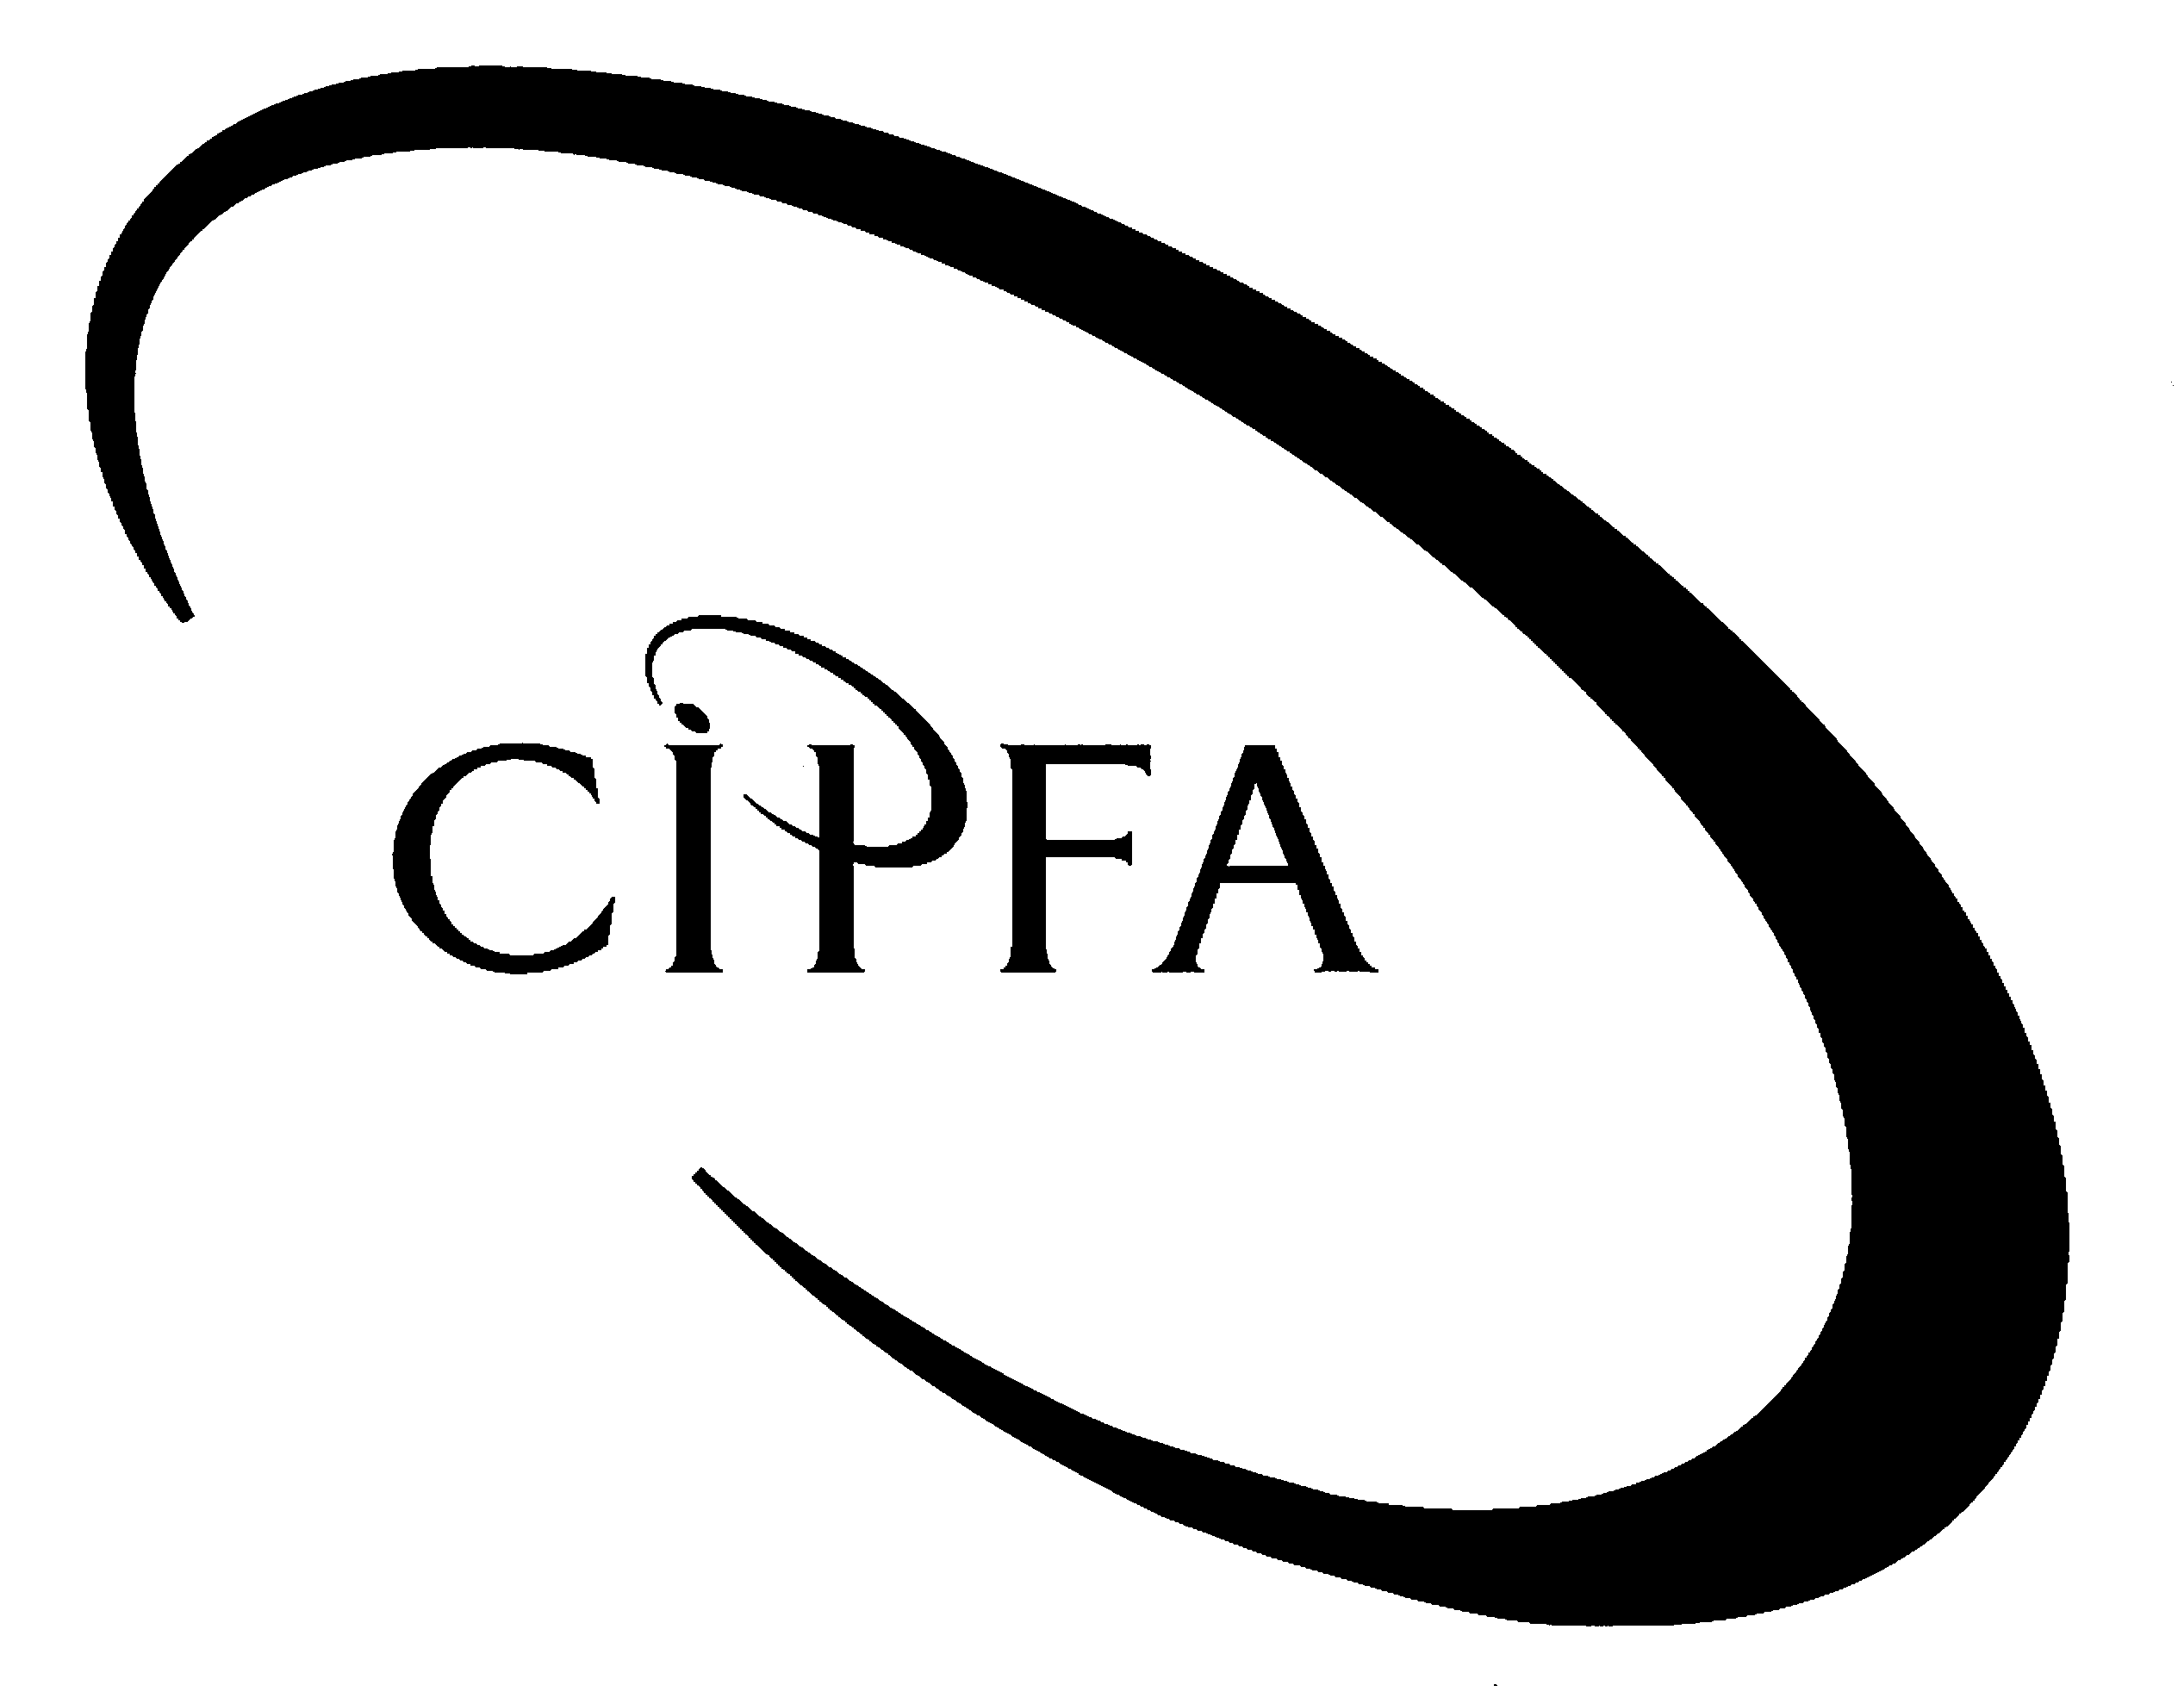

Question 1

(a)
Subscriptions account
£ |  | £
 |  | Subs in advance b/d 210 |  | ½
 |  | Receipts & Payments a/c 9,060
Income & Expenditure a/c 8,610 |  |  |  | ½
Subs in advance c/d 660 |  |  |  | ½
 | 9,270 |  | 9,270
 |  | Subs in advance b/d | 660

Life membership fees account
£ |  | £
 |  | Balances b/d
 |  | £250 x 3 750
 |  | £300 x 1 300 |  | ½
 |  | Receipts & Payments a/c 700
Income & Expenditure a/c
£50 x 6 300 |  |  |  | ½
Balances c/d
£200 x 3 600
£250 x 1 250
£300 x 2 600 |  |  |  | ½
 | 1,750 |  | 1,750
 |  | Balances b/d | 1,450
(3)
(b)

Bar trading account

Year to 31 March 2005

 | £ |  | £
Sales |  |  | 37,336 | ½
Less: Cost of sales
Stock at 1 April 2004 | 2,190
Purchases (£28,835 – £1,927 + £3,644) | 30,552
 | 32,742
Stock at 31 March 2005 | 2,370 |  | 30,372 | 1
Gross profit |  |  | 6,964

Racquets and balls trading account

Year to 31 March 2005

 | £ |  | £
Sales (£3,940 - £80 + £140) |  |  | 4,000 | ½
Less: Cost of sales
Stock at 1 April 2004 | 745
Purchases (£3,350 – £430 + £225) | 3,145
 | 3,890
Stock at 31 March 2005 | 638 |  | 3,252 | 1
Gross profit |  |  | 748
(3)
(c) Middleton Squash Racquets Club

Income and expenditure account

Year to 31 March 2005

 | £ |  | £
Income
Subscriptions |  |  | 8,610 | ½
Life membership fees |  |  | 300 | ½
Gross profit on bar |  |  | 6,964 | ½
Gross profit on sale of racquets and balls |  |  | 748 | ½
Bank interest received (£111 + £9) |  |  | 120 | ½
 |  |  | 16,742
Expenditure
Bar staff wages | 6,349
Cleaners' wages | 3,120
Repairs and maintenance | 2,985
Heat, light & power (£1,608 - £300 + £330) | 1,638 |  |  | ½
Insurance (£780 - £585 + £558) | 753 |  |  | ½
Postage, stationery & sundries | 1,851
Fee to National Association | 200
Charitable donations | 1,800
Loss on Xmas raffle (£875 - £735) | 140 |  |  | ½
Loss on tournament trips (£710 - £610) | 100 |  |  | ½
Treasurer's honorarium | 200
Depreciation (£480 x 25%) | 120 |  |  | ½
Bank charges (£151 + £17) | 168 |  | 19,424 | ½
Excess of expenditure over income |  |  | 2,682

Balance sheet as at 31 March 2005
 | £ |  | £ |  | £
Fixed assets
Land and buildings at cost |  |  |  |  | 18,000 | ½
Restringing machine at cost |  |  | 480
Less: Depreciation to date |  |  | 120 |  | 360 | ½
 |  |  |  |  | 18,360
Current assets
Bar stock |  |  | 2,370
Stock of racquets and balls |  |  | 638
Debtors |  |  | 140
Prepayments |  |  | 585 |  |  | ½
Cash at bank (£253 + £9 - £17) |  |  | 245 |  |  | 1
Cash in hand |  |  | 143
 |  |  | 4,121
Current liabilities
Subscriptions in advance | 660 |  |  |  |  | ½
Creditors (£3,644 + £225) | 3,869 |  |  |  |  | ½
Accruals | 330 |  | 4,859 |  | (738)
 |  |  |  |  | 17,622
Long term liabilities
Life membership fees |  |  |  |  | (1,450) | ½
 |  |  |  |  | 16,172
Accumulated fund
As at 1 April 2004 (Working W1) |  |  |  |  | 18,854 | 1
Less: Excess of expenditure over income |  |  |  |  | 2,682 | ½
 |  |  |  |  | 16,172
(11)
(d) A receipts and payments account is prepared on a cash basis. No attempt is made to account for the (possibly significant) effects of opening and closing stocks, debtors, creditors, accruals or prepayments. Furthermore, non-cash items such as the depreciation of fixed assets are ignored. An income and expenditure account incorporates all of these factors and so provides a more meaningful guide to a club's financial performance. 1

Also, the only assets (or liabilities) shown in a receipts and payments account are cash and bank balances. A balance sheet lists all assets and liabilities and so provides a more meaningful guide to the club's financial position. 1

The squash club balance sheet shows land and buildings at historical cost. This figure is reliable but may not be very relevant to the users of the balance sheet. For instance, the club’s bank would be more interested in the market value of the land and buildings if these were offered as security for a loan. 1
(3)

(20)

Workings

W1 Opening accumulated fund | Assets |  | Liabilities
 | £ |  | £
Land and buildings | 18,000
Bar stock | 2,190
Brewery creditor |  |  | 1,927
Stock of racquets and balls | 745
Racquets and balls creditor |  |  | 430
Accruals |  |  | 300
Debtors | 80
Prepayments | 558
Subscriptions in advance |  |  | 210
Life membership fees |  |  | 1,050
Cash and bank balances | 1,198
 | 22,771 |  | 3,917
 | 3,917
 | 18,854

Question 2

(a)
Journal
 |  | £ | £
1 | Sales returns | 123
 | Sales | 123
 | Trade debtors |  | 246 | 1
2 | Bank charges | 19
 | Suspense account |  | 19 | 1
3 | Sales | 3,000
 | Capital |  | 3,000 | 1
4 | Motor vans | 8,560
 | Motor expenses |  | 8,560
 | Depreciation (£8,560 x 15% x 3/12) | 321
 | Provision for depreciation |  | 321 | 1
5 | Suspense account | 1,000
 | Purchases |  | 1,000 | 1
6 | Trade creditors | 34
 | Suspense account |  | 34 | 1
7 | Rent payable | 200
 | Suspense account |  | 200 | 1
8 | Trade debtors | 275
 | Sales |  | 275 | 1
9 | Sales returns | 520
 | Purchase returns | 520
 | Suspense account |  | 1,040 | 1
10 | Suspense account | 100
 | Trade debtors |  | 100 | 1

Suspense account
£ |  | £
Balance b/d 193
 |  | Bank charges (2) 19
Purchases (5) 1,000
 |  | Trade creditors (6) 34
 |  | Rent payable (7) 200
 |  | Sales returns (9) 520
 |  | Purchase returns (9) 520
Trade debtors (10) 100 |  |  |  |  | 2
 | 1,293 |  | 1,293
(12)

(b)
Statement of corrected net profit
 | £ |  | £
Net loss per draft accounts |  |  | 1,412
Add:
Increase in sales returns (1) |  |  | 123 | ½
Decrease in sales (1) |  |  | 123 | ½
Increase in bank charges (2) |  |  | 19 | ½
Decrease in sales (3) |  |  | 3,000 | ½
Increase in depreciation (4) |  |  | 321 | ½
Increase in rent payable (7) |  |  | 200 | ½
Increase in sales returns (9) |  |  | 520 | ½
Decrease in purchase returns (9) |  |  | 520 | ½
 |  |  | 6,238
Less:
Decrease in motor expenses (4) | 8,560 |  |  | ½
Decrease in purchases (5) | 1,000 |  |  | ½
Increase in sales (8) | 275 |  |  | ½
Suspense account removed from expenses | 193 |  | 10,028 | ½
Corrected net profit |  |  | 3,790
(6)

(c) The debit balance on the suspense account had to be included somewhere in the draft accounts (otherwise the draft balance sheet would not have balanced). The £193 could have been treated as an expense in the profit and loss account or as an asset in the balance sheet. Treating the £193 as an expense was the more prudent approach and reduced the danger that the draft accounts would overstate both profits and assets.
(2)

(20)

Question 3

(a)
Malham Ltd
Cash flow statement for the year to 31 December 2004

Reconciliation of operating profit to net cash  inflow from operating activities | Working | £000
Operating profit | W1 | 50 | 3
Depreciation charge | W2 | 105 | 1
Loss on disposal of tangible fixed assets (35 - 24) |  | 11 | 1
Loss on disposal of FA investments |  | 7 | ½
Increase in stocks (330 - 220) |  | (110) | ½
Increase in trade debtors (285 - 175) |  | (110) | ½
Decrease in prepayments |  | 5 | ½
Increase in trade creditors (121 - 110) |  | 11 | ½
Increase in accruals ((9 - deb. interest 3) - 5) |  | 1 | 1
Net cash outflow from operating activities |  | (30)

 | Working | £000 | £000

Cash flow statement
Net cash outflow from operating activities |  |  | (30) | ½
Returns on investments and servicing of finance
Dividends received |  | 1
Interest paid |  | (4) | (3) | ½
Taxation (85 - 5) |  |  | (80) | ½
Capital expenditure
Purchase of tangible fixed assets | W2 | (225) |  | 1
Sale of tangible fixed assets |  | 24 |  | ½
Sale of fixed asset investments |  | 23 | (178) | ½
Equity dividends paid (50 + 9) |  |  | (59) | ½
Management of liquid resources
Cash withdrawn from 7-day deposit |  |  | 20 | ½
 |  |  | (330)
Financing
Issue of ordinary share capital (225 - 150) |  | 75 |  | ½
Issue of debentures |  | 50 | 125 | ½
Decrease in cash during the year (75 + 130) |  |  | (205)
(14)

Workings

W1 Operating profit | £000
Operating profit (deduced) | 50
Income from FA investments | 1
Interest payable (4 + 3) | (7)
Profit before taxation | 44
Taxation (17 - 5) | 12
Profit for the financial year | 32
Dividends (9 + 18) | 27
Retained profit for the year | 5
Retained profit brought forward | 275
Retained profit carried forward | 280

W2 Tangible fixed assets | £000
Cost or valuation at 31/12/03 | 570
Revaluation surplus | 70
Cost of disposals | (80)
 | 560
Acquisitions year to 31/12/04 (derived figure) | 225
Cost or valuation at 31/12/04 | 785
Accumulated depreciation at 31/12/03 | 345
Depreciation on disposals | (45)
 | 300
Depreciation year to 31/12/04 (derived figure) | 105
Accumulated depreciation at 31/12/04 | 405

(b)
 |  | 2003
Current ratio | 500 ÷250 | 2.00 | ½
Acid test ratio | (500 – 220) ÷ 250 | 1.12 | ½
 |  | 2004
Current ratio | 620 ÷ 295 | 2.10 | ½
Acid test ratio | (620 – 330) ÷ 295 | 0.98 | ½
 |  |  | (2)

(c) The profit and loss account is not intended to focus on a company's cash movements. Profit is computed in accordance with a number of accounting concepts (or conventions) and the profit may bear no resemblance to the change in the company's cash reserves. Two concepts are especially relevant:

(a) The realisation concept allows revenue to be shown in the profit and loss account before that revenue is actually received. For example, if an increase in turnover is achieved by offering customers extended credit terms, the amount of cash collected from customers during an accounting period may fall well short of the turnover shown in the profit and loss account for that period. 1

(b) The matching (or accruals) concept states that expenses should be matched against the revenues to which they relate, regardless of the dates on which the expenses are actually paid. Consequently, an expense may be paid in one accounting period but not appear in the profit and loss account until a future period. Such timing differences are particularly significant in the case of capital expenditure, which is usually transferred to the profit and loss account by instalments (in the form of depreciation charges) over several years. 1

Also, the calculation of a company's profit does not take into account any appropriations of that profit. Substantial payments of taxation and/or dividends will therefore drain the cash resources of the company without affecting its reported profit in any way. 1

Similarly, a balance sheet suffers from a number of shortcomings which prevent it from providing a comprehensive analysis of the company's cash position. These include:

(a) A balance sheet shows only a snapshot of the financial position at the end of an accounting period. The cash resources existing on the balance sheet date may not be typical of the accounting period as a whole and may provide a misleading indication of the likely extent of those resources in the future.

(b) A balance sheet does not give information on the sources of cash or the uses of cash during the accounting period. This is the information which is provided by a cash flow statement. 1
(4)

(20)

Question 4

(a) The main legal requirements which must be complied with when producing the financial statements of limited companies are as follows:

- The financial statements must give a true and fair view of the company's results for the period concerned. They must also give a true and fair view of the company's financial position at the end of that period. 1

- The financial statements must be in one of a number of approved formats and must comply with certain disclosure requirements. They must be prepared in accordance with four stated accounting concepts (going concern, consistency, matching and prudence). 2

- The rules relating to format, disclosure and accounting concepts may be over-ridden if compliance with these rules would prevent the financial statements from showing a true and fair view. 1

- For companies with an annual turnover exceeding £5.6 million, the financial statements must be audited by an independent, qualified person. In practice, a firm of professional accountants will usually act as auditors. 1

- The financial statements must include:
- a profit and loss account
- a balance sheet
- a set of accompanying notes.

- There must also be a directors' report and (where relevant) an audit report. 2

- Each shareholder must receive a copy of the financial statements. A copy must also be filed with the Registrar of Companies but small and medium-sized companies are allowed to file abbreviated financial statements. 1
(8)

(b) The purpose of accounting standards is to provide guidance as to how companies should treat certain items in their financial statements. Some standards are prescriptive, requiring all companies to adopt a specified accounting treatment. Others provide a range of acceptable treatments and require companies to disclose the chosen approach. In effect, accounting standards are an attempt to bring uniformity to financial accounting, so that comparability is improved and the deliberate distortion of financial information becomes much more difficult. (3)

(c) As stated above, the Companies Acts require that the financial statements of limited companies are prepared in accordance with four stated concepts (going concern, consistency, matching and prudence).

The Accounting Standards Board has also given its support to some of the accounting concepts in its accounting standards, especially in FRS18 (Accounting policies). This standard states that the going concern concept and the accruals (or matching) concept both play a “pervasive role” in financial statements and in the selection of accounting policies. (2)

(d) The main features of the Statement of Principles include:

- a specification of the objective of financial statements ("to provide information about the reporting entity's financial performance and financial position that is useful to a wide range of users for assessing the stewardship of management and for making economic decisions") 2

- a list of the qualitative characteristics which should be possessed by financial information (materiality, relevance, reliability, comparability, understandability) 1

- a list of the elements of which financial statements should be composed (eg assets, liabilities, gains, losses) and a definition of each element 1

- a statement of the criteria for recognising elements in the financial statements 1

- guidance on the selection of a measurement basis for each category of asset and liability shown in the financial statements 1

- a specification of the way in which information should be presented in financial statements (in the form of a set of inter-related reports which include the profit and loss account, statement of total gains and losses, balance sheet and cash flow statement). 1
(7)

(20)

Question 5

(a) Accounting standard SSAP9 states that stock should be valued at the lower of cost and net realisable value. The cost of a stock item comprises all of the expenditure incurred so as to bring the item to its present location and condition, including: 1

- the cost of buying or manufacturing the item ½

- any further costs incurred in moving the item to its current location ½

- the cost of any work done on the item since it was acquired. ½

The net realisable value of a stock item consists of:

- the estimated selling price of the item, less ½

- any further costs which must be incurred before the item is sold, less ½

- any expected selling expenses. ½

(4)

(b) SSAP9 requires that the cost and net realisable value (NRV) of each stock item should be considered separately if possible. However, it is permissible to group items if it would be impracticable to deal with them on an individual basis (which is not the case for the machines described in this question). 1

It is not permissible to value stock at the lower of total cost and total NRV. Even if it were, total cost would be £27,000 (not £26,000) and total NRV would be £27,440 ((95% x £30,600) - £1,630). 1
(2)

(c)
 | Cost to date | Net realisable value (NRV) | Lower of cost and NRV
 | £ | £ | £
Machine A | 5,470 | (95% x £6,500) = 6,175 | 5,470 |  |  | 1
Machine B | 8,060 | (95% x £8,500) – £230 = 7,845 | 7,845 |  |  | 1
Machine C | 9,330 | (95% x £11,000) – £1,000 = 9,450 | 9,330 |  |  | 1
Machine D | 4,140 | (95% x £4,600) – £400 = 3,970 | 3,970 |  |  | 1
 |  |  |  | 26,615
(4)

(d)

Motor vans at cost
£ |  | £
Balance b/d 72,000 |  |  |  | ½
Bank (Van 5) 17,600 |  |  |  | ½
 |  | Disposal a/c (Van 1) 16,000 |  | ½
 |  | Balance c/d 73,600
 | 89,600 |  | 89,600
Balance b/d | 73,600
Provision for depreciation of motor vans
£ |  | £
 |  | Balance b/d:
 |  | 1 £16,000 x 36 x 1.25% 7,200 |  | ½
 |  | 2 £24,000 x 20 x 1.25% 6,000 |  | ½
 |  | 3 £20,000 x 16 x 1.25% 4,000 |  | ½
 |  | 4 £12,000 x 6 x 1.25% 900 |  | ½
 |  |  | 18,100
 |  | Profit and loss a/c:
 |  | 1 £16,000 x 4 x 1.25% 800 |  | ½
 |  | 2 £24,000 x 12 x 1.25% 3,600 |  | ½
 |  | 3 £20,000 x 12 x 1.25% 3,000 |  | ½
 |  | 4 £12,000 x 12 x 1.25% 1,800 |  | ½
 |  | 5 £17,600 x 8 x 1.25% 1,760 |  | ½
Disposal a/c (Van 1) 8,000 |  |  |  | ½
Balance c/d 21,060
 | 29,060 |  | 29,060
 |  | Balance b/d | 21,060

Disposal of motor vans
£ |  | £
Motor vans (Van 1) 16,000 |  |  |  | ½
 |  | Provision for dep'n (Van 1) 8,000 |  | ½
 |  | Bank 8,500 |  | ½
P & L (profit on disposal) 500
 | 16,500 |  | 16,500
(8)

(e) FRS15 defines depreciation for an accounting period as "the measure of the cost or revalued amount of the economic benefits of a tangible fixed asset that have been consumed during the period". Consumption includes the wearing out, using up or other reduction in the useful economic life of an asset whether arising from use, effluxion of time or obsolescence. 1

The purpose of charging depreciation is spread the net cost of a fixed asset over the accounting periods in which the asset is used. This is in line with the matching (or accruals) concept which requires that the revenue for an accounting period should be matched against all of the expenses incurred so as to earn that revenue. 1
(2)

(20)

Question 6

(a) The role of a financial accountant is to provide useful information (generally historical in nature) to owners, investors and other external users such as lenders, employees, customers and the tax authorities. This information usually takes the form of a set of annual financial statements comprising a profit and loss account (financial performance) and a balance sheet (financial position). Further financial statements such as a cash flow statement (financial adaptability) may also be provided. Users need this information in order to make better economic decisions and to judge the stewardship of management. For instance, shareholders may use the information provided by financial accountants to help them decide whether to:

- buy more shares in the company
- sell their shareholdings
- vote to reappoint the board of directors
- vote to dismiss the board of directors etc. 4

The role of a management accountant is to provide useful economic information to the managers of an organisation. This information is generally much more detailed than the information provided to external users and is prepared on a continual basis rather than annually. Forecasts may be provided as well as historical information. Managers use this information in order to make better management decisions. For instance, a sales manager may be provided with a monthly sales report which analyses sales by product group, compares actual sales with budgeted sales and highlights variances. The manager may use this information to help him or her to identify problem areas and to take necessary corrective action. 4

The role of an external auditor is to review the financial statements of an organisation (generally a company) and to determine whether these statements give a true and fair view of the company's financial performance and financial position. The external auditor reports to the shareholders (who may be entirely distinct from the company's management). Shareholders use the auditors' report to help them determine whether or not the financial statements can be relied upon as a source of information. 2

Whilst all companies with an annual turnover exceeding £5.6 million must have an external auditor, there is no compulsion for any company at all to have an internal auditor. An internal auditor reports to the management of a company and does whatever work is required by management. Typically, an internal auditor may examine accounting systems and pinpoint areas of weakness or inefficiency. The information provided by internal auditors may help management to improve such systems. 2

The role of a financial manager is not well defined and may include a variety of activities which are related to the finances of an organisation. For instance, a financial manager may seek out new sources of finance or carry out investment appraisals. The information provided by a financial manager should help an organisation to obtain required finance as cheaply as possible and to invest spare resources as efficiently as possible. 2
(14)

(b) A qualified accountant is expected to maintain a high standard of ethical behaviour and each of the accountancy bodies issues ethical guidelines to its members. In general, ethical requirements for an accountant cover the following areas:

(i) Conflicts of interest. A qualified accountant should try to avoid conflicts of interest wherever possible and should openly declare such conflicts if they arise. For example, a bank may ask an accountant to carry out an independent review of a company's finances with a view to granting the company a major loan (for which the company is desperate). The bank may be totally unaware that the accountant is married to one of the company's directors. A conflict of interest could arise in such circumstances and the accountant should either decline the work or (at least) explain the situation to the bank and offer to withdraw. 1 ½

(ii) Gifts. Gifts and/or hospitality offered to an accountant could be viewed as a bribe and should generally be refused. For example, an accountant who is performing the audit of a company's financial statements would be expected to refuse any gifts etc. which are offered by the company's directors. 1 ½

(iii) Confidentiality. Accountants are expected at all times to maintain confidentiality in relation to the financial affairs of their clients or employers. For example, an accountant who discussed a client's financial position with friends or relatives would be in breach of ethical guidelines. 1 ½

(iv) Professional updating. All qualified accountants are expected to keep their technical knowledge up-to-date as a matter of course. For example, a financial accountant should absorb changes to the law relating to accounting and should also become familiar with new or amended financial reporting standards. Some professional bodies require their members to undergo an annual programme of professional development in order to ensure that this requirement is satisfied. 1 ½
(6)

(20)

