AUDIT

Professional 1 examination
7 December 2001

From 2.00 pm to 5.00 pm,
plus ten minutes reading time from 1.50 pm to 2.00 pm.

Instructions to candidates

Answer four questions. Question 1 from Section A and three questions from Section B. The marks available for each question are shown in italics in the right-hand margin.

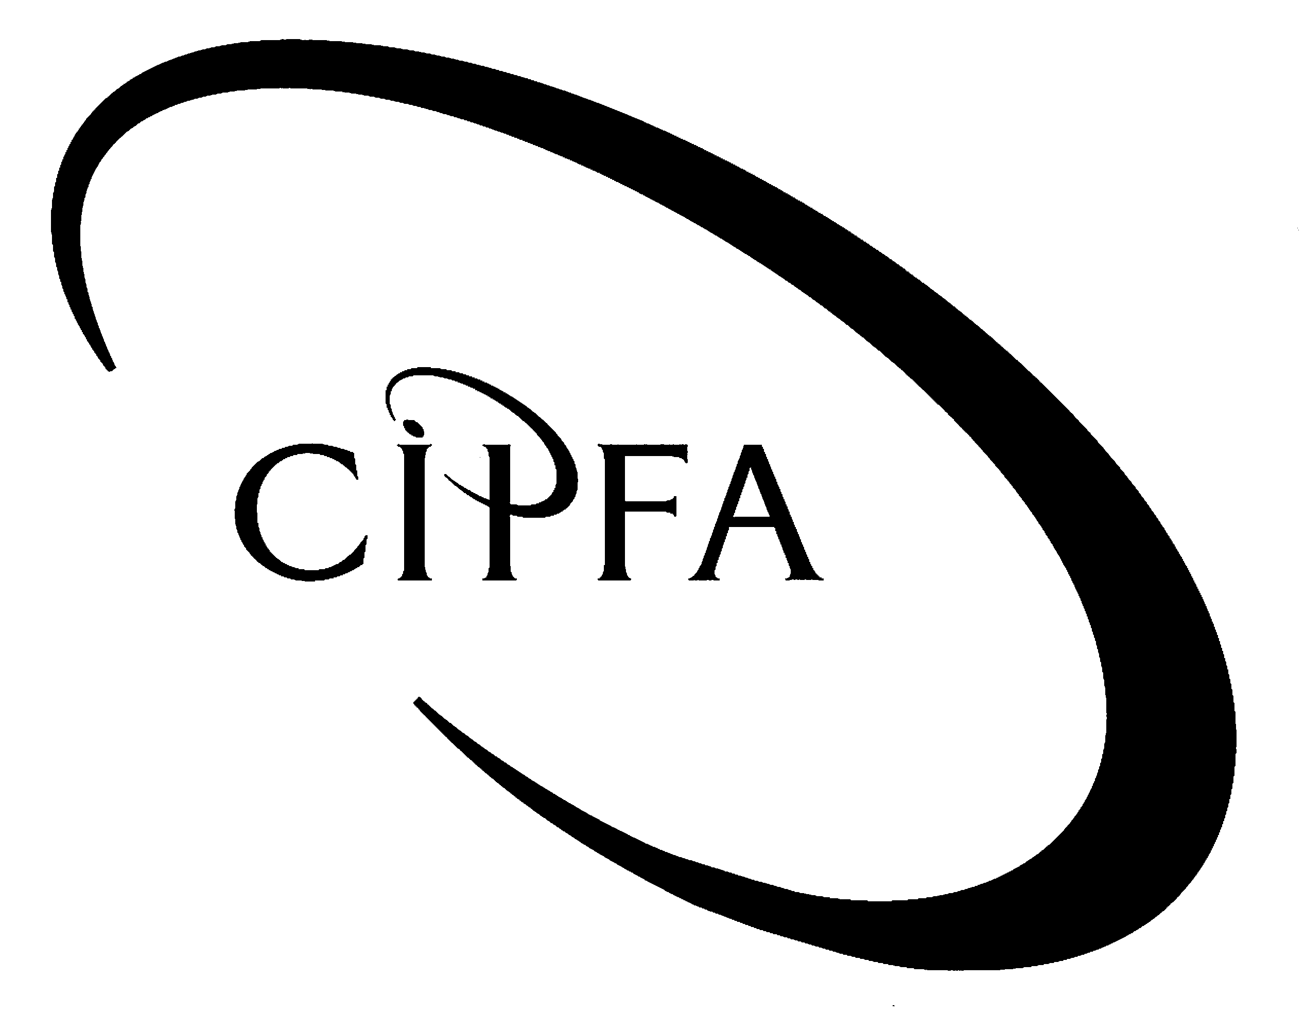

SECTION A (Compulsory)
1
Parkhead Council is a medium sized local authority. Like all local authorities there are a number of services for which the Council charges the public directly, for example, removal of non-domestic waste and processing planning applications. Similarly, the Council also charges the public for any goods sold, such as local maps, wheelie bins and sports and leisure equipment, to name a few.

As the external auditor, you are conducting the interim audit of Parkhead Council and have decided to concentrate your audit efforts on the system of cash collection within the authority. This decision has partly been due to irregularities uncovered in the system of cash collection in the past and also due to the matter being raised with you by the Chief Executive of the authority.

Cash is collected at the Council by one of three methods:

1. Sales direct to customers who collect goods from the Council and pay cash immediately for the goods, or who pay cash at the Council for services received

2. Cash collected on delivery of goods to customers

3. Cash received through the post from credit customers

The Council uses two types of invoice; one which is used for cash sales, and the other for credit sales. When payment is received for cash sales by the cashier, a copy of the invoice is stamped as paid and filed alphabetically by her whilst the other copy of the invoice is given to the customer as a receipt. Petty cash is also reimbursed on a weekly basis out of cash sales.

As regards credit sales, the invoice is sent to the customer and when payment is received, the copy invoice is stamped as paid and filed alphabetically with the cash sales invoices. Mail is opened by the secretary to the Chief Accountant and she passes any remittances to the Chief Accountant for his review, without recording the amounts received. The Chief Accountant gives the remittances to the cashier by depositing them in a tray on the cashier’s desk. The cashier then prepares a listing of the remittances which is used by the Chief Accountant for posting to the sales ledger.

All cheques from credit customers and cash sales receipts are banked daily by the cashier. The Chief Accountant posts remittances to the sales ledger by means of a computerised cash receipting system, and verifies any cash discounts that may be allowable.
The Chief Accountant obtains approval from the Assistant Director of Finance to write off bad debts, and any remittances received in respect of these amounts are credited to sundry income if they are received after the debts have been written off.

The Chief Executive of Parkhead Council has asked you to review the system of control over cash collection and remittances as he suspects that irregularities are taking place. In order to avoid giving an incorrect audit opinion at the year-end, you are keen to help as you want to minimise overall audit risk.

The Chief Executive also informs you that he has been asked by several Councillors about the regulation of audit. A recent fraud by one of the senior internal auditors in the authority has led the Councillors to question the system of standard setting, monitoring and disciplinary control of the auditing profession in the UK.

- Requirement for question 1

You are required to prepare a report for the Chief Executive of Parkhead Council which addresses the following points:

- Describe the potential irregularities which could occur under the present system of accounting for cash collection and remittances through the post. 5

(b) Suggest improvements in the system of internal control which could prevent any potential irregularities in the collection of cash and remittances. 6

(c) Describe, with reasons, the audit tests which you would carry out to assess whether any irregularities had taken place. 5

(d) Describe the controls you would expect to be in operation to ensure that payment is received from credit customers. 5

(e) Overall audit risk is the risk that the auditors may give an audit opinion that is wrong, therefore to minimise overall audit risk, auditors seek to evaluate its different components. Explain what the three constituent parts are of overall audit risk. 6

(f) Explain the roles and responsibilities of the key players in the new regulatory structure for auditing in the UK. 5

- The personal qualities required of an auditor are more demanding than those required of staff in many other disciplines. In order to convince the Councillors of this, outline the most important personal qualities required of an auditor. 6

Marks available for presentation, tone, style
2

(40)

SECTION B (Answer three questions)
2
The examination of evidence is fundamental to the audit process. SAS 400 states that ‘the auditor should obtain relevant and reliable audit evidence sufficient to enable him or her to draw reasonable conclusions therefrom’. While the main source of evidence will usually be in the accounting records, they cannot alone provide sufficient evidence. Evidence is available to the auditor from sources under his own control, from the management of the organisation and from third parties. Each of these sources present the auditor with differing considerations as to the quality of the evidence produced.

- Requirement for question 2

(a) Discuss the reliability of the following types of audit evidence, giving two examples of each form of evidence.

(i) Evidence originated by the auditor; 3

(ii) Evidence created by third parties; 3

(iii) Evidence created by the client. 3

(b) Describe the various techniques used by the auditor to collect audit evidence. 6

(c) Outline the general considerations which the auditor must bear in mind when evaluating audit evidence. 5

(20)

You are the Senior Partner of an audit firm responsible for the audit of Hale & Hearty Health Board. On your way back from a meeting with the Chief Executive of the Board, you overhear a conversation between two of the members of the Health Board;
3
Board Member 1: “Have you heard the latest as a result of the scandal that the auditors uncovered last year?”

Board Member 2: “Don’t tell me, another person has now been caught fiddling their expenses!”

Board Member 1: “Probably, but no; the auditors are coming back next week to carry out more work.”

Board Member 2: “What are they looking at this time?”

Board Member 1: “I don’t know exactly but the Chief Accountant muttered something about systems based auditing.”

Board Member 2: “What’s that all about then?”

Board Member 1: “I’m not very sure, but sounds like auditor jargon to me. The Chief Accountant says its probably just another plan to get more audit fees out of us!”

Feeling rather enraged you decide to write a letter to the Chief Accountant outlining the exact purpose and importance of Systems Based Auditing.

- Requirement for question 3

Draft a letter to the Chief Accountant of Hale & Hearty Health Board outlining the following points for his clarification:

(a) The definition of Systems Based Auditing. 3

(b) The differing internal and external audit approaches to Systems Based Auditing. 4

(c) The stages involved in Systems Based Auditing. 6

(d) The advantages and disadvantages of Systems Based Auditing. 7

(20)

Contract audit is fundamentally no different from other audits, although the working environments and the control of objectives applicable to the client activities are unfamiliar to many auditors. CIPFA’s statement of best practice on contract audit, issued on 1 January 1995, recommends that contract audit be divided into three stages:
4

- Pre-contract
- Current contract
- Post-completion

- Requirement for question 4

(a) Outline the key management controls which the auditor would expect to test when carrying out the three stages of contract audit. 8

(b) Detail two compliance tests and two substantive tests which could be carried out at each of the above contract audit stages. 12

(20)

You are the Chief Internal Auditor of Studytown University. The university, under a Steering Group led by the Principal of the university, is proposing to install a new computer system to improve financial management.
5

A recent external audit report of internal audit has recommended that the internal audit section should have a dedicated computer auditor to help when the new computer system is implemented. It also recommended that internal audit should be involved in the development phase of any new systems.

The Principal of the university is yet to be convinced of the use of scarce resources in employing a dedicated computer auditor and is rather apprehensive about letting internal audit get involved in any systems under development.

- Requirement for question 5

You are required to prepare a paper for the Principal which answers the following questions:

(a) What specialist skills are needed by computer auditors? 6

(b) What tasks would normally be undertaken by specialist computer auditors? 4

(c) What advantages are there in the auditor being involved in the development phase of any new system? 4

(d) When carrying out the audit of systems under development, what would the auditor be specifically looking at? 5

Marks available for presentation, tone, style

1

(20)

